Morning Prayer: Sunday, July 26th, 2026
The Ninth Sunday after Pentecost
Christ Church Easton

Officiant: As we gather to worship, let us recognize that we gather on the ancestral lands and traditional territory of the (Aspetuck River Valley dwelling) Paugussett people.

Officiant: Grace to you and peace from God our Father and the Lord Jesus Christ. Philippians 1:2
Opening Hymn “Morning Has Broken”
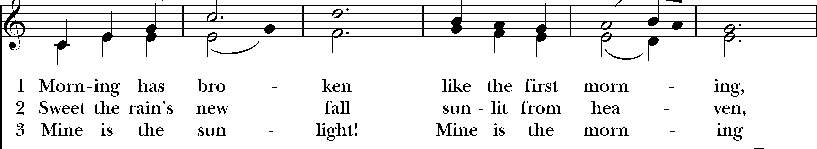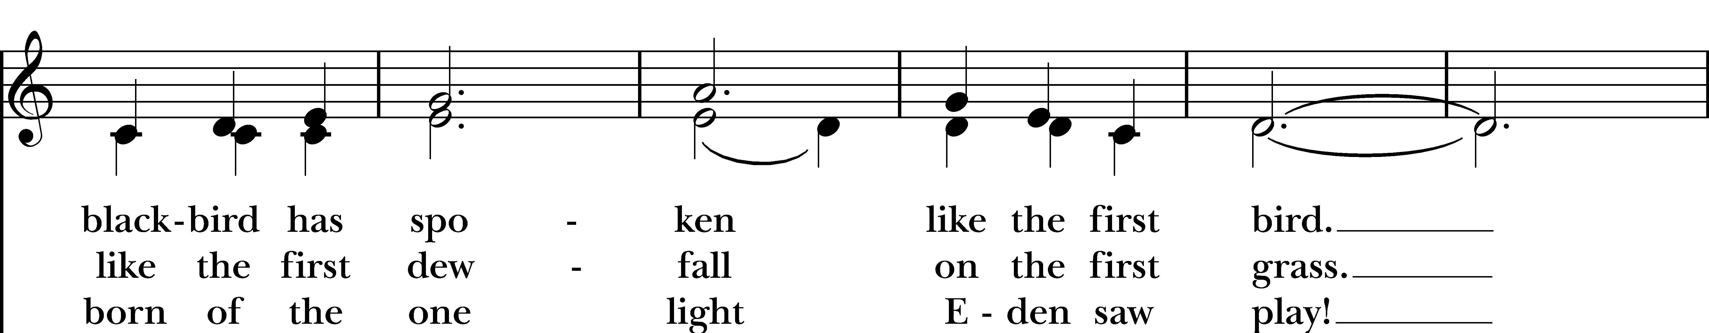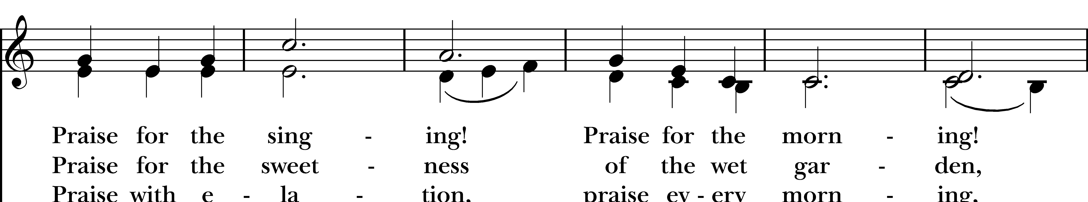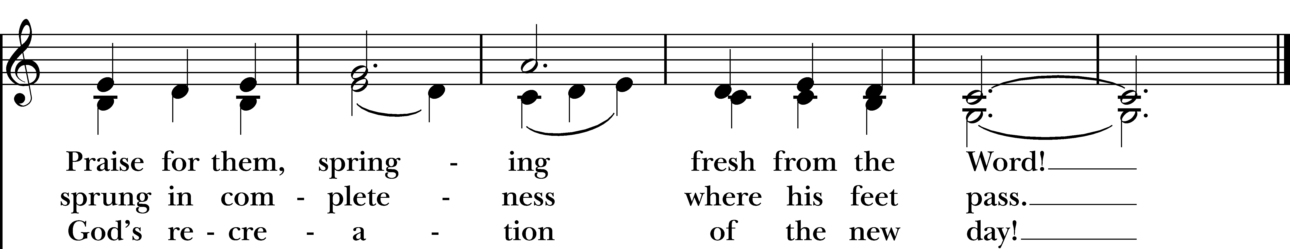
Reprinted/streamed with permission via One License and RiteSong. All rights reserved.

Litany for Our Times

Forgive us, O God, whenever we build cages where you have called us to build homes. May love set us free.

Forgive us whenever we choose comfort over compassion. May love set us free.

Forgive us whenever we remain silent because speaking the truth is costly. May love set us free.

Deliver us from every obedience that betrays love. May love set us free.

When laws demand what mercy forbids, grant us the perseverance to obey conscience before comfort and your love before every earthly power. May love set us free.

Keep us faithful to the nonviolent way of Christ, who overcame hatred not with hatred but with love. May love set us free.

Woe to those who build walls where you have called us to build tables, who teach us to fear the stranger instead of welcoming our neighbor, and who ask us to believe that another person’s suffering can become the price of our own security. May love set us free.

Strip away every lie that justifies cruelty. May love set us free.

Break the spell of indifference. May love set us free.

Teach those entrusted with power that no nation is made stronger by forgetting the sacredness of the human person, and that no law is worthy of honor when it denies the dignity you have given. May love set us free.

Invitatory and Psalter

Officiant: Lord, open our lips.
People: And our mouth shall proclaim your praise.

Glory to the Father, and to the Son, and to the Holy Spirit: as it was in the beginning, is now, and will be for ever. Amen.

Psalm 95: Venite

Come, let us sing to the Lord; let us shout for joy to the Rock of our salvation.
Let us come before his presence with thanksgiving and raise a loud shout to him with psalms.
For the Lord is a great God, and a great King above all gods.
In his hand are the caverns of the earth, and the heights of the hills are his also.
The sea is his, for he made it, and his hands have molded the dry land.
Come, let us bow down, and bend the knee, and kneel before the Lord our Maker.
For he is our God, and we are the people of his pasture and the sheep of his hand.
Oh, that today you would hearken to his voice!

The Psalm Appointed: Psalm 105

Give thanks to the Lord and call upon his Name; *
make known his deeds among the peoples.
Sing to him, sing praises to him, *
and speak of all his marvelous works.
Glory in his holy Name; *
let the hearts of those who seek the Lord rejoice.
Search for the Lord and his strength; *
continually seek his face.
Remember the marvels he has done, *
his wonders and the judgments of his mouth,
O offspring of Abraham his servant, *
O children of Jacob his chosen.
He is the Lord our God; *
his judgments prevail in all the world.
He has always been mindful of his covenant, *
the promise he made for a thousand generations:
The covenant he made with Abraham, *
the oath that he swore to Isaac,
Which he established as a statute for Jacob, *
an everlasting covenant for Israel,
Saying, "To you will I give the land of Canaan *
to be your allotted inheritance." Hallelujah!

Glory to the Father, and to the Son, and to the Holy Spirit; as it was in the beginning, is now, and will
be for ever. Amen.

The First Reading Genesis 29:15-28
A Reading from the Book of Genesis.

Laban said to Jacob, “Because you are my kinsman, should you therefore serve me for nothing? Tell me, what shall your wages be?” Now Laban had two daughters; the name of the elder was Leah, and the name of the younger was Rachel. Leah’s eyes were lovely, and Rachel was graceful and beautiful. Jacob loved Rachel; so he said, “I will serve you seven years for your younger daughter Rachel.” Laban said, “It is better that I give her to you than that I should give her to any other man; stay with me.” So Jacob served seven years for Rachel, and they seemed to him but a few days because of the love he had for her.

Then Jacob said to Laban, “Give me my wife that I may go in to her, for my time is completed.” So Laban gathered together all the people of the place, and made a feast. But in the evening he took his daughter Leah and brought her to Jacob; and he went in to her. (Laban gave his maid Zilpah to his daughter Leah to be her maid.) When morning came, it was Leah! And Jacob said to Laban, “What is this you have done to me? Did I not serve with you for Rachel? Why then have you deceived me?” Laban said, “This is not done in our country—giving the younger before the firstborn. Complete the week of this one, and we will give you the other also in return for serving me another seven years.” Jacob did so, and completed her week; then Laban gave him his daughter Rachel as a wife.

Hear what the Spirit is saying to God’s people.
Thanks be to God.

The Second Reading Romans 8:26-39
A Reading from the Letter to the Romans.

The Spirit helps us in our weakness; for we do not know how to pray as we ought, but that very Spirit intercedes with sighs too deep for words. And God, who searches the heart, knows what is the mind of the Spirit, because the Spirit intercedes for the saints according to the will of God.

We know that all things work together for good for those who love God, who are called according to his purpose. For those whom he foreknew he also predestined to be conformed to the image of his Son, in order that he might be the firstborn within a large family. And those whom he predestined he also called; and those whom he called he also justified; and those whom he justified he also glorified.

What then are we to say about these things? If God is for us, who is against us? He who did not withhold his own Son, but gave him up for all of us, will he not with him also give us everything else? Who will bring any charge against God's elect? It is God who justifies. Who is to condemn? It is Christ Jesus, who died, yes, who was raised, who is at the right hand of God, who indeed intercedes for us. Who will separate us from the love of Christ? Will hardship, or distress, or persecution, or famine, or nakedness, or peril, or sword? As it is written, “For your sake we are being killed all day long; we are accounted as sheep to be slaughtered.”

No, in all these things we are more than conquerors through him who loved us. For I am convinced that neither death, nor life, nor angels, nor rulers, nor things present, nor things to come, nor powers, nor height, nor depth, nor anything else in all creation, will be able to separate us from the love of God in Christ Jesus our Lord.

Hear what the Spirit is saying to God’s people.
Thanks be to God.

The Gospel Matthew 13:31-33,44-52
A Reading from the Holy Gospel according to Matthew.

Jesus put before the crowds another parable: “The kingdom of heaven is like a mustard seed that someone took and sowed in his field; it is the smallest of all the seeds, but when it has grown it is the greatest of shrubs and becomes a tree, so that the birds of the air come and make nests in its branches.”
He told them another parable: “The kingdom of heaven is like yeast that a woman took and mixed in with three measures of flour until all of it was leavened.”

“The kingdom of heaven is like treasure hidden in a field, which someone found and hid; then in his joy he goes and sells all that he has and buys that field. “Again, the kingdom of heaven is like a merchant in search of fine pearls; on finding one pearl of great value, he went and sold all that he had and bought it.
“Again, the kingdom of heaven is like a net that was thrown into the sea and caught fish of every kind; when it was full, they drew it ashore, sat down, and put the good into baskets but threw out the bad. So it will be at the end of the age. The angels will come out and separate the evil from the righteous and throw them into the furnace of fire, where there will be weeping and gnashing of teeth.

“Have you understood all this?” They answered, “Yes.” And he said to them, “Therefore every scribe who has been trained for the kingdom of heaven is like the master of a household who brings out of his treasure what is new and what is old.”

Hear what the Spirit is saying to God’s people.
Thanks be to God.

Reflection Andy Hathaway

Reflection Hymn “Just When I Need Him”

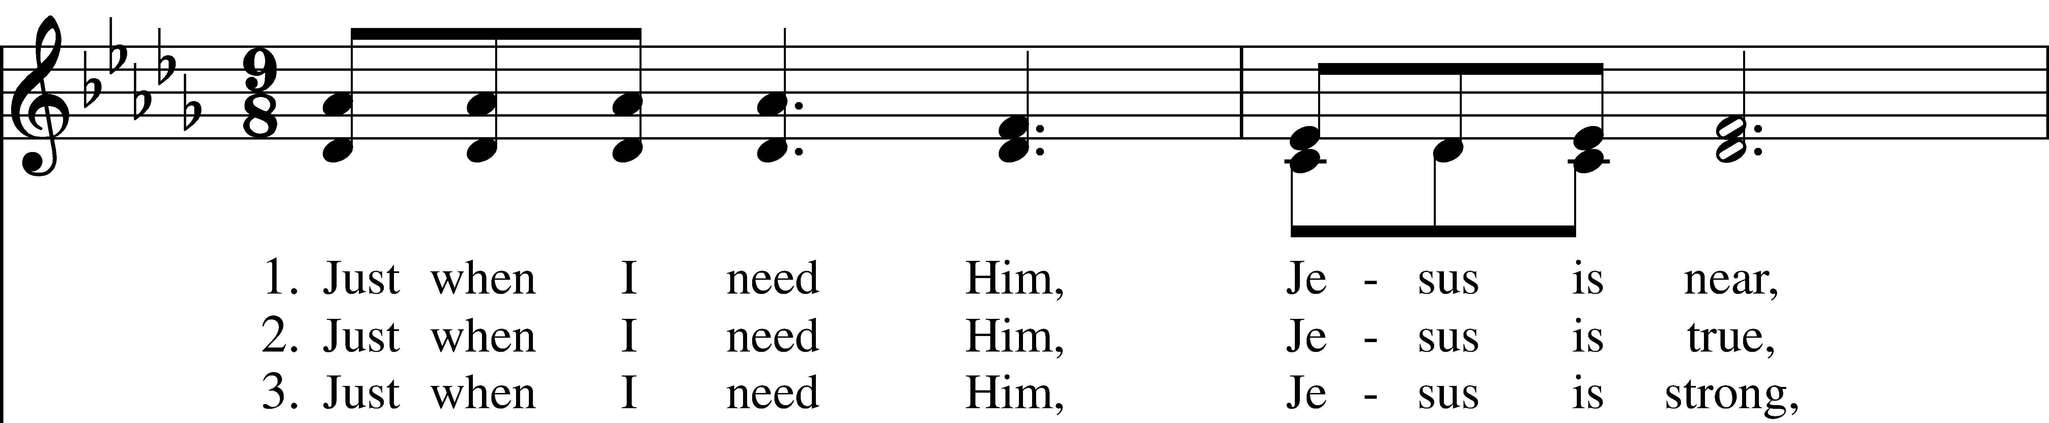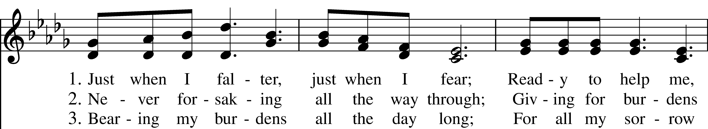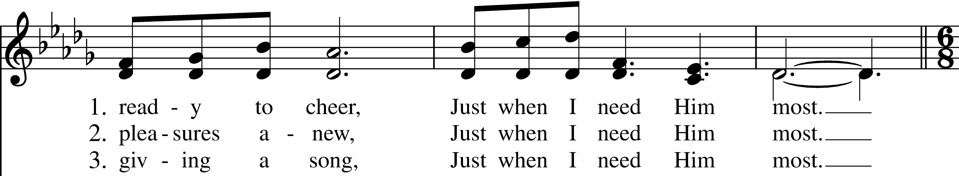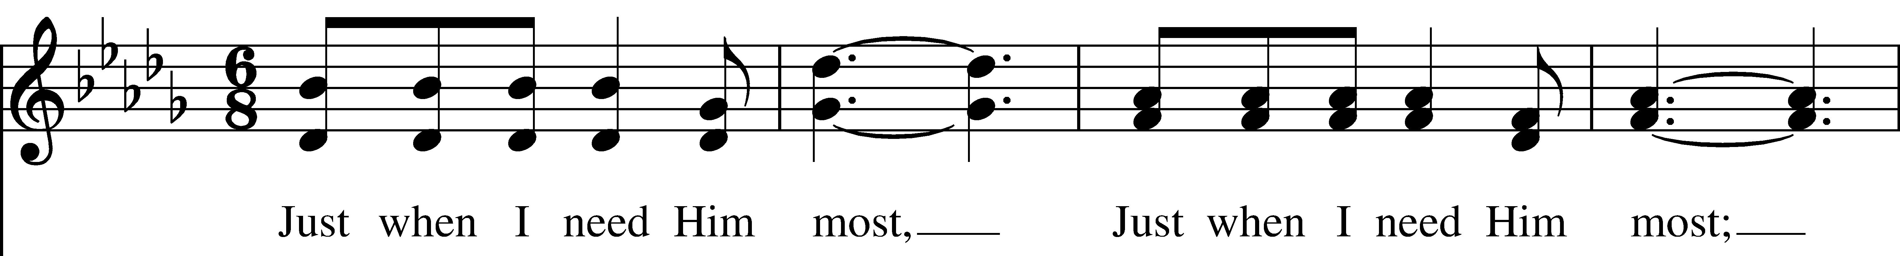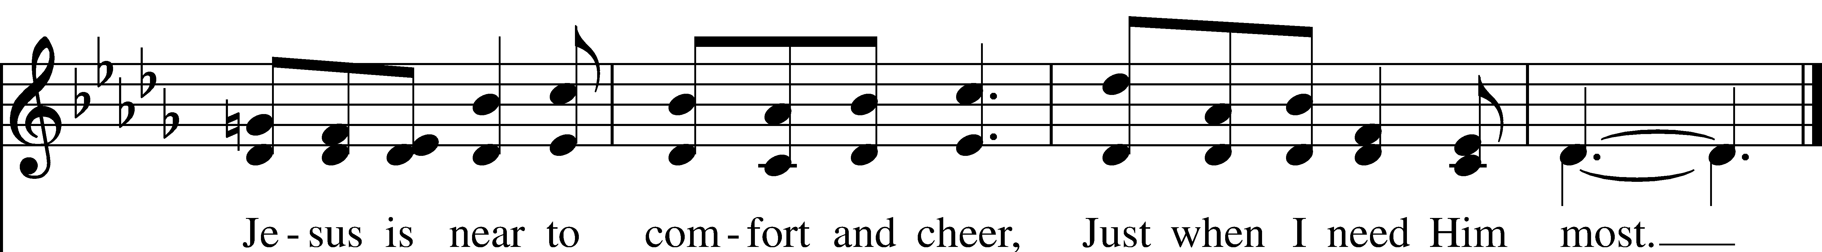

Reprinted/streamed with permission via One License and RiteSong. All rights reserved.
Apostles’ Creed

I believe in God, the Father almighty, creator of heaven and earth. I believe in Jesus Christ, his only son, our Lord. He was conceived by the power of the Holy Spirit, born of the Virgin Mary. He suffered under Pontius Pilate, was crucified, died, and was buried. He descended to the dead. On the third day he rose again. He ascended into heaven, and is seated at the right hand of the Father. He will come again to judge the living and the dead. I believe in the Holy Spirit, the holy catholic Church, the communion of saints, the forgiveness of sins, the resurrection of the body, and the life everlasting. Amen.
The Prayers

Officiant: The Lord be with you.
People: And also with you.
Officiant: Let us pray.

Our Father, who art in heaven, hallowed be thy Name, thy kingdom come, thy will be done, on earth as it is in heaven. Give us this day our daily bread. And forgive us our trespasses, as we forgive those who trespass against us. And lead us not into temptation, but deliver us from evil. For thine is the kingdom, and the power, and the glory, for ever and ever. Amen.

Suffrages for Use in Morning Prayer From EOW (Enriching our Worship)
V. Help us, O God our Savior;
R. Deliver us and forgive us our sins.
V. Look upon your congregation.
R. Give to your people the blessing of peace.
V. Declare your glory among the nations;
R. And your wonders among all peoples.
V. Do not let the oppressed be shamed and turned away;
R. Never forget the lives of your poor.
V. Continue your loving-kindness to those who know you;
R. And your favor to those who are true of heart.
V. Satisfy us by your loving-kindness in the morning;
R. So shall we rejoice and be glad all the days of our life.

The Collect of the Day

O God, the protector of all who trust in you, without whom nothing is strong, nothing is holy: Increase and multiply upon us your mercy; that, with you as our ruler and guide, we may so pass through things temporal, that we lose not the things eternal; through Jesus Christ our Lord, who lives and reigns with you and the Holy Spirit, one God, for ever and ever. Amen.

Prayers of the People: Form III

Father, we pray for your holy Catholic Church;
That we all may be one.

Grant that every member of the Church may truly and humbly serve you;
That your Name may be glorified by all people.

We pray for all bishops, priests, and deacons;
That they may be faithful ministers of your Word and Sacraments.

We pray for all who govern and hold authority in the nations of the world;
That there may be justice and peace on the earth.
Give us grace to do your will in all that we undertake;
That our works may find favor in your sight.

Have compassion on those who suffer from any grief or trouble;
That they may be delivered from their distress.

Give to the departed eternal rest.
Let light perpetual shine upon them.

We praise you for your saints who have entered into joy;
May we also come to share in your heavenly kingdom.

Let us pray for our own needs and those of others. We pray especially for those on our parish prayer list…

O Lord our God, accept the fervent prayers of your people; in the multitude of your mercies, look with compassion upon us and all who turn to you for help; for you are gracious, O lover of souls, and to you we give glory, Father, Son, and Holy Spirit, now and for ever. Amen.

Offering & Announcements

Prayer of St. Chrysostom

Almighty God, you have given us grace at this time with one accord to make our common supplication to you; and you have promised through your well-beloved Son that when two or three are gathered together in his Name you will be in the midst of them: Fulfill now, O Lord, our desires & petitions as may be best for us; granting us in this world knowledge of your truth, and in the age to come life everlasting. Amen.

Concluding Prayer

Glory to God whose power, working in us, can do infinitely more than we can ask or imagine: Glory to him from generation to generation in the Church, and in Christ Jesus for ever and ever. Amen.

Closing Hymn “O for a thousand tongues to sing”

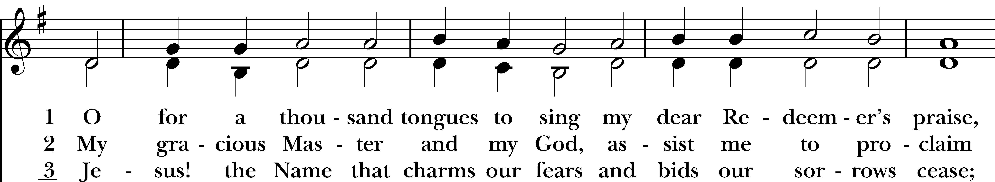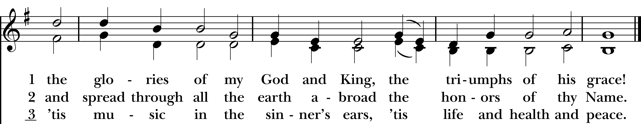
Reprinted/streamed with permission via One License and RiteSong. All rights reserved.
Dismissal

Officiant: Our worship is ended. Our Service begins. Let us go in peace to love & serve the Lord. Alleluia, alleluia.
People: Thanks be to God. Alleluia, alleluia.

Announcements for July 26th, 2026

CONCERT TONIGHT: Dan Tressler & Friends play from 6-8 pm, with Me’stezo Grill. Arrive early at 5:30 to get your food truck orders in!

LAST CONCERT: Bugs on a Log String Band (originally scheduled for 7/5) will perform on Sunday, 8/9.

COTH VOLUNTEERS NEEDED: See Vicki to sign up to help.

CHRISTMAS IN JULY: Diaper drive for Nourish Bridgeport this month. Donations of diapers, pullups, and wipes are needed and greatly appreciated!

GIFT CARDS to gas stations & grocery stores are always needed. Thank you for your continued generosity.

Welcome to Christ Church Easton!
Whether you are a newcomer, visitor, or longtime member, we bid you a warm welcome!
Please join us for coffee hour following service.
Sign up for our email list at www.christchurcheaston.com
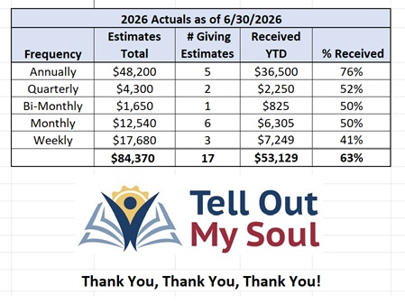
Christ Church – Parish Office Hours:
Mondays & Wednesdays: 9:30-1:30

59 Church Rd, Easton, CT
(203) 268-3569

christchurcheaston@gmail.com
www.christchurcheaston.com

Priest-in-Charge: Katy Piazza

Senior Warden: Vicki MarkAnthony

Parish Administrator: Tracy Carlucci
UPCOMING SUNDAY WORSHIP – Outdoors at 9:00 am thru Sept. 6th

Sunday, 8/2: Eucharist – Rev. Katy Piazza

Sunday, 8/9: Eucharist – Rev. Sandy Belcher

Sunday, 8/16: Eucharist – Rev. Katy Piazza

Sunday, 8/23: Eucharist – Rev. Sandy Belcher

Vestry: Jim Swann, Jr. Warden; Bob Ellwanger, Treasurer; Amy Bailas, Clerk

Vestry Members: Russ Bailas, Marina Philips, Claire Wilkes, Peg Ellwanger

Diocesan Delegates: Diane McCann, Bob Ellwanger; Alternate: Deborah Swann
Music Minister: Tracy Carlucci

Choir Members: Amy Strachan, Andy Verrocchi, Bob Ellwanger, David McCann, Diane McCann, Marina Philips, Katie Tressler, Vicki MarkAnthony

Christ Church Nursery School: Maggie Supple, Director www.ccnseaston.com

