Morning Prayer: Sunday, March 22nd, 2026
The Fifth Sunday in Lent
Christ Church Easton

Officiant: As we gather to worship, let us recognize that we gather on the ancestral lands and traditional territory of the (Aspetuck River Valley dwelling) Paugussett people.

To the Lord our God belong mercy and forgiveness, because we have rebelled against him and have not obeyed the voice of the Lord our God by following his laws which he set before us. Daniel 9:9,10

Officiant: Please stand as you are able and sing together our Opening Hymn, #495, Hail thou once despised Jesus”

Opening Hymn “Hail thou once despised Jesus” Hymnal #495

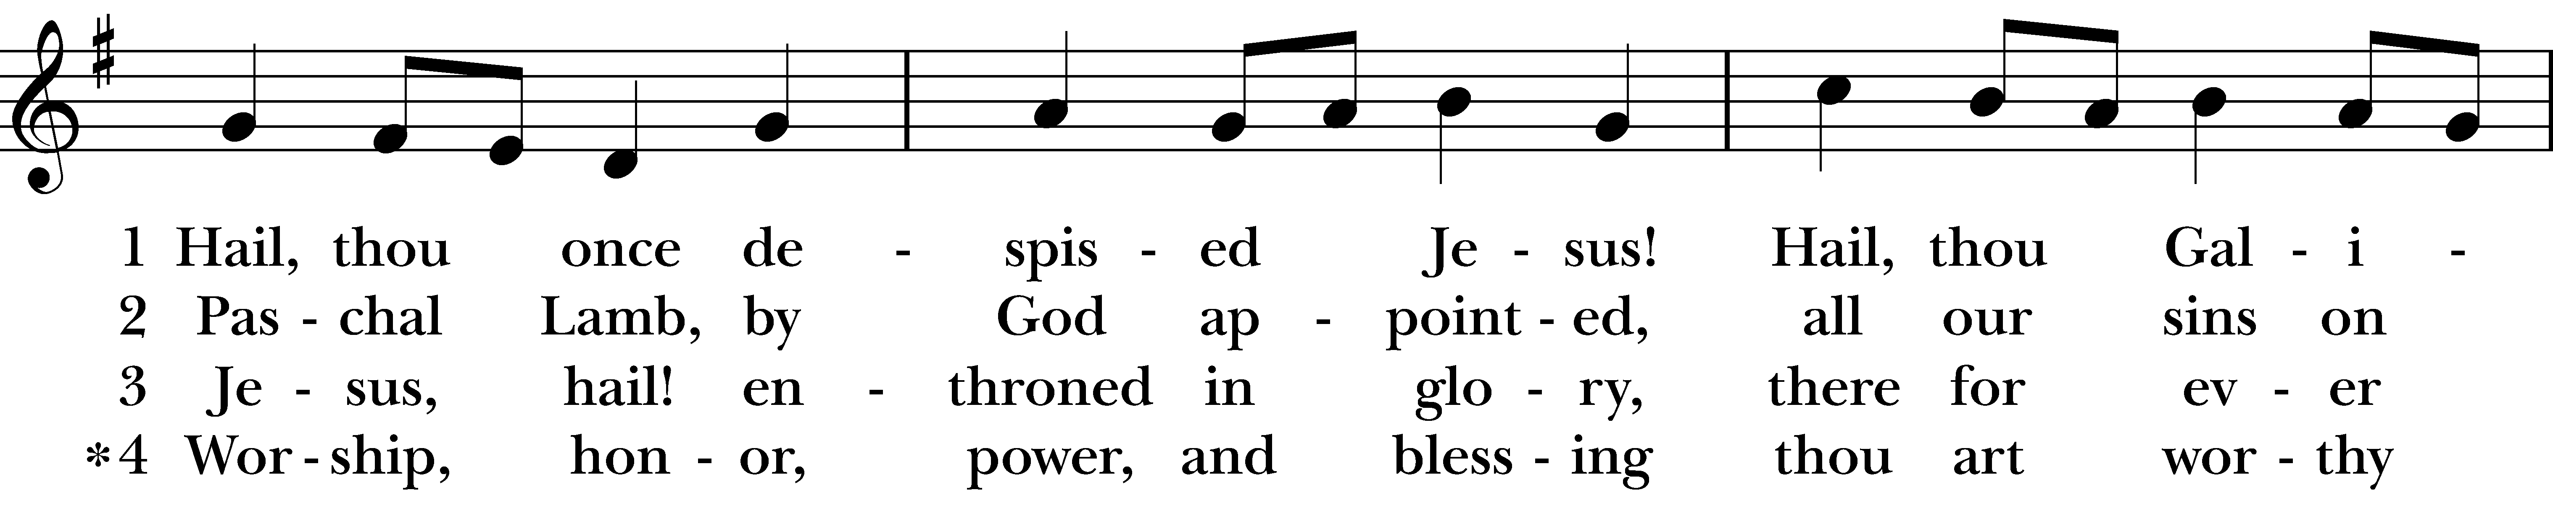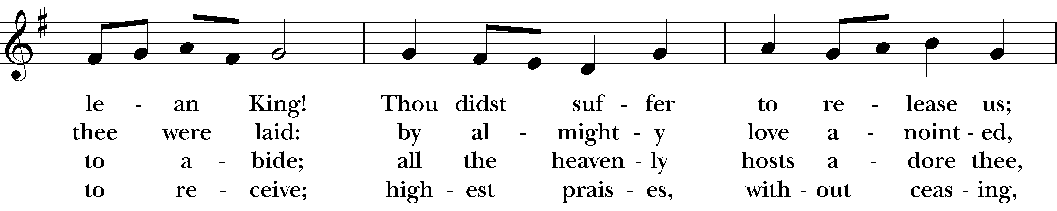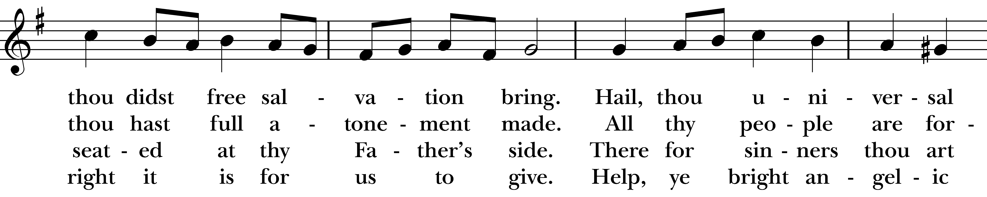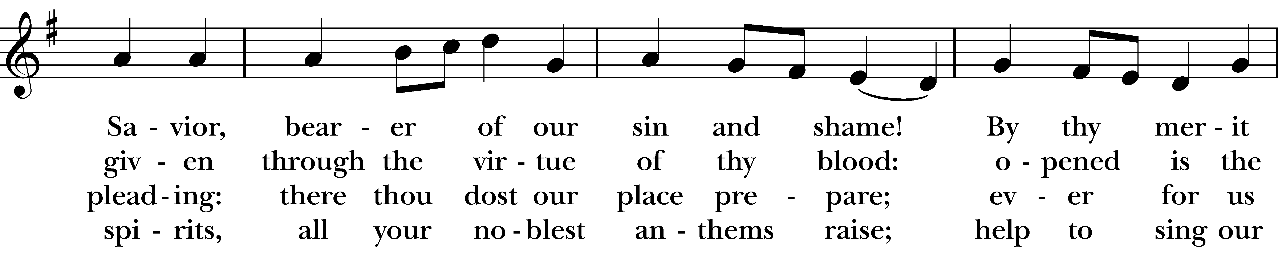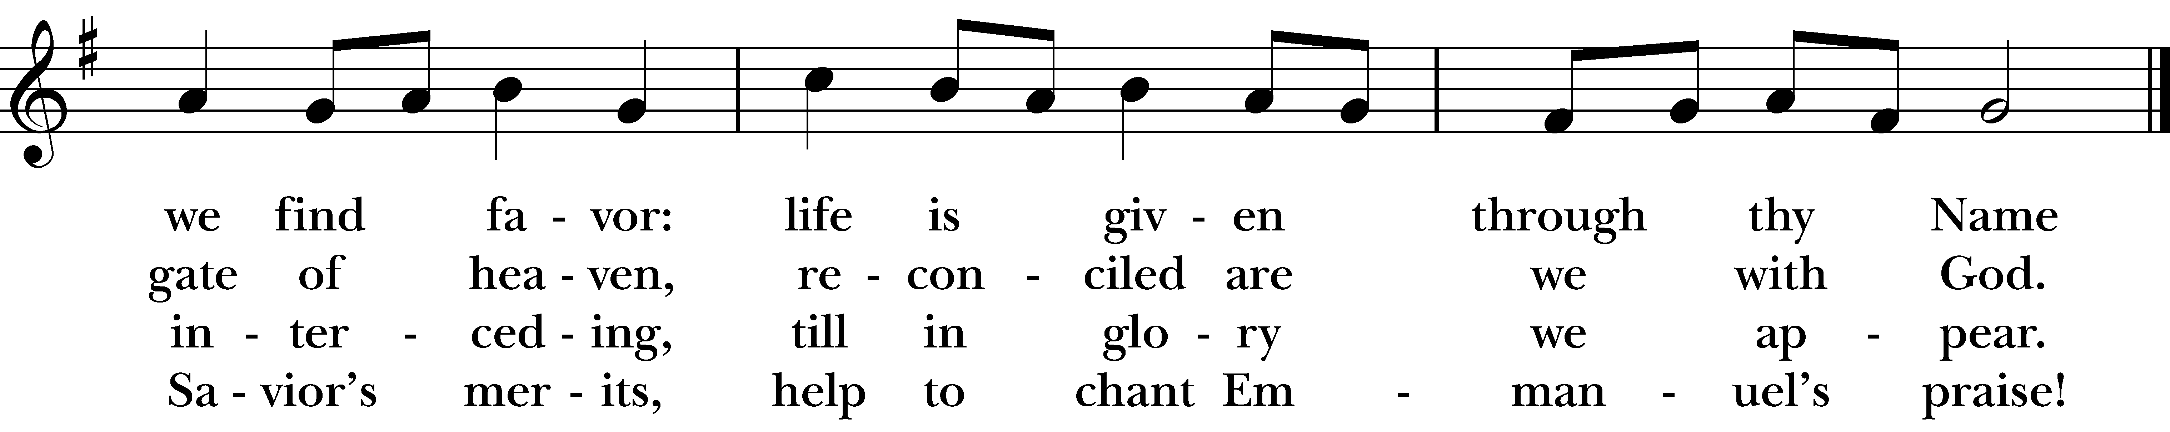
Reprinted/streamed with permission via One License and RiteSong. All rights reserved.
Confession of Sin BCP p. 79
Officiant: Turning to page 79 in the Book of Common Prayer, let us confess our sins against God and our neighbor.

Most merciful God, we confess that we have sinned against you in thought, word, and deed, by what we have done, and by what we have left undone. We have not loved you with our whole heart; we have not loved our neighbors as ourselves. We are truly sorry and we humbly repent. For the sake of your Son Jesus Christ, have mercy on us and forgive us; that we may delight in your will, and walk in your ways, to the glory of your Name. Amen.
Almighty God have mercy on us, forgive us all our sins through our Lord Jesus Christ, strengthen us in all goodness, and by the power of the Holy Spirit keep us in eternal life. Amen.
Invitatory and Psalter BCP p. 80

Officiant: Lord, open our lips.
People: And our mouth shall proclaim your praise.

Glory to the Father, and to the Son, and to the Holy Spirit: as it was in the beginning, is now, and will be for ever. Amen.

Officiant: The Lord has shown forth his glory: Come let us adore him.

Lector: Turning now to page 82 in the Book of Common Prayer, we will recite the Venite responsively at the asterisk.

Psalm 95: Venite BCP p. 82
Come, let us sing to the Lord; *
let us shout for joy to the Rock of our salvation.
Let us come before his presence with thanksgiving *
and raise a loud shout to him with psalms.
For the Lord is a great God, *
and a great King above all gods.
In his hand are the caverns of the earth, *
and the heights of the hills are his also.
The sea is his, for he made it, *
and his hands have molded the dry land.
Come, let us bow down, and bend the knee, *
and kneel before the Lord our Maker.
For he is our God, and we are the people of his pasture and the sheep of his hand. *
Oh, that today you would hearken to his voice!

The Psalm Appointed: Psalm 121

Out of the depths have I called to you, O LORD; LORD, hear my voice; *
let your ears consider well the voice of my supplication.
If you, LORD, were to note what is done amiss, *
O LORD, who could stand?
For there is forgiveness with you; *
therefore you shall be feared.
I wait for the LORD; my soul waits for him; *
in his word is my hope.
My soul waits for the LORD, more than watchmen for the morning, *
more than watchmen for the morning.
O Israel, wait for the LORD, *
for with the LORD there is mercy;
With him there is plenteous redemption, *
and he shall redeem Israel from all their sins.

Glory to the Father, and to the Son, and to the Holy Spirit; as it was in the beginning, is now, and will
be for ever. Amen.

The First Reading Ezekiel 37:1-14
A Reading from the Book of the Prophet Ezekiel.

The hand of the LORD came upon me, and he brought me out by the spirit of the LORD and set me down in the middle of a valley; it was full of bones. He led me all around them; there were very many lying in the valley, and they were very dry. He said to me, “Mortal, can these bones live?” I answered, “O Lord GOD, you know.” Then he said to me, “Prophesy to these bones, and say to them: O dry bones, hear the word of the LORD. Thus says the Lord GOD to these bones: I will cause breath to enter you, and you shall live. I will lay sinews on you, and will cause flesh to come upon you, and cover you with skin, and put breath in you, and you shall live; and you shall know that I am the LORD.” So I prophesied as I had been commanded; and as I prophesied, suddenly there was a noise, a rattling, and the bones came together, bone to its bone. I looked, and there were sinews on them, and flesh had come upon them, and skin had covered them; but there was no breath in them. Then he said to me, “Prophesy to the breath, prophesy, mortal, and say to the breath: Thus says the Lord GOD: Come from the four winds, O breath, and breathe upon these slain, that they may live.” I prophesied as he commanded me, and the breath came into them, and they lived, and stood on their feet, a vast multitude. Then he said to me, “Mortal, these bones are the whole house of Israel. They say, Our bones are dried up, and our hope is lost; we are cut off completely.’ Therefore prophesy, and say to them, Thus says the Lord GOD: I am going to open your graves, and bring you up from your graves, O my people; and I will bring you back to the land of Israel. And you shall know that I am the LORD, when I open your graves, and bring you up from your graves, O my people. I will put my spirit within you, and you shall live, and I will place you on your own soil; then you shall know that I, the LORD, have spoken and will act,” says the LORD.

The Word of the Lord.
Thanks be to God.

The Second Reading Romans 8:6-11
A Reading from the Letter to the Romans.

To set the mind on the flesh is death, but to set the mind on the Spirit is life and peace. For this reason the mind that is set on the flesh is hostile to God; it does not submit to God’s law—indeed it cannot, and those who are in the flesh cannot please God. But you are not in the flesh; you are in the Spirit, since the Spirit of God dwells in you. Anyone who does not have the Spirit of Christ does not belong to him.

But if Christ is in you, though the body is dead because of sin, the Spirit is life because of righteousness. If the Spirit of him who raised Jesus from the dead dwells in you, he who raised Christ from the dead will give life to your mortal bodies also through his Spirit that dwells in you.

The Word of the Lord
Thanks be to God.

The Gospel Officiant: Please remain seated for the Gospel. John 11:1-45

A Reading from the Gospel of John.

Now a certain man was ill, Lazarus of Bethany, the village of Mary and her sister Martha. Mary was the one who anointed the Lord with perfume and wiped his feet with her hair; her brother Lazarus was ill. So the sisters sent a message to Jesus, “Lord, he whom you love is ill.” But when Jesus heard it, he said, “This illness does not lead to death; rather it is for God’s glory, so that the Son of God may be glorified through it.” Accordingly, though Jesus loved Martha and her sister and Lazarus, after having heard that Lazarus was ill, he stayed two days longer in the place where he was. Then after this he said to the disciples, “Let us go to Judea again.” The disciples said to him, “Rabbi, the Jews were just now trying to stone you, and are you going there again?” Jesus answered, “Are there not twelve hours of daylight? Those who walk during the day do not stumble, because they see the light of this world. But those who walk at night stumble, because the light is not in them.” After saying this, he told them, “Our friend Lazarus has fallen asleep, but I am going there to awaken him.” The disciples said to him, “Lord, if he has fallen asleep, he will be all right.” Jesus, however, had been speaking about his death, but they thought that he was referring merely to sleep. Then Jesus told them plainly, “Lazarus is dead. For your sake I am glad I was not there, so that you may believe. But let us go to him.” Thomas, who was called the Twin, said to his fellow disciples, “Let us also go, that we may die with him.”

When Jesus arrived, he found that Lazarus had already been in the tomb four days. Now Bethany was near Jerusalem, some two miles away, and many of the Jews had come to Martha and Mary to console them about their brother. When Martha heard that Jesus was coming, she went and met him, while Mary stayed at home. Martha said to Jesus, “Lord, if you had been here, my brother would not have died. But even now I know that God will give you whatever you ask of him.” Jesus said to her, “Your brother will rise again.” Martha said to him, “I know that he will rise again in the resurrection on the last day.” Jesus said to her, “I am the resurrection and the life. Those who believe in me, even though they die, will live, and everyone who lives and believes in me will never die. Do you believe this?” She said to him, “Yes, Lord, I believe that you are the Messiah, the Son of God, the one coming into the world.” When she had said this, she went back and called her sister Mary, and told her privately, “The Teacher is here and is calling for you.” And when she heard it, she got up quickly and went to him. Now Jesus had not yet come to the village, but was still at the place where Martha had met him. The Jews who were with her in the house, consoling her, saw Mary get up quickly and go out. They followed her because they thought that she was going to the tomb to weep there. When Mary came where Jesus was and saw him, she knelt at his feet and said to him, “Lord, if you had been here, my brother would not have died.”

When Jesus saw her weeping, and the Jews who came with her also weeping, he was greatly disturbed in spirit and deeply moved. He said, “Where have you laid him?” They said to him, “Lord, come and see.” Jesus began to weep. So the Jews said, “See how he loved him!” But some of them said, “Could not he who opened the eyes of the blind man have kept this man from dying?” Then Jesus, again greatly disturbed, came to the tomb. It was a cave, and a stone was lying against it. Jesus said, “Take away the stone.” Martha, the sister of the dead man, said to him, “Lord, already there is a stench because he has been dead four days.” Jesus said to her, “Did I not tell you that if you believed, you would see the glory of God?” So they took away the stone. And Jesus looked upward and said, “Father, I thank you for having heard me. I knew that you always hear me, but I have said this for the sake of the crowd standing here, so that they may believe that you sent me.” When he had said this, he cried with a loud voice, “Lazarus, come out!” The dead man came out, his hands and feet bound with strips of cloth, and his face wrapped in a cloth. Jesus said to them, “Unbind him, and let him go.”

Many of the Jews therefore, who had come with Mary and had seen what Jesus did, believed in him.

The Word of the Lord
Thanks be to God.

Reflection Molly Adams

Officiant: Please join in singing “Humbly I adore thee,” #314 in the hymnal.

Post-Reflection Hymn “Humbly I adore thee” Hymnal #314
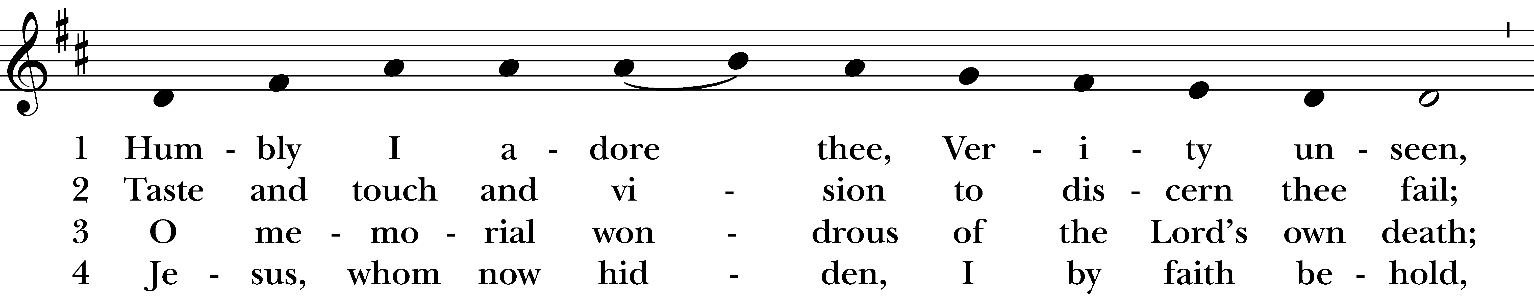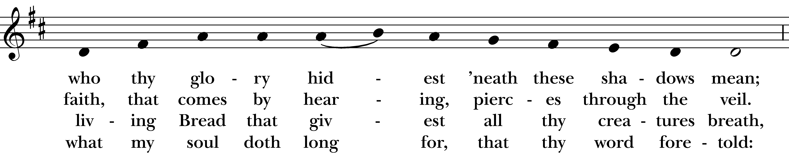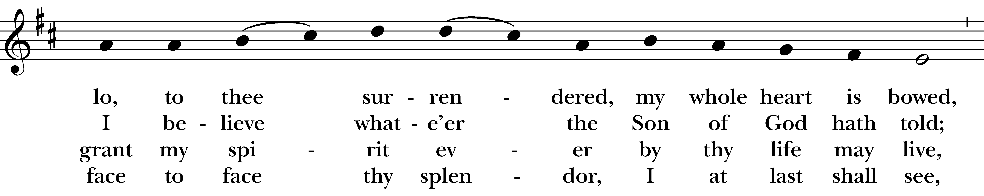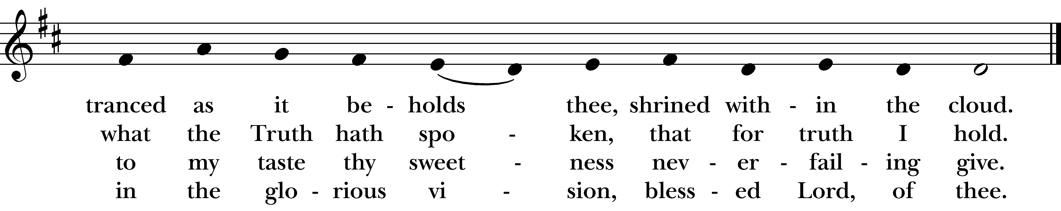
Reprinted/streamed with permission via One License and RiteSong. All rights reserved.
Officiant: Please stand as you are able for The Apostles Creed, page 96 in the Book of Common Prayer.

Apostles’ Creed BCP p. 96

I believe in God, the Father almighty, creator of heaven and earth. I believe in Jesus Christ, his only son, our Lord. He was conceived by the Holy Spirit, born of the Virgin Mary. He suffered under Pontius Pilate, was crucified, died, and was buried. He descended to the dead. On the third day he rose again. He ascended into heaven, and is seated at the right hand of the Father. He will come again to judge the living and the dead. I believe in the Holy Spirit, the holy catholic Church, the communion of saints, the forgiveness of sins, the resurrection of the body, and the life everlasting. Amen.

Officiant: The Lord be with you.
People: And also with you.
Officiant: Let us pray.

Lord’s Prayer BCP p. 97

Our Father, who art in heaven, hallowed be thy Name, thy kingdom come, thy will be done, on earth as it is in heaven. Give us this day our daily bread. And forgive us our trespasses, as we forgive those who trespass against us. And lead us not into temptation, but deliver us from evil. For thine is the kingdom, and the power, and the glory, for ever and ever. Amen.

Officiant: Turning now to page 98 in the Book of Common Prayer, let us pray the Suffrages B.

Suffrages B BCP p. 98

V. Save your people, Lord, and bless your inheritance;
R. Govern and uphold them, now and always.
V. Day by day we bless you;
R. We praise your name for ever.
V. Lord, keep us from all sin today;
R. Have mercy on us, Lord, have mercy.
V. Lord, show us your love and mercy;
R. For we put our trust in you.
V. In you, Lord, is our hope;
R. And we shall never hope in vain.

The Collect of the Day
Almighty God, you alone can bring into order the unruly wills and affections of sinners: Grant your people grace to love what you command and desire what you promise; that, among the swift and varied changes of the world, our hearts may surely there be fixed where true joys are to be found; through Jesus Christ our Lord, who lives and reigns with you and the Holy Spirit, one God, now and for ever. Amen.

Officiant: Please turn to page 387 in the Book of Common Prayer for the Prayers of the People, Form III.

Prayers of the People: Form III BCP p. 387

Father, we pray for your holy Catholic Church;
That we all may be one.

Grant that every member of the Church may truly and humbly serve you;
That your Name may be glorified by all people.

We pray for all bishops, priests, and deacons;
That they may be faithful ministers of your Word and Sacraments.

We pray for all who govern and hold authority in the nations of the world;
That there may be justice and peace on the earth.

Give us grace to do your will in all that we undertake;
That our works may find favor in your sight.

Have compassion on those who suffer from any grief or trouble;
That they may be delivered from their distress.

Give to the departed eternal rest.
Let light perpetual shine upon them.

We praise you for your saints who have entered into joy;
May we also come to share in your heavenly kingdom.

Let us pray for our own needs and those of others. We pray especially for those on our parish prayer list…
O Lord our God, accept the fervent prayers of your people; in the multitude of your mercies, look with compassion upon us and all who turn to you for help; for you are gracious, O lover of souls, and to you we give glory, Father, Son, and Holy Spirit, now and for ever. Amen.

Offering & Announcements

Officiant: Let us pray together the Prayer of St. Chrysostom, found on page 102 in the Book of Common Prayer.

Prayer of St. Chrysostom BCP p. 102

Almighty God, you have given us grace at this time with one accord to make our common supplication to you; and you have promised through your well-beloved Son that when two or three are gathered together in his Name you will be in the midst of them: Fulfill now, O Lord, our desires & petitions as may be best for us; granting us in this world knowledge of your truth, and in the age to come life everlasting. Amen.
Officiant: Please stand as you are able and sing our closing hymn, #344, “Lord, dismiss us with thy blessing.”

Closing Hymn “Lord, dismiss us with thy blessing” Hymnal #344
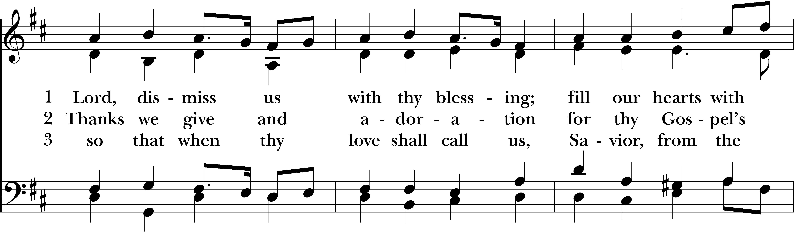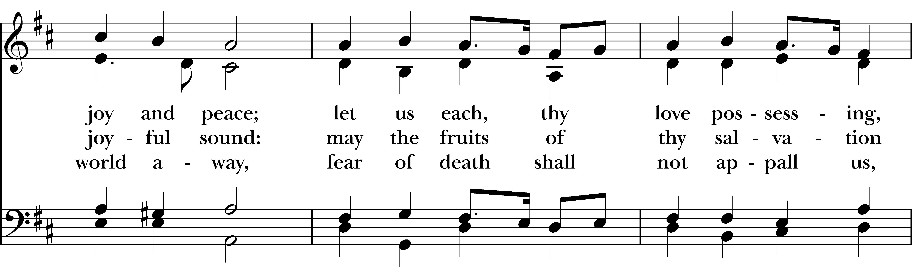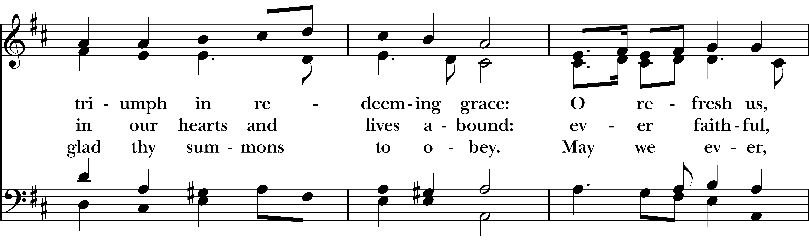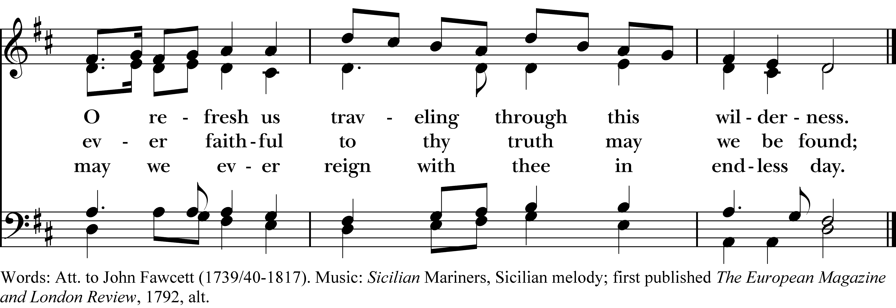
Reprinted/streamed with permission via One License and RiteSong. All rights reserved.

Dismissal

Officiant: Our worship is ended. Our Service begins. Let us go in peace to love & serve the Lord.
People: Thanks be to God.

Announcements for March 22nd, 2026

EASTER FLOWER ENVELOPES can be found in the pews and in the narthex. Due by Sun, 3/29.

COTH SPONSORS NEEDED: Forms are in the narthex. Please solicit any local businesses you frequent.

EASTER CANDY: Donations of individually wrapped Easter candy are due today. We’ll be stuffing eggs today after service, if anyone can stay and help!

VESTRY MEETING: Tuesday, March 24th at 7pm via Zoom. All are welcome. Email Vicki for the Zoom link.

LUMOS CONCERT: Friday, March 27th – Lumos concert here at Christ Church, presenting a “Beatles Candlelight Experience.” Tickets available on their website: lumos-experiences.com.

GIFT CARDS to gas stations & grocery stores are always needed. Thank you for your continued generosity.

Welcome to Christ Church Easton!
Whether you are a newcomer, visitor, or longtime member, we bid you a warm welcome!
Please join us for coffee hour following service.
Sign up for our email list at www.christchurcheaston.com
Vestry: Jim Swann, Jr. Warden; Bob Ellwanger, Treasurer; Amy Bailas, Clerk

Vestry Members: Russ Bailas, Marina Philips, Claire Wilkes, Peg Ellwanger

Diocesan Delegates: Diane McCann, Bob Ellwanger; Alternate: Deborah Swann
Music Minister: Tracy Carlucci

Choir Members: Amy Strachan, Andy Verrocchi, Bob Ellwanger, David McCann, Diane McCann, Marina Philips, Katie Tressler, Vicki MarkAnthony

Christ Church Nursery School: Maggie Supple, Director www.ccnseaston.com
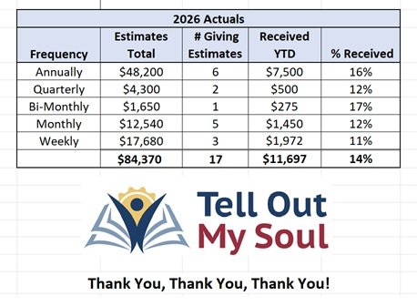
UPCOMING WORSHIP DATES – Sunday Services @ 9:30 am

Sunday, 3/29: Eucharist: Palm Sunday – Rev. Katy Piazza

Thursday, 4/2: Maundy Thursday at Emmanuel Parish Hall, Weston @ 6pm – Rev. Katy Piazza

Friday, 4/3: Good Friday Service, incl. Stations of the Cross @ 12pm – Rev. Katy Piazza

Sunday, 4/5: Eucharist: Easter Sunday – Rev. Katy Piazza

Sunday, 4/12: Morning Prayer – Andy Hathaway
Christ Church – Parish Office Hours:
Mondays & Wednesdays: 9:30-1:30

59 Church Rd, Easton, CT
(203) 268-3569

christchurcheaston@gmail.com
www.christchurcheaston.com

Priest-in-Charge: Katy Piazza

Senior Warden: Vicki MarkAnthony

Parish Administrator: Tracy Carlucci

