Morning Prayer: Sunday, February 15th, 2026
The Last Sunday after the Epiphany: The Transfiguration
Christ Church Easton

Officiant: As we gather to worship, let us recognize that we gather on the ancestral lands and traditional territory of the (Aspetuck River Valley dwelling) Paugussett people.

Grace to you and peace from God our Father and the Lord Jesus Christ. Philippians 1:2

Officiant: Please stand as you are able and sing together our Opening Hymn, #460, “Alleluia! sing to Jesus!”
Opening Hymn “Alleluia! sing to Jesus! Hymnal #460
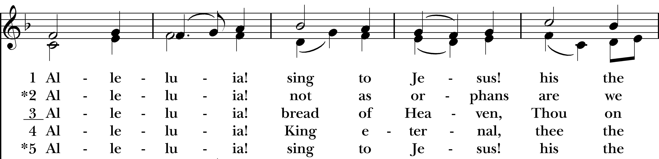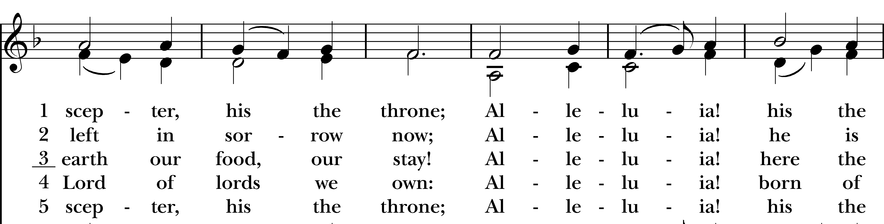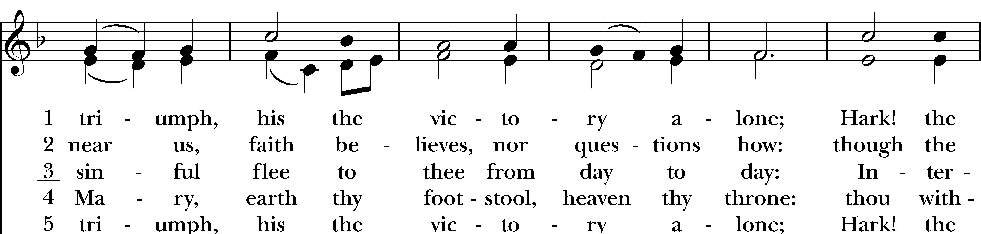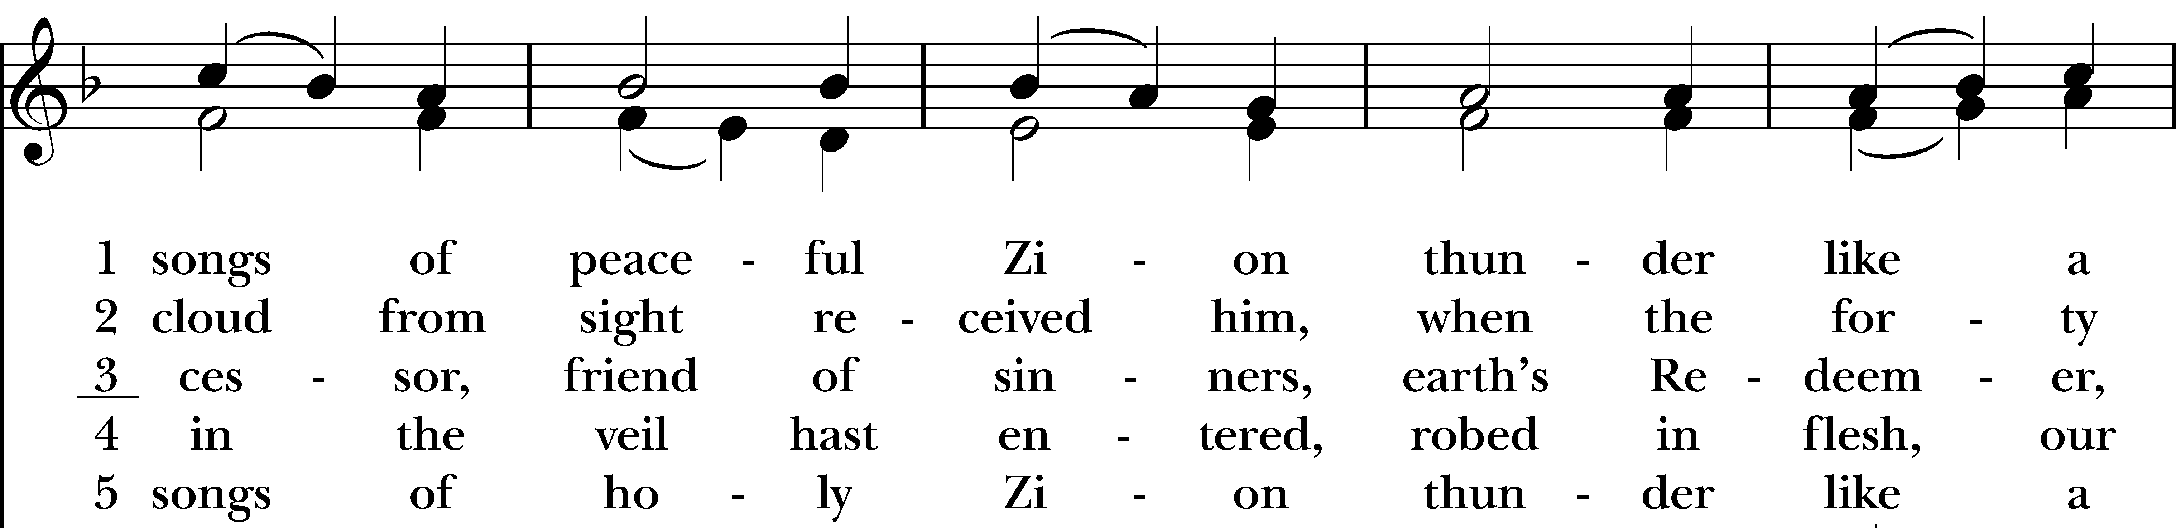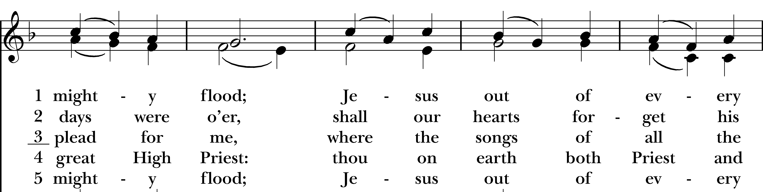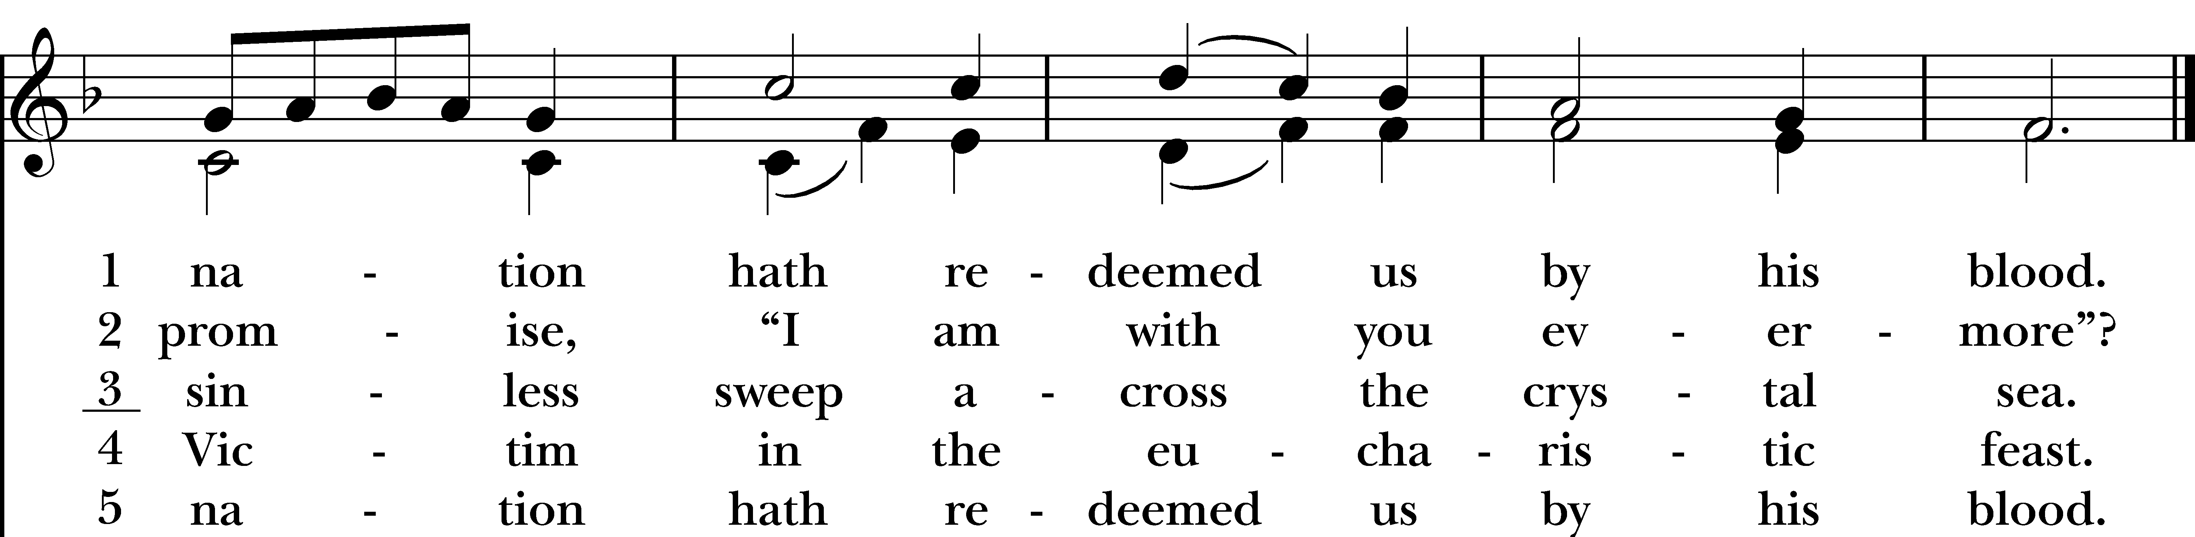
Reprinted/streamed with permission via One License and RiteSong. All rights reserved.
Confession of Sin BCP p. 79
Officiant: Turning to page 79 in the Book of Common Prayer, let us confess our sins against God and our neighbor.

Most merciful God, we confess that we have sinned against you in thought, word, and deed, by what we have done, and by what we have left undone. We have not loved you with our whole heart; we have not loved our neighbors as ourselves. We are truly sorry and we humbly repent. For the sake of your Son Jesus Christ, have mercy on us and forgive us; that we may delight in your will, and walk in your ways, to the glory of your Name. Amen.
Almighty God have mercy on us, forgive us all our sins through our Lord Jesus Christ, strengthen us in all goodness, and by the power of the Holy Spirit keep us in eternal life. Amen.
Invitatory and Psalter BCP p. 80
Officiant: Lord, open our lips.
People: And our mouth shall proclaim your praise.

Glory to the Father, and to the Son, and to the Holy Spirit: as it was in the beginning, is now, and will be for ever. Amen. Alleluia.

Officiant: The Lord has shown forth his glory: Come let us adore him.

Officiant: Turning now to page 82 in the Book of Common Prayer, we will recite the Venite responsively at the asterisk.
Psalm 95: Venite BCP p. 82
Come, let us sing to the Lord; *
let us shout for joy to the Rock of our salvation.
Let us come before his presence with thanksgiving *
and raise a loud shout to him with psalms.
For the Lord is a great God, *
and a great King above all gods.
In his hand are the caverns of the earth, *
and the heights of the hills are his also.
The sea is his, for he made it, *
and his hands have molded the dry land.
Come, let us bow down, and bend the knee, *
and kneel before the Lord our Maker.
For he is our God, and we are the people of his pasture and the sheep of his hand. *
Oh, that today you would hearken to his voice!

The Psalm Appointed: Psalm 2

Why are the nations in an uproar? *
Why do the peoples mutter empty threats?
Why do the kings of the earth rise up in revolt, and the princes plot together, *
against the LORD and against his Anointed?
“Let us break their yoke,” they say; *
“let us cast off their bonds from us.”
He whose throne is in heaven is laughing; *
the Lord has them in derision.
Then he speaks to them in his wrath, *
and his rage fills them with terror.
“I myself have set my king *
upon my holy hill of Zion.”
Let me announce the decree of the LORD: *
he said to me, “You are my Son; this day have I begotten you.
Ask of me, and I will give you the nations for your inheritance *
and the ends of the earth for your possession.
You shall crush them with an iron rod *
and shatter them like a piece of pottery.”
And now, you kings, be wise; *
be warned, you rulers of the earth.
Submit to the LORD with fear, *
and with trembling bow before him;
Lest he be angry and you perish; *
for his wrath is quickly kindled.
Happy are they all *
who take refuge in him!

Glory to the Father, and to the Son, and to the Holy Spirit; as it was in the beginning, is now, and will
be for ever. Amen. Alleluia.

The First Reading Exodus 24:12-18
A Reading from the Book of Exodus.

The LORD said to Moses, “Come up to me on the mountain, and wait there; and I will give you the tablets of stone, with the law and the commandment, which I have written for their instruction.” So Moses set out with his assistant Joshua, and Moses went up into the mountain of God. To the elders he had said, “Wait here for us, until we come to you again; for Aaron and Hur are with you; whoever has a dispute may go to them.” Then Moses went up on the mountain, and the cloud covered the mountain. The glory of the LORD settled on Mount Sinai, and the cloud covered it for six days; on the seventh day he called to Moses out of the cloud. Now the appearance of the glory of the LORD was like a devouring fire on the top of the mountain in the sight of the people of Israel. Moses entered the cloud, and went up on the mountain. Moses was on the mountain for forty days and forty nights.

The Word of the Lord.
Thanks be to God.

The Second Reading 2 Peter 1:16-21
A Reading from the Second Letter of Peter.

For we did not follow cleverly devised myths when we made known to you the power and coming of our Lord Jesus Christ, but we had been eyewitnesses of his majesty. For he received honor and glory from God the Father when that voice was conveyed to him by the Majestic Glory, saying, “This is my Son, my Beloved, with whom I am well pleased.” We ourselves heard this voice come from heaven, while we were with him on the holy mountain.

So we have the prophetic message more fully confirmed. You will do well to be attentive to this as to a lamp shining in a dark place, until the day dawns and the morning star rises in your hearts. First of all you must understand this, that no prophecy of scripture is a matter of one’s own interpretation, because no prophecy ever came by human will, but men and women moved by the Holy Spirit spoke from God.

The Word of the Lord
Thanks be to God.

The Gospel Officiant: Please remain seated for the Gospel. Matthew 17:1-9

A Reading from the Gospel of Matthew.
Six days later, Jesus took with him Peter and James and his brother John and led them up a high mountain, by themselves. And he was transfigured before them, and his face shone like the sun, and his clothes became dazzling white. Suddenly there appeared to them Moses and Elijah, talking with him. Then Peter said to Jesus, “Lord, it is good for us to be here; if you wish, I will make three dwellings here, one for you, one for Moses, and one for Elijah.” While he was still speaking, suddenly a bright cloud overshadowed them, and from the cloud a voice said, “This is my Son, the Beloved; with him I am well pleased; listen to him!” When the disciples heard this, they fell to the ground and were overcome by fear. But Jesus came and touched them, saying, “Get up and do not be afraid.” And when they looked up, they saw no one except Jesus himself alone. As they were coming down the mountain, Jesus ordered them, “Tell no one about the vision until after the Son of Man has been raised from the dead.”

The Word of the Lord
Thanks be to God.

Reflection Vicki MarkAnthony

Officiant: Please join in singing “We are marching in the light of God,” found in your bulletin.
Post-Reflection Hymn “We are marching in the light of God” WLP #787
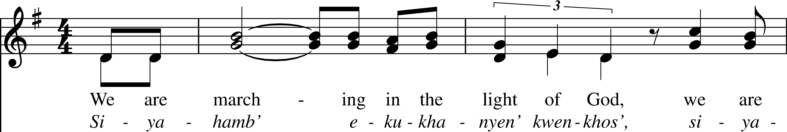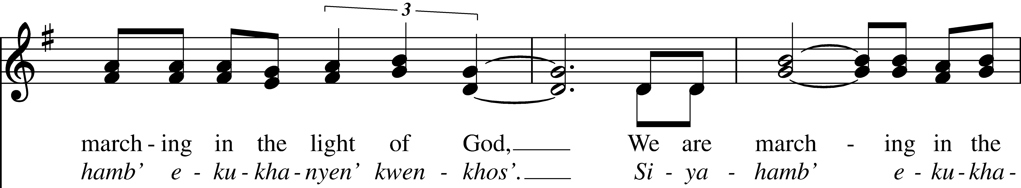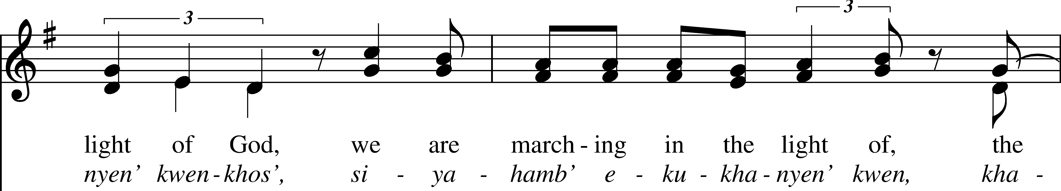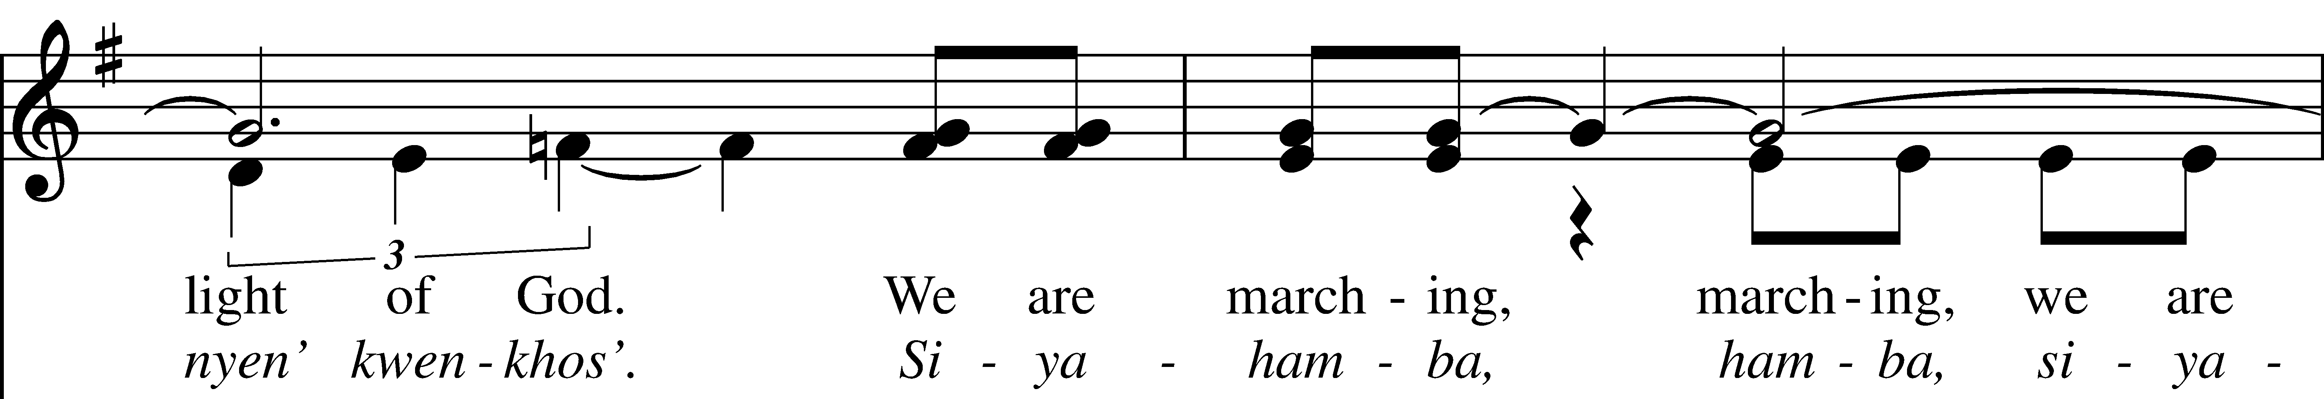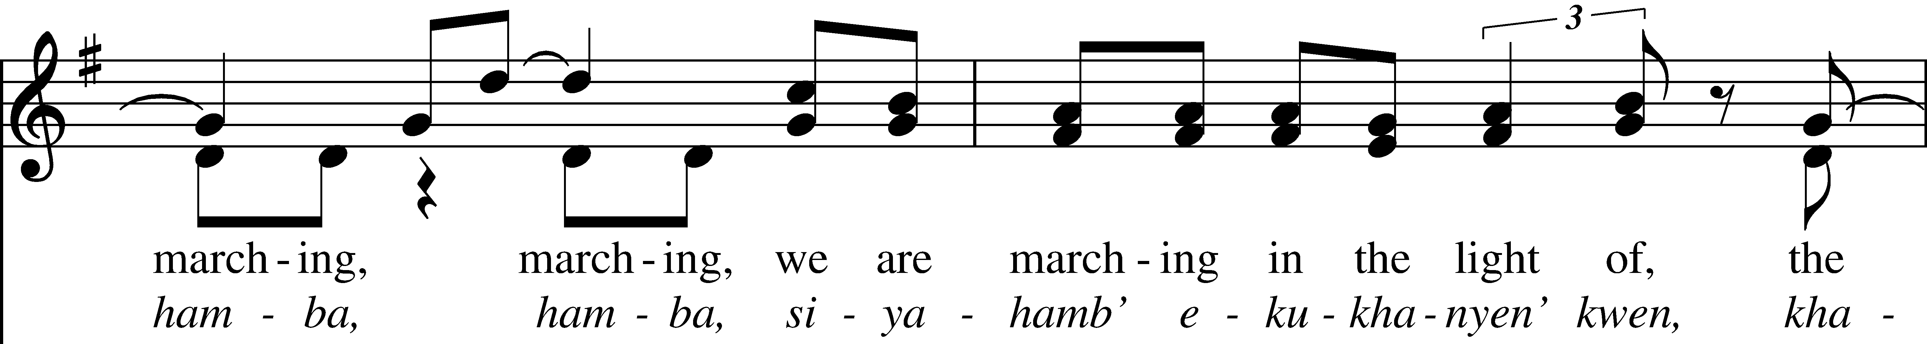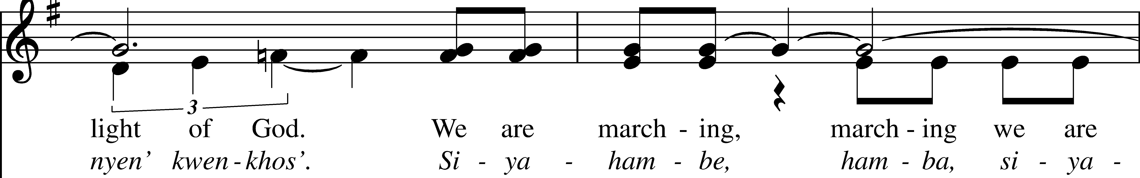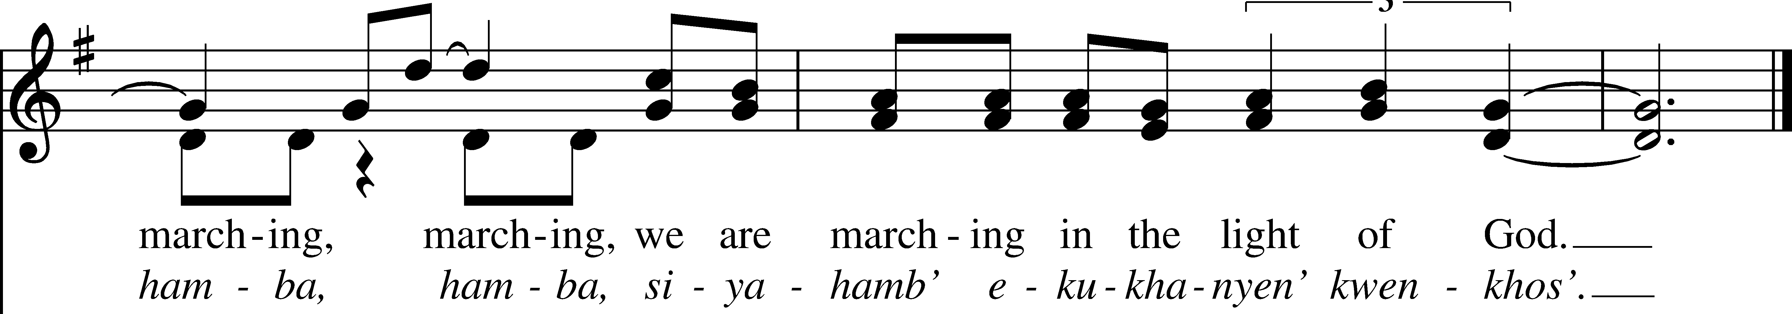
Reprinted/streamed with permission via One License and RiteSong. All rights reserved.
Officiant: Please stand as you are able for The Apostles Creed, page 96 in the Book of Common Prayer.

Apostles’ Creed BCP p. 96

I believe in God, the Father almighty, creator of heaven and earth. I believe in Jesus Christ, his only son, our Lord. He was conceived by the Holy Spirit, born of the Virgin Mary. He suffered under Pontius Pilate, was crucified, died, and was buried. He descended to the dead. On the third day he rose again. He ascended into heaven, and is seated at the right hand of the Father. He will come again to judge the living and the dead. I believe in the Holy Spirit, the holy catholic Church, the communion of saints, the forgiveness of sins, the resurrection of the body, and the life everlasting. Amen.

Officiant: The Lord be with you.
People: And also with you.
Officiant: Let us pray.

Lord’s Prayer BCP p. 97

Our Father, who art in heaven, hallowed be thy Name, thy kingdom come, thy will be done, on earth as it is in heaven. Give us this day our daily bread. And forgive us our trespasses, as we forgive those who trespass against us. And lead us not into temptation, but deliver us from evil. For thine is the kingdom, and the power, and the glory, for ever and ever. Amen.

Officiant: Turning now to page 98 in the Book of Common Prayer, let us pray the Suffrages B.

Suffrages B BCP p. 98

V. Save your people, Lord, and bless your inheritance;
R. Govern and uphold them, now and always.
V. Day by day we bless you;
R. We praise your name for ever.
V. Lord, keep us from all sin today;
R. Have mercy on us, Lord, have mercy.
V. Lord, show us your love and mercy;
R. For we put our trust in you.
V. In you, Lord, is our hope;
R. And we shall never hope in vain.

The Collect of the Day

O God, who before the passion of your only-begotten Son revealed his glory upon the holy mountain: Grant to us that we, beholding by faith the light of his countenance, may be strengthened to bear our cross, and be changed into his likeness from glory to glory; through Jesus Christ our Lord, who lives and reigns with you and the Holy Spirit, one God, for ever and ever. Amen.

Officiant: Please turn to page 392 in the Book of Common Prayer for the Prayers of the People.

Prayers of the People: Form VI BCP p. 392

In Peace, we pray to you Lord God. For all people in their daily life and work; For our families, friends, and neighbors, and for those who are alone.

For this community, the nation, and the world; For all who work for justice, freedom, and peace.
For the just and proper use of your creation; For the victims of hunger, fear, injustice, and oppression.
For all who are in danger, sorrow, or any kind of trouble; For those who minister to the sick, the friendless, and the needy.
For the peace and unity of the Church of God; For all who proclaim the Gospel, and all who seek the Truth.
For Sean our Presiding Bishop, and Jeffrey and Laura our Bishops; and for all bishops and other ministers; For all who serve God in his Church.
For the special needs and concerns of this congregation, including those on our parish prayer list …
Hear us, Lord; For your mercy is great.
We will exalt you, O God our King; And praise your Name for ever and ever.
We pray for all who have died that they may have a place in your eternal kingdom. Lord, let your loving-kindness be upon them; Who put their trust in you.
We thank you, Lord, for all the blessings of this life. Amen.

Announcements

Officiant: Let us pray together the Prayer of St. Chrysostom, found on page 102 in the Book of Common Prayer.

Prayer of St. Chrysostom BCP p. 102

Almighty God, you have given us grace at this time with one accord to make our common supplication to you; and you have promised through your well-beloved Son that when two or three are gathered together in his Name you will be in the midst of them: Fulfill now, O Lord, our desires & petitions as may be best for us; granting us in this world knowledge of your truth, and in the age to come life everlasting. Amen.

Officiant: Please stand as you are able and sing our closing hymn, #618, “Ye watchers and ye holy ones.”

Closing Hymn “Ye watchers and ye holy ones” Hymnal #618

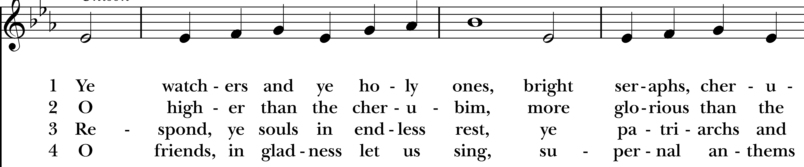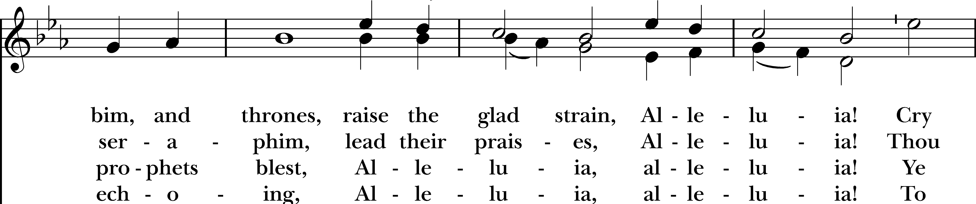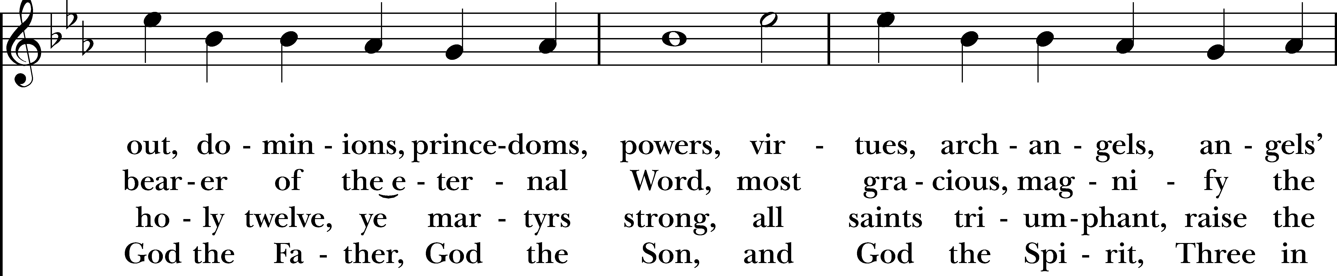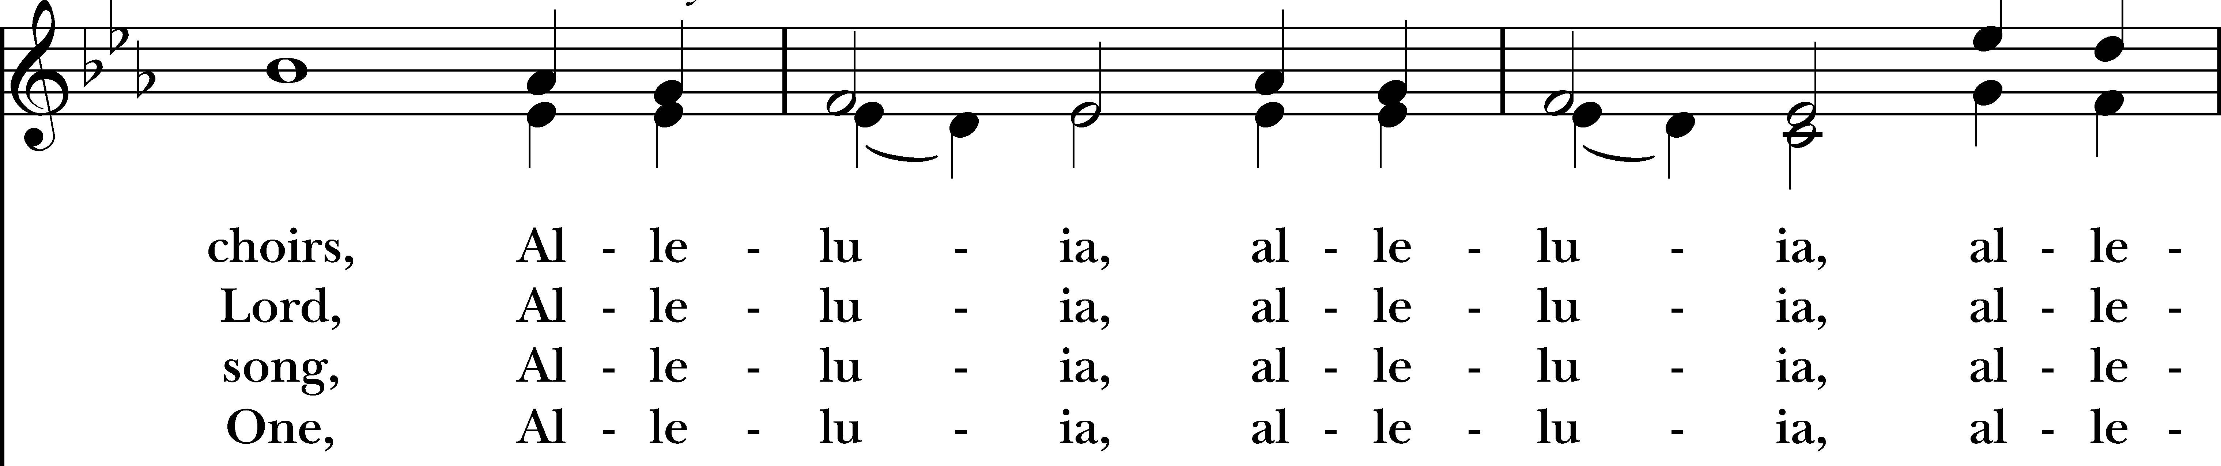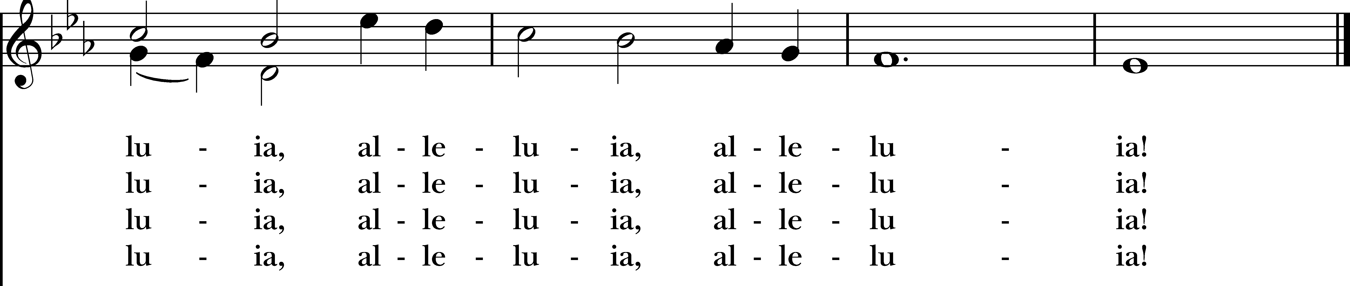
Reprinted/streamed with permission via One License and RiteSong. All rights reserved.
Dismissal

Officiant: Our worship is ended. Our Service begins. Let us go in peace to love & serve the Lord.
People: Thanks be to God.

Welcome to Christ Church Easton!

Whether you are a newcomer, visitor, or longtime member, we bid you a warm welcome!
Please join us for coffee hour following service.
Sign up for our email list at www.christchurcheaston.com
Announcements for February 15th, 2026

NAME TAGS: A reminder to please wear your name tag each week, found in the back of the church.

COFFEE HOUR: Please consider signing up to provide refreshments for an upcoming Sunday.

ASH WEDNESDAY, FEB. 18th: Ash and Dash in the parking lot, 8-9:30 am and 3-6 pm. Joint service at Emmanuel Episcopal in Weston at 7 pm.

NOURISH BRIDGEPORT: Our next day of service at Nourish is Thursday, 2/19. Contact Jim Swann to participate in either dinner prep and/or serving.

ANNUAL MEETING: Our Annual Meeting is Sunday, February 22nd during 9:30 service.

GIFT CARDS to gas stations & grocery stores are always needed. Thank you for your continued generosity.

Vestry: Jim Swann, Jr. Warden; Bob Ellwanger, Treasurer; Peg Ellwanger, Clerk

Vestry Members: Russ Bailas, Amy Bailas, Marina Philips, Claire Wilkes

Diocesan Delegates: Diane McCann, Bob Ellwanger; Alternate: Deborah Swann
Music Minister: Tracy Carlucci

Choir Members: Amy Strachan, Andy Verrocchi, Bob Ellwanger, David McCann, Diane McCann, Marina Philips, Katie Tressler, Vicki MarkAnthony

Christ Church Nursery School: Maggie Supple, Director www.ccnseaston.com

UPCOMING WORSHIP DATES – Sunday Services @ 9:30 am

Wednesday, 2/18: Ash Wednesday Service at Emmanuel @ 7 pm – Rev. Katy Piazza

Sunday, 2/22: Eucharist & Annual Meeting – Rev. Katy Piazza

Sunday, 3/1: Morning Prayer – Andy Hathaway

Sunday, 3/8: Eucharist & Family Sunday – Rev. Katy Piazza

Sunday, 3/15: Morning Prayer – Deborah Swann
Vestry: Jim Swann, Jr. Warden; Bob Ellwanger, Treasurer; Peg Ellwanger, Clerk

Vestry Members: Russ Bailas, Amy Bailas, Marina Philips, Claire Wilkes

Diocesan Delegates: Diane McCann, Bob Ellwanger; Alternate: Deborah Swann


Christ Church – Parish Office Hours:
Mondays & Wednesdays: 9:30-1:30

59 Church Rd, Easton, CT
(203) 268-3569

christchurcheaston@gmail.com
www.christchurcheaston.com

Priest-in-Charge: Katy Piazza

Senior Warden: Vicki MarkAnthony

Parish Administrator: Tracy Carlucci
Music Minister: Tracy Carlucci

Choir Members: Amy Strachan, Andy Verrocchi, Bob Ellwanger, David McCann, Diane McCann, Marina Philips, Katie Tressler, Vicki MarkAnthony

Christ Church Nursery School: Maggie Supple, Director www.ccnseaston.com

