Sunday, September 13th, 2026:
The Sixteenth Sunday after Pentecost
Rev. Katy Piazza, Priest-in-Charge
Christ Church Easton

Celebrant: As we gather to worship, let us recognize that we gather on the ancestral lands and traditional territory of the (Aspetuck River Valley dwelling) Paugussett people.

Celebrant: Please stand as you are able and sing together, “Praise to the Lord,” #390 in the hymnal.

Processional Hymn Praise to the Lord, the Almighty Hymnal #390

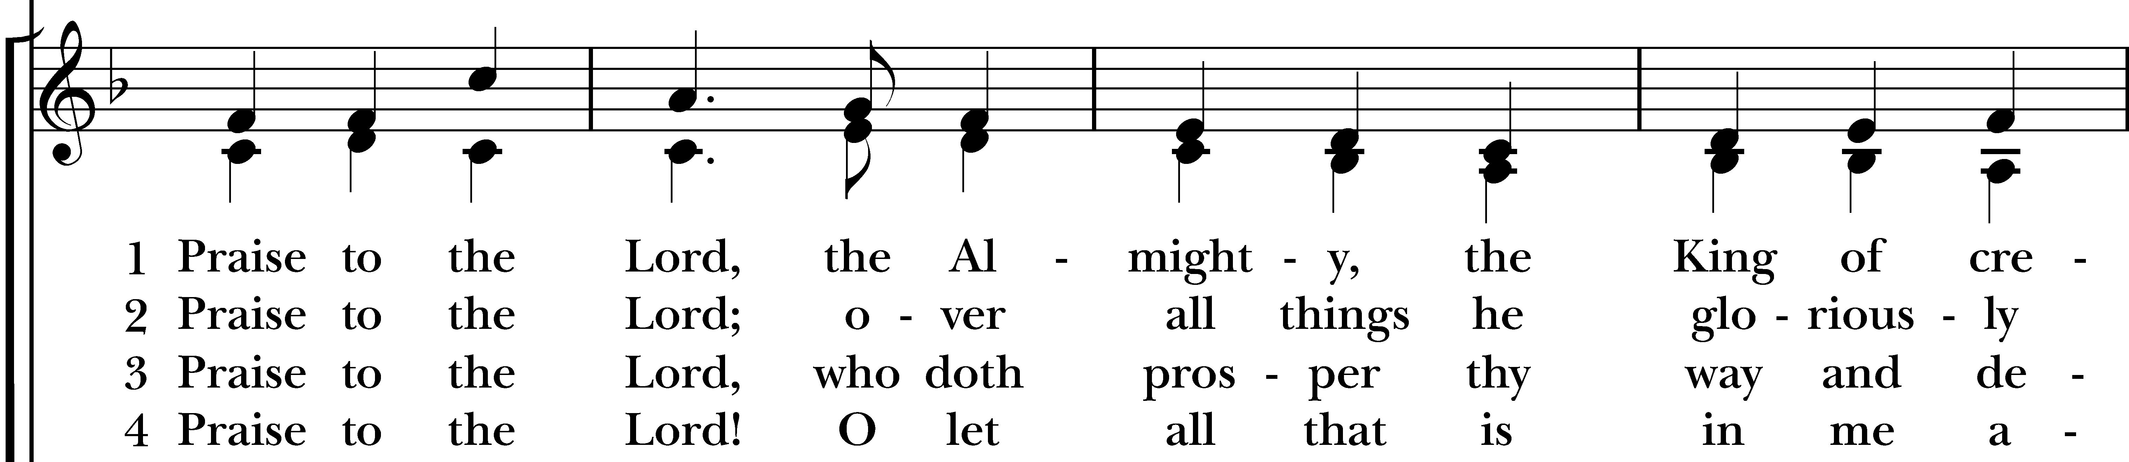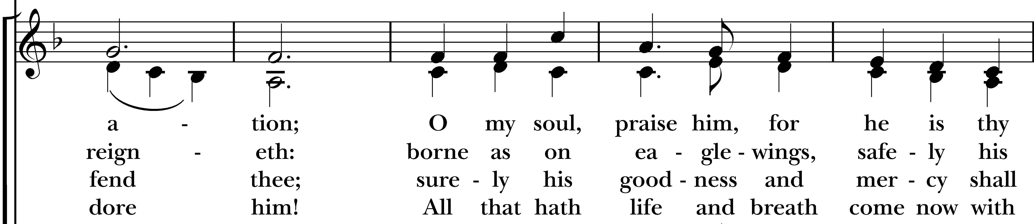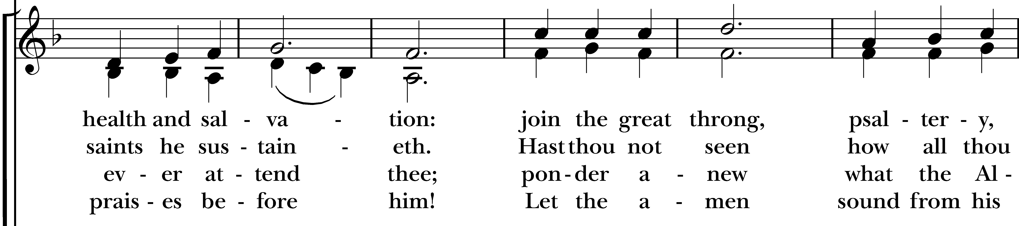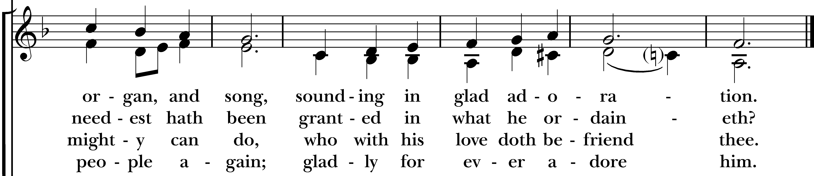
Reprinted/streamed with permission via One License and RiteSong. All rights reserved.

Celebrant: Please turn to page 355 in the Book of Common Prayer.

The Word of God BCP p. 355

Celebrant: Blessed be God: Father, Son, and Holy Spirit.
People: And blessed be his kingdom, now and for ever. Amen.

Collect for Purity

Almighty God, to you all hearts are open, all desires known, and from you no secrets are hid: Cleanse the thoughts of our hearts by the inspiration of your Holy Spirit, that we may perfectly love you, and worthily magnify your holy Name; through Christ our Lord. Amen.

Gloria in Excelsis Pew Card/Hymnal #S280

Collect of the Day

Celebrant: The Lord be with you.
People: And also with you.
Let us pray. O God, because without you we are not able to please you, mercifully grant that your Holy Spirit may in all things direct and rule our hearts; through Jesus Christ our Lord, who lives and reigns with you and the Holy Spirit, one God, now and for ever. Amen.

The First Reading Exodus 14:19-31
A Reading from the Book of Genesis.

The angel of God who was going before the Israelite army moved and went behind them; and the pillar of cloud moved from in front of them and took its place behind them. It came between the army of Egypt and the army of Israel. And so the cloud was there with the darkness, and it lit up the night; one did not come near the other all night.

Then Moses stretched out his hand over the sea. The Lord drove the sea back by a strong east wind all night, and turned the sea into dry land; and the waters were divided. The Israelites went into the sea on dry ground, the waters forming a wall for them on their right and on their left. The Egyptians pursued, and went into the sea after them, all of Pharaoh’s horses, chariots, and chariot drivers. At the morning watch the Lord in the pillar of fire and cloud looked down upon the Egyptian army, and threw the Egyptian army into panic. He clogged their chariot wheels so that they turned with difficulty. The Egyptians said, “Let us flee from the Israelites, for the Lord is fighting for them against Egypt.”

Then the Lord said to Moses, “Stretch out your hand over the sea, so that the water may come back upon the Egyptians, upon their chariots and chariot drivers.” So Moses stretched out his hand over the sea, and at dawn the sea returned to its normal depth. As the Egyptians fled before it, the Lord tossed the Egyptians into the sea. The waters returned and covered the chariots and the chariot drivers, the entire army of Pharaoh that had followed them into the sea; not one of them remained. But the Israelites walked on dry ground through the sea, the waters forming a wall for them on their right and on their left.

Thus the Lord saved Israel that day from the Egyptians; and Israel saw the Egyptians dead on the seashore. Israel saw the great work that the Lord did against the Egyptians. So the people feared the Lord and believed in the Lord and in his servant Moses.

The Word of the Lord.
Thanks be to God.

The Psalm Psalm 114

Hallelujah! When Israel came out of Egypt, *
the house of Jacob from a people of strange speech,
Judah became God's sanctuary *
and Israel his dominion.
The sea beheld it and fled; *
Jordan turned and went back.
The mountains skipped like rams, *
and the little hills like young sheep.
What ailed you, O sea, that you fled? *
O Jordan, that you turned back?
You mountains, that you skipped like rams? *
you little hills like young sheep?
Tremble, O earth, at the presence of the Lord, *
at the presence of the God of Jacob,
Who turned the hard rock into a pool of water *
and flint-stone into a flowing spring.

The Second Reading Romans 14:1-12
A Reading from the Letter to the Romans.

Welcome those who are weak in faith, but not for the purpose of quarreling over opinions. Some believe in eating anything, while the weak eat only vegetables. Those who eat must not despise those who abstain, and those who abstain must not pass judgment on those who eat; for God has welcomed them.

Who are you to pass judgment on servants of another? It is before their own lord that they stand or fall. And they will be upheld, for the Lord is able to make them stand.

Some judge one day to be better than another, while others judge all days to be alike. Let all be fully convinced in their own minds. Those who observe the day, observe it in honor of the Lord. Also those who eat, eat in honor of the Lord, since they give thanks to God; while those who abstain, abstain in honor of the Lord and give thanks to God.

We do not live to ourselves, and we do not die to ourselves. If we live, we live to the Lord, and if we die, we die to the Lord; so then, whether we live or whether we die, we are the Lord's. For to this end Christ died and lived again, so that he might be Lord of both the dead and the living.

Why do you pass judgment on your brother or sister? Or you, why do you despise your brother or sister? For we will all stand before the judgment seat of God. For it is written, "As I live, says the Lord, every knee shall bow to me, and every tongue shall give praise to God." So then, each of us will be accountable to God.

The Word of the Lord.
Thanks be to God.

Celebrant: Please stand as you are able and sing together hymn #674, “Forgive our sins.” We will sing verses 1-2 before the Gospel and verses 3-4 after.

Gospel Hymn Forgive our sins as we forgive Hymnal #674
(vs 1-2 before Gospel, vs 3-4 after)
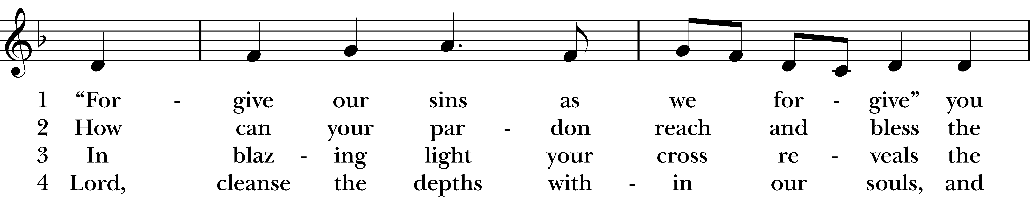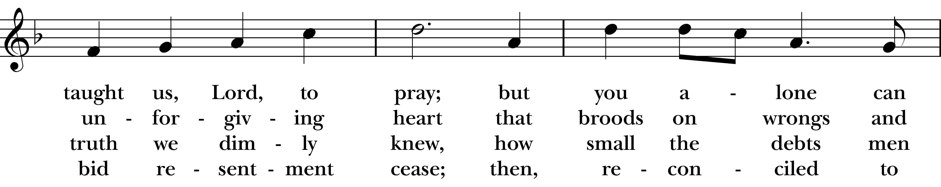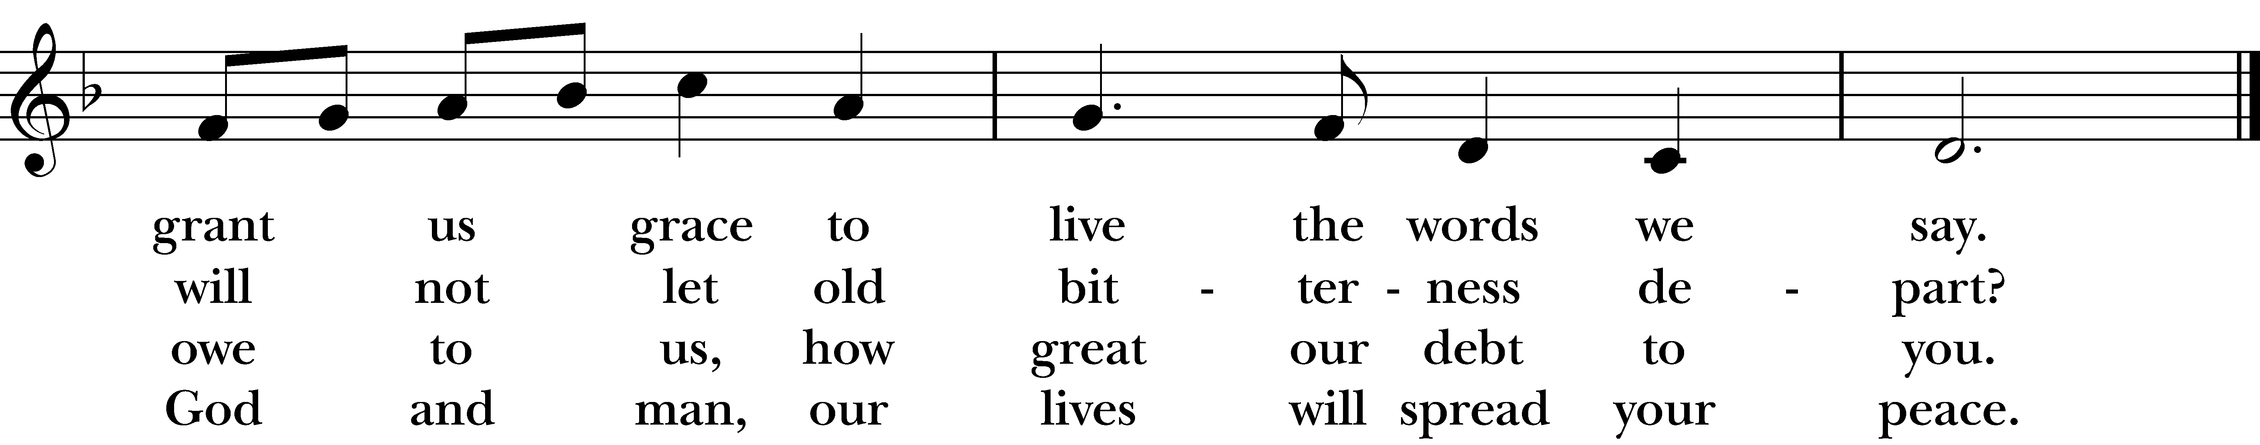
Reprinted/streamed with permission via One License and RiteSong. All rights reserved.

The Gospel Matthew 18:21-35
The Holy Gospel of our Lord Jesus Christ, according to Matthew.
Glory to you, Lord Christ.

Peter came and said to Jesus, “Lord, if another member of the church sins against me, how often should I forgive? As many as seven times?” Jesus said to him, “Not seven times, but, I tell you, seventy-seven times.

“For this reason the kingdom of heaven may be compared to a king who wished to settle accounts with his slaves. When he began the reckoning, one who owed him ten thousand talents was brought to him; and, as he could not pay, his lord ordered him to be sold, together with his wife and children and all his possessions, and payment to be made. So the slave fell on his knees before him, saying, ‘Have patience with me, and I will pay you everything.’ And out of pity for him, the lord of that slave released him and forgave him the debt. But that same slave, as he went out, came upon one of his fellow slaves who owed him a hundred denarii; and seizing him by the throat, he said, ‘Pay what you owe.’ Then his fellow slave fell down and pleaded with him, ‘Have patience with me, and I will pay you.’ But he refused; then he went and threw him into prison until he would pay the debt. When his fellow slaves saw what had happened, they were greatly distressed, and they went and reported to their lord all that had taken place. Then his lord summoned him and said to him, ‘You wicked slave! I forgave you all that debt because you pleaded with me. Should you not have had mercy on your fellow slave, as I had mercy on you?’ And in anger his lord handed him over to be tortured until he would pay his entire debt. So my heavenly Father will also do to every one of you, if you do not forgive your brother or sister from your heart.”

The Gospel of the Lord.
Praise to you, Lord Christ.

Sermon Rev. Katy Piazza

Celebrant: Please stand as you are able for The Nicene Creed, page 358 of the Book of Common Prayer.

The Nicene Creed BCP p. 358

We believe in one God, the Father, the Almighty, maker of heaven and earth, of all that is, seen and unseen. We believe in one Lord, Jesus Christ, the only Son of God, eternally begotten of the Father, God from God, Light from Light, true God from true God, begotten, not made, of one Being with the Father. Through him all things were made.

For us and for our salvation, he came down from heaven: by the power of the Holy Spirit he became incarnate from the Virgin Mary, and was made man. For our sake he was crucified under Pontius Pilate; he suffered death and was buried. On the third day he rose again in accordance with the Scriptures; he ascended into heaven and is seated at the right hand of the Father. He will come again in glory to judge the living and the dead, and his kingdom will have no end.

We believe in the Holy Spirit, the Lord, the giver of life, who proceeds from the Father and the Son. With the Father and the Son he is worshiped and glorified. He has spoken through the Prophets. We believe in one holy catholic and apostolic Church. We acknowledge one baptism for the forgiveness of sins. We look for the resurrection of the dead, and the life of the world to come. Amen.

Subdeacon: The Prayers of the People are Form VI, found on page 392 in the Book of Common Prayer.

Prayers of the People: Form VI BCP p. 392

In peace, we pray to you, Lord God.

For all people in their daily life and work;
For our families, friends, and neighbors, and for those who are alone.

For this community, the nation, and the world;
For all who work for justice, freedom, and peace.

For the just and proper use of your creation;
For the victims of hunger, fear, injustice, and oppression.

For all who are in danger, sorrow, or any kind of trouble;
For those who minister to the sick, the friendless, and the needy.

For the peace and unity of the Church of God;
For all who proclaim the Gospel, and all who seek the Truth.

For Sean, our Presiding Bishop, Laura & Jeffery, our Bishops; and for all bishops and other ministers;
For all who serve God in his Church.

For the special needs and concerns of this congregation, including those on our parish prayer list…

Hear us, Lord; For your mercy is great.

We thank you, Lord, for all the blessings of this life.

We will exalt you, O *God* our King; And praise your Name for ever and ever.

We pray for all who have died, that they may have a place in your eternal kingdom.

Lord, let your loving-kindness be upon them; Who put their trust in you.

We pray to you also for the forgiveness of our sins.

Have mercy upon us, most merciful Father; in your compassion forgive us our sins, known and unknown, things done and left undone; and so uphold us by your Spirit, that we may live and serve you in newness of life, to the honor and glory of your Name; through Jesus Christ our Lord. Amen.

Celebrant: O Lord our God, accept the fervent prayers of your people; in the multitude of your mercies, look with compassion upon us and all who turn to you for help; for you are gracious, O lover of souls, and to you we give glory, Father, Son, and Holy Spirit, now and for ever. Amen.

Celebrant: Turning now to page 360 in the Book of Common Prayer, let us confess our sins to God.

The Confession of Sin BCP p. 360

Most merciful God, we confess that we have sinned against you in thought, word, and deed,
by what we have done, and by what we have left undone. We have not loved you with our whole heart; we have not loved our neighbors as ourselves. We are truly sorry and we humbly repent. For the sake of your Son Savior Jesus Christ, have mercy on us and forgive us; that we may delight in your will, and walk in your ways, to the glory of your Name. Amen.

Almighty God have mercy on you, forgive you all your sins through our Lord Jesus Christ, strengthen you in all goodness, and by the power of the Holy Spirit keep you in eternal life. Amen.

The Peace Please stand.

Celebrant: The peace of the Lord be always with you.
People: And also with you.

Announcements Vicki MarkAnthony

The Holy Communion

Walk in love, as Christ loved us and gave himself for us, an offering and sacrifice to God. Ephesians 5:2

Offertory Anthem A Jubilant Song Mary Lynn Lightfoot

Cantate Domino canticum novum omnis terra
Sing to the Lord a new jubilant song, all the earth

Eucharistic Prayer C BCP p. 369
Celebrant: Please stand as you are able and turn to page 369 in the Book of Common Prayer.

Celebrant: The Lord be with you.
People: And also with you.
Celebrant: Lift up your hearts.
People: We lift them to the Lord.
Celebrant: Let us give thanks to the Lord our God.
People: It is right to give our thanks and praise.

God of all power, Ruler of the Universe, you are worthy of glory and praise. Glory to you for ever and ever.

At your command all things came to be: the vast expanse of interstellar space, galaxies, suns, the planets in their courses, and this fragile earth, our island home. By your will they were created and have their being.

From the primal elements you brought forth the human race, and blessed us with memory, reason, and skill. You made us the rulers of creation. But we turned against you, and betrayed your trust; and we turned against one another. Have mercy, Lord, for we are sinners in your sight.

Again and again, you called us to return. Through prophets and sages you revealed your righteous Law. And in the fullness of time you sent your only Son, born of a woman, to fulfill your Law, to open for us the way of freedom and peace. By his blood, he reconciled us. By his wounds, we are healed.

And therefore we praise you, joining with the heavenly chorus, with prophets, apostles, and martyrs, and with all those in every generation who have looked to you in hope, to proclaim with them your glory, in their unending hymn:

Sanctus Pew Card

And so, Father, we who have been redeemed by him, and made a new people by water and the Spirit, now bring before you these gifts. Sanctify them by your Holy Spirit to be the Body and Blood of Jesus Christ our Lord.

On the night he was betrayed he took bread, said the blessing, broke the bread, and gave it to his friends, and said, “Take, eat: This is my Body, which is given for you. Do this for the remembrance of me.”
After supper, he took the cup of wine, gave thanks, and said, “Drink this, all of you: This is my Blood of the new Covenant, which is shed for you and for many for the forgiveness of sins. Whenever you drink it, do this for the remembrance of me.”

Remembering now his work of redemption, and offering to you this sacrifice of thanksgiving, We celebrate his death and resurrection, as we await the day of his coming.

Lord God of our Fathers: God of Abraham, Isaac, and Jacob; God and Father of our Lord Jesus Christ: Open our eyes to see your hand at work in the world about us. Deliver us from the presumption of coming to this Table for solace only, and not for strength; for pardon only, and not for renewal. Let the grace of this Holy Communion make us one body, one spirit in Christ, that we may worthily serve the world in his name. Risen Lord, be known to us in the breaking of the Bread.
Accept these prayers and praises, Father, through Jesus Christ our great High Priest, to whom, with you and the Holy Spirit, your Church gives honor, glory, and worship, from generation to generation.

Amen (sung) Pew Card

And now, as our Savior Christ has taught us, we are bold to say,

Our Father who art in heaven, hallowed be thy Name, thy kingdom come, thy will be done, on earth as it is in in heaven. Give us this day our daily bread. And forgive us our trespasses as we forgive those who trespass against us. And lead us not into temptation but deliver us from evil. For thine is the kingdom, the power, and the glory, for ever and ever. Amen.

The Breaking of the Bread

Celebrant: Alleluia. Christ our Passover is sacrificed for us.
People: Therefore let us keep the feast. Alleluia.
Celebrant: The Gifts of God for the People of God.

A Prayer for Spiritual Communion

Let us pray: We believe that you are truly present in the Holy Sacrament, and we pray you to come into our hearts, praying especially with those at home who cannot at this time receive communion. I unite myself with you and embrace you with all my heart, my soul, and my mind. Let nothing separate me from you; let me serve you in this life until, by your grace, I come to your glorious kingdom and unending peace. Amen.

Invitation to the Table

Celebrant: This is the table, not of the Church but of Jesus Christ. It is made ready for those who love God and who want to love God more.

So come:

You who have much faith and you who have little.
Come, You who have been here often and you who have not been for a long time.
Come, You who have tried to follow and you who have failed.
Come, it is Christ who invites you to be known and fed here.

Communion Hymn Jesu, Jesu, fill us with your love Hymnal #602
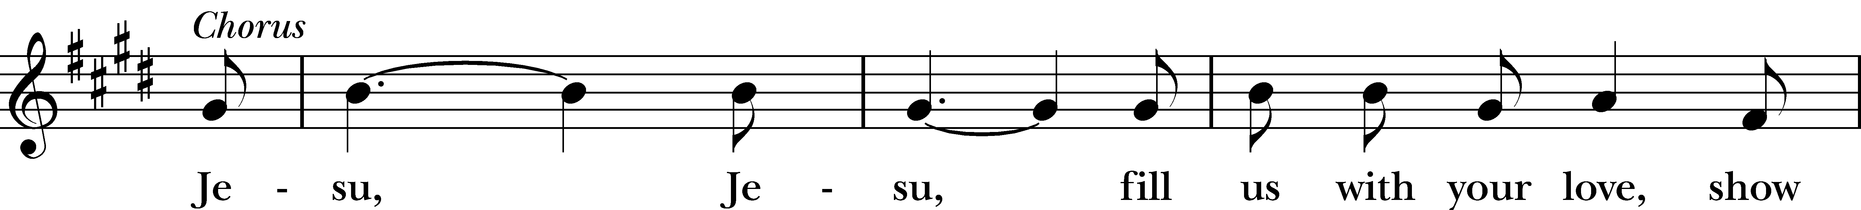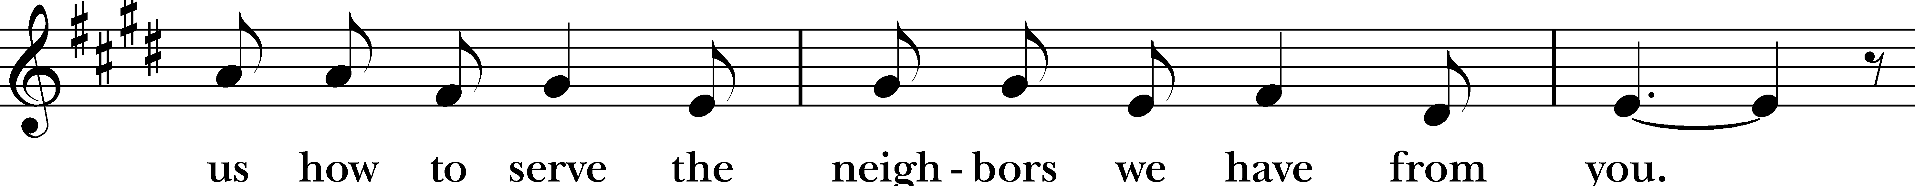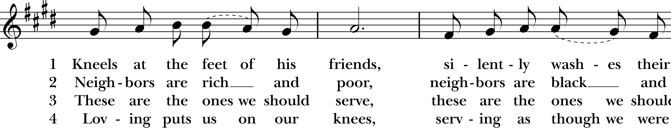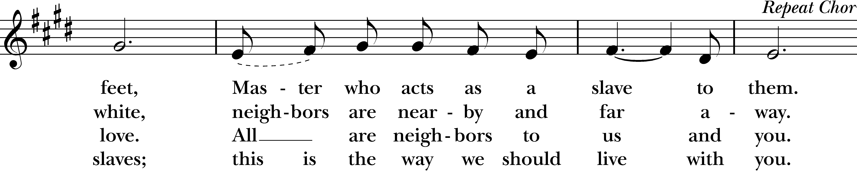
Reprinted/streamed with permission via One License and RiteSong. All rights reserved.

Celebrant: Turning now to page 365 in the Book of Common Prayer, let us pray:

Prayer After Communion BCP p. 365

Eternal God, heavenly Father, you have graciously accepted us as living members of your Son our Savior Jesus Christ, and you have fed us with spiritual food in the Sacrament of his Body and Blood. Send us now into the world in peace, and grant us strength and courage to love and serve you with gladness and singleness of heart; through Christ our Lord. Amen.
Blessing Rev. Katy

Celebrant: Please stand as you are able and sing together our Recessional Hymn, “Joyful, joyful,” #376.

Recessional Hymn Joyful, joyful, we adore thee Hymnal #376
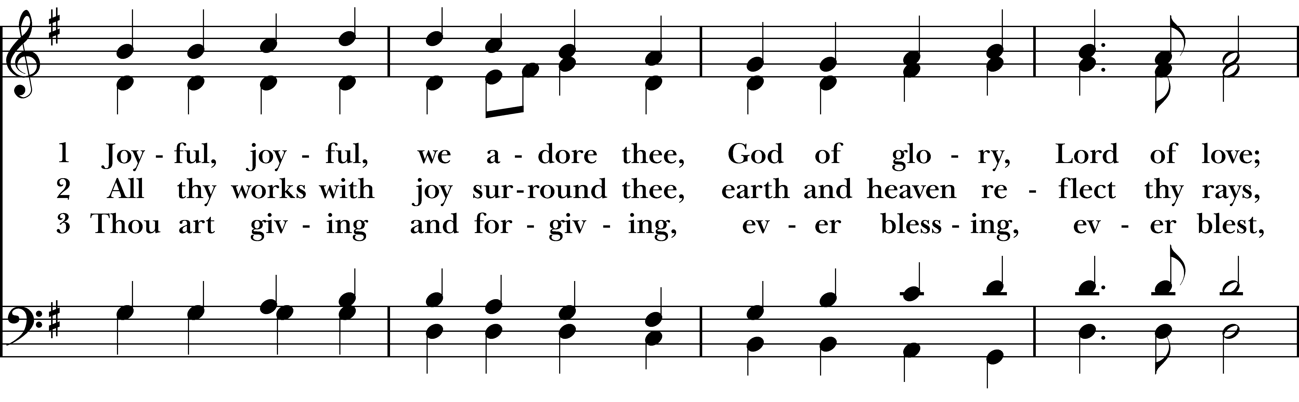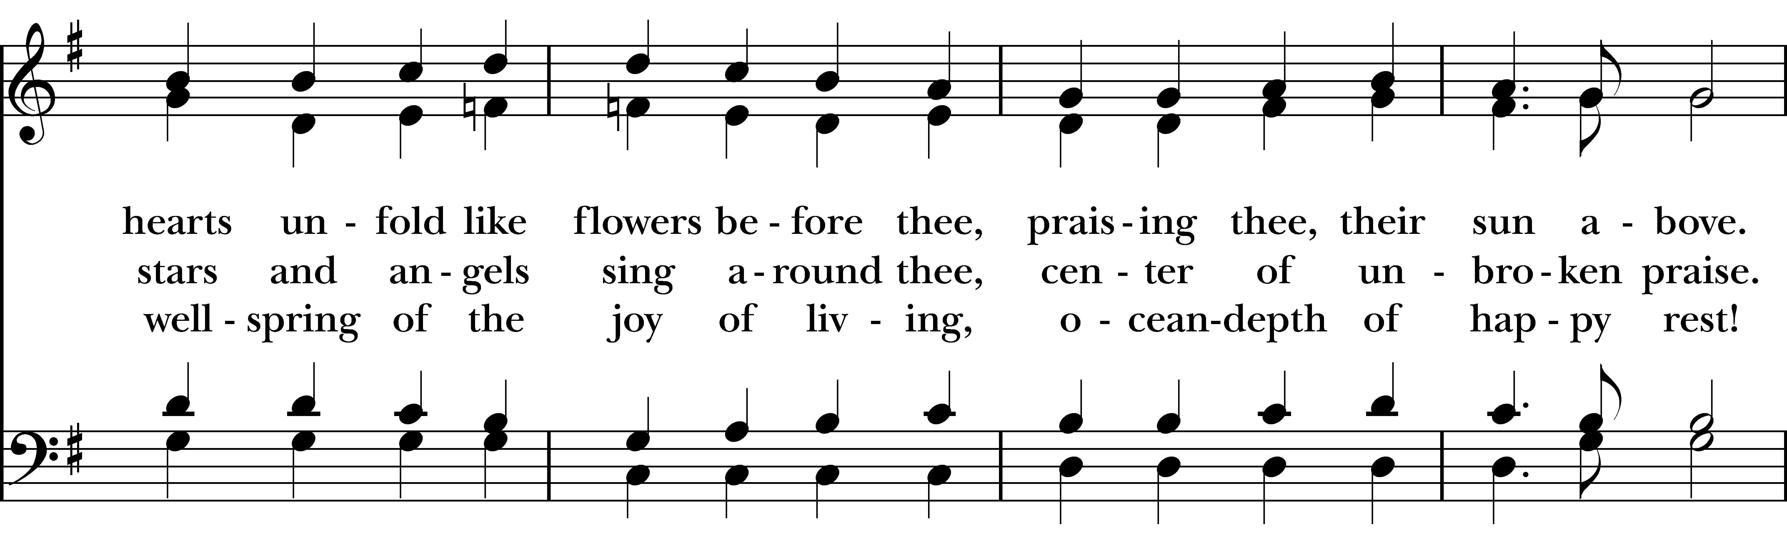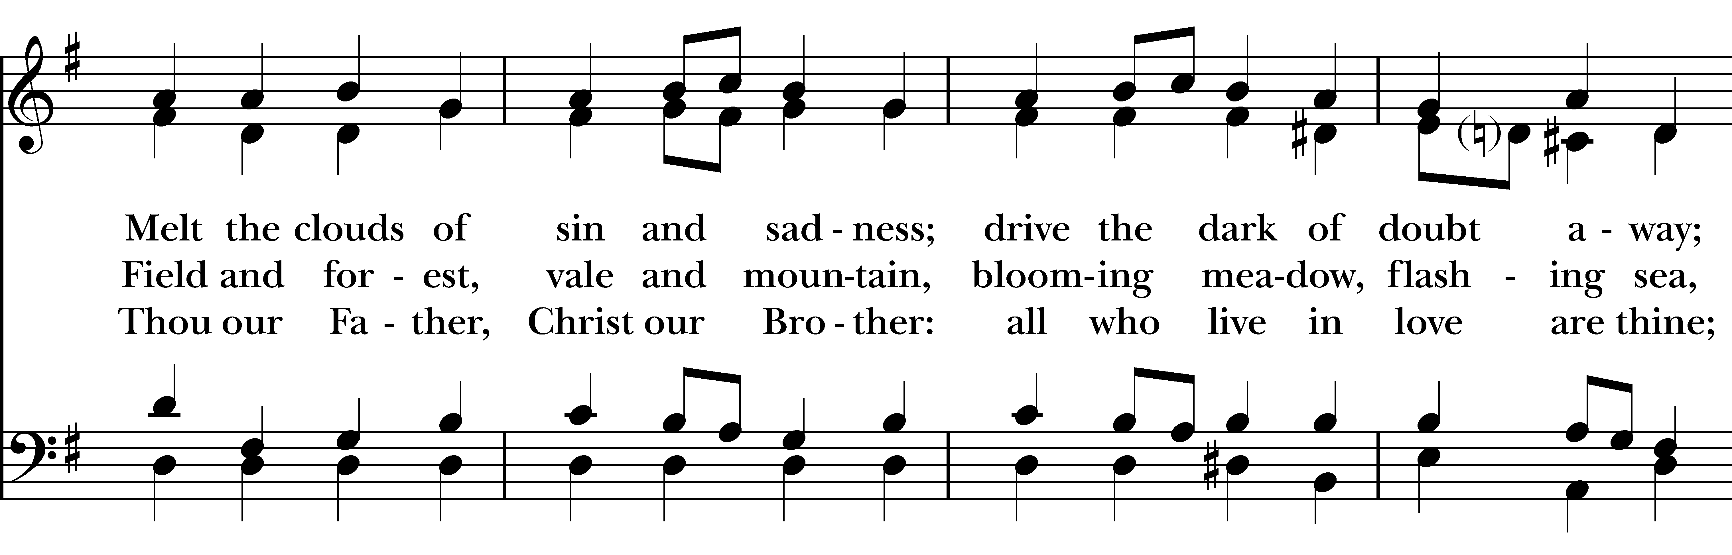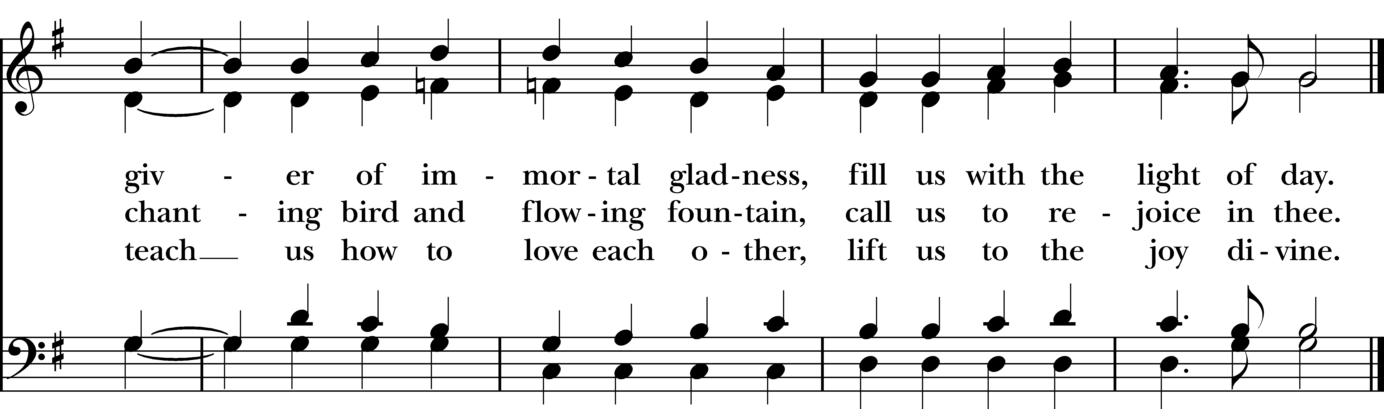
Reprinted/streamed with permission via One License and RiteSong. All rights reserved.
Dismissal

Celebrant: Our worship is ended. Our Service begins. Let us go in peace to love & serve the Lord. Alleluia, alleluia!
People: Thanks be to God. Alleluia, alleluia!
Announcements for September 13th, 2026

COFFEE HOUR: Sign-up to host an upcoming coffee hour! Sign-up sheet is in the narthex.

NEXT VESTRY MEETING: Tuesday, 9/22 on Zoom at 7pm. All are welcome. Email Vicki for the link.

MEMORIAL FOR CLIFF EMANUELSON: Saturday, 9/26 at 11:00 am.

FAMILY SUNDAY: The next Family Sunday will be our Blessing of the Animals service on October 4th.

GIFT CARDS to gas stations & grocery stores are always needed. Thank you for your continued generosity.

Welcome to Christ Church Easton!
Whether you are a newcomer, visitor, or longtime member, we bid you a warm welcome!
Please join us for coffee hour following service. Sign up for our email list at www.christchurcheaston.com.
Music Minister: Tracy Carlucci

Choir Members: Amy Strachan, Andy Verrocchi, Bob Ellwanger, David McCann, Diane McCann, Marina Philips, Katie Tressler, Vicki MarkAnthony

Christ Church Nursery School: Maggie Supple, Director, www.ccnseaston.com
Vestry: Jim Swann, Jr. Warden; Bob Ellwanger, Treasurer; Amy Bailas, Clerk

Vestry Members: Russ Bailas, Marina Philips, Claire Wilkes, Peg Ellwanger

Diocesan Delegates: Diane McCann, Bob Ellwanger; Alternate: Deborah Swann
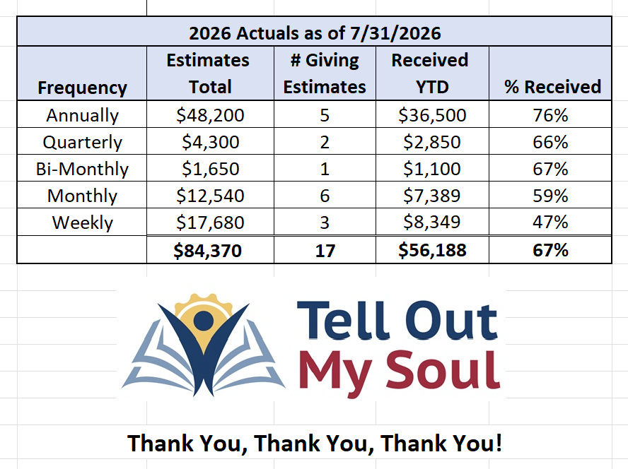
UPCOMING WORSHIP SCHEDULE

Sundays at 9:30 am:

September 20th: Morning Prayer – Deborah Swann

September 27th: Eucharist – Rev. Katy Piazza

October 4th: Family Service & Blessing of the Animals – Rev. Katy Piazza

October 11th: Morning Prayer & Indigenous Peoples Day – Vicki MarkAnthony

Sunday, 9/27: Eucharist – Rev. Katy Piazza

Christ Church – Parish Office Hours:

Mondays & Wednesdays: 9:30-1:30

59 Church Rd, Easton, CT
(203) 268-3569

christchurcheaston@gmail.com
www.christchurcheaston.com

Priest-in-Charge: Katy Piazza

Senior Warden: Vicki MarkAnthony

Parish Administrator: Tracy Carlucci

