Morning Prayer: Sunday, March 15th, 2026
The Fourth Sunday in Lent
Christ Church Easton

As we gather to worship, let us recognize that we gather on the ancestral lands and traditional territory of the Aspetuck River Valley dwelling Paugussett people.

Grace to you and Peace from God our Father and the Lord Jesus Christ. Philippians 1:2 (pgs76-78)

Opening Hymn #8 Morning Has Broken
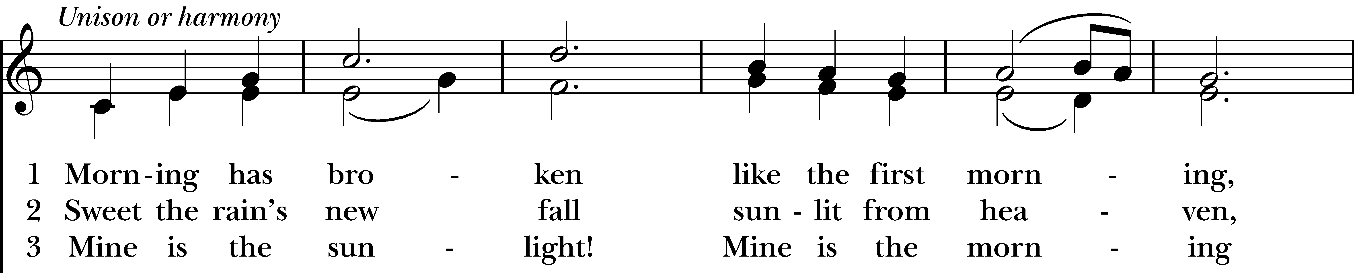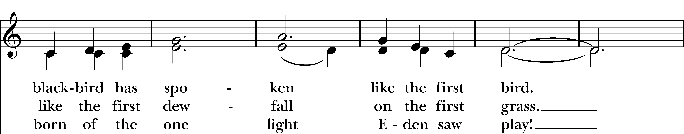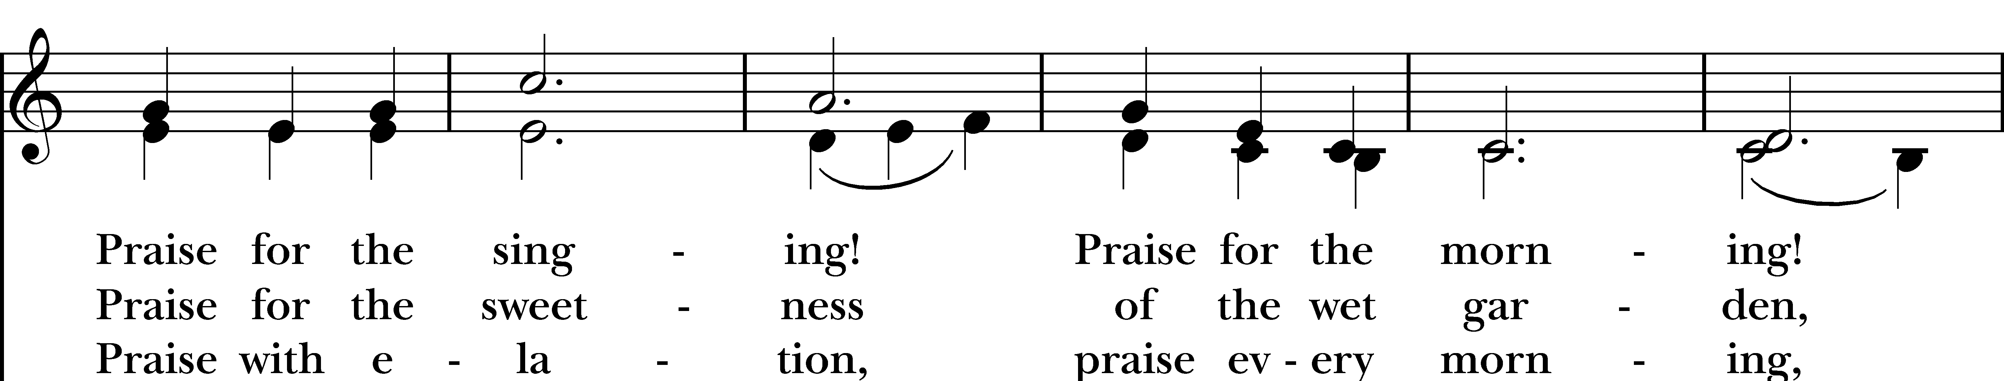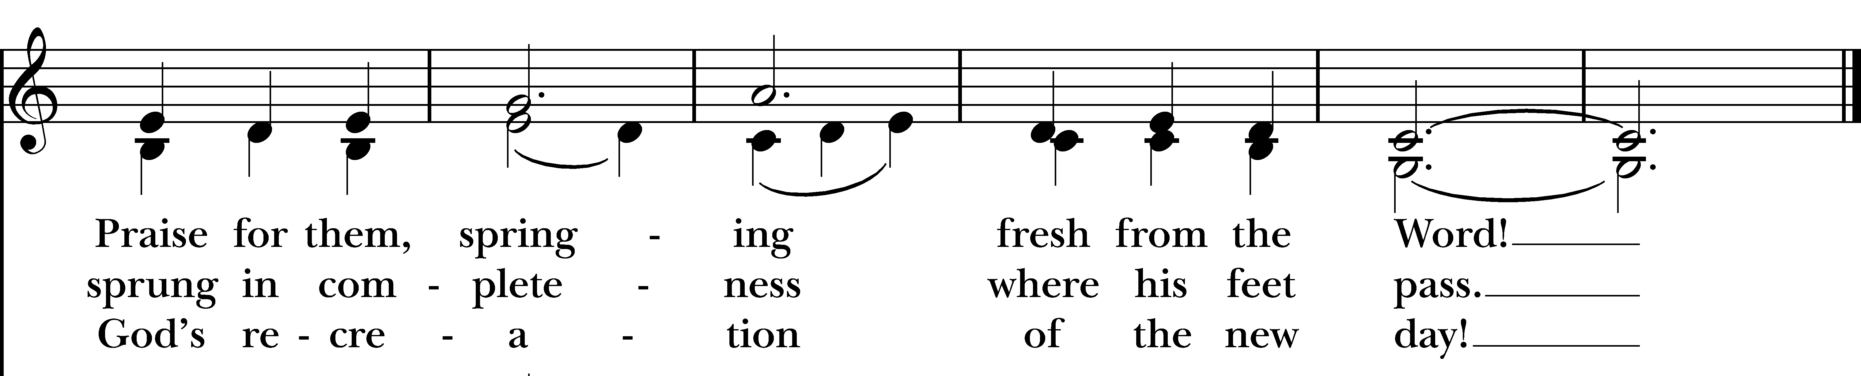

Confession of Sin BCP p. 79
Dearly beloved, we have come together in the presence of Almighty God our heavenly Father, to set forth his praise, to hear his holy Word, and to ask, for ourselves and on behalf of others, those things that are necessary for our life and our salvation. And so that we may prepare ourselves in heart and mind to worship him, let us kneel in silence, and with penitent and obedient hearts confess our sins, that we may obtain forgiveness by his infinite goodness and mercy.
Most merciful God, we confess that we have sinned against you in thought, word, and deed, by what we have done, and by what we have left undone. We have not loved you with our whole heart; we have not loved our neighbors as ourselves. We are truly sorry and we humbly repent. For the sake of your Son Jesus Christ, have mercy on us and forgive us; that we may delight in your will, and walk in your ways, to the glory of your Name. Amen.
Almighty God have mercy on us, forgive us all our sins through our Lord Jesus Christ, strengthen us in all goodness, and by the power of the Holy Spirit keep us in eternal life. Amen.

Invitatory and Psalter BCP p. 80

Lord, open our lips.
And our mouth shall proclaim your praise.

Glory to the Father, and to the Son, and to the Holy Spirit; as it was in the beginning, is now, and will be forever. Amen.

The Lord is full of compassion and mercy, Come let us adore Him.
Psalm 95 Venite BCP p. 82
Come, let us sing to the Lord; *
let us shout for joy to the Rock of our salvation.
Let us come before his presence with thanksgiving *
and raise a loud shout to him with psalms.
For the Lord is a great God, *
and a great King above all gods.
In his hand are the caverns of the earth, *
and the heights of the hills are his also.
The sea is his, for he made it, *
and his hands have molded the dry land.
Come, let us bow down, and bend the knee, *
and kneel before the Lord our Maker. For he is our God,
and we are the people of his pasture and the sheep of his hand. *
Oh, that today you would hearken to his voice!
Psalm Appointed: Psalm 23
The Lord is my shepherd; *
I shall not be in want.
He makes me lie down in green pastures *
and leads me beside still waters.
He revives my soul *
and guides me along right pathways for his Name's sake.
Though I walk through the valley of the shadow of death, I shall fear no evil; *
for you are with me; your rod and your staff, they comfort me.
You spread a table before me in the presence of those who trouble me; *
you have anointed my head with oil, and my cup is running over.
Surely your goodness and mercy shall follow me all the days of my life, *
and I will dwell in the house of the Lord for ever.

Glory to the Father, and to the Son, and to the Holy Spirit; as it was in the beginning, is now, and will be for ever. Amen.

First Reading 1 Samuel 16:1-13
The Lord said to Samuel, “How long will you grieve over Saul? I have rejected him from being king over Israel. Fill your horn with oil and set out; I will send you to Jesse the Bethlehemite, for I have provided for myself a king among his sons.” Samuel said, “How can I go? If Saul hears of it, he will kill me.” And the Lord said, “Take a heifer with you, and say, ‘I have come to sacrifice to the Lord.’ Invite Jesse to the sacrifice, and I will show you what you shall do; and you shall anoint for me the one whom I name to you.” Samuel did what the Lord commanded, and came to Bethlehem. The elders of the city came to meet him trembling, and said, “Do you come peaceably?” He said, “Peaceably; I have come to sacrifice to the Lord; sanctify yourselves and come with me to the sacrifice.” And he sanctified Jesse and his sons and invited them to the sacrifice.
When they came, he looked on Eliab and thought, “Surely the Lord’s anointed is now before the Lord.” But the Lord said to Samuel, “Do not look on his appearance or on the height of his stature, because I have rejected him; for the Lord does not see as mortals see; they look on the outward appearance, but the Lord looks on the heart.” Then Jesse called Abinadab, and made him pass before Samuel. He said, “Neither has the Lord chosen this one.” Then Jesse made Shammah pass by. And he said, “Neither has the Lord chosen this one.” Jesse made seven of his sons pass before Samuel, and Samuel said to Jesse, “The Lord has not chosen any of these.” Samuel said to Jesse, “Are all your sons here?” And he said, “There remains yet the youngest, but he is keeping the sheep.” And Samuel said to Jesse, “Send and bring him; for we will not sit down until he comes here.” He sent and brought him in. Now he was ruddy, and had beautiful eyes, and was handsome. The Lord said, “Rise and anoint him; for this is the one.” Then Samuel took the horn of oil, and anointed him in the presence of his brothers; and the spirit of the Lord came mightily upon David from that day forward. Samuel then set out and went to Ramah.
Reader Here ends the Reading.
People Thanks be to God.

Canticle A Song of the Love of Wisdom

The beginning of wisdom is the true desire to receive teaching, and a longing to be taught comes from a love of her; the one who loves her will keep her laws. Observing the laws of wisdom assures immortality, and immortality brings one nearer still to God; so the desire for wisdom leads to the authority of one who rules.

Second Reading/Epistle Ephesians 5:8-14
Once you were darkness, but now in the Lord you are light. Live as children of light— for the fruit of the light is found in all that is good and right and true. Try to find out what is pleasing to the Lord. Take no part in the unfruitful works of darkness, but instead expose them. For it is shameful even to mention what such people do secretly; but everything exposed by the light becomes visible, for everything that becomes visible is light. Therefore it says,
“Sleeper, awake! Rise from the dead, and Christ will shine on you.”

The Word of the Lord.
Thanks be to God.

Gospel Reading John 9:1-41
As Jesus walked along, he saw a man blind from birth. His disciples asked him, “Rabbi, who sinned, this man or his parents, that he was born blind?” Jesus answered, “Neither this man nor his parents sinned; he was born blind so that God’s works might be revealed in him. We must work the works of him who sent me while it is day; night is coming when no one can work. As long as I am in the world, I am the light of the world.” When he had said this, he spat on the ground and made mud with the saliva and spread the mud on the man’s eyes, saying to him, “Go, wash in the pool of Siloam” (which means Sent). Then he went and washed and came back able to see. The neighbors and those who had seen him before as a beggar began to ask, “Is this not the man who used to sit and beg?” Some were saying, “It is he.” Others were saying, “No, but it is someone like him.” He kept saying, “I am the man.” But they kept asking him, “Then how were your eyes opened?” He answered, “The man called Jesus made mud, spread it on my eyes, and said to me, ‘Go to Siloam and wash.’ Then I went and washed and received my sight.” They said to him, “Where is he?” He said, “I do not know.”

They brought to the Pharisees the man who had formerly been blind. Now it was a sabbath day when Jesus made the mud and opened his eyes. Then the Pharisees also began to ask him how he had received his sight. He said to them, “He put mud on my eyes. Then I washed, and now I see.” Some of the Pharisees said, “This man is not from God, for he does not observe the sabbath.” But others said, “How can a man who is a sinner perform such signs?” And they were divided. So they said again to the blind man, “What do you say about him? It was your eyes he opened.” He said, “He is a prophet.”

The Jews did not believe that he had been blind and had received his sight until they called the parents of the man who had received his sight and asked them, “Is this your son, who you say was born blind? How then does he now see?” His parents answered, “We know that this is our son, and that he was born blind; but we do not know how it is that now he sees, nor do we know who opened his eyes. Ask him; he is of age. He will speak for himself.” His parents said this because they were afraid of the Jews; for the Jews had already agreed that anyone who confessed Jesus to be the Messiah would be put out of the synagogue. Therefore his parents said, “He is of age; ask him.”

So for the second time they called the man who had been blind, and they said to him, “Give glory to God! We know that this man is a sinner.” He answered, “I do not know whether he is a sinner. One thing I do know, that though I was blind, now I see.” They said to him, “What did he do to you? How did he open your eyes?” He answered them, “I have told you already, and you would not listen. Why do you want to hear it again? Do you also want to become his disciples?” Then they reviled him, saying, “You are his disciple, but we are disciples of Moses. We know that God has spoken to Moses, but as for this man, we do not know where he comes from.” The man answered, “Here is an astonishing thing! You do not know where he comes from, and yet he opened my eyes. We know that God does not listen to sinners, but he does listen to one who worships him and obeys his will. Never since the world began has it been heard that anyone opened the eyes of a person born blind. If this man were not from God, he could do nothing.” They answered him, “You were born entirely in sins, and are you trying to teach us?” And they drove him out.

Jesus heard that they had driven him out, and when he found him, he said, “Do you believe in the Son of Man?” He answered, “And who is he, sir? Tell me, so that I may believe in him.” Jesus said to him, “You have seen him, and the one speaking with you is he.” He said, “Lord, I believe.” And he worshiped him. Jesus said, “I came into this world for judgment so that those who do not see may see, and those who do see may become blind.” Some of the Pharisees near him heard this and said to him, “Surely we are not blind, are we?” Jesus said to them, “If you were blind, you would not have sin. But now that you say, ‘We see,’ your sin remains.”

The Word of the Lord.
Thanks be to God.
Reflection Deborah Swann

Post-Reflection Hymn #671 Amazing Grace
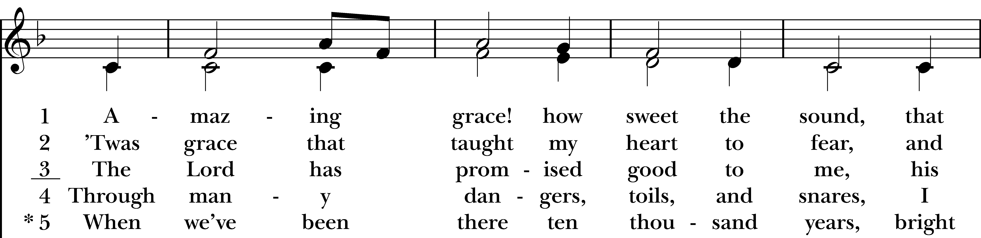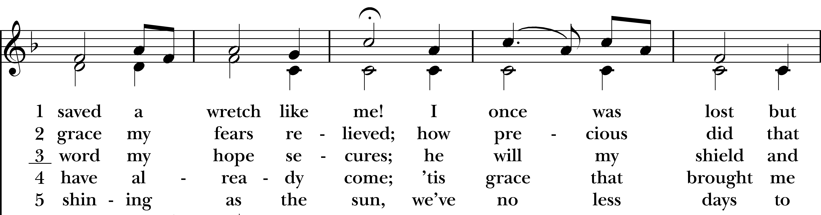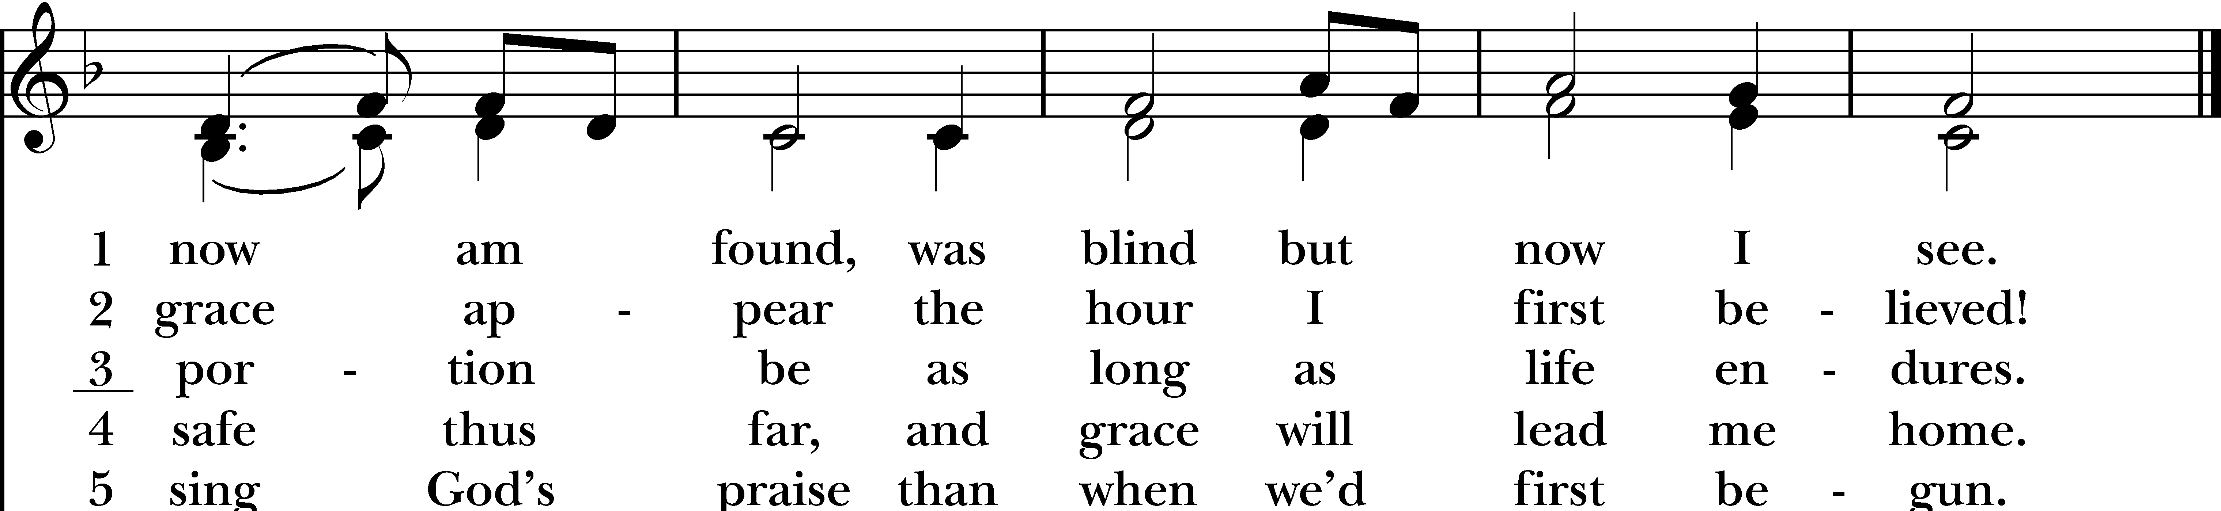

Apostles’ Creed BCP p. 96

I believe in God, the Father almighty, creator of heaven and earth. I believe in Jesus Christ, his only son, our Lord. He was conceived by the Holy Spirit, born of the Virgin Mary. He suffered under Pontius Pilate, was crucified, died, and was buried. He descended to the dead. On the third day he rose again. He ascended into heaven, and is seated at the right hand of the Father. He will come again to judge the living and the dead. I believe in the Holy Spirit, the holy catholic Church, the communion of saints, the forgiveness of sins, the resurrection of the body, and the life everlasting. Amen.

The Prayers
Officiant The Lord be with you.
People And also with you.
Officiant Let us pray.

Lord’s Prayer BCP p. 97
Our Father, who art in heaven, hallowed be thy Name, thy kingdom come, thy will be done, on earth as it is in heaven. Give us this day our daily bread. And forgive us our trespasses, as we forgive those who trespass against us. And lead us not into temptation, but deliver us from evil. For thine is the kingdom, and the power, and the glory, for ever and ever. Amen.

Suffrages A BCP p. 97
V. Show us your mercy, O Lord;
R. And grant us your salvation.
V. Clothe your ministers with righteousness;
R. Let your people sing with joy.
V. Give peace, O Lord, in all the world;
R. For only in you can we live in safety.
V. Lord, keep this nation under your care;
R. And guide us in the way of justice and truth.
V. Let your way be known upon earth;
R. Your saving health among all nations.
V. Let not the needy, O Lord, be forgotten;
R. Nor the hope of the poor be taken away.
V. Create in us clean hearts, O God;
R. And sustain us with your Holy Spirit
Collect of the Day
Gracious Father, whose blessed Son Jesus Christ came down from heaven to be the true bread which gives life to the world: Evermore give us this bread, that he may live in us, and we in him; who lives and reigns with you and the Holy Spirit, one God, now and for ever. Amen.

Prayers of the People: Form VI BCP p. 392
Lector: In Peace, we pray to you Heavenly Father,

For all people in their daily life and work;
For our families, friends, and neighbors, and for those who are alone.

For this community, the nation, and the world;
For all who work for justice, freedom, and peace.

For the just and proper use of your creation;
For the victims of hunger, fear, injustice, and oppression.

For all who are in danger, sorrow, or any kind of trouble;
For those who minister to the sick, the friendless, and the needy.

For the peace and unity of the Church of God;
For all who proclaim the Gospel, and all who seek the Truth.

For Sean our Presiding Bishop, and Jeffrey and Laura our Bishops; and for all bishops and other ministers; For all who serve God in his Church.

For the special needs and concerns of this congregation. (Parish Prayer List). Hear us, Lord;
For your mercy is great.

We will exalt you, O God our King;
And praise your Name for ever and ever.

We pray for all who have died that they may have a place in your eternal kingdom. Lord, let your loving-kindness be upon them; Who put their trust in you.

We thank you, Lord, for all the Blessings of this life.

Officiant: Good and gracious God, who loves and delights in all people, we stand in awe before You, knowing that the spark of life within each person on earth is the spark of your divine life. Differences among cultures and races are multicolored manifestations of Your Light. May our hearts and minds be open to celebrate similarities and differences among our sisters and brothers. We place our hopes for racial harmony in our committed action and in Your Presence in our Neighbor. May all peoples live in Peace. Amen.

Offering and Announcements

A Prayer of St. Chrysostom BCP p. 102
Almighty God, you have given us grace at this time with one accord to make our common supplication to you; and you have promised through your well-beloved Son that when two or three are gathered together in his Name you will be in the midst of them: Fulfill now, O Lord, our desires and petitions as may be best for us; granting us in this world knowledge of your truth, and in the age to come life everlasting. Amen.
Recessional Hymn: #493 O for a thousand tongues to sing

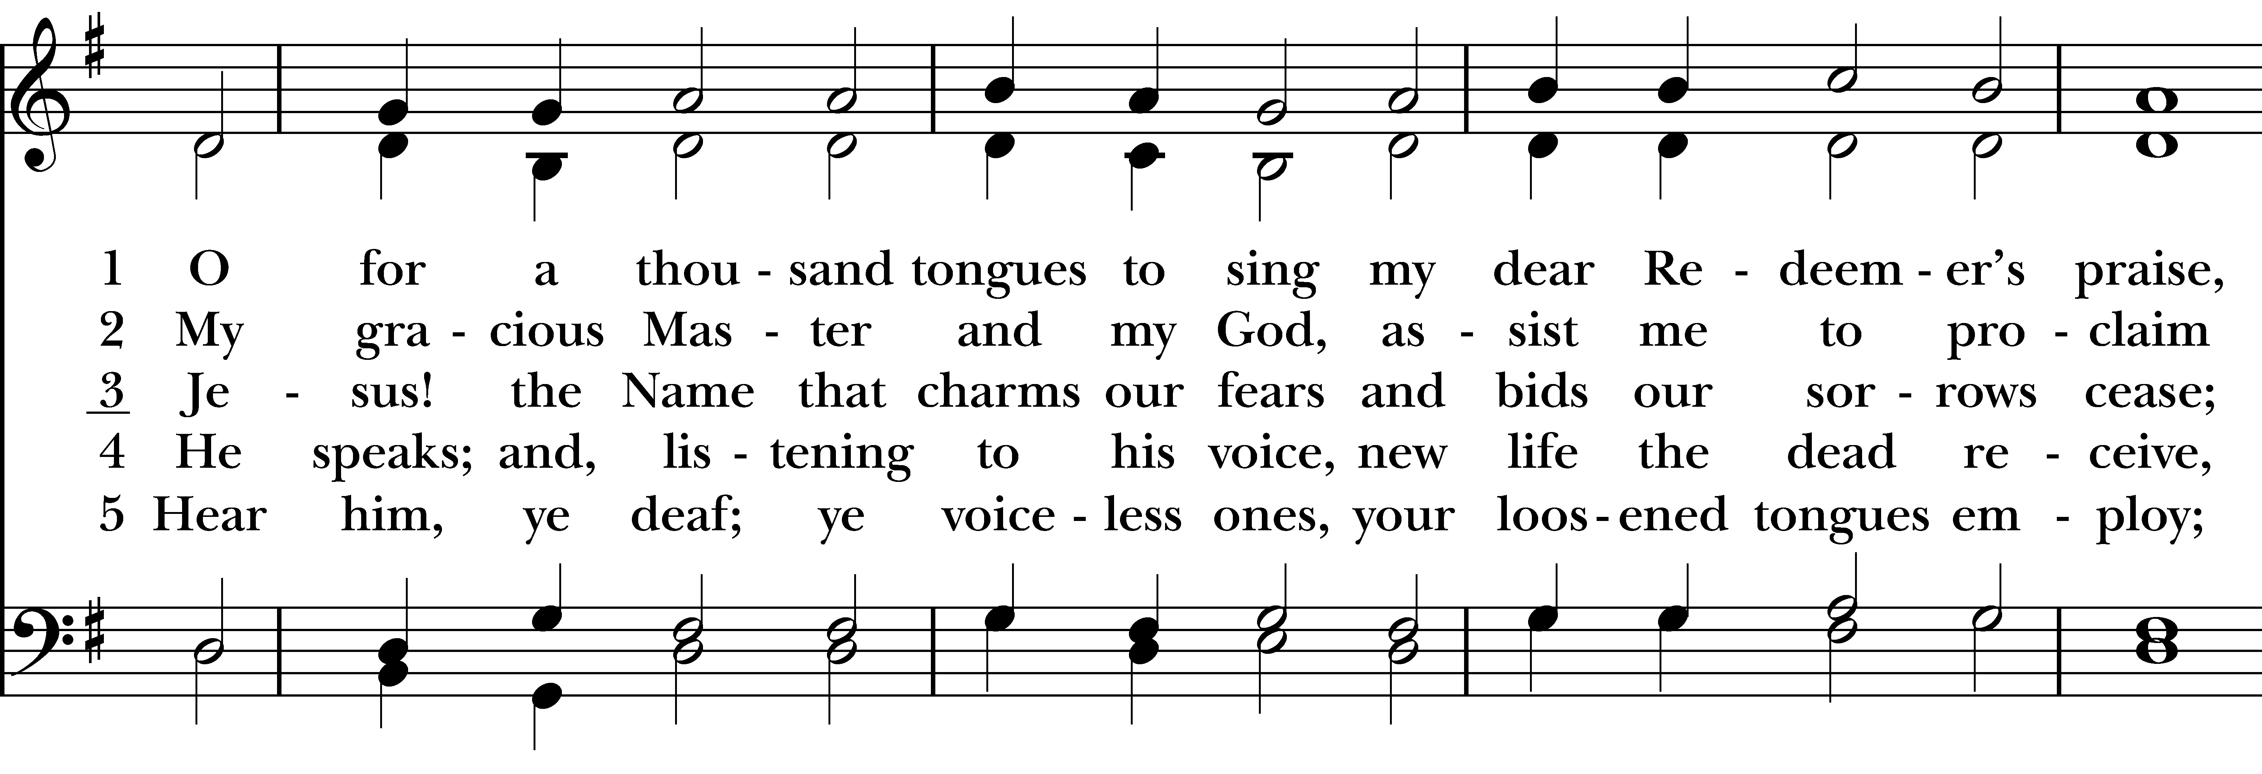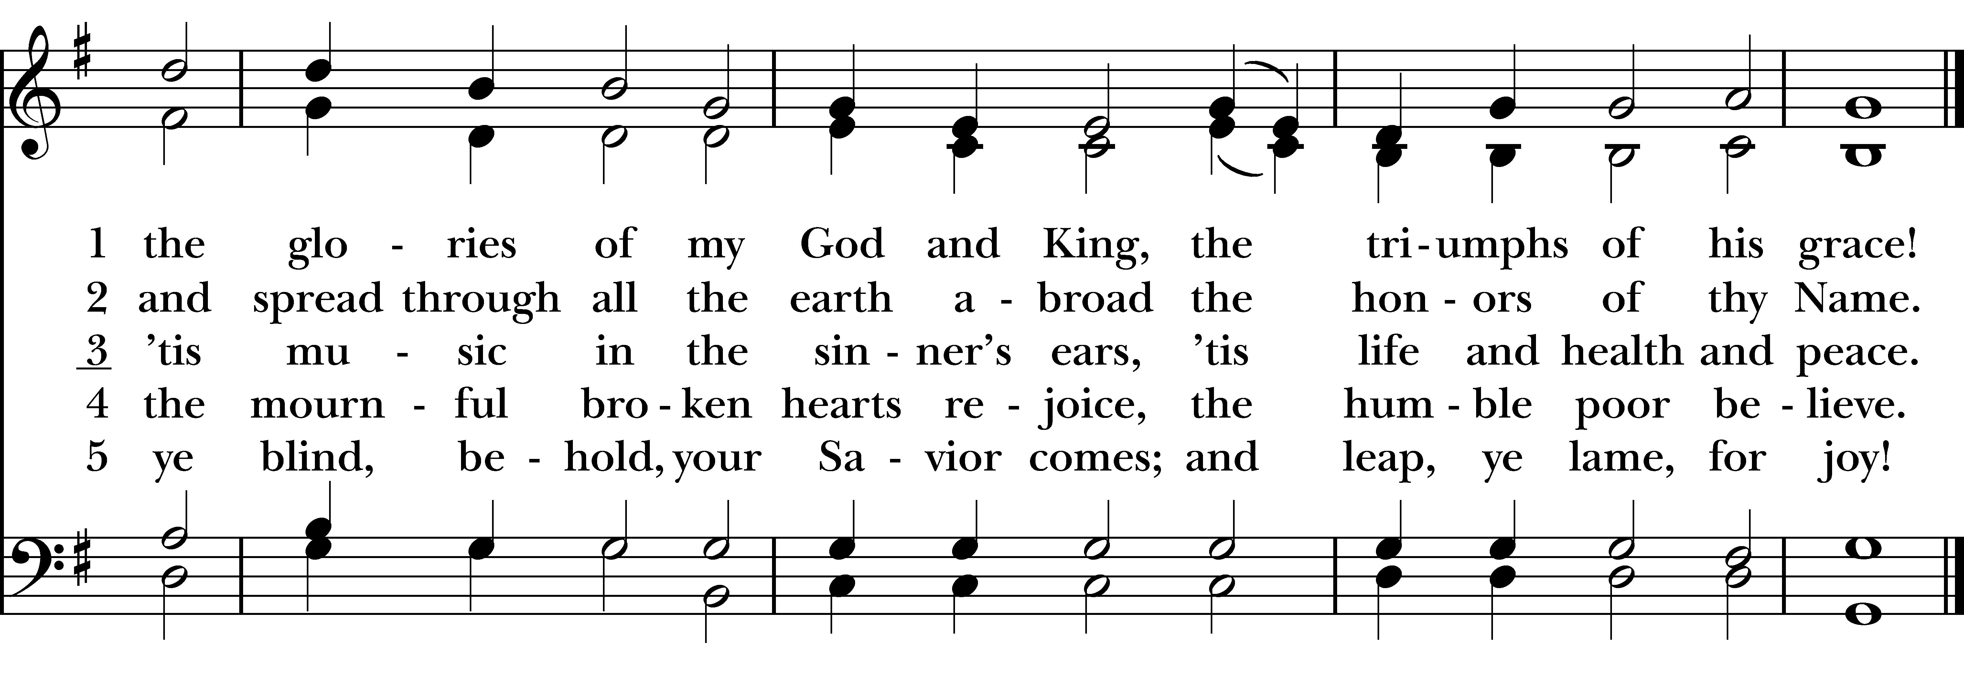
May the Lord Jesus go with us, wherever he may send us; may he guide us through the wilderness, protect us through the storm; may he bring us home rejoicing at the wonders he has shown us; may he bring us home rejoicing once again into our doors. Amen.
Officiant Let us bless the Lord.
People Thanks be to God.
Welcome to Christ Church Easton!

Whether you are a newcomer, visitor, or longtime member, we bid you a warm welcome!
Please join us for coffee hour following service.

Sign up for our email list: christchurcheaston.com

Announcements for March 15th, 2026

EASTER FLOWER ENVELOPES can be found in the pews and in the narthex. Due by Sun, 3/29.

COTH SPONSORS NEEDED: Forms are in the narthex. Please solicit any local businesses you frequent.

COMMUNITY MEDITATION: SPIRITUAL SPRING with Deborah, Thurs, March 19th @ 7pm on Zoom.
BOY SCOUT BREAKFAST: Sat, March 21st @ Easton Community Center, 7:30am to noon.

EASTER CANDY: Donations of individually wrapped Easter candy are welcome now thru 3/22 for our annual Easter egg hunt. Volunteers are needed to help stuff eggs the week of 3/22.

VESTRY MEETING: Tuesday, March 24th at 7pm via Zoom. All are welcome. Email Vicki for the Zoom link.

LUMOS CONCERT: Friday, March 27th – Lumos concert here at Christ Church, presenting a “Beatles Candlelight Experience.” Tickets available on their website: lumos-experiences.com.

UPCOMING WORSHIP DATES – Sunday Services @ 9:30 am

Sunday, 3/22: Morning Prayer – Molly Adams

Sunday, 3/29: Eucharist: Palm Sunday – Rev. Katy Piazza

Thursday, 4/2: Maundy Thursday at Emmanuel Parish Hall, Weston @ 6pm – Rev. Katy Piazza

Friday, 4/3: Good Friday Service, incl. Stations of the Cross @ 12pm – Rev. Katy Piazza

Sunday, 4/5: Eucharist: Easter Sunday – Rev. Katy Piazza

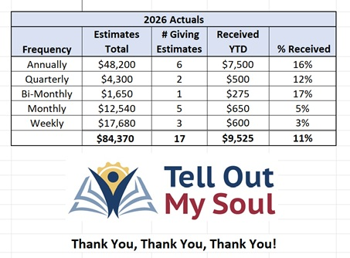
Christ Church – Parish Office Hours:
Mondays & Wednesdays: 9:30-1:30

59 Church Rd, Easton, CT
(203) 268-3569

christchurcheaston@gmail.com
www.christchurcheaston.com

Priest-in-Charge: Katy Piazza

Senior Warden: Vicki MarkAnthony

Parish Administrator: Tracy Carlucci
Music Minister: Tracy Carlucci

Choir Members: Amy Strachan, Andy Verrocchi, Bob Ellwanger, David McCann, Diane McCann, Marina Philips, Katie Tressler, Vicki MarkAnthony

Christ Church Nursery School: Maggie Supple, Director www.ccnseaston.com
Vestry: Jim Swann, Jr. Warden; Bob Ellwanger, Treasurer; Amy Bailas, Clerk

Vestry Members: Russ Bailas, Marina Philips, Claire Wilkes, Peg Ellwanger

Diocesan Delegates: Diane McCann, Bob Ellwanger; Alternate: Deborah Swann

