Morning Prayer: Sunday, April 19th, 2026
The Third Sunday of Easter
Christ Church Easton

Officiant: As we gather to worship, let us recognize that we gather on the ancestral lands and traditional territory of the (Aspetuck River Valley dwelling) Paugussett people.

Thanks be to God, who gives us the victory through our Lord Jesus Christ. 1 Corinthians 15:57

Officiant: Please stand as you are able and sing together our opening hymn, “Good Christians all, rejoice and sing!” #205 in the hymnal.

Opening Hymn “Good Christians all, rejoice and sing!” Hymnal #205

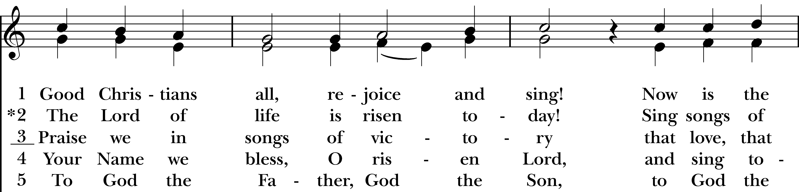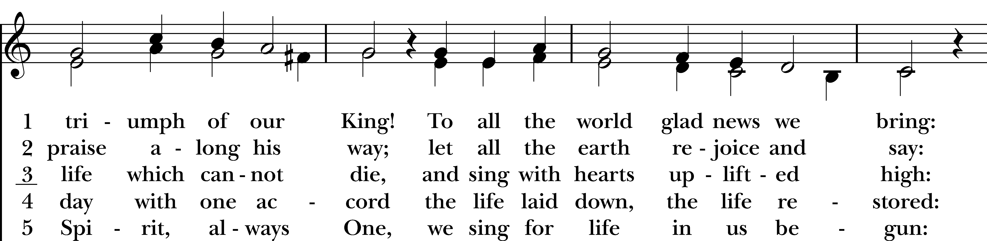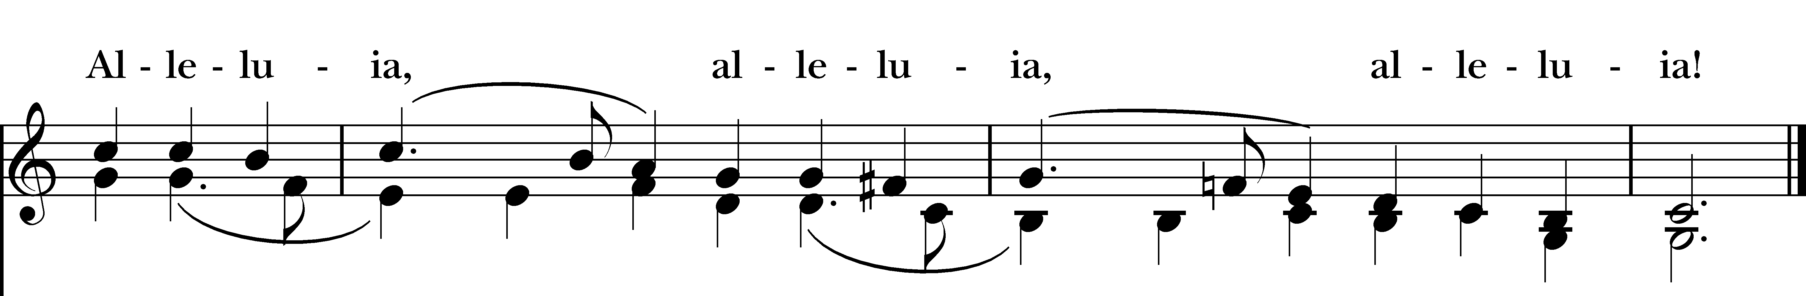

Confession of Sin BCP p. 79
Officiant: Turning to page 79 in the Book of Common Prayer, let us confess our sins against God and our neighbor.

Most merciful God, we confess that we have sinned against you in thought, word, and deed, by what we have done, and by what we have left undone. We have not loved you with our whole heart; we have not loved our neighbors as ourselves. We are truly sorry and we humbly repent. For the sake of your Son Jesus Christ, have mercy on us and forgive us; that we may delight in your will, and walk in your ways, to the glory of your Name. Amen.
Almighty God have mercy on us, forgive us all our sins through our Lord Jesus Christ, strengthen us in all goodness, and by the power of the Holy Spirit keep us in eternal life. Amen.
Invitatory and Psalter BCP p. 80

Officiant: Lord, open our lips.
People: And our mouth shall proclaim your praise.

Glory to the Father, and to the Son, and to the Holy Spirit: as it was in the beginning, is now, and will be for ever. Amen.

Lector: Turning now to page 82 in the Book of Common Prayer, let us recite the Venite.

Psalm 95: Venite BCP p. 82
Come, let us sing to the Lord; *
let us shout for joy to the Rock of our salvation.
Let us come before his presence with thanksgiving *
and raise a loud shout to him with psalms.
For the Lord is a great God, *
and a great King above all gods.
In his hand are the caverns of the earth, *
and the heights of the hills are his also.
The sea is his, for he made it, *
and his hands have molded the dry land.
Come, let us bow down, and bend the knee, *
and kneel before the Lord our Maker.
For he is our God, and we are the people of his pasture and the sheep of his hand. *
Oh, that today you would hearken to his voice!

The Psalm Appointed: Psalm 116

I love the LORD, because he has heard the voice of my supplication, *
because he has inclined his ear to me whenever I called upon him.
The cords of death entangled me; the grip of the grave took hold of me; *
I came to grief and sorrow.
Then I called upon the Name of the LORD: *
“O LORD, I pray you, save my life.”
How shall I repay the LORD *
for all the good things he has done for me?
I will lift up the cup of salvation *
and call upon the Name of the LORD.
I will fulfill my vows to the LORD *
in the presence of all his people.
Precious in the sight of the LORD *
is the death of his servants.
O LORD, I am your servant; *
I am your servant and the child of your handmaid; you have freed me from my bonds.
I will offer you the sacrifice of thanksgiving *
and call upon the Name of the LORD.
I will fulfill my vows to the LORD *
in the presence of all his people,
In the courts of the LORD’S house, *
in the midst of you, O Jerusalem. Hallelujah!

Glory to the Father, and to the Son, and to the Holy Spirit; as it was in the beginning, is now, and will
be for ever. Amen.

The First Reading Acts 2:14a,36-41
A Reading from the Acts of the Apostles.

But Peter, standing with the eleven, raised his voice and addressed them, “Men of Judea and all who live in Jerusalem, let this be known to you, and listen to what I say. Therefore let the entire house of Israel know with certainty that God has made him both Lord and Messiah, this Jesus whom you crucified.”
Now when they heard this, they were cut to the heart and said to Peter and to the other apostles, “Brothers, what should we do?” Peter said to them, “Repent, and be baptized every one of you in the name of Jesus Christ so that your sins may be forgiven; and you will receive the gift of the Holy Spirit. For the promise is for you, for your children, and for all who are far away, everyone whom the Lord our God calls to him.” And he testified with many other arguments and exhorted them, saying, “Save yourselves from this corrupt generation.” So those who welcomed his message were baptized, and that day about three thousand persons were added.

The Word of the Lord.
Thanks be to God.

The Second Reading 1 Peter 1:17-23
A Reading from the First Letter of Peter.

If you invoke as Father the one who judges all people impartially according to their deeds, live in reverent fear during the time of your exile. You know that you were ransomed from the futile ways inherited from your ancestors, not with perishable things like silver or gold, but with the precious blood of Christ, like that of a lamb without defect or blemish. He was destined before the foundation of the world, but was revealed at the end of the ages for your sake. Through him you have come to trust in God, who raised him from the dead and gave him glory, so that your faith and hope are set on God. Now that you have purified your souls by your obedience to the truth so that you have genuine mutual love, love one another deeply from the heart. You have been born anew, not of perishable but of imperishable seed, through the living and enduring word of God.

The Word of the Lord
Thanks be to God.

The Gospel Officiant: Please remain seated for the Gospel. Luke 24:13-35
A Reading from the Gospel of Luke.

Now on that same day two of them were going to a village called Emmaus, about seven miles from Jerusalem, and talking with each other about all these things that had happened. While they were talking and discussing, Jesus himself came near and went with them, but their eyes were kept from recognizing him. And he said to them, “What are you discussing with each other while you walk along?” They stood still, looking sad. Then one of them, whose name was Cleopas, answered him, “Are you the only stranger in Jerusalem who does not know the things that have taken place there in these days?” He asked them, “What things?” They replied, “The things about Jesus of Nazareth, who was a prophet mighty in deed and word before God and all the people, and how our chief priests and leaders handed him over to be condemned to death and crucified him. But we had hoped that he was the one to redeem Israel. Yes, and besides all this, it is now the third day since these things took place. Moreover, some women of our group astounded us. They were at the tomb early this morning, and when they did not find his body there, they came back and told us that they had indeed seen a vision of angels who said that he was alive. Some of those who were with us went to the tomb and found it just as the women had said; but they did not see him.” Then he said to them, “Oh, how foolish you are, and how slow of heart to believe all that the prophets have declared! Was it not necessary that the Messiah should suffer these things and then enter into his glory?” Then beginning with Moses and all the prophets, he interpreted to them the things about himself in all the scriptures. As they came near the village to which they were going, he walked ahead as if he were going on. But they urged him strongly, saying, “Stay with us, because it is almost evening and the day is now nearly over.” So he went in to stay with them. When he was at the table with them, he took bread, blessed and broke it, and gave it to them. Then their eyes were opened, and they recognized him; and he vanished from their sight. They said to each other, “Were not our hearts burning within us while he was talking to us on the road, while he was opening the scriptures to us?” That same hour they got up and returned to Jerusalem; and they found the eleven and their companions gathered together. They were saying, “The Lord has risen indeed, and he has appeared to Simon!” Then they told what had happened on the road, and how he had been made known to them in the breaking of the bread.

The Word of the Lord
Thanks be to God.

Reflection Vicki MarkAnthony

Officiant: Please join in singing our Reflection Hymn, “Because He Lives,” found in your bulletin.
Reflection Hymn “Because He Lives” LEVAS #43
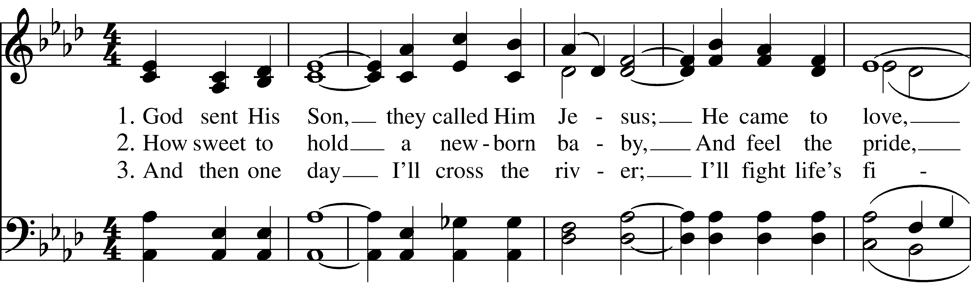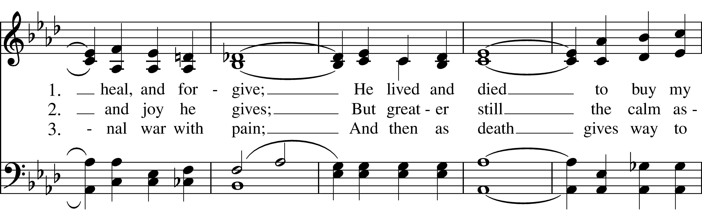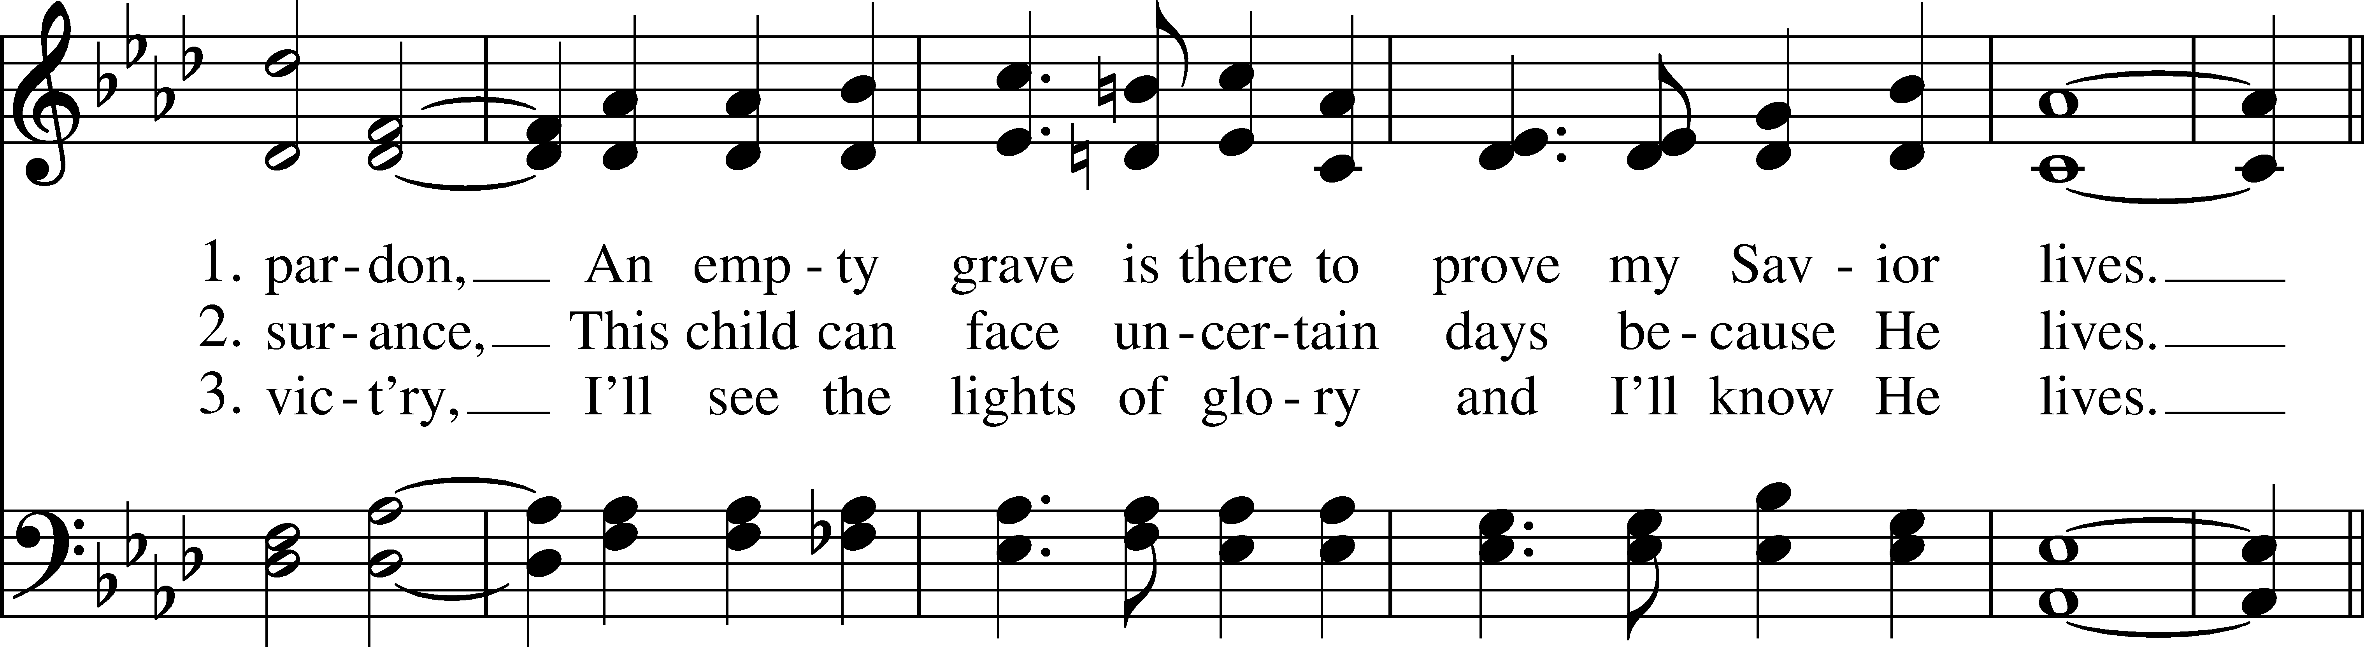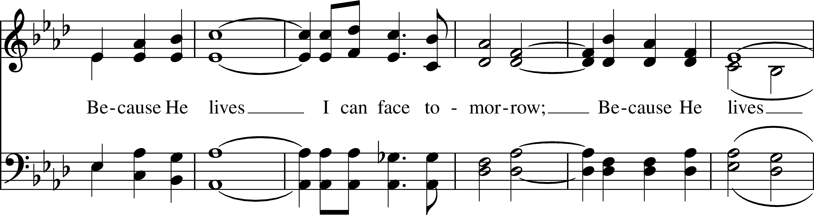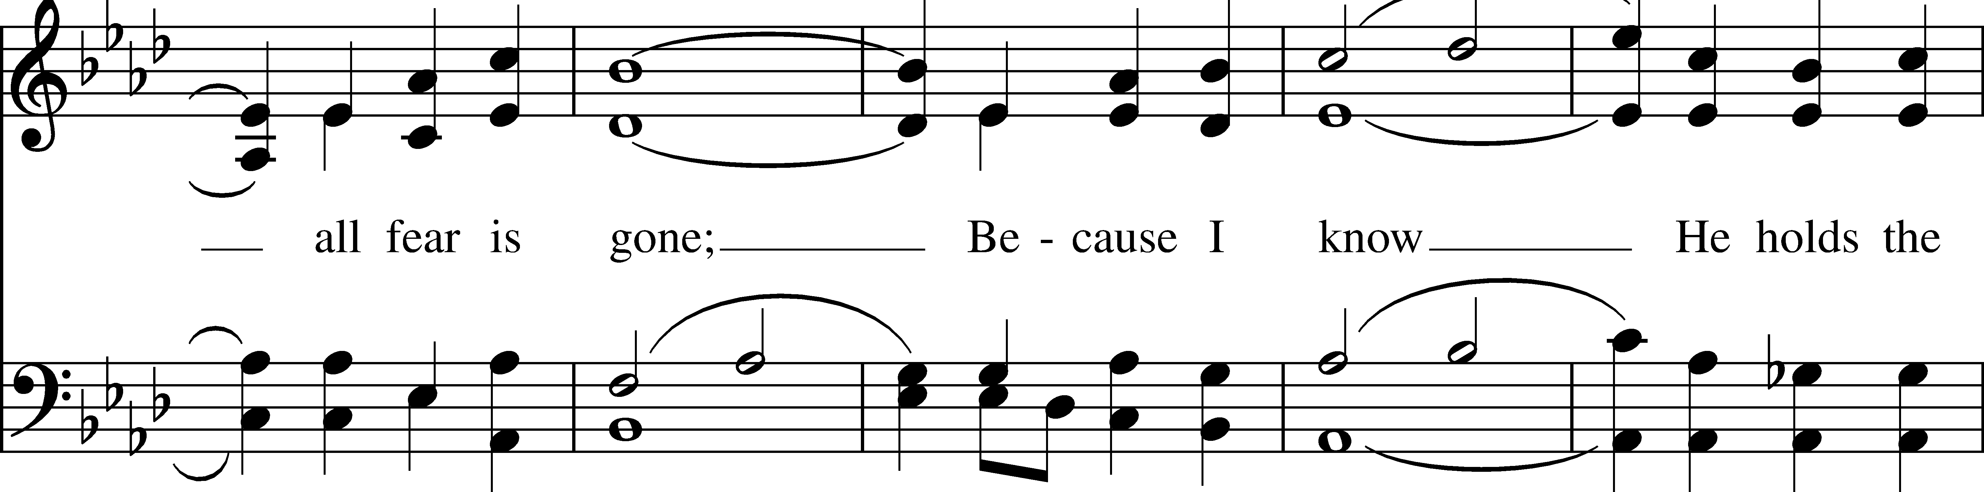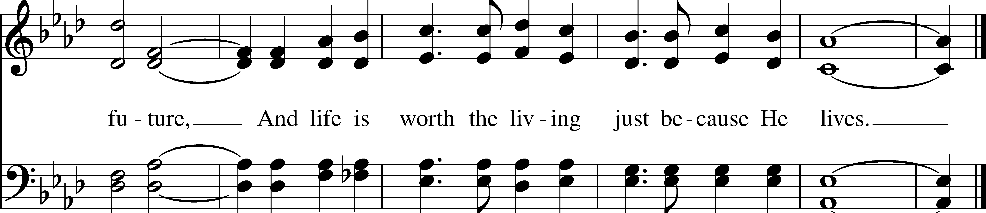
Officiant: Please stand as you are able for The Apostles Creed, page 96 in the Book of Common Prayer.

Apostles’ Creed BCP p. 96

I believe in God, the Father almighty, creator of heaven and earth. I believe in Jesus Christ, his only son, our Lord. He was conceived by the Holy Spirit, born of the Virgin Mary. He suffered under Pontius Pilate, was crucified, died, and was buried. He descended to the dead. On the third day he rose again. He ascended into heaven, and is seated at the right hand of the Father. He will come again to judge the living and the dead. I believe in the Holy Spirit, the holy catholic Church, the communion of saints, the forgiveness of sins, the resurrection of the body, and the life everlasting. Amen.

The Prayers BCP p. 97

Officiant: The Lord be with you.
People: And also with you.
Officiant: Let us pray.

Our Father, who art in heaven, hallowed be thy Name, thy kingdom come, thy will be done, on earth as it is in heaven. Give us this day our daily bread. And forgive us our trespasses, as we forgive those who trespass against us. And lead us not into temptation, but deliver us from evil. For thine is the kingdom, and the power, and the glory, for ever and ever. Amen.

Officiant: Turning now to page 98 in the Book of Common Prayer, let us pray the Suffrages B.

Suffrages B BCP p. 98

V. Save your people, Lord, and bless your inheritance;
R. Govern and uphold them, now and always.
V. Day by day we bless you;
R. We praise your name for ever.
V. Lord, keep us from all sin today;
R. Have mercy on us, Lord, have mercy.
V. Lord, show us your love and mercy;
R. For we put our trust in you.
V. In you, Lord, is our hope;
R. And we shall never hope in vain.

The Collect of the Day

O God, whose blessed Son made himself known to his disciples in the breaking of bread: Open the eyes of our faith, that we may behold him in all his redeeming work; who lives and reigns with you, in the unity of the Holy Spirit, one God, now and for ever. Amen.

Officiant: Please turn to page 387 in the Book of Common Prayer for the Prayers of the People, Form III.

Prayers of the People: Form III BCP p. 387

Father, we pray for your holy Catholic Church;
That we all may be one.

Grant that every member of the Church may truly and humbly serve you;
That your Name may be glorified by all people.

We pray for all bishops, priests, and deacons;
That they may be faithful ministers of your Word and Sacraments.

We pray for all who govern and hold authority in the nations of the world;
That there may be justice and peace on the earth.

Give us grace to do your will in all that we undertake;
That our works may find favor in your sight.

Have compassion on those who suffer from any grief or trouble;
That they may be delivered from their distress.

Give to the departed eternal rest.
Let light perpetual shine upon them.

We praise you for your saints who have entered into joy;
May we also come to share in your heavenly kingdom.

Let us pray for our own needs and those of others. We pray especially for those on our parish prayer list…

O Lord our God, accept the fervent prayers of your people; in the multitude of your mercies, look with compassion upon us and all who turn to you for help; for you are gracious, O lover of souls, and to you we give glory, Father, Son, and Holy Spirit, now and for ever. Amen.

Offering & Announcements

Officiant: Let us pray together the Prayer of St. Chrysostom, found on page 102 in the Book of Common Prayer.

Prayer of St. Chrysostom BCP p. 102

Almighty God, you have given us grace at this time with one accord to make our common supplication to you; and you have promised through your well-beloved Son that when two or three are gathered together in his Name you will be in the midst of them: Fulfill now, O Lord, our desires & petitions as may be best for us; granting us in this world knowledge of your truth, and in the age to come life everlasting. Amen.

Officiant: Please stand as you are able & sing our closing hymn #296 “We know that Christ is raised & dies no more”

Closing Hymn “We know that Christ is raised and dies no more” Hymnal #296

Dismissal

Officiant: Our worship is ended. Our Service begins. Let us go in peace to love & serve the Lord. Alleluia, alleluia.
People: Thanks be to God. Alleluia, alleluia.

Announcements for April 19th, 2026

COFFEE HOUR: Volunteers are always needed for coffee hour. Sign-up sheet is located in the narthex.

COTH SPONSORS NEEDED: Forms are in the narthex. Please solicit any local businesses you frequent

SAVE THE DATE: Church field trip! Let Vicki know if you’d like to attend a matinee performance of Jesus Christ Superstar on Saturday, 5/16 at Goodspeed Opera House.

VESTRY MEETING: Tuesday, April 28th at 7pm via Zoom. All are welcome. Email Vicki for the Zoom link.

GIFT CARDS to gas stations & grocery stores are always needed. Thank you for your continued generosity.

Welcome to Christ Church Easton!
Whether you are a newcomer, visitor, or longtime member, we bid you a warm welcome!
Please join us for coffee hour following service.
Sign up for our email list at www.christchurcheaston.com
Vestry: Jim Swann, Jr. Warden; Bob Ellwanger, Treasurer; Amy Bailas, Clerk

Vestry Members: Russ Bailas, Marina Philips, Claire Wilkes, Peg Ellwanger

Diocesan Delegates: Diane McCann, Bob Ellwanger; Alternate: Deborah Swann
Music Minister: Tracy Carlucci

Choir Members: Amy Strachan, Andy Verrocchi, Bob Ellwanger, David McCann, Diane McCann, Marina Philips, Katie Tressler, Vicki MarkAnthony

Christ Church Nursery School: Maggie Supple, Director www.ccnseaston.com
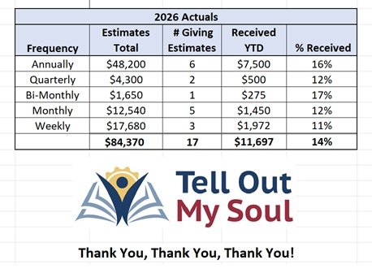
UPCOMING WORSHIP DATES – Sunday Services @ 9:30 am

Sunday, 4/26: Eucharist Service – Rev. Katy Piazza

Sunday, 5/3: Eucharist Service & Family Sunday – Rev. Katy Piazza

Sunday, 5/10: Morning Prayer & Red Dress Day – Vicki MarkAnthony

Sunday, 5/17: Eucharist Service & Ascension Sunday – Rev. Katy Piazza

Christ Church – Parish Office Hours:
Mondays & Wednesdays: 9:30-1:30

59 Church Rd, Easton, CT
(203) 268-3569

christchurcheaston@gmail.com
www.christchurcheaston.com

Priest-in-Charge: Katy Piazza

Senior Warden: Vicki MarkAnthony

Parish Administrator: Tracy Carlucci

