**Sunday, August 24th, 2025: The Eleventh Sunday after Pentecost**

**Rev. Isabel Geller, Supply Priest**

**Christ Church Easton**

*Celebrant:* As we gather to worship, let us recognize that we gather on the ancestral lands and traditional territory of the (Aspetuck River Valley dwelling) Paugussett people.

**Opening Hymn Father, we praise thee, now the night is over**

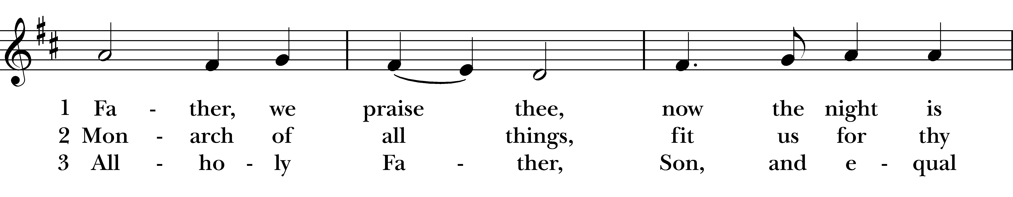  
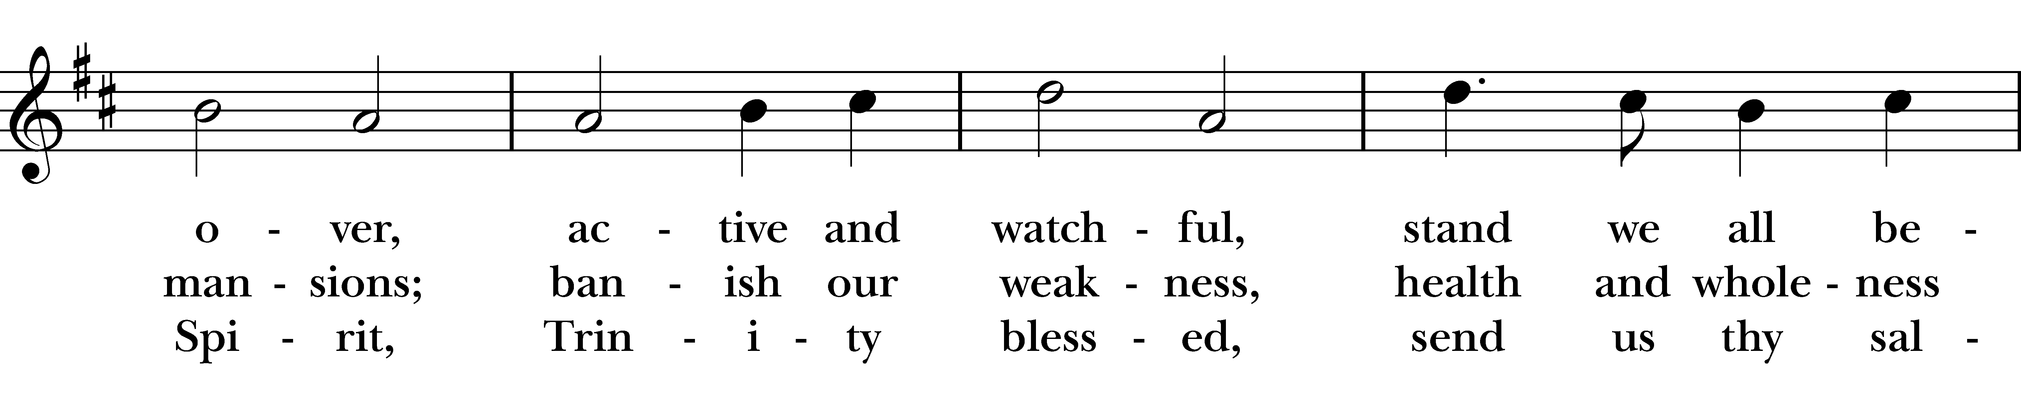  
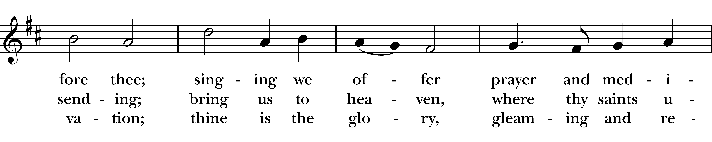  
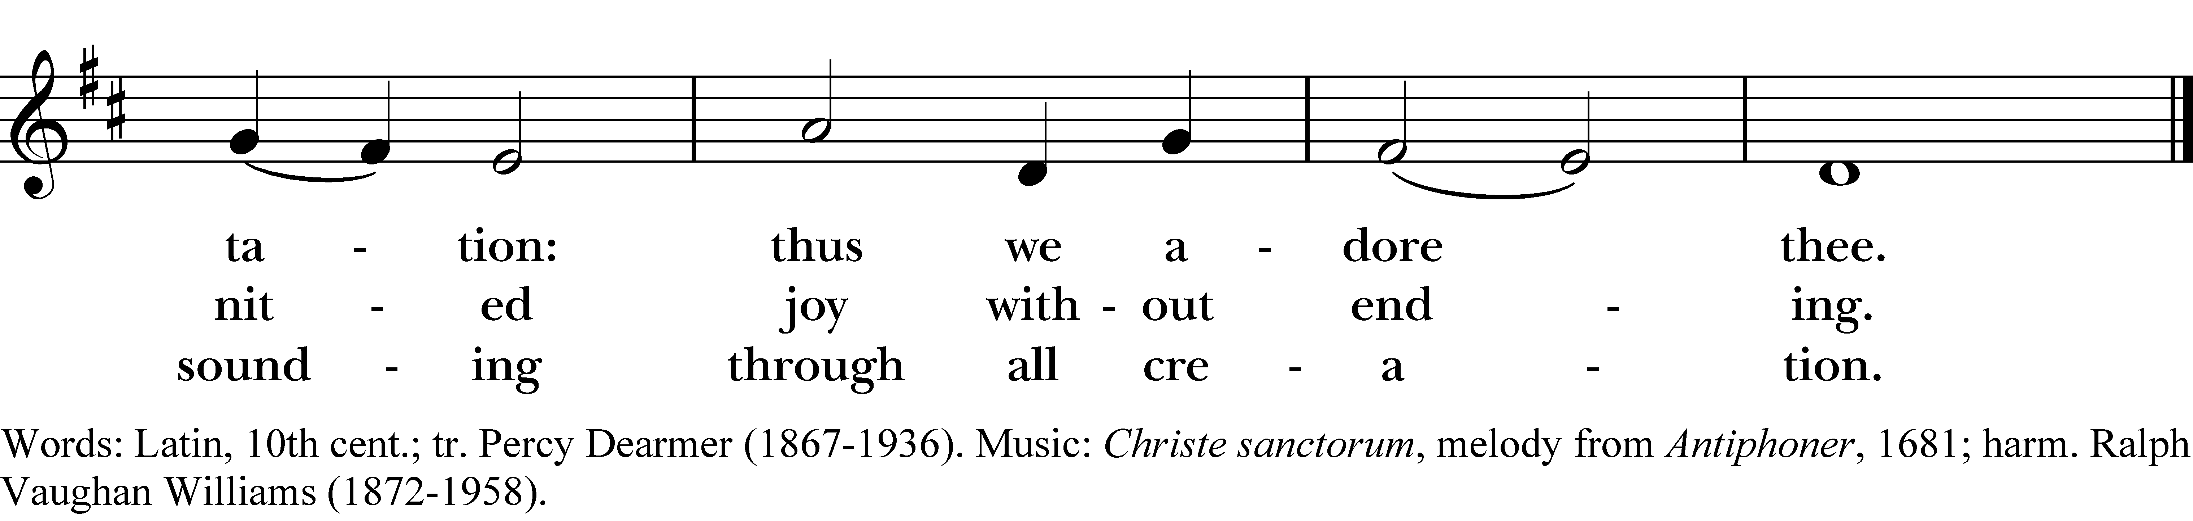

*Reprinted/streamed with permission via One License and RiteSong. All rights reserved.*

*Celebrant:* Blessed be the one, holy, and living God.  
People: Glory to God for ever and ever.

**The Collect for Purity**

Almighty God, to you all hearts are open, all desires known, and from you no secrets are hid: Cleanse the thoughts of our hearts by the inspiration of your Holy Spirit, that we may perfectly love you, and worthily magnify your holy Name; through Christ our Lord. **Amen.**

**Gloria in Excelsis**

**Glory to God in the highest, and peace to his people on earth. Lord God, heavenly King,  
 almighty God and Father, we worship you, we give you thanks, we praise you for your glory.**

**Lord Jesus Christ, only Son of the Father, Lord God, Lamb of God, you take away the sin of the world:**

**have mercy on us; you are seated at the right hand of the Father: receive our prayer.**

**For you alone are the Holy One, you alone are the Lord, you alone are the Most High, Jesus Christ,**

**with the Holy Spirit, in the glory of God the Father. Amen.**

**The Collect of the Day**

*Celebrant:* God be with you.**People:** **And also with you.**

*Let us pray.* Grant, O merciful God, that your Church, being gathered together in unity by your Holy Spirit, may show forth your power among all peoples, to the glory of your Name; through Jesus Christ our Lord, who lives and reigns with you and the Holy Spirt, one God, for ever and ever. Amen.

**The First Reading Jeremiah 1:4-10**

A Reading from the Book of the Prophet Jeremiah.

Now the word of the LORD came to me saying, “Before I formed you in the womb I knew you, and before you were born I consecrated you; I appointed you a prophet to the nations.” Then I said, “Ah, Lord GOD! Truly I do not know how to speak, for I am only a boy.” But the LORD said to me, “Do not say, ‘I am only a boy’; for you shall go to all to whom I send you, and you shall speak whatever I command you, Do not be afraid of them, for I am with you to deliver you, says the LORD.” Then the LORD put out his hand and touched my mouth; and the LORD said to me, “Now I have put my words in your mouth. See, today I appoint you over nations and over kingdoms, to pluck up and to pull down, to destroy and to overthrow, to build and to plant.”

Hear what the Spirit is saying to God’s people. **Thanks be to God.**

**Psalm 71 *Psalm 71:1-6***

In you, O LORD, have I taken refuge; *  
**let me never be ashamed.**

In your righteousness, deliver me and set me free; *  
**incline your ear to me and save me.**

Be my strong rock, a castle to keep me safe; *  
**you are my crag and my stronghold.**

Deliver me, my God, from the hand of the wicked, *  
**from the clutches of the evildoer and the oppressor.**

For you are my hope, O LORD God, *  
**my confidence since I was young.**

I have been sustained by you ever since I was born; from my mother’s womb you have been my strength; *  
**my praise shall be always of you.**

**The Second Reading Hebrews 12:18-29**

A Reading from the Book of Hebrews.

You have not come to something that can be touched, a blazing fire, and darkness, and gloom, and a tempest, and the sound of a trumpet, and a voice whose words made the hearers beg that not another word be spoken to them. (For they could not endure the order that was given, “If even an animal touches the mountain, it shall be stoned to death.” Indeed, so terrifying was the sight that Moses said, “I tremble with fear.”) But you have come to Mount Zion and to the city of the living God, the heavenly Jerusalem, and to innumerable angels in festal gathering, and to the assembly of the firstborn who are enrolled in heaven, and to God the judge of all, and to the spirits of the righteous made perfect, and to Jesus, the mediator of a new covenant, and to the sprinkled blood that speaks a better word than the blood of Abel. See that you do not refuse the one who is speaking; for if they did not escape when they refused the one who warned them on earth, how much less will we escape if we reject the one who warns from heaven! At that time his voice shook the earth; but now he has promised, “Yet once more I will shake not only the earth but also the heaven.” This phrase, “Yet once more,” indicates the removal of what is shaken—that is, created things—so that what cannot be shaken may remain. Therefore, since we are receiving a kingdom that cannot be shaken, let us give thanks, by which we offer to God an acceptable worship with reverence and awe; for indeed our God is a consuming fire.

Hear what the Spirit is saying to God’s people. **Thanks be to God.**

Gospel Hymn  **Heal me, hands of Jesus**

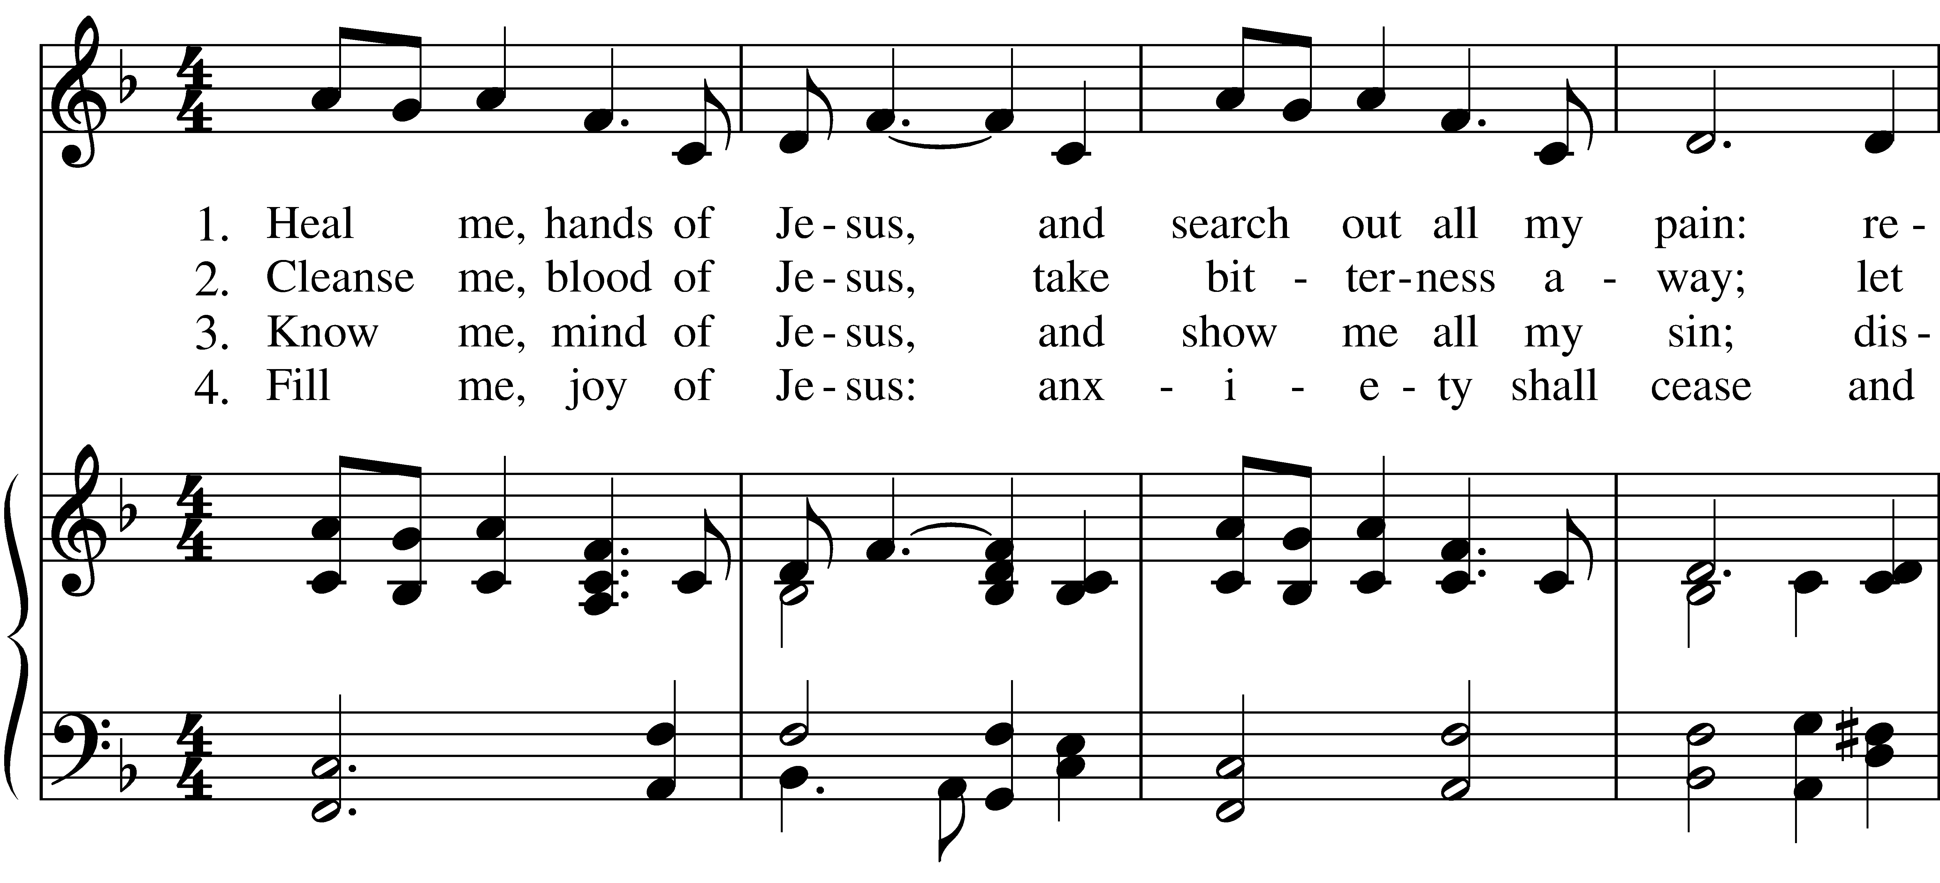  
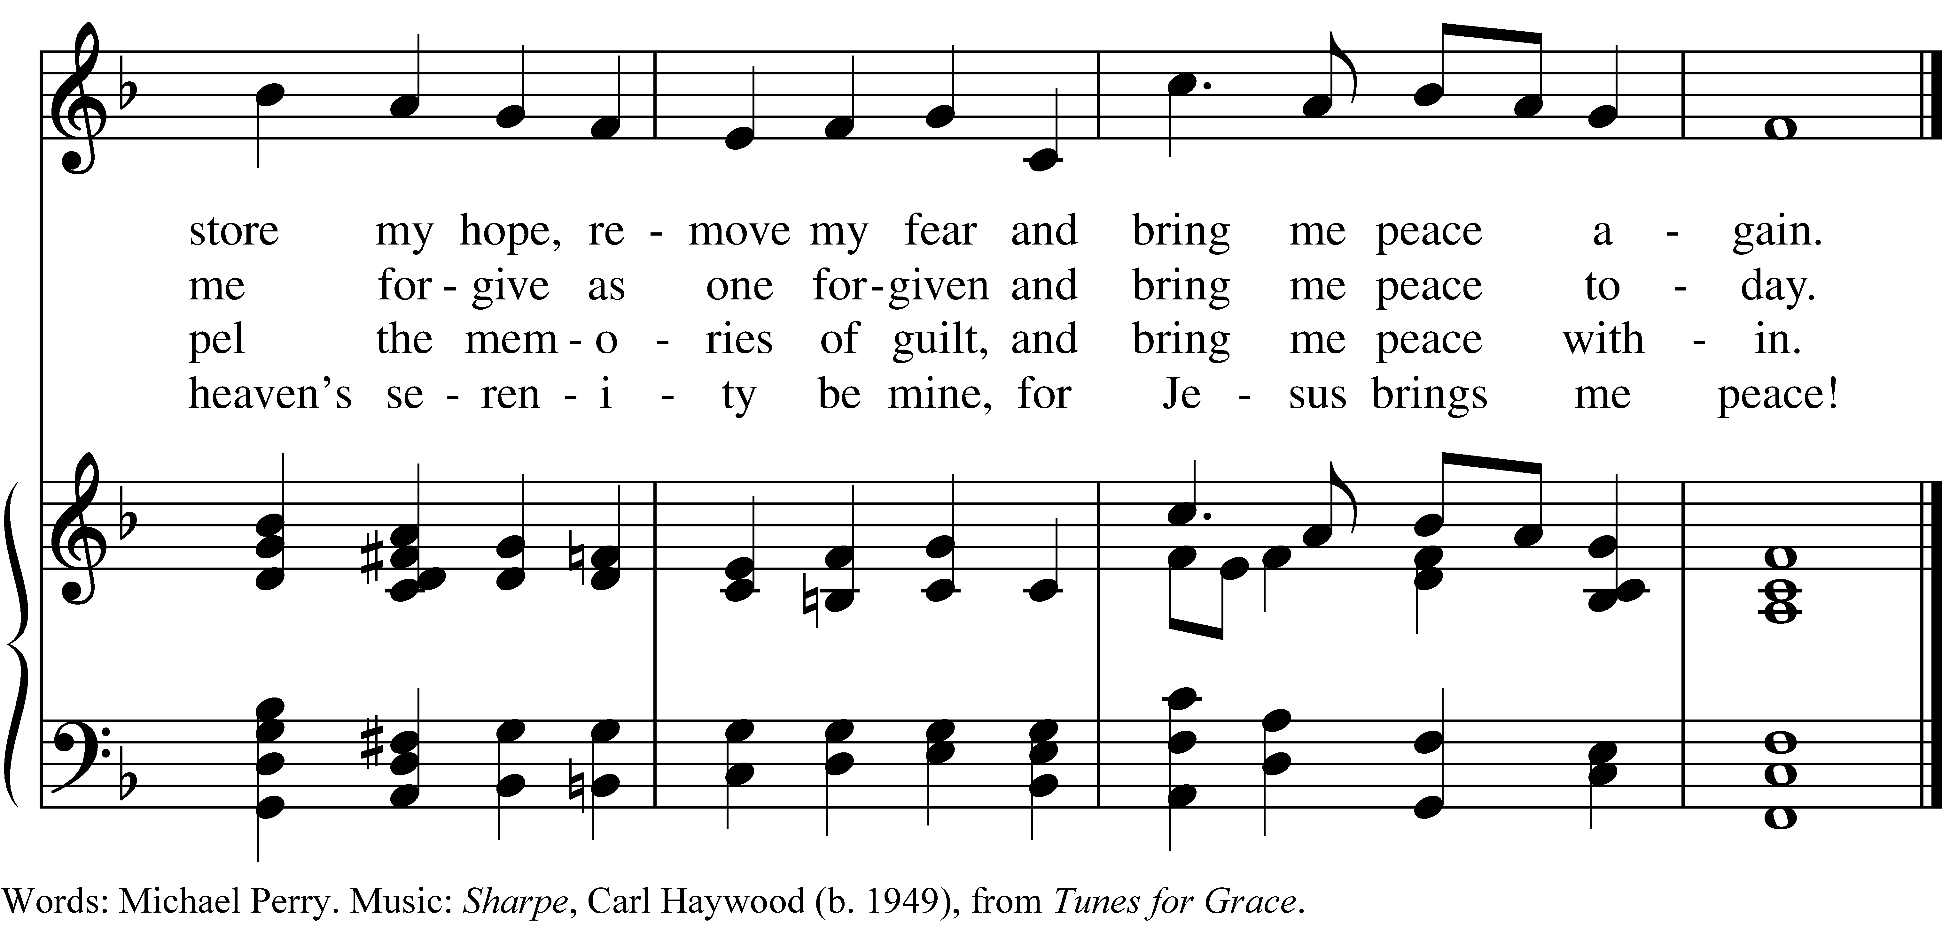

*Reprinted/streamed with permission via One License and/or RiteSong. All rights reserved.*

**The Gospel Luke 13:10-17**

*The Holy Gospel of our Lord Jesus Christ, according to Saint Luke.***Glory to you, Lord Christ.**

Now he was teaching in one of the synagogues on the sabbath. And just then there appeared a woman with a spirit that had crippled her for eighteen years. She was bent over and was quite unable to stand up straight. When Jesus saw her, he called her over and said, “Woman, you are set free from your ailment.” When he laid his hands on her, immediately she stood up straight and began praising God. But the leader of the synagogue, indignant because Jesus had cured on the sabbath, kept saying to the crowd, “There are six days on which work ought to be done; come on those days and be cured, and not on the sabbath day.” But the Lord answered him and said, “You hypocrites! Does not each of you on the sabbath untie his ox or his donkey from the manger, and lead it away to give it water? And ought not this woman, a daughter of Abraham whom Satan bound for eighteen long years, be set free from this bondage on the sabbath day?” When he said this, all his opponents were put to shame; and the entire crowd was rejoicing at all the wonderful things that he was doing.

*The Gospel of the Lord.* **Praise to you, Lord Christ.**

**The Sermon Rev. Isabel Geller**

**The Nicene Creed**

**We believe in one God, the Father, the Almighty, maker of heaven and earth, of all that is, seen and unseen. We believe in one Lord, Jesus Christ, the only Son of God, eternally begotten of the Father, God from God, Light from Light, true God from true God, begotten, not made, of one Being with the Father. Through him all things were made.**

**For us and for our salvation, he came down from heaven: by the power of the Holy Spirit he became incarnate from the Virgin Mary, and was made man. For our sake he was crucified under Pontius Pilate; he suffered death and was buried. On the third day he rose again in accordance with the Scriptures; he ascended into heaven and is seated at the right hand of the Father. He will come again in glory to judge the living and the dead, and his kingdom will have no end.**

**We believe in the Holy Spirit, the Lord, the giver of life, who proceeds from the Father and the Son. With the Father and the Son he is worshiped and glorified. He has spoken through the Prophets. We believe in one holy catholic and apostolic Church. We acknowledge one baptism for the forgiveness of sins. We look for the resurrection of the dead, and the life of the world to come. Amen.**

**The Prayers of the People: Form III**

Father, we pray for your holy Catholic Church; **That we all may be one.**

Grant that every member of the Church may truly and humbly serve you;   
**That your Name may be glorified by all people.**

We pray for all bishops, priests, and deacons; **That they may be faithful ministers of your Word and Sacraments.**

We pray for all who govern and hold authority in the nations of the world;  
**That there may be justice and peace on the earth.**

Give us grace to do your will in all that we undertake;  
**That our works may find favor in your sight.**

Have compassion on those who suffer from any grief or trouble;  
**That they may be delivered from their distress.**

Give to the departed eternal rest.  
**Let light perpetual shine upon them.**

We praise you for your saints who have entered into joy;  
**May we also come to share in your heavenly kingdom.**

Let us pray for our own needs and those of others, especially those on our parish prayer list…

O Lord our God, accept the fervent prayers of your people; in the multitude of your mercies, look with compassion upon us and all who turn to you for help; for you are gracious, O lover of souls, and to you we give glory, Father, Son, and Holy Spirit, now and for ever. **Amen.**

**The Confession of Sin**

*Let us confess our sins to God.*

**God of all mercy, we confess that we have sinned against you, opposing your will in our lives. We have denied your goodness in each other, in ourselves, and in the world you have created. We repent of the evil that enslaves us, the evil we have done, and the evil done on our behalf. Forgive, restore, and strengthen us through our Savior Jesus Christ, that we may abide in your love and serve only your will. Amen.**

Almighty God have mercy on you, forgive you all your sins through our Lord Jesus Christ, strengthen you in all goodness, and by the power of the Holy Spirit keep you in eternal life. Amen.

**The Peace**

*Celebrant:* The peace of Christ be always with you.

**People: And also with you.**

**Announcements**

**The Holy Communion**

Walk in love, as Christ loved us and gave himself for us, an offering and sacrifice to God. *Ephesians 5:2*

**Offertory Hymn Taste and See**

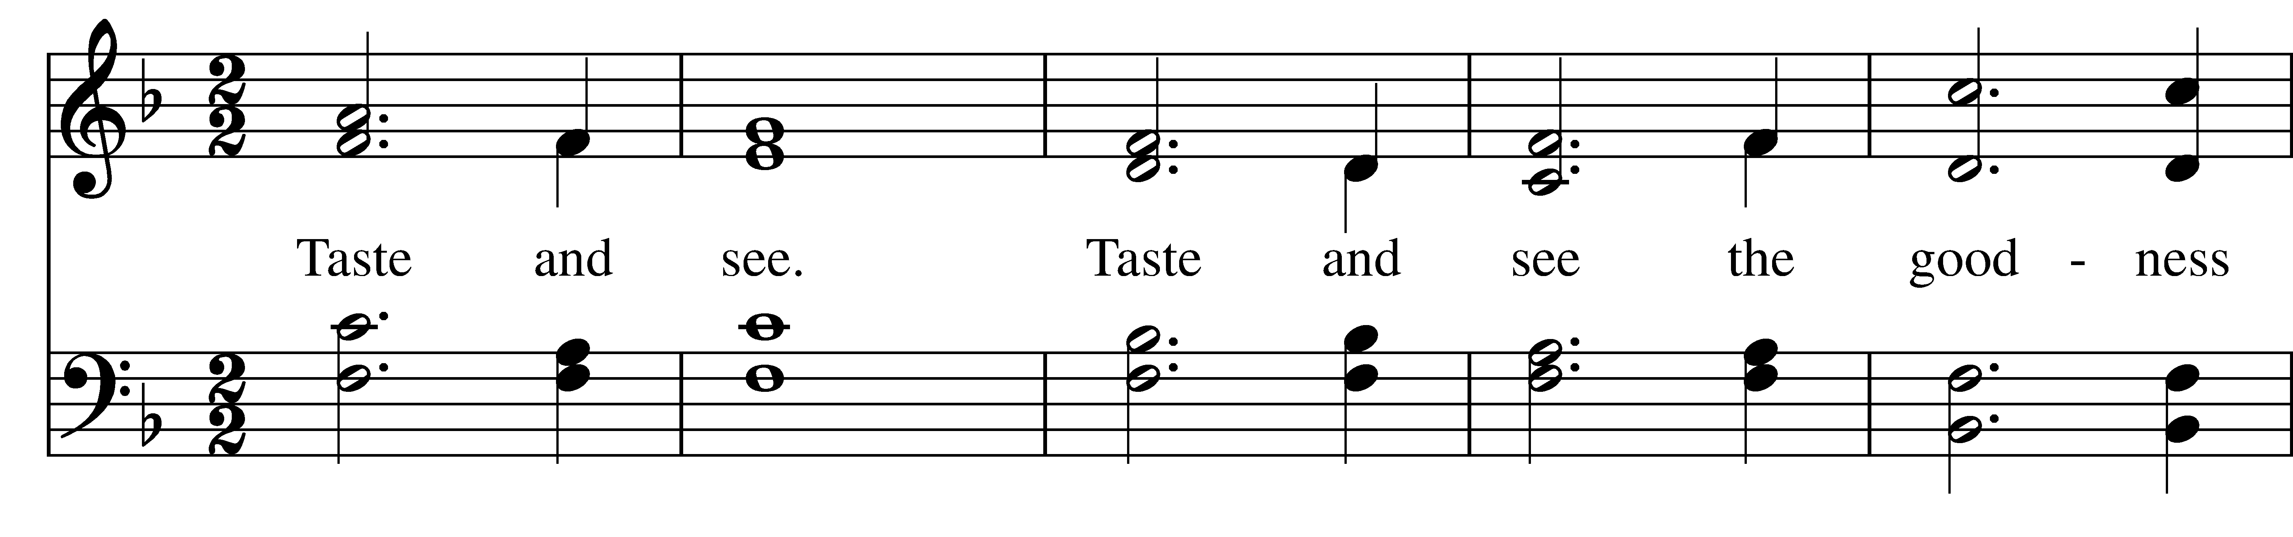  
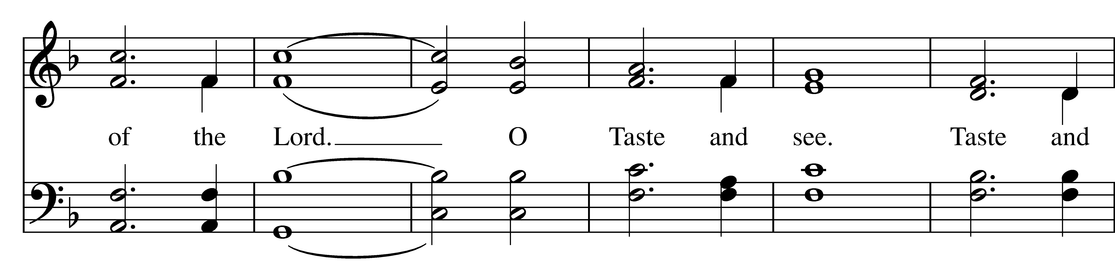  
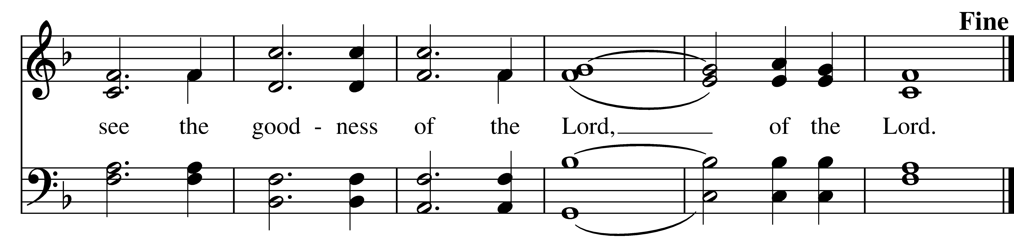

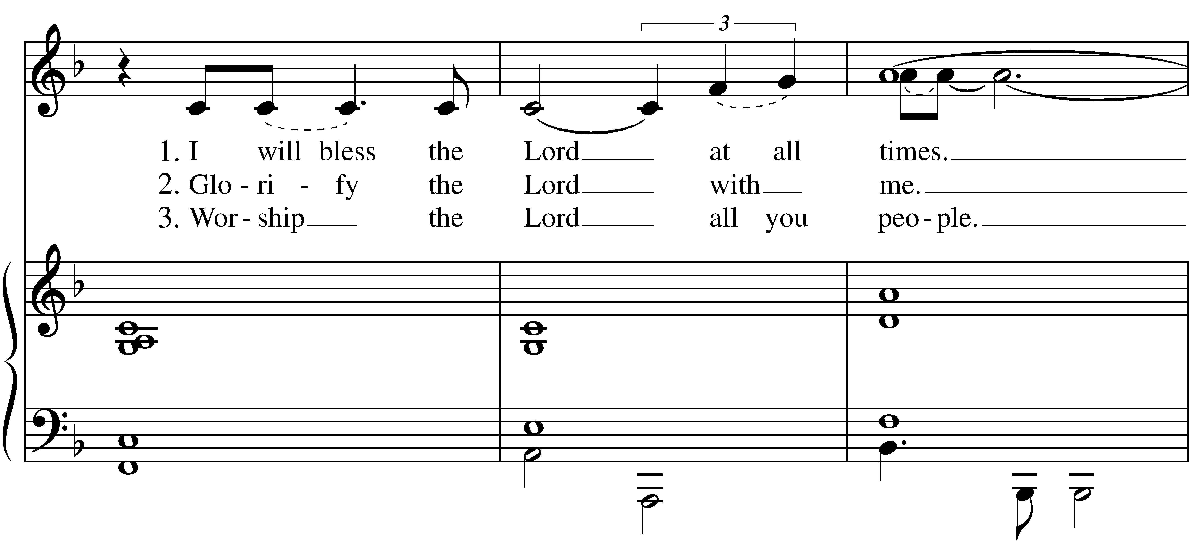

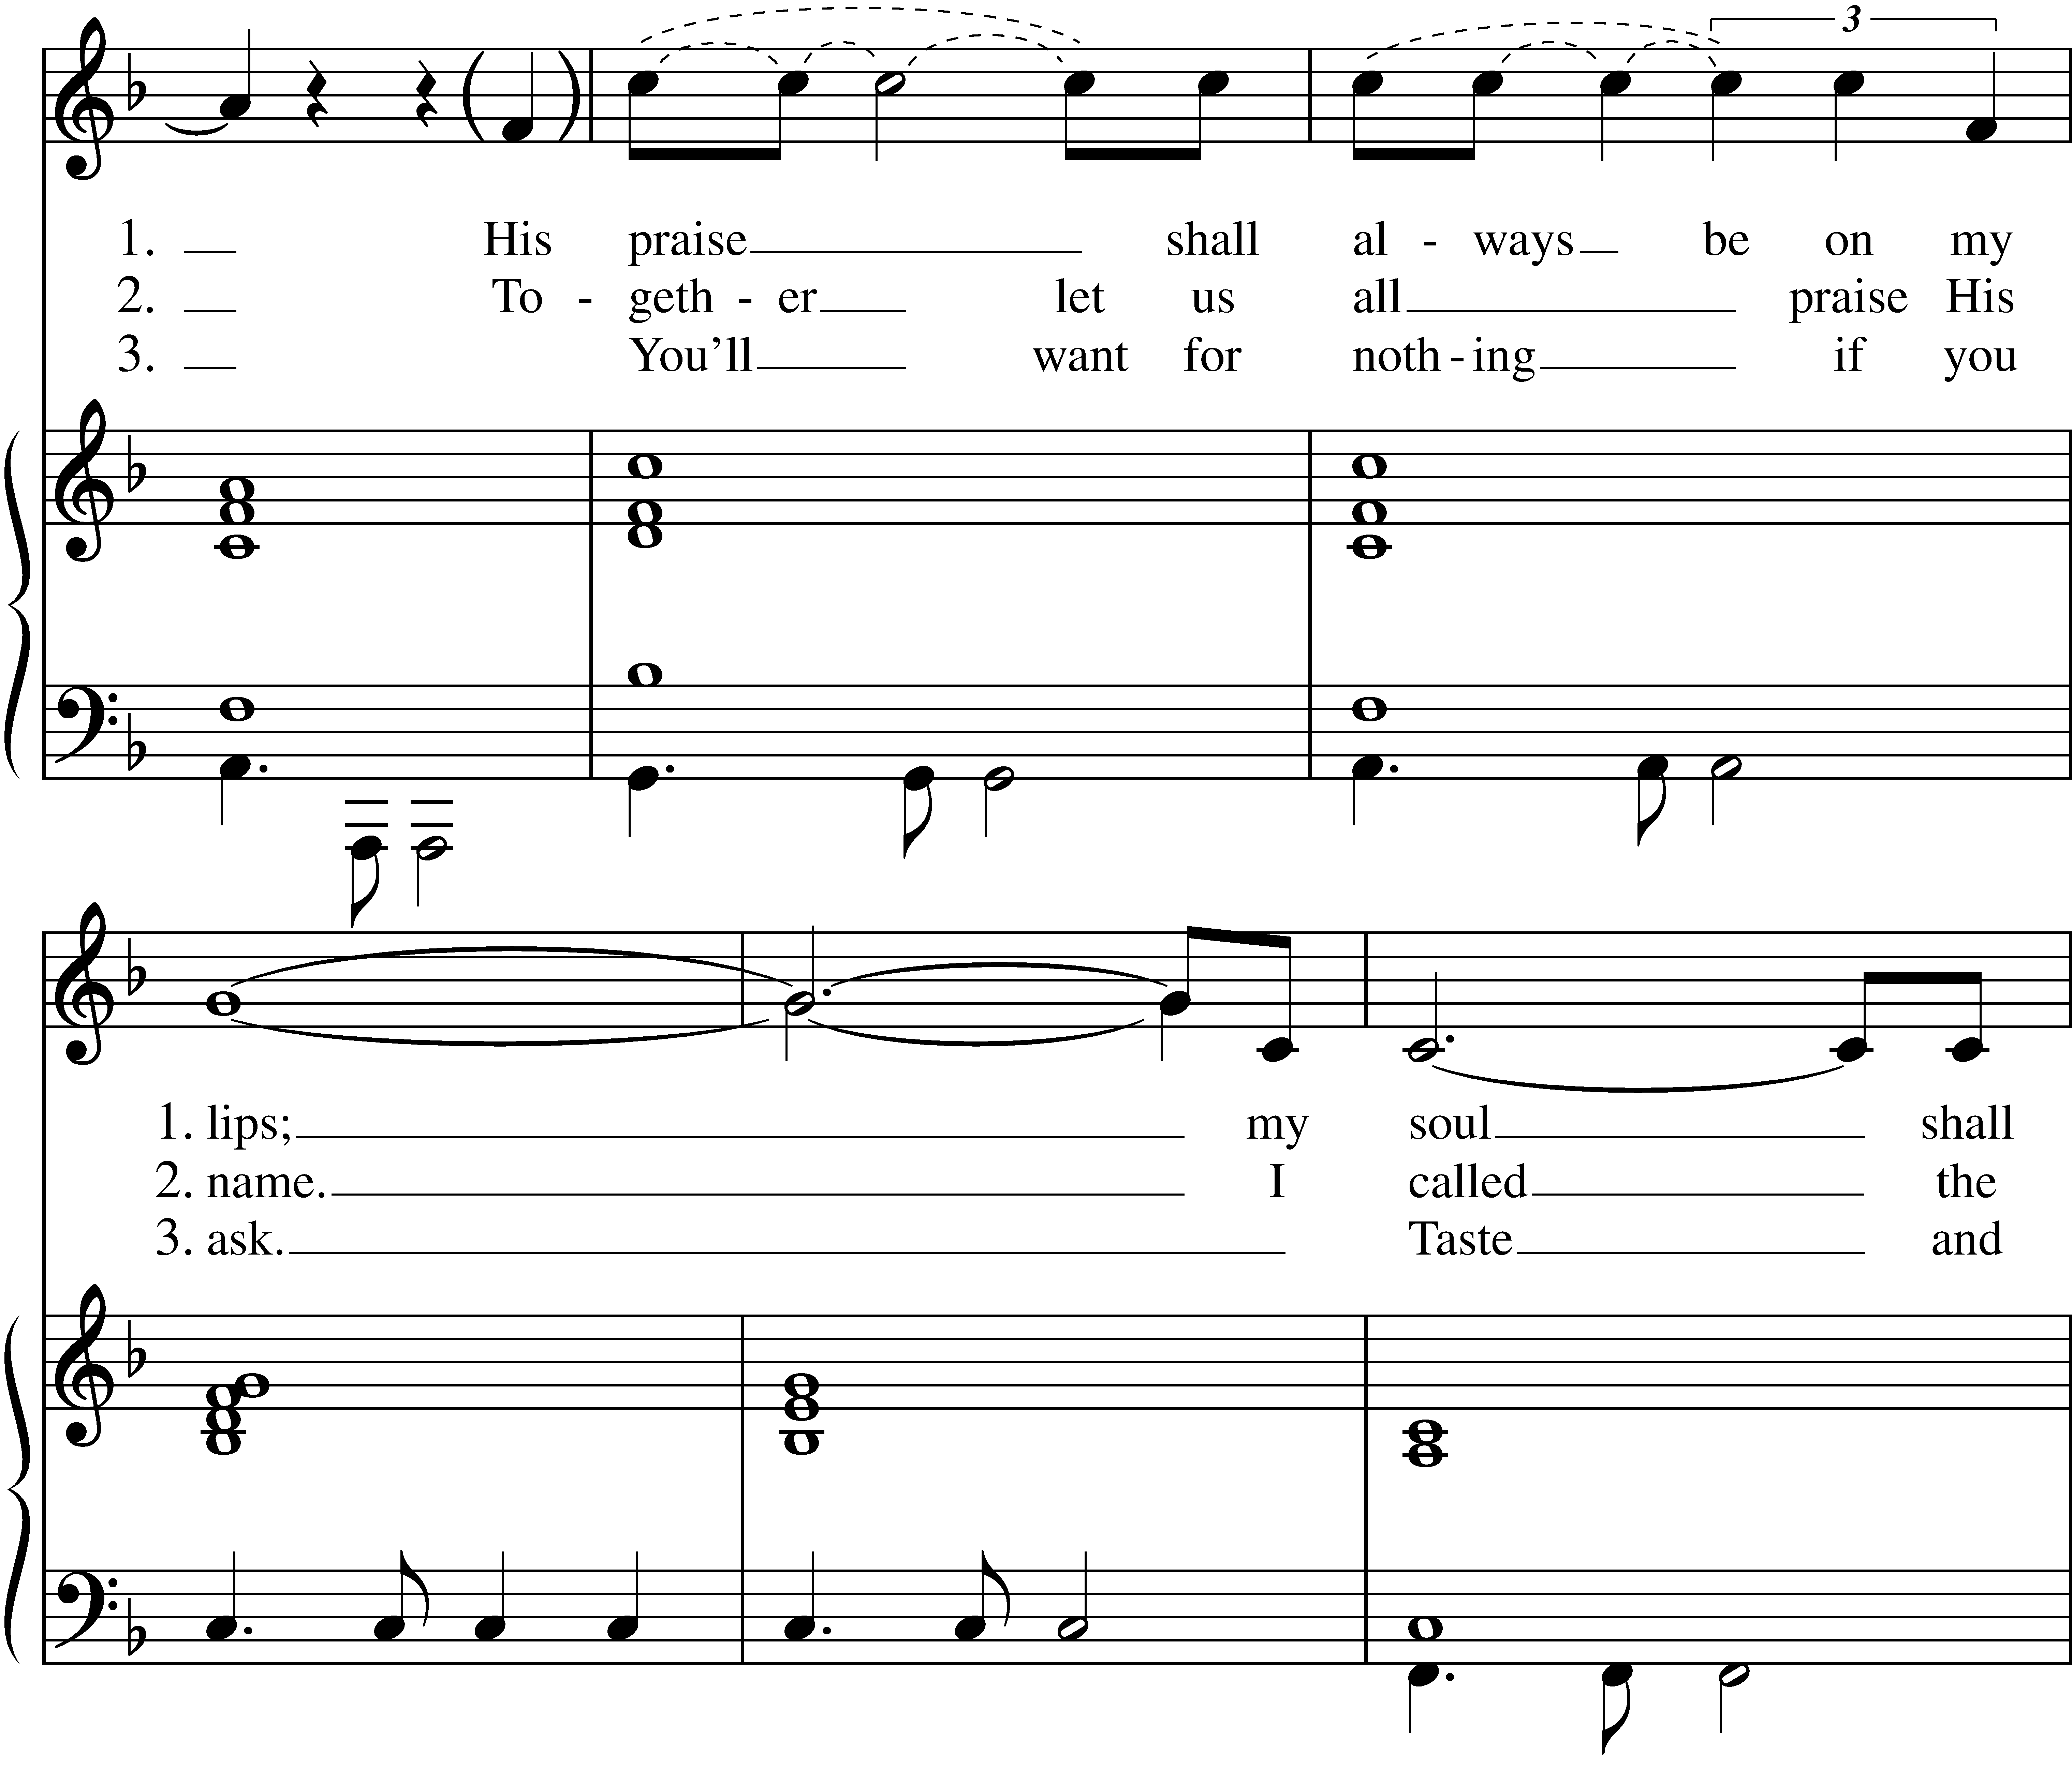



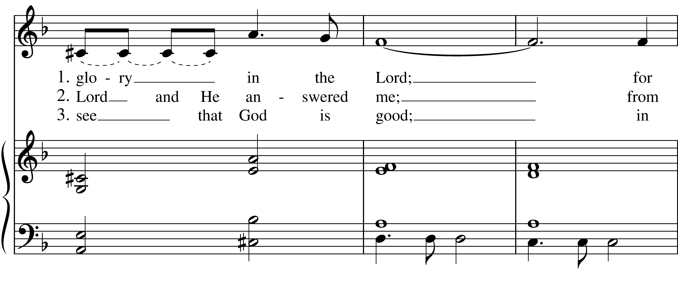

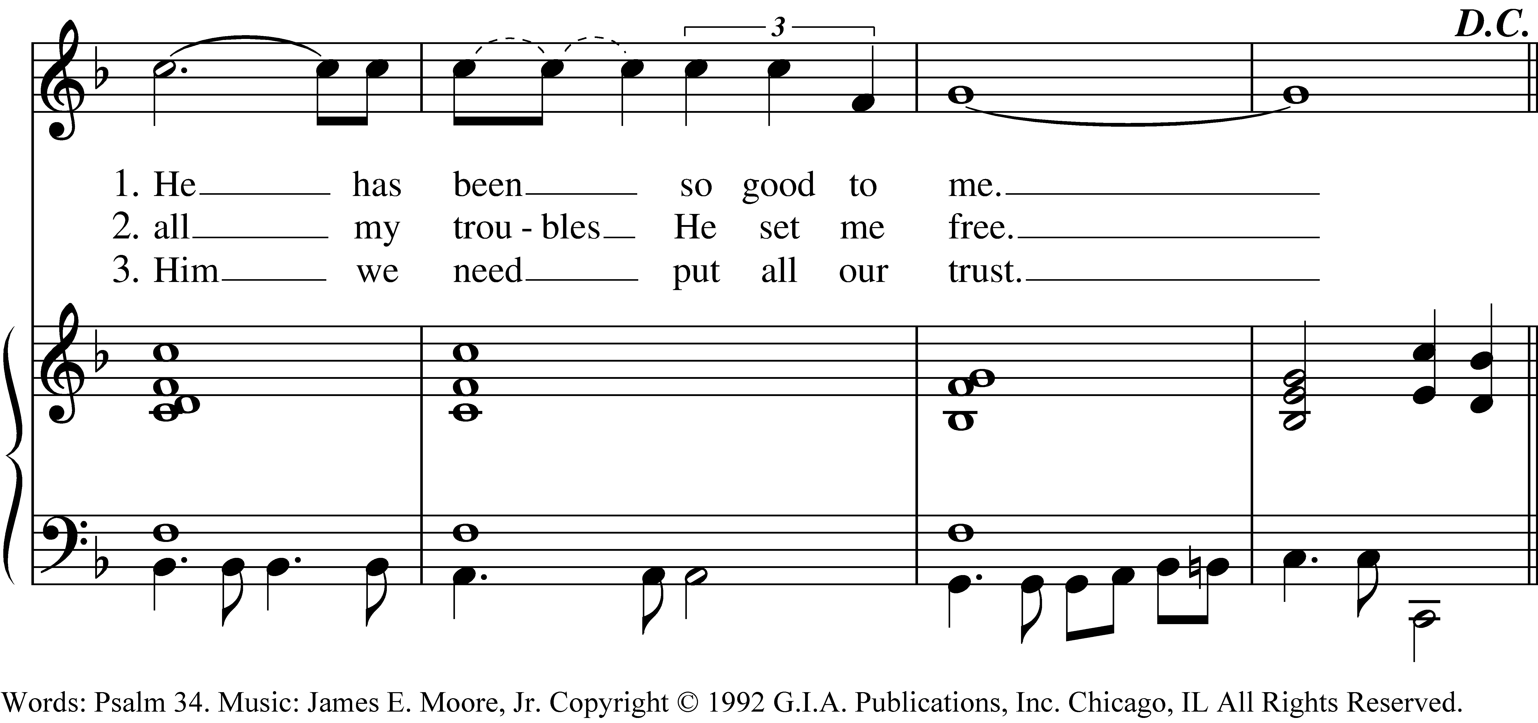

*Reprinted/streamed with permission via One License and RiteSong. All rights reserved.*

**Eucharistic Prayer**

*Celebrant:* The Lord be with you.

**People: And also with you.**

*Celebrant:* Lift up your hearts.

**People: We lift them to the Lord.**

*Celebrant:* Let us give thanks to the Lord our God.

**People: It is right to give God thanks and praise.**

We praise you and we bless you, holy and gracious God, source of life abundant. From before time you made ready the creation. Your Spirit moved over the deep and brought all things into being: sun, moon, and stars; earth, winds, and waters; and every living thing. You made us in your image, and taught us to walk in your ways. But we rebelled against you, and wandered far away; and yet, as a mother cares for her children, you would not forget us. Time and again you called us to live in the fullness of your love. And so this day we join with Saints and Angels in the chorus of praise that rings through eternity, lifting our voices to magnify you as we say:

**Holy, Holy, Holy Lord, God of power and might, heaven and earth are full of your glory. Hosanna in the highest. Blessed is he who comes in the name of the Lord. Hosanna in the highest.**

Glory and honor and praise to you, holy and living God. To deliver us from the power of sin and death and to reveal the riches of your grace, you looked with favor upon Mary, your willing servant, that she might conceive and bear a son, Jesus the holy child of God. Living among us, Jesus loved us. He broke bread with outcasts and sinners, healed the sick, and proclaimed good news to the poor. He yearned to draw all the world to himself yet we were heedless of his call to walk in love. Then, the time came for him to complete upon the cross the sacrifice of his life, and to be glorified by you.

On the night before he died for us, Jesus was at table with his friends. He took bread, gave thanks to you,   
broke it, and gave it to them, and said: “Take, eat: This is my Body, which is given for you. Do this for the remembrance of me.” As supper was ending, Jesus took the cup of wine. Again, he gave thanks to you,   
gave it to them, and said: “Drink this, all of you: This is my Blood of the new Covenant, which is poured out for you and for all for the forgiveness of sins. Whenever you drink it, do this for the remembrance of me.”

Now gathered at your table, O God of all creation, and remembering Christ, crucified and risen,   
who was and is and is to come, we offer to you our gifts of bread and wine, and ourselves, a living sacrifice.

Pour out your Spirit upon these gifts that they may be the Body and Blood of Christ. Breathe your Spirit over the whole earth and make us your new creation, the Body of Christ given for the world you have made.

In the fullness of time bring us, with St. Bartholomew the Apostle on this his feast day, and all your saints, from every tribe and language and people and nation, to feast at the banquet prepared from the foundation of the world.

Through Christ and with Christ and in Christ, in the unity of the Holy Spirit, to you be honor, glory, and praise, for ever and ever. **AMEN.**

And now, as our Savior Christ has taught us, we are bold to say,

**Our Father who art in heaven, hallowed be thy Name, thy kingdom come, thy will be done, on earth as it is in in heaven. Give us this day our daily bread. And forgive us our trespasses as we forgive those who trespass against us. And lead us not into temptation but deliver us from evil. For thine is the kingdom, the power, and the glory, for ever and ever. Amen.**

**The Breaking of the Bread**

*Celebrant:* We break this bread to share in the Body of Christ.

**People: We who are many are one body, for we all share in the one bread.**

*Celebrant:* The Gifts of God for the People of God.

**A Prayer for Spiritual Communion:**

*Let us pray.* **We believe that you are truly present in the Holy Sacrament, and we pray you to come into our hearts, praying especially with those at home who cannot at this time receive communion. I unite myself with you and embrace you with all my heart, my soul, and my mind. Let nothing separate me from you; let me serve you in this life until, by your grace, I come to your glorious kingdom and unending peace. Amen.**

**Communion Instrumental**

**Prayer After Communion**

*Let us pray.* **God of abundance, you have fed us with the bread of life and cup of salvation; you have united us with Christ and one another; and you have made us one with all your people in heaven and on earth. Now send us forth in the power of your Spirit, that we may proclaim your redeeming love to the world and continue for ever in the risen life of Christ our Savior. Amen.**

**Blessing**

Live without fear: your Creator has made you holy, has always protected you, and loves you as a mother. Go in peace to follow the good road and may God’s blessing be with you always. Amen.

**Closing Hymn O bless the Lord, my soul**

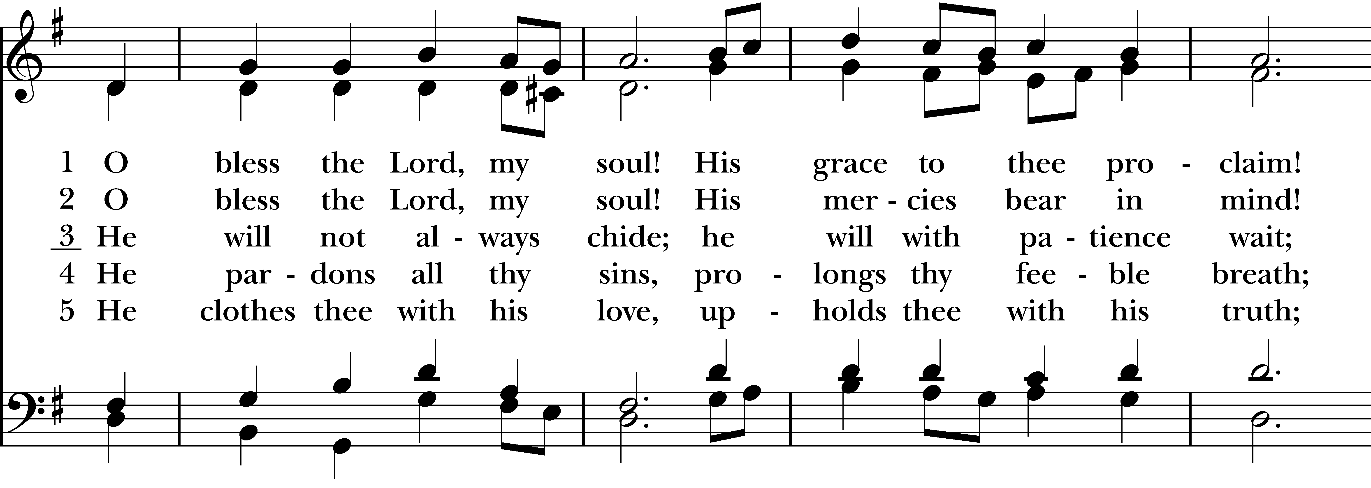  
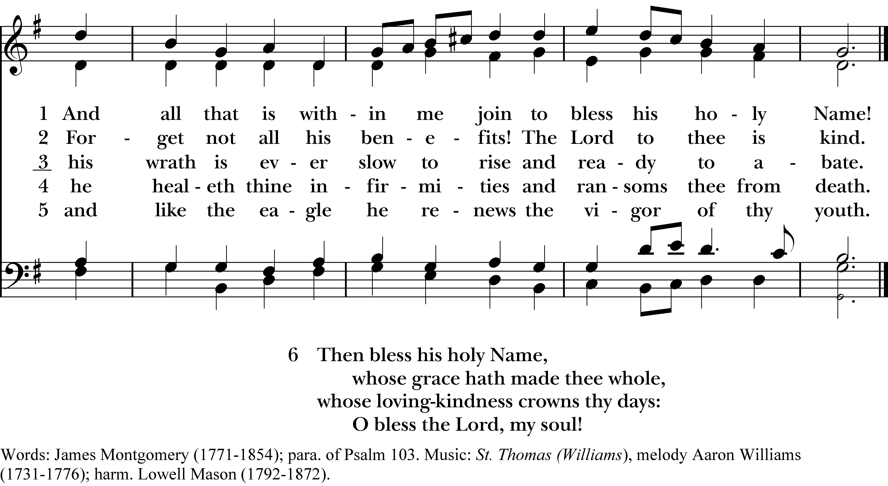

*Reprinted/streamed with permission via One License and RiteSong. All rights reserved.*

**Dismissal**

*Celebrant:* Go in peace to love and serve the Lord. Alleluia, alleluia.

**People: Thanks be to God. Alleluia, alleluia.**

**Announcements for August 24th**

**COFFEE HOUR:** Please consider signing up for an upcoming Sunday.

**SCHEDULE:** Next week (8/31) is the last outdoor Sunday service at 9 am. The following week, **Sunday 9/7,** we will resume our regular indoor services at **9:30 am.**

**GIFT CARDS** to gas stations/grocery stores are always needed. Thank you for your continued generosity.

**UPCOMING WORSHIP DATES**

**Sunday, 8/31 @ 9:00 am: Morning Prayer (Andy Hathaway)**

**\*Sunday, 9/7 @ 9:30 am: Eucharist (Rev. Isabel Geller)**

**Sunday, 9/14 @ 9:30 am: Morning Prayer (Deborah Swann)**

**Sunday, 9/21 @ 9:30 am: Eucharist & Family Service (Rev. Katy Piazza)**

**Christ Church – Parish Office:**

(203) 268-3569 | christchurcheastonct@gmail.com

59 Church Road, Easton, CT | [www.christchurcheaston.com](http://www.christchurcheaston.com)

Senior Warden: Vicki MarkAnthony | Parish Administrator: Tracy Carlucci

Vestry: Jim Swann, Jr. Warden; Bob Ellwanger, Treasurer; Peg Ellwanger, Clerk

Vestry Members: Russ Bailas, Amy Bailas, Marina Philips, Claire Wilkes

Diocesan Delegates: Diane McCann, Bob Ellwanger

Diocesan Alternate Delegate: Deborah Swann

Music Minister: Tracy Carlucci

Choir Members: Amy Strachan, Andy Verrocchi, Bob Ellwanger, David McCann,

Diane McCann, Marina Philips, Katie Tressler, Vicki MarkAnthony

Christ Church Nursery School: Maggie Supple, Director | [www.ccnseaston.com](http://www.ccnseaston.com)