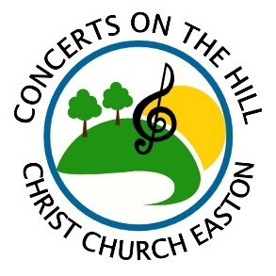
Sponsorship Form for 2026 Concert Series
Please submit this form and payment as soon as possible.
Questions? Call 203-268-3569 or email concertsonthehilleaston@gmail.com.

NAME OF BUSINESS or INDIVIDUAL (as it should appear on all acknowledgements):
___________________________________________________________________________________________________________
ADDRESS: ___________________________________________________________ PHONE: ______________________________
EMAIL: ____________________________________________ WEBSITE: ______________________________________________
For business sponsorships: Authorized by (please print name): ________________________________________________________
DESCRIPTION of business (1-2 sentences - for Facebook posts): ______________________________________________________
___________________________________________________________________________________________________________
___________________________________________________________________________________________________________
Choose from the following sponsorship levels:
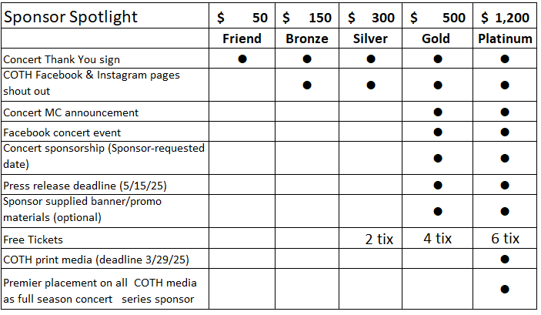

Please choose your level: ________________ If Gold, which concert date?____________ Do you want tickets?__________
Instructions:
Mail this form and a check made out to “Christ Church”, Memo CONCERTS to: 59 Church Rd, Easton, CT 06612.
Or email this form to concertsonthehilleaston@gmail.com and pay online at www.christchurcheaston.com (click “Donate” button).

All sponsorship payments are a tax-deductible donation to the amount allowable by law.
A receipt will be mailed to the address you provide above.

About Concerts on the Hill:
Set on the scenic grounds of Christ Church Easton, this outdoor concert series has quickly become a local community favorite since its inaugural season in 2017, averaging 120 people at each concert. 2026 season dates: 6/21, 6/28, 7/5, 7/12, 7/19, 7/26. Gates: 5:30 pm. Music: 6:00-8:00 pm. Craft beer/wine, food trucks, or BYOB & picnic! Rain dates TBD. $12 adults, $8 seniors, kids 18 & under free. More Info: www.facebook.com/concertsonthehilleaston

