Sunday, February 8th, 2026: The Fifth Sunday after the Epiphany
Rev. Sandy Belcher, Supply Priest
Christ Church Easton

Celebrant: As we gather to worship, let us recognize that we gather on the ancestral lands and traditional territory of the (Aspetuck River Valley dwelling) Paugussett people.

Celebrant: Please stand as you are able and sing together our Processional Hymn, #7, “Christ, whose glory fills the skies.”

Processional Hymn “Christ, whose glory fills the skies” Hymnal #7

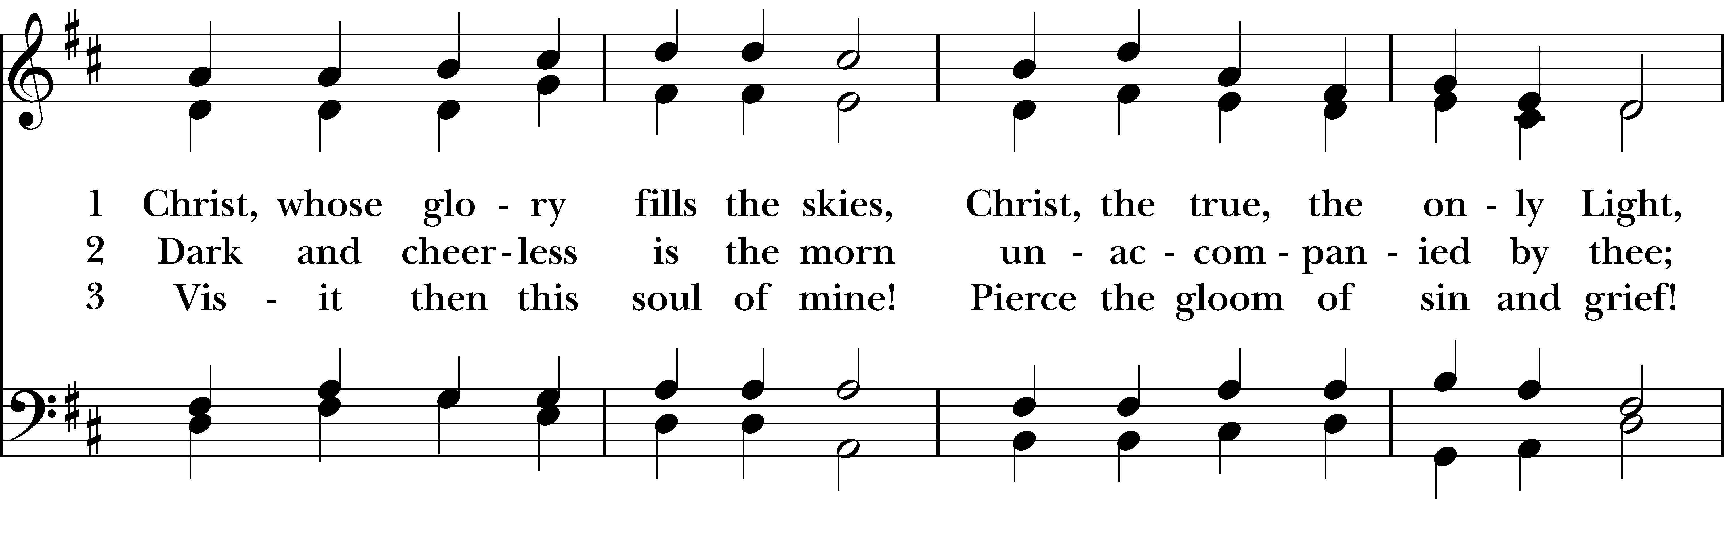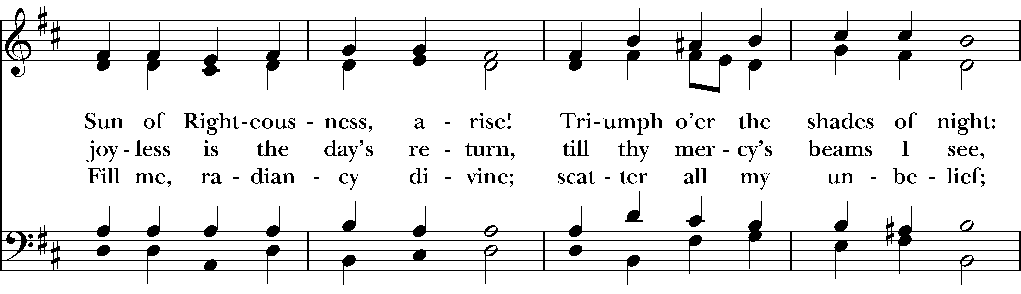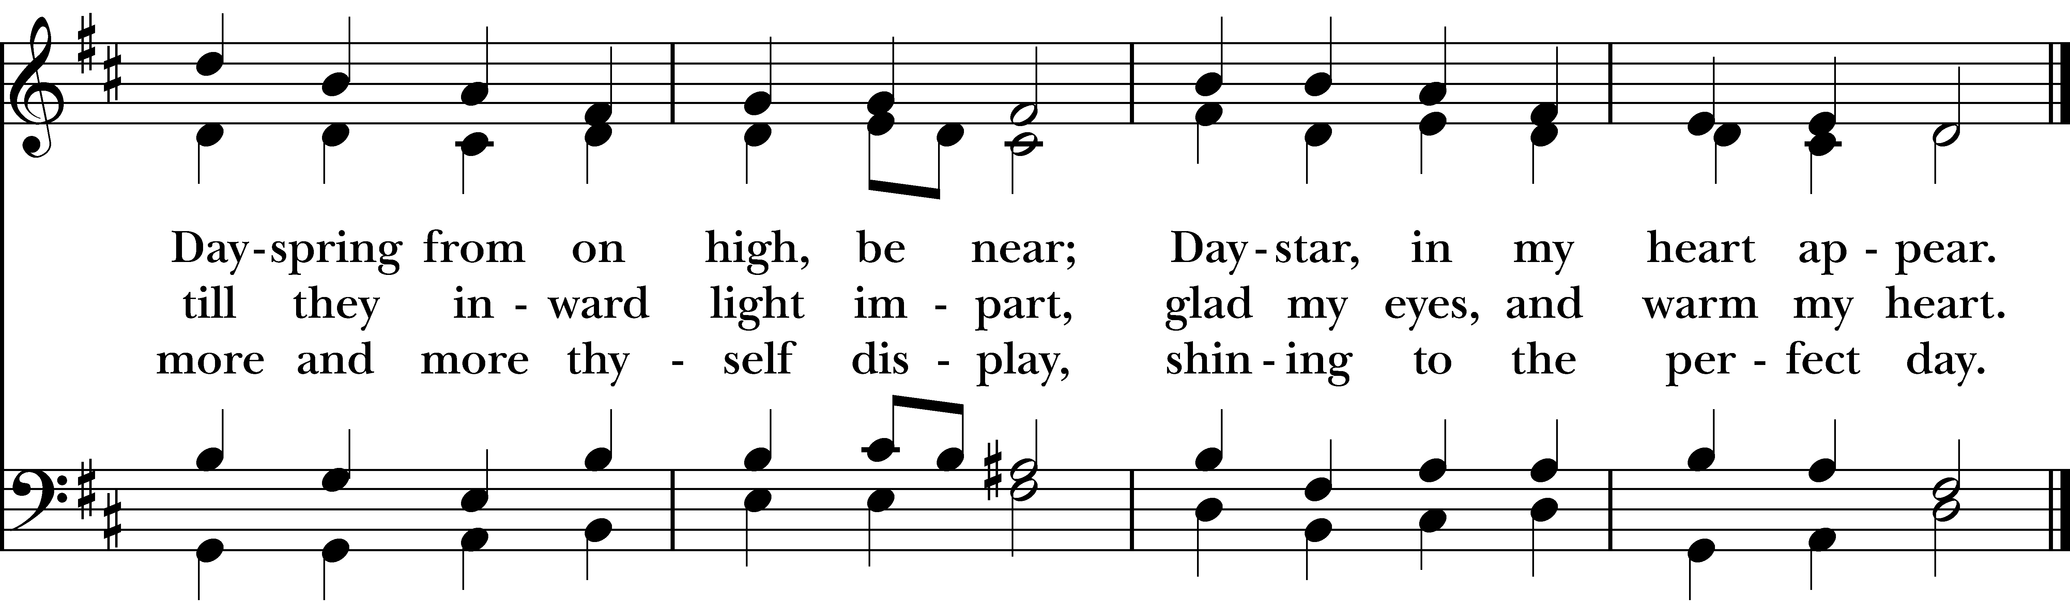
Reprinted/streamed with permission via One License and RiteSong. All rights reserved.
The Word of God BCP p. 355
Celebrant: Please turn to page 355 in the Book of Common Prayer.

Celebrant: Blessed be God: Father, Son, and Holy Spirit.
People: And blessed be his kingdom, now and for ever. Amen.

The Collect for Purity
Almighty God, to you all hearts are open, all desires known, and from you no secrets are hid: Cleanse the thoughts of our hearts by the inspiration of your Holy Spirit, that we may perfectly love you, and worthily magnify your holy Name; through Christ our Lord. Amen.

Gloria “The Lord is My Light” Pew Card

Collect of the Day

Celebrant: The Lord be with you.
People: And also with you.

Let us pray. Set us free, O God, from the bondage of our sins, and give us the liberty of that abundant life which you have made known to us in your Son our Savior Jesus Christ; who lives and reigns with you, in the unity of the Holy Spirit, one God, now and for ever. Amen.

The First Reading Isaiah 58:1-9a,(9b-12)

A Reading from the Book of the Prophet Isaiah.

Shout out, do not hold back! Lift up your voice like a trumpet! Announce to my people their rebellion, to the house of Jacob their sins. Yet day after day they seek me and delight to know my ways, as if they were a nation that practiced righteousness and did not forsake the ordinance of their God; they ask of me righteous judgments, they delight to draw near to God.

“Why do we fast, but you do not see? Why humble ourselves, but you do not notice?” Look, you serve your own interest on your fast day, and oppress all your workers. Look, you fast only to quarrel and to fight and to strike with a wicked fist. Such fasting as you do today will not make your voice heard on high. Is such the fast that I choose, a day to humble oneself? Is it to bow down the head like a bulrush, and to lie in sackcloth and ashes? Will you call this a fast, a day acceptable to the LORD? Is not this the fast that I choose: to loose the bonds of injustice, to undo the thongs of the yoke, to let the oppressed go free, and to break every yoke? Is it not to share your bread with the hungry, and bring the homeless poor into your house; when you see the naked, to cover them, and not to hide yourself from your own kin?

Then your light shall break forth like the dawn, and your healing shall spring up quickly; your vindicator shall go before you, the glory of the LORD shall be your rear guard. Then you shall call, and the LORD will answer; you shall cry for help, and he will say, Here I am. If you remove the yoke from among you, the pointing of the finger, the speaking of evil, [Then you shall call, and the LORD will answer; you shall cry for help, and he will say, Here I am. If you remove the yoke from among you, the pointing of the finger, the speaking of evil, if you offer your food to the hungry and satisfy the needs of the afflicted, then your light shall rise in the darkness and your gloom be like the noonday. The LORD will guide you continually, and satisfy your needs in parched places, and make your bones strong; and you shall be like a watered garden, like a spring of water, whose waters never fail. Your ancient ruins shall be rebuilt; you shall raise up the foundations of many generations; you shall be called the repairer of the breach, the restorer of streets to live in.]

The Word of the Lord.
Thanks be to God.

The Psalm Psalm 112:1-9,(10)

Hallelujah! Happy are they who fear the Lord *
and have great delight in his commandments!
Their descendants will be mighty in the land; *
the generation of the upright will be blessed.
Wealth and riches will be in their house, *
and their righteousness will last for ever.
Light shines in the darkness for the upright; *
the righteous are merciful and full of compassion.
It is good for them to be generous in lending *
and to manage their affairs with justice.
For they will never be shaken; *
the righteous will be kept in everlasting remembrance.
They will not be afraid of any evil rumors; *
their heart is right; they put their trust in the Lord.
Their heart is established and will not shrink, *
until they see their desire upon their enemies.
They have given freely to the poor, *
and their righteousness stands fast for ever; they will hold up their head with honor.
[The wicked will see it and be angry; they will gnash their teeth and pine away; *
the desires of the wicked will perish.]

The Second Reading 1 Corinthians 2:1-12,(13-16)
A Reading from the First Letter to the Corinthians.

When I came to you, brothers and sisters, I did not come proclaiming the mystery of God to you in lofty words or wisdom. For I decided to know nothing among you except Jesus Christ, and him crucified. And I came to you in weakness and in fear and in much trembling. My speech and my proclamation were not with plausible words of wisdom, but with a demonstration of the Spirit and of power, so that your faith might rest not on human wisdom but on the power of God.

Yet among the mature we do speak wisdom, though it is not a wisdom of this age or of the rulers of this age, who are doomed to perish. But we speak God’s wisdom, secret and hidden, which God decreed before the ages for our glory. None of the rulers of this age understood this; for if they had, they would not have crucified the Lord of glory. But, as it is written, “What no eye has seen, nor ear heard, nor the human heart conceived, what God has prepared for those who love him”— these things God has revealed to us through the Spirit; for the Spirit searches everything, even the depths of God. For what human being knows what is truly human except the human spirit that is within? So also no one comprehends what is truly God’s except the Spirit of God. Now we have received not the spirit of the world, but the Spirit that is from God, so that we may understand the gifts bestowed on us by God.[ And we speak of these things in words not taught by human wisdom but taught by the Spirit, interpreting spiritual things to those who are spiritual. Those who are unspiritual do not receive the gifts of God’s Spirit, for they are foolishness to them, and they are unable to understand them because they are spiritually discerned. Those who are spiritual discern all things, and they are themselves subject to no one else’s scrutiny. “For who has known the mind of the Lord so as to instruct him?” But we have the mind of Christ.]

The Word of the Lord
Thanks be to God.

Celebrant: Please stand as you are able and sing together hymn #707 “Take my life and let it be.” We will sing verse before the Gospel and verse 2 after.

Gospel Hymn “Take my life and let it be” Hymnal #707
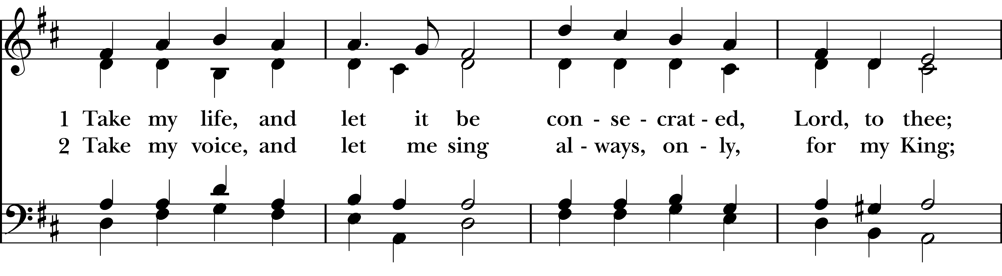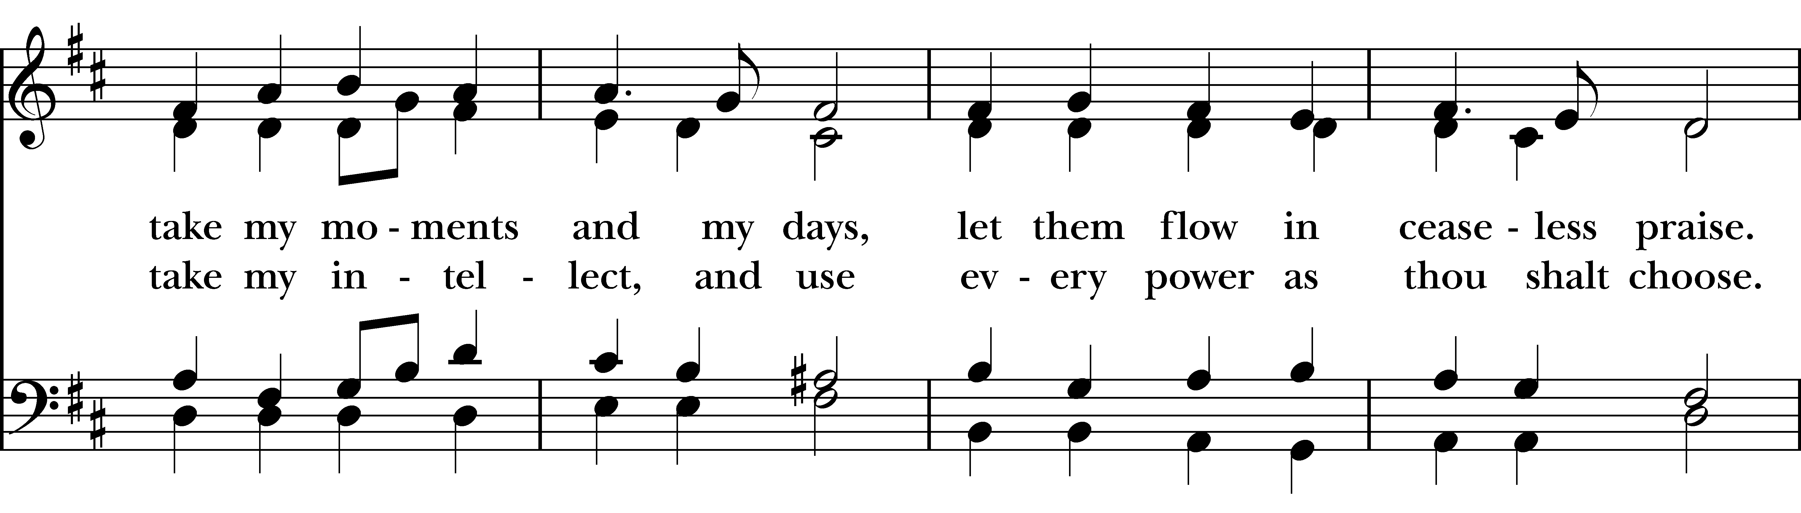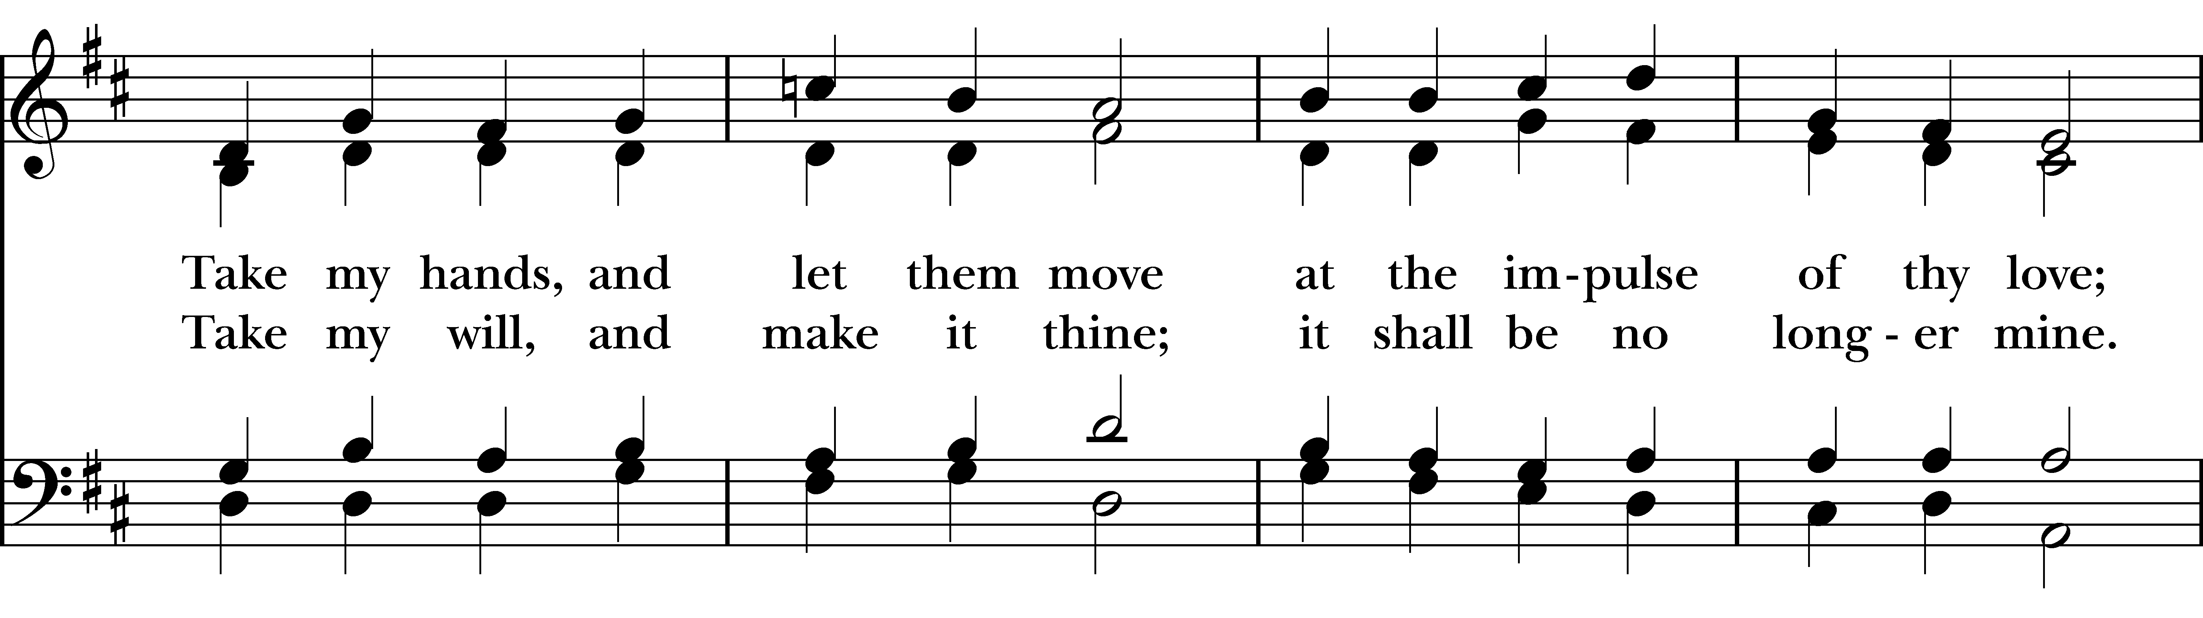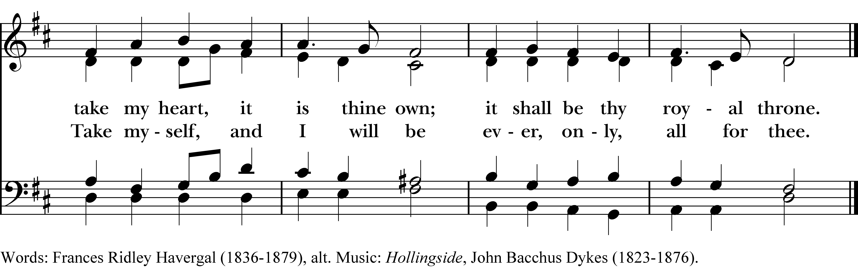
Reprinted/streamed with permission via One License and/or RiteSong. All rights reserved.
The Gospel Matthew 5:13-20

The Holy Gospel of our Lord Jesus Christ, according to Matthew.
Glory to you, Lord Christ.

“You are the salt of the earth; but if salt has lost its taste, how can its saltiness be restored? It is no longer good for anything, but is thrown out and trampled under foot. “You are the light of the world. A city built on a hill cannot be hid. No one after lighting a lamp puts it under the bushel basket, but on the lampstand, and it gives light to all in the house. In the same way, let your light shine before others, so that they may see your good works and give glory to your Father in heaven.

“Do not think that I have come to abolish the law or the prophets; I have come not to abolish but to fulfill. For truly I tell you, until heaven and earth pass away, not one letter, not one stroke of a letter, will pass from the law until all is accomplished. Therefore, whoever breaks one of the least of these commandments, and teaches others to do the same, will be called least in the kingdom of heaven; but whoever does them and teaches them will be called great in the kingdom of heaven. For I tell you, unless your righteousness exceeds that of the scribes and Pharisees, you will never enter the kingdom of heaven.

The Gospel of the Lord.
Praise to you, Lord Christ.

Reflection Molly Adams

The Nicene Creed BCP p. 358
Celebrant: Please stand as you are able for The Nicene Creed, page 358 of the Book of Common Prayer.

We believe in one God, the Father, the Almighty, maker of heaven and earth, of all that is, seen and unseen. We believe in one Lord, Jesus Christ, the only Son of God, eternally begotten of the Father, God from God, Light from Light, true God from true God, begotten, not made, of one Being with the Father. Through him all things were made.

For us and for our salvation, he came down from heaven: by the power of the Holy Spirit he became incarnate from the Virgin Mary, and was made man. For our sake he was crucified under Pontius Pilate; he suffered death and was buried. On the third day he rose again in accordance with the Scriptures; he ascended into heaven and is seated at the right hand of the Father. He will come again in glory to judge the living and the dead, and his kingdom will have no end.

We believe in the Holy Spirit, the Lord, the giver of life, who proceeds from the Father and the Son. With the Father and the Son he is worshiped and glorified. He has spoken through the Prophets. We believe in one holy catholic and apostolic Church. We acknowledge one baptism for the forgiveness of sins. We look for the resurrection of the dead, and the life of the world to come. Amen.

Prayers of the People: Form VI BCP p. 392
Subdeacon: The Prayers of the People are Form VI, found on page 392 in the Book of Common Prayer.

In Peace, we pray to you Lord God. For all people in their daily life and work; For our families, friends, and neighbors, and for those who are alone.

For this community, the nation, and the world; For all who work for justice, freedom, and peace.

For the just and proper use of your creation; For the victims of hunger, fear, injustice, and oppression.

For all who are in danger, sorrow, or any kind of trouble; For those who minister to the sick, the friendless, and the needy.
For the peace and unity of the Church of God; For all who proclaim the Gospel, and all who seek the Truth.
For Sean our Presiding Bishop, and Jeffrey and Laura our Bishops; and for all bishops and other ministers; For all who serve God in his Church.
For the special needs and concerns of this congregation, including those on our parish prayer list … Hear us, Lord; For your mercy is great.
We will exalt you, O God our King; And praise your Name for ever and ever.
We pray for all who have died that they may have a place in your eternal kingdom. Lord, let your loving-kindness be upon them; Who put their trust in you.
We thank you, Lord, for all the blessings of this life. Amen.
Celebrant: Heavenly Father, you have promised to hear what we ask in the Name of your Son: Accept and fulfill our petitions, we pray, not as we ask in our ignorance, nor as we deserve in our sinfulness, but as you know and love us in your Son Jesus Christ our Lord. Amen.

The Confession of Sin BCP p. 360
Celebrant: Turning now to page 360 in the Book of Common Prayer, let us confess our sins to God.

Most merciful God, we confess that we have sinned against you in thought, word, and deed,
by what we have done, and by what we have left undone. We have not loved you with our whole heart; we have not loved our neighbors as ourselves. We are truly sorry and we humbly repent. For the sake of our Savior Jesus Christ, have mercy on us and forgive us; that we may delight in your will, and walk in your ways, to the glory of your Name. Amen.

Almighty God have mercy on you, forgive you all your sins through our Lord Jesus Christ, strengthen you in all goodness, and by the power of the Holy Spirit keep you in eternal life. Amen.

The Peace
Celebrant: Please stand for The Peace.

Celebrant: The peace of the Lord be always with you.
People: And also with you.

Announcements
The Holy Communion

Walk in love, as Christ loved us and gave himself for us, an offering and sacrifice to God. Ephesians 5:2

Offertory Anthem Christ Church Choir

Eucharistic Prayer B BCP p. 367
Celebrant: Please stand as you are able and turn to page 367 in the Book of Common Prayer.

Celebrant: The Lord be with you.
People: And also with you.
Celebrant: Lift up your hearts.
People: We lift them to the Lord.
Celebrant: Let us give thanks to the Lord our God.
People: It is right to give him thanks and praise.

It is right, and a good and joyful thing, always and everywhere to give thanks to you, Father Almighty, Creator of heaven and earth.

For by water and the Holy Spirit you have made us a new people in Jesus Christ our Lord, to show forth your glory in all the world.

Therefore we praise you, joining our voices with Angels and Archangels and with all the company of heaven, who for ever sing this hymn to proclaim the glory of your Name:

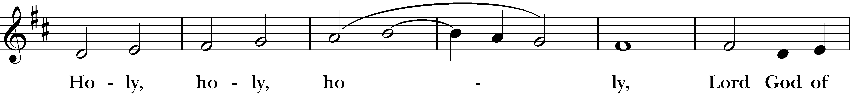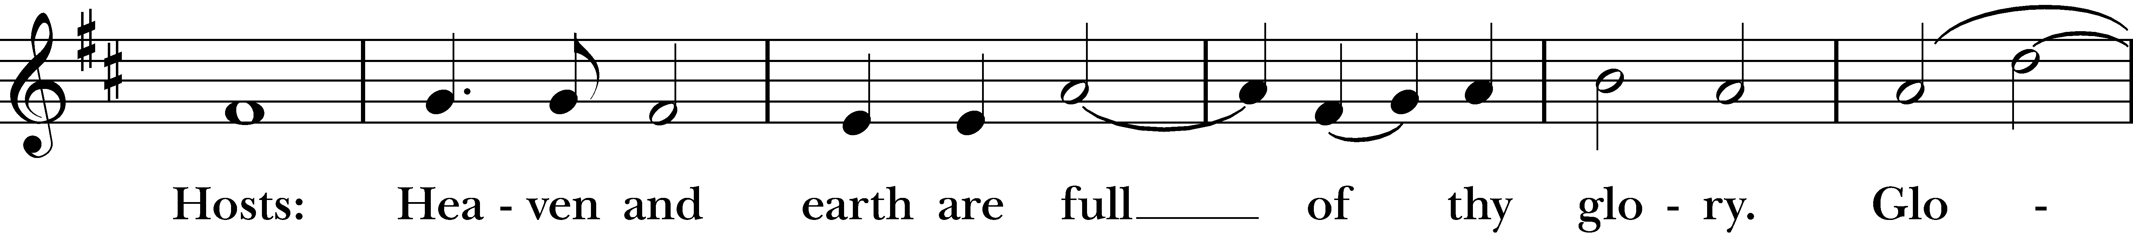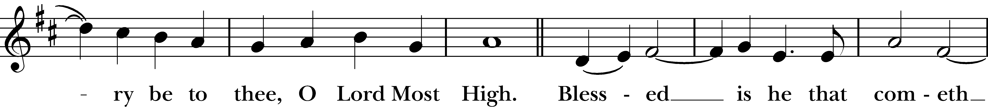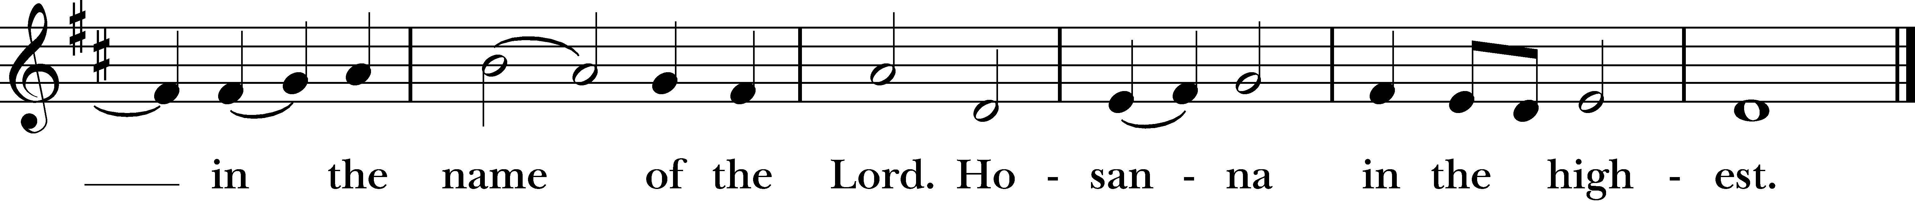
Reprinted/streamed with permission via One License and/or RiteSong. All rights reserved.
We give thanks to you, O God, for the goodness and love which you have made known to us in creation; in the calling of Israel to be your people; in your Word spoken through the prophets; and above all in the Word made flesh, Jesus, your Son. For in these last days you sent him to be incarnate from the Virgin Mary, to be the Savior and Redeemer of the world. In him, you have delivered us from evil, and made us worthy to stand before you. In him, you have brought us out of error into truth, out of sin into righteousness, out of death into life.

On the night before he died for us, our Lord Jesus Christ took bread; and when he had given thanks to you, he broke it, and gave it to his disciples, and said, “Take, eat: This is my Body, which is given for you. Do this for the remembrance of me.”

After supper he took the cup of wine; and when he had given thanks, he gave it to them, and said, “Drink this, all of you: This is my Blood of the new Covenant, which is shed for you and for many for the forgiveness of sins. Whenever you drink it, do this for the remembrance of me.”

Fraction Anthem (sung): “The Bread which we break is the sharing of the body of Christ” (3x’s)

And now, as our Savior Christ has taught us, we are bold to say,

Our Father who art in heaven, hallowed be thy Name, thy kingdom come, thy will be done, on earth as it is in in heaven. Give us this day our daily bread. And forgive us our trespasses as we forgive those who trespass against us. And lead us not into temptation but deliver us from evil. For thine is the kingdom, the power, and the glory, for ever and ever. Amen.

The Breaking of the Bread

Celebrant: Christ our Passover is sacrificed for us.
People: Therefore let us keep the feast.
Celebrant: The Gifts of God for the People of God.

A Prayer for Spiritual Communion:

Let us pray. We believe that you are truly present in the Holy Sacrament, and we pray you to come into our hearts, praying especially with those at home who cannot at this time receive communion. I unite myself with you and embrace you with all my heart, my soul, and my mind. Let nothing separate me from you; let me serve you in this life until, by your grace, I come to your glorious kingdom and unending peace. Amen.

Communion Hymn “Let us break bread together” Hymnal #325
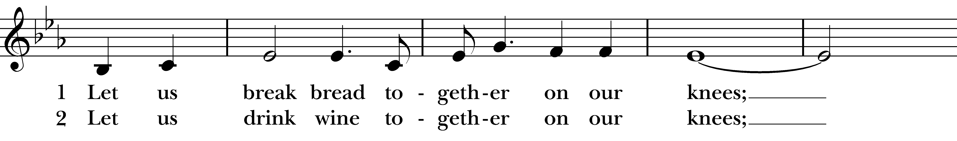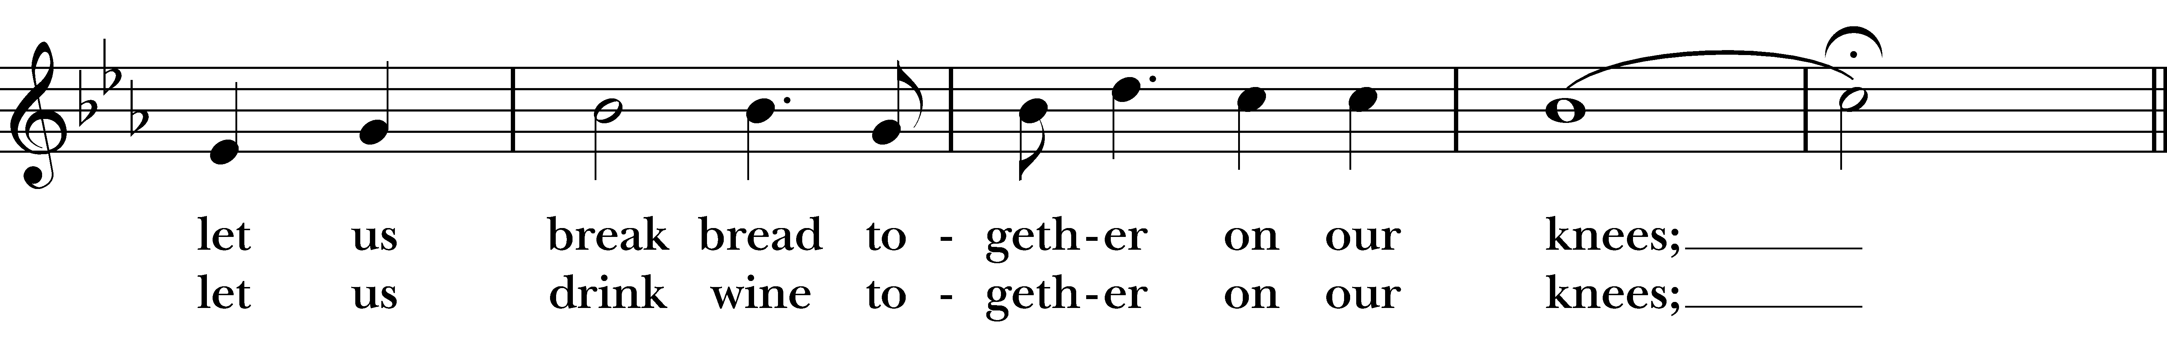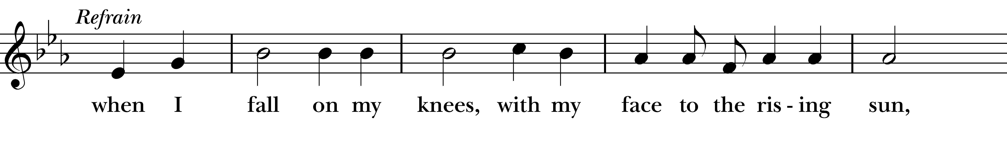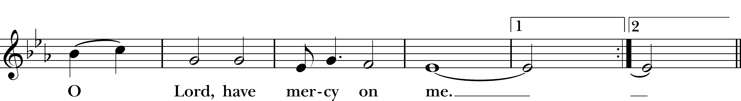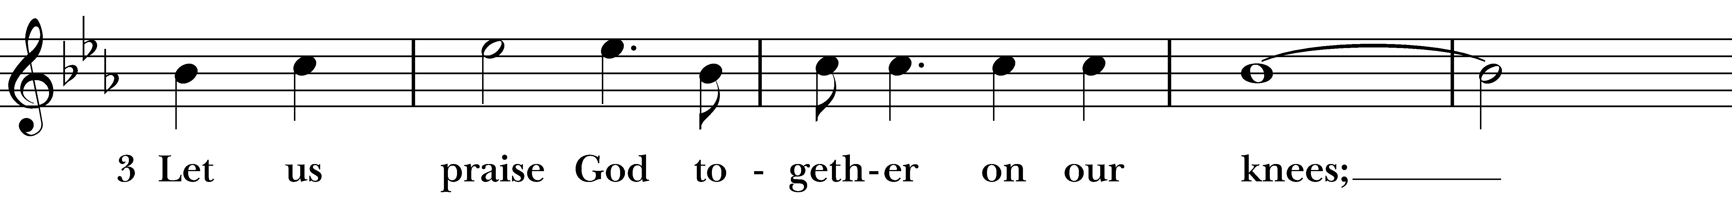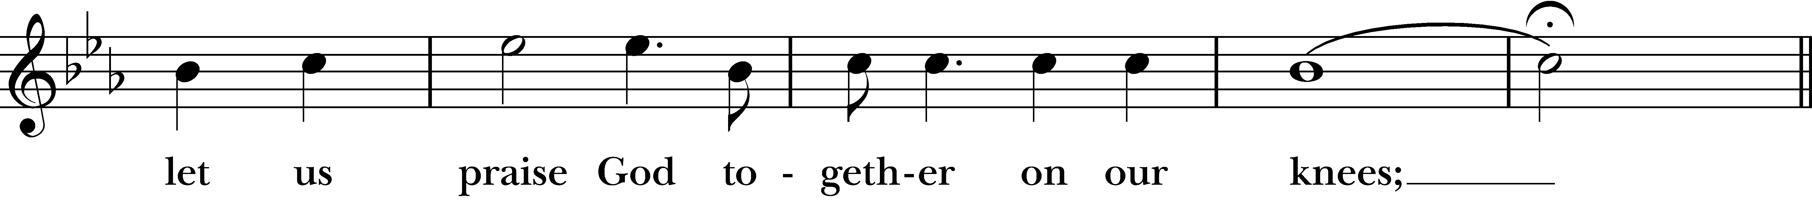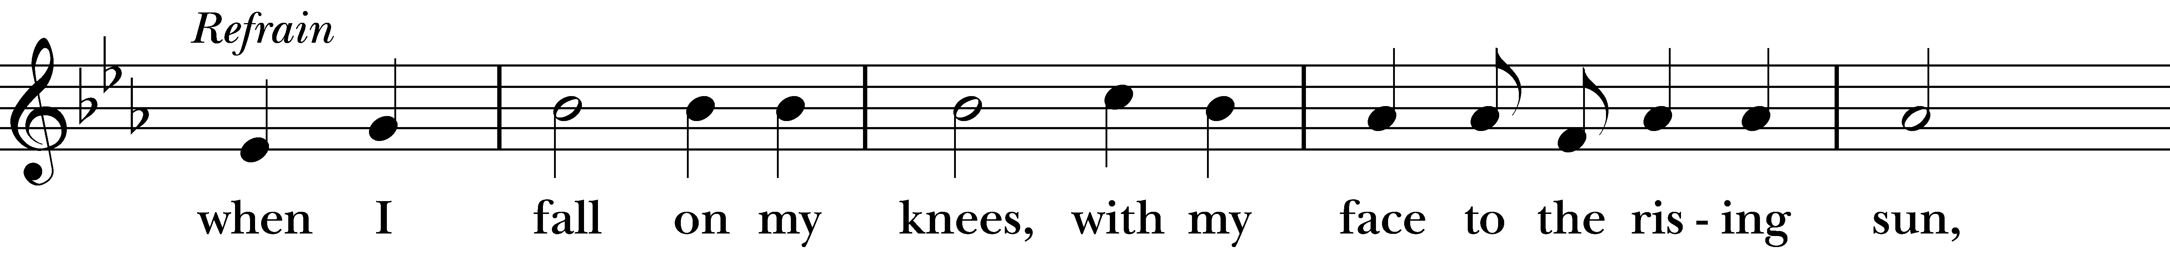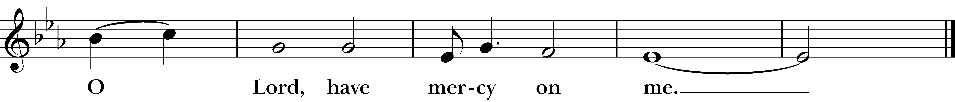
Reprinted/streamed with permission via RiteSong. All rights reserved.
Prayer After Communion BCP p. 365

Celebrant: Turning now to page 365 in the Book of Common Prayer, let us pray:

Eternal God, heavenly Father, you have graciously accepted us as living members of your Son our Savior Jesus Christ, and you have fed us with spiritual food in the Sacrament of his Body and Blood.
Send us now into the world in peace, and grant us strength and courage to love and serve you with gladness and singleness of heart; through Christ our Lord. Amen.
Blessing Rev. Sandy

Celebrant: Please stand as you are able for our Recessional Hymn, “Tis the gift to be simple,” #554.

Recessional Hymn “Be thou my vision” Hymnal #488

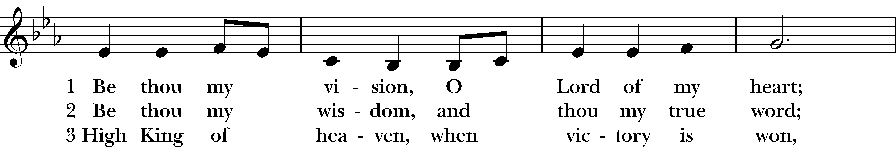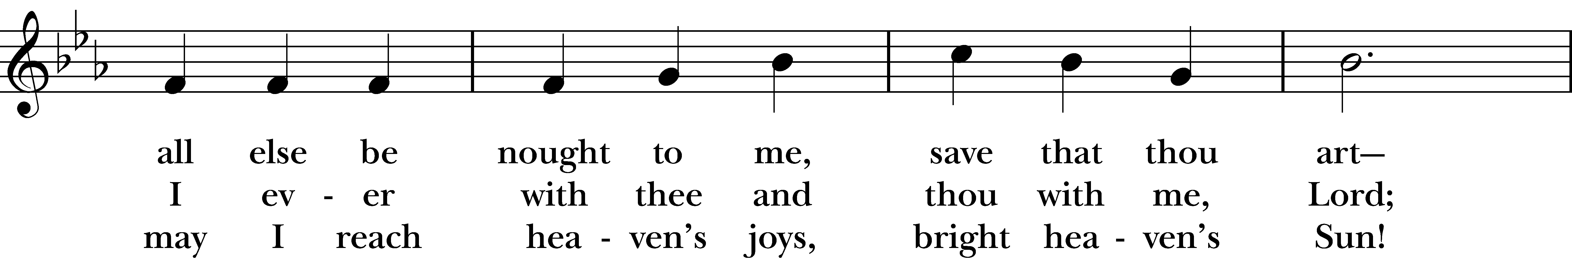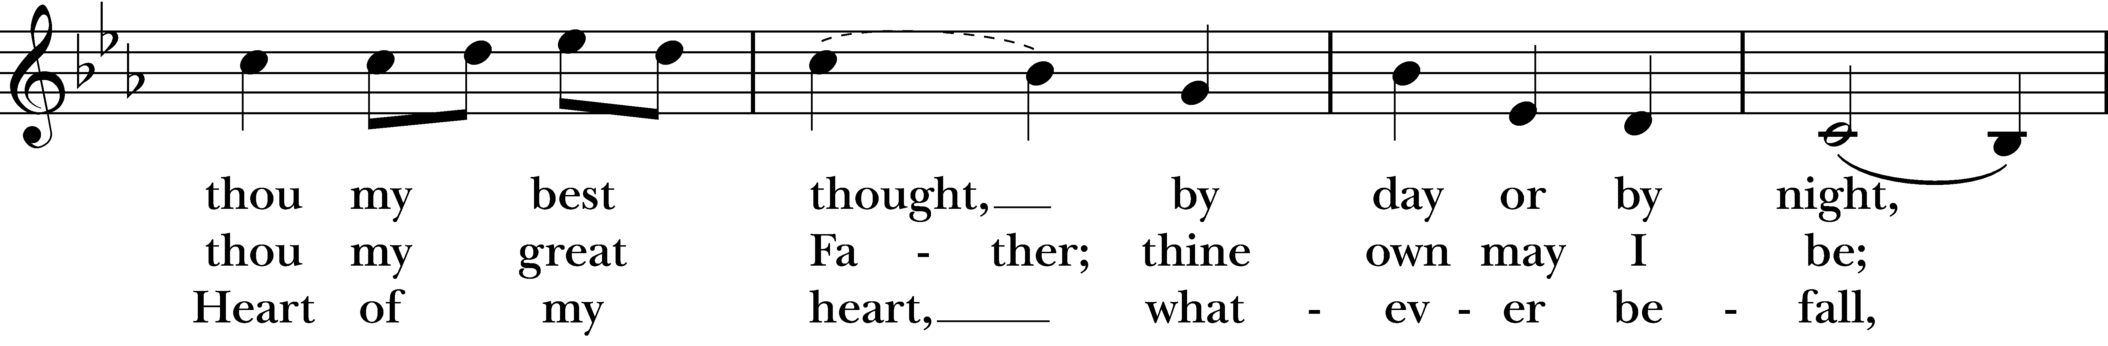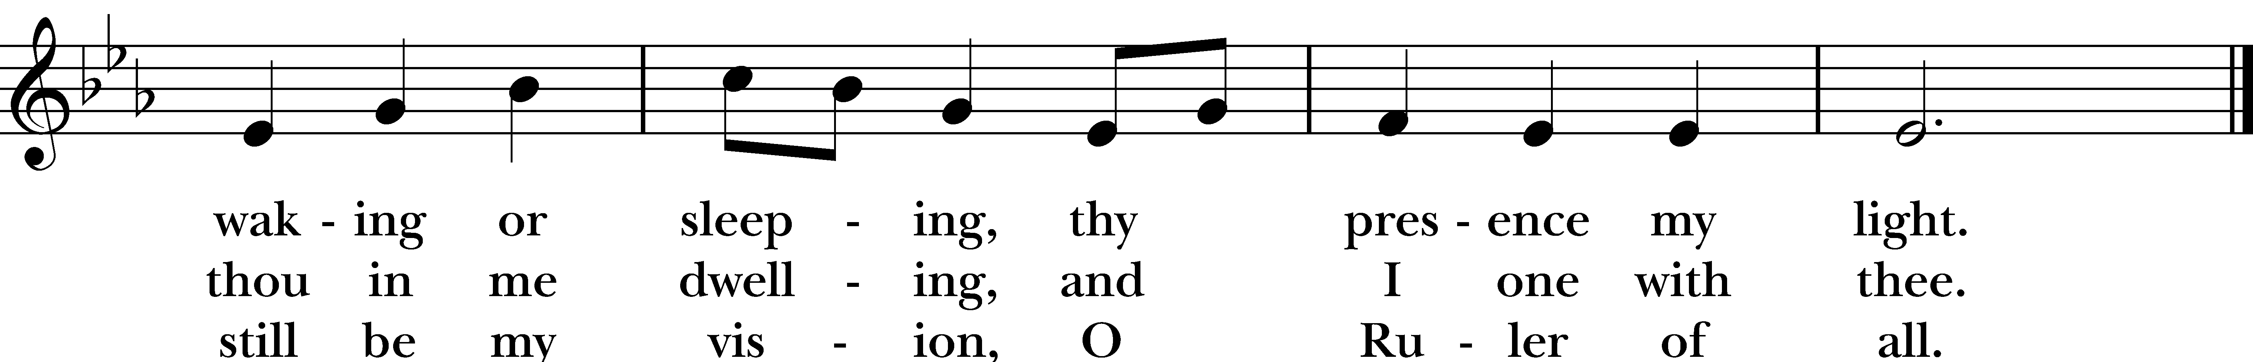
Reprinted/streamed with permission via RiteSong. All rights reserved.

Dismissal

Celebrant: Our worship is ended. Our Service begins. Go in peace to love & serve the Lord.
People: Thanks be to God.

Announcements for February 8th, 2026

NAME TAGS: A reminder to please wear your name tag each week, found in the back of the church.

COFFEE HOUR: Please consider signing up to provide refreshments for an upcoming Sunday.

ASH WEDNESDAY, FEB. 18th: Ash and Dash in the parking lot, 8-9:30 am and 3-6 pm. Joint service at Emmanuel Episcopal in Weston at 7 pm.

NOURISH BRIDGEPORT: Our next day of service at Nourish is Thursday, 2/19. Contact Jim Swann to participate in either dinner prep and/or serving.

ANNUAL MEETING: Our Annual Meeting is Sunday, February 22nd. All reports should be emailed to the office in Word document format by 2/9.

GIFT CARDS to gas stations & grocery stores are always needed. Thank you for your continued generosity.

Vestry: Jim Swann, Jr. Warden; Bob Ellwanger, Treasurer; Peg Ellwanger, Clerk

Vestry Members: Russ Bailas, Amy Bailas, Marina Philips, Claire Wilkes

Diocesan Delegates: Diane McCann, Bob Ellwanger; Alternate: Deborah Swann
Music Minister: Tracy Carlucci

Choir Members: Amy Strachan, Andy Verrocchi, Bob Ellwanger, David McCann, Diane McCann, Marina Philips, Katie Tressler, Vicki MarkAnthony

Christ Church Nursery School: Maggie Supple, Director www.ccnseaston.com

UPCOMING WORSHIP DATES – Sunday Services @ 9:30 am

Sunday, 2/15: Morning Prayer – Vicki MarkAnthony

Wednesday, 2/18: Ash Wednesday Service at Emmanuel @ 7 pm – Rev. Katy Piazza

Sunday, 2/22: Eucharist & Annual Meeting – Rev. Katy Piazza

Sunday, 3/1: Morning Prayer – Andy Hathaway

Sunday, 3/8: Eucharist & Family Sunday – Rev. Katy Piazza
Vestry: Jim Swann, Jr. Warden; Bob Ellwanger, Treasurer; Peg Ellwanger, Clerk

Vestry Members: Russ Bailas, Amy Bailas, Marina Philips, Claire Wilkes

Diocesan Delegates: Diane McCann, Bob Ellwanger; Alternate: Deborah Swann


Christ Church – Parish Office Hours:
Mondays & Wednesdays: 9:30-1:30

59 Church Rd, Easton, CT
(203) 268-3569

christchurcheaston@gmail.com
www.christchurcheaston.com

Priest-in-Charge: Katy Piazza

Senior Warden: Vicki MarkAnthony

Parish Administrator: Tracy Carlucci
Music Minister: Tracy Carlucci

Choir Members: Amy Strachan, Andy Verrocchi, Bob Ellwanger, David McCann, Diane McCann, Marina Philips, Katie Tressler, Vicki MarkAnthony

Christ Church Nursery School: Maggie Supple, Director www.ccnseaston.com

