Sunday, October 4th, 2026

The Blessing of the Animals &
The Feast of St. Francis

Rev. Katy Piazza, Priest-in-Charge
Christ Church Easton

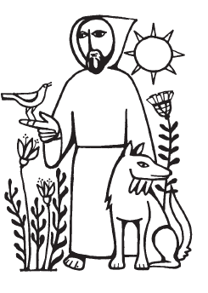

Why do we bless pets on this day?

St. Francis of Assisi lived in Italy in the 12th century. Having grown up in a wealthy family, he renounced his wealth and worldly possessions and lived very simply. When Francis spoke, everyone listened, including the animals. He told the animals that Jesus loved them too. There is a story of a wolf who lived in the town of Gubbio. The wolf came into the town each evening, frightening the inhabitants or eating them. Francis went to speak to “Brother Wolf” and found out that the wolf was hungry. Francis explained that that was not reason enough to eat people and their pets or to terrorize them. The wolf became very gentle, the people fed him and he gave the children in the town rides on his back.

Francis also brought us the Christmas creche. In the town of Gubbio, he built a small outdoor stable and put people in the stable to portray Mary, Joseph, the shepherds, the angels. Then he added the animals - cow, donkey, sheep, etc. When asked, Francis said, “Surely the animals praised the new Messiah just as the shepherds and angels did.” And so in honor of this blessed saint of the church we gather today with our animals - our pets, our service animals, police dogs and horses, zoo animals and all God’s creatures and give thanks for what they do for us and for what they mean to us.
Welcome to Christ Church Easton!

Whether you are a newcomer, visitor, or longtime member, we bid you a warm welcome!
Please join us for coffee hour following service. Sign up for our email list at www.christchurcheaston.com

A Service of Holy Word & Holy Eucharist

Celebrant: As we gather to worship, let us recognize that we gather on the ancestral lands and traditional territory of the (Aspetuck River Valley dwelling) Paugussett people.

Opening Hymn “All things bright and beautiful” Hymnal #405

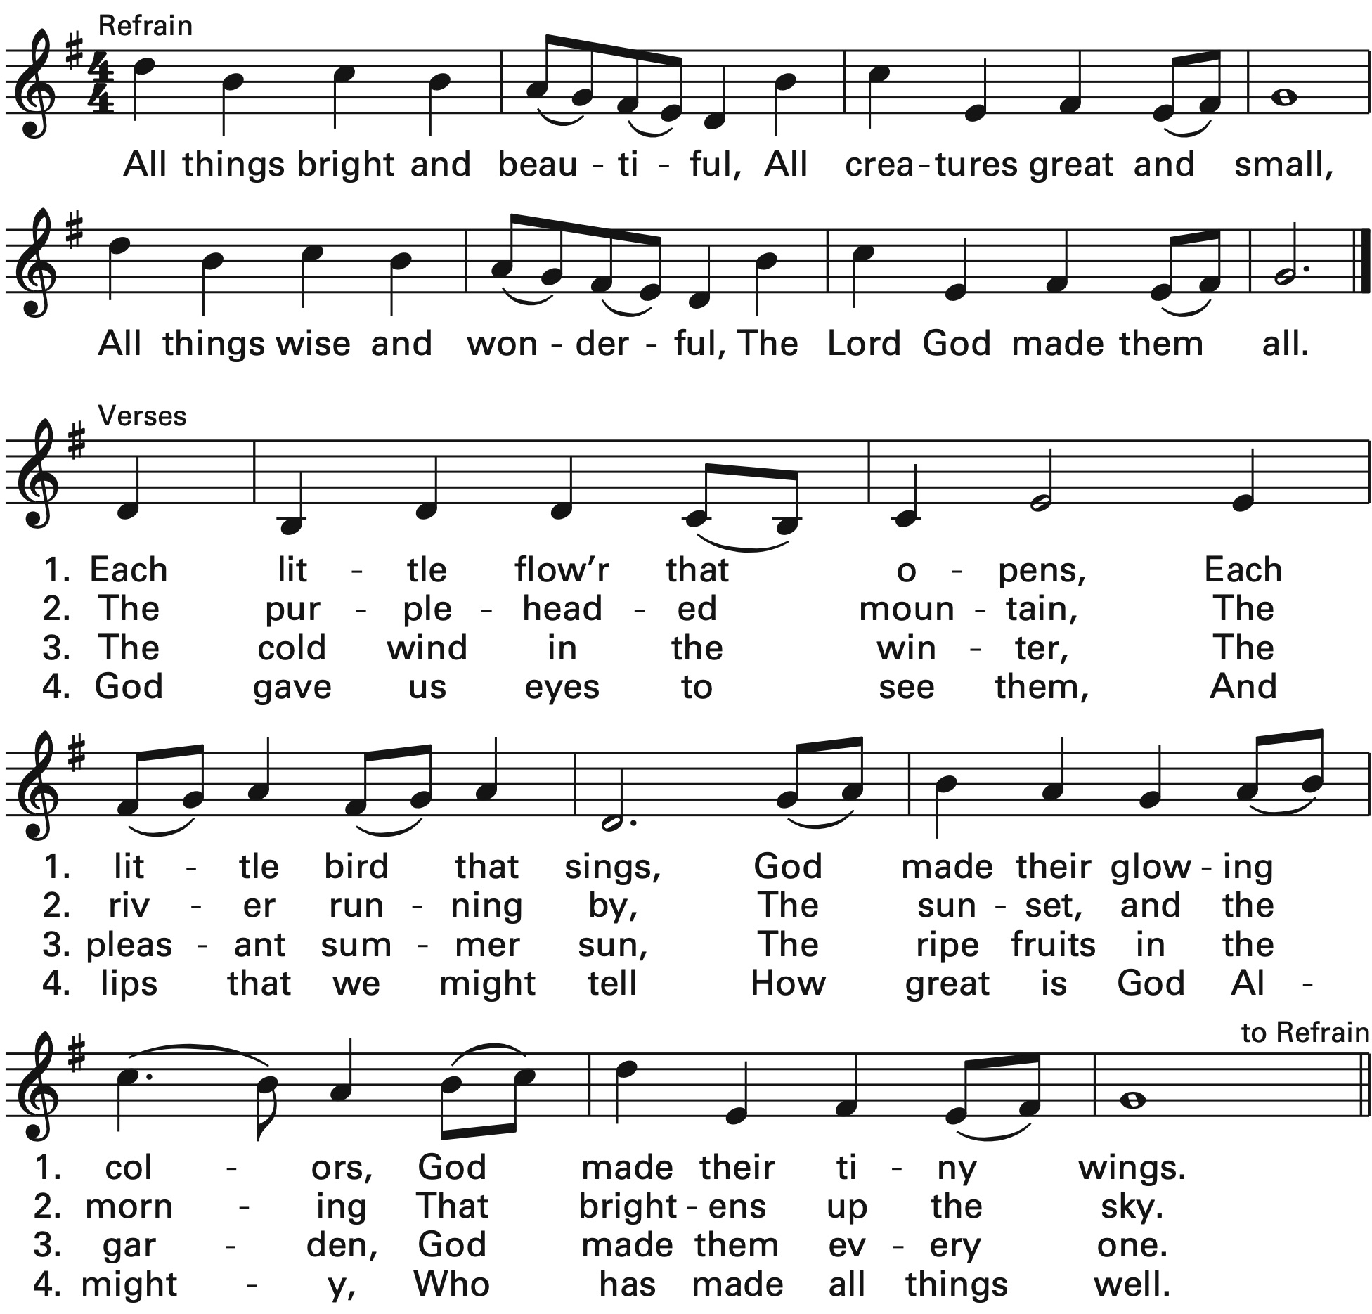
Reprinted/streamed with permission via One License and/or RiteSong. All rights reserved.

The Collect of the Day
Celebrant: Bless the Lord, all you his creatures.
People: Bless the Lord, in heaven and on earth.

Celebrant: Most high, omnipotent, good Lord, grant your people grace to renounce gladly the vanities
of this world; that, following the way of blessed Francis, we may, for love of you, delight in your whole creation with perfectness of joy; through Jesus Christ our Lord, who lives and reigns with you and the Holy Spirit, one God, for ever and ever. Amen.
Gloria in Excelsis

Glory to God in the highest, and peace to his people on earth. Lord God, heavenly King,
almighty God and Father, we worship you, we give you thanks, we praise you for your glory.
Lord Jesus Christ, only Son of the Father, Lord God, Lamb of God, you take away the sin of the world:
have mercy on us; you are seated at the right hand of the Father: receive our prayer.
For you alone are the Holy One, you alone are the Lord, you alone are the Most High, Jesus Christ,
with the Holy Spirit, in the glory of God the Father. Amen.

Old Testament Reading Job 39:1-18
A Reading from the Book of Job.

“Do you know when the mountain goats give birth? Do you observe the calving of the deer? Can you number the months that they fulfil, and do you know the time when they give birth, when they crouch to give birth to their offspring, and are delivered of their young? Their young ones become strong, they grow up in the open; they go forth, and do not return to them.

Who has let the wild ass go free? Who has loosed the bonds of the swift ass, to which I have given the steppe for its home, the salt land for its dwelling-place? It scorns the tumult of the city; it does not hear the shouts of the driver. It ranges the mountains as its pasture, and it searches after every green thing.

Is the wild ox willing to serve you? Will it spend the night at your crib? Can you tie it in the furrow with ropes, or will it harrow the valleys after you? Will you depend on it because its strength is great, and will you hand over your labor to it? Do you have faith in it that it will return, and bring your grain to your threshing-floor?

The ostrich’s wings flap wildly, though its pinions lack plumage. For it leaves its eggs to the earth, and lets them be warmed on the ground, forgetting that a foot may crush them, and that a wild animal may trample them. It deals cruelly with its young, as if they were not its own; though its labor should be in vain, yet it has no fear; because God has made it forget wisdom, and given it no share in understanding.
When it spreads its plumes aloft, it laughs at the horse and its rider."

The Word of the Lord.
Thanks be to God.

The Psalm Psalm 121
I lift up my eyes to the hills; *
from where is my help to come?
My help comes from the Lord, *
the maker of heaven and earth.
He will not let your foot be moved*
and he who watches over you will not fall asleep.
Behold, he who keeps watch over Israel *
shall neither slumber nor sleep;
The Lord himself watches over you; *
the Lord is your shade at your right hand,
So that the sun shall not strike you by day, *
nor the moon by night.
The Lord shall preserve you from all evil; *
it is he who shall keep you safe.
The Lord shall watch over your going out and your coming in, *
from this time forth for evermore.
The New Testament Acts 4:32-35, 5:1-11
A Reading from the Acts of the Apostles.

The whole group of those who believed were of one heart and soul, and no one claimed private ownership of any possessions, but everything they owned was held in common. With great power the apostles gave their testimony to the resurrection of the Lord Jesus, and great grace was upon them all. There was not a needy person among them, for as many as owned lands or houses sold them and brought the proceeds of what was sold. They laid it at the apostles’ feet, and it was distributed to each as any had need.

But a man named Ananias, with the consent of his wife Sapphira, sold a piece of property; with his wife’s knowledge, he kept back some of the proceeds, and brought only a part and laid it at the apostles’ feet. “Ananias,” Peter asked, “why has Satan filled your heart to lie to the Holy Spirit and to keep back part of the proceeds of the land? While it remained unsold, did it not remain your own? And after it was sold, were not the proceeds at your disposal? How is it that you have contrived this deed in your heart? You did not lie to us but to God!” Now when Ananias heard these words, he fell down and died. And great fear seized all who heard of it. The young men came and wrapped up his body, then carried him out and buried him.

After an interval of about three hours his wife came in, not knowing what had happened. Peter said to her, “Tell me whether you and your husband sold the land for such and such a price.” And she said, “Yes, that was the price.” Then Peter said to her, “How is it that you have agreed together to put the Spirit of the Lord to the test? Look, the feet of those who have buried your husband are at the door, and they will carry you out.” Immediately she fell down at his feet and died. When the young men came in they found her dead, so they carried her out and buried her beside her husband. And great fear seized the whole church and all who heard of these things.

The Word of the Lord.
Thanks be to God.

Please stand and sing together our Gospel hymn. We will sing vs 1-2 before the Gospel, and vs 3 after.

Gospel Hymn “I sing the almighty power of God” Hymnal #398

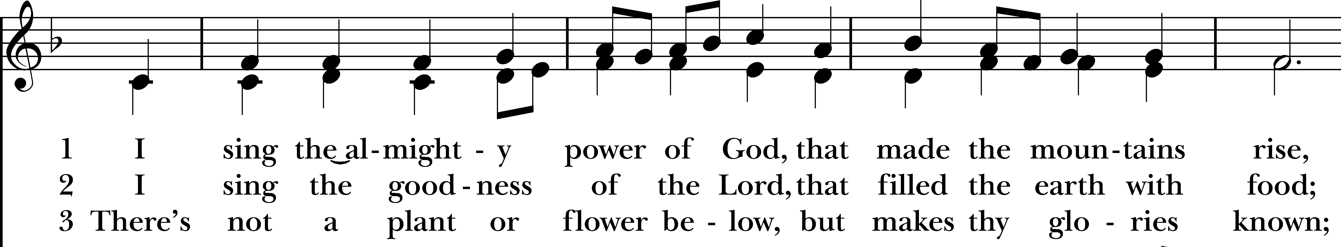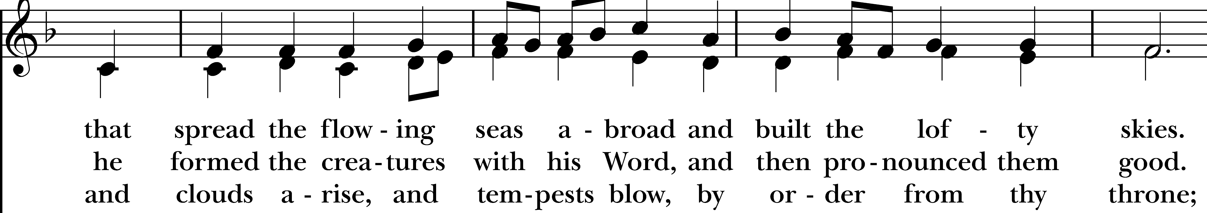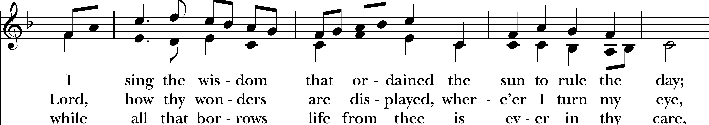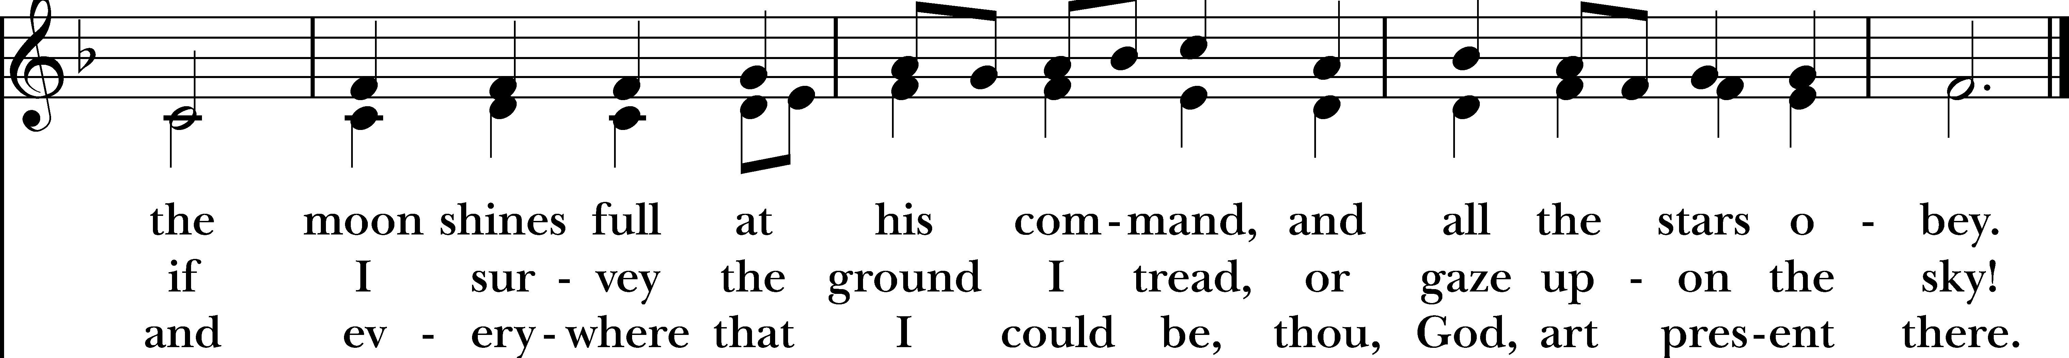
Reprinted/streamed with permission via One License and/or RiteSong. All rights reserved.
The Gospel Luke 12:13-21
The Holy Gospel of our Lord Jesus Christ, according to Luke.
Glory to you, Lord Christ.

Someone in the crowd said to Jesus, “Teacher, tell my brother to divide the family inheritance with me.” But he said to him, “Friend, who set me to be a judge or arbitrator over you?” And he said to them, “Take care! Be on your guard against all kinds of greed; for one’s life does not consist in the abundance of possessions.” Then he told them a parable: “The land of a rich man produced abundantly. And he thought to himself, ‘What should I do, for I have no place to store my crops?’ Then he said, ‘I will do this: I will pull down my barns and build larger ones, and there I will store all my grain and my goods. And I will say to my soul, ‘Soul, you have ample goods laid up for many years; relax, eat, drink, be merry.’ But God said to him, ‘You fool! This very night your life is being demanded of you. And the things you have prepared, whose will they be?’ So it is with those who store up treasures for themselves but are not rich toward God.”

The Gospel of the Lord.
Praise to you, Lord Christ.

The Sermon Rev. Katy Piazza

The Prayers of the People

Let us give thanks to God, our Creator, for all the gifts that we have been given.

We thank you, God: for the sun and moon, the stars and planets.

We thank you, God: for wind and cloud, rain and sun.

We thank you, God: for water - to drink, to play in, to bathe in and for baptism.

We thank you, God: for fire that gives us light in darkness and warmth.

We thank you, God: for Mother Earth who feeds us and protects us. We thank you for flowers, trees, grass, bushes.

We thank you, God: for our pets you have entrusted to us. They bring us such joy, they calm us, make us laugh, play with us and keep us safe.

We thank you, God: for all the animals on the earth.

Heavenly Father, our human ties with our friends of other species is a wonderful and special gift from you. We now ask you to grant our special animal companions your care and healing power to take away any suffering they have. Give us, their human friends, new understanding of our responsibilities and connection to your creatures. Amen.

The Blessing of the Animals

The Peace

Celebrant: The peace of the Lord be always with you.
People: And also with you.

Announcements Vicki MarkAnthony

A note on Communion: All are welcome at God’s table. Please let the minister know if you would prefer a gluten free wafer.
If you wish to receive the wafer but not the wine, simply cross your arms over your chest when the wine comes before you.

The Holy Communion

Walk in love, as Christ loved us and gave himself for us, an offering and sacrifice to God. Ephesians 5:2

Offertory Anthem “A Prayer for St. Francis” Sebastian Temple
Christ Church Choir
Eucharistic Prayer C

Celebrant: The Lord be with you.
People: And also with you.
Celebrant: Lift up your hearts.
People: We lift them to the Lord.
Celebrant: Let us give thanks to the Lord our God.
People: It is right to give God thanks and praise.

God of all power, Ruler of the Universe, you are worthy of glory and praise. Glory to you for ever and ever.

At your command all things came to be: the vast expanse of interstellar space, galaxies, suns, the planets in their courses, and this fragile earth, our island home. By your will they were created and have their being.

From the primal elements you brought forth the human race, and blessed us with memory, reason, and skill. You made us the rulers of creation. But we turned against you, and betrayed your trust; and we turned against one another. Have mercy, Lord, for we are sinners in your sight.

Again and again, you called us to return. Through prophets and sages you revealed your righteous Law. And in the fullness of time you sent your only Son, born of a woman, to fulfill your Law, to open for us the way of freedom and peace. By his blood, he reconciled us. By his wounds, we are healed.

And therefore we praise you, joining with the heavenly chorus, with prophets, apostles, and martyrs, and with all those in every generation who have looked to you in hope, to proclaim with them your glory, in their unending hymn.

Holy, holy, holy Lord, God of power and might,
Heaven and earth are full of your glory. Hosanna in the highest.
Blessed is he who comes in the name of the Lord. Hosanna in the highest.

And so, Father, we who have been redeemed by him, and made a new people by water and the Spirit, now bring before you these gifts. Sanctify them by your Holy Spirit to be the Body and Blood of Jesus Christ our Lord.

On the night he was betrayed he took bread, said the blessing, broke the bread, and gave it to his friends, and said, “Take, eat: This is my Body, which is given for you. Do this for the remembrance of me.”
After supper, he took the cup of wine, gave thanks, and said, “Drink this, all of you: This is my Blood of the new Covenant, which is shed for you and for many for the forgiveness of sins. Whenever you drink it, do this for the remembrance of me.”

Remembering now his work of redemption, and offering to you this sacrifice of thanksgiving, We celebrate his death and resurrection, as we await the day of his coming.

Lord God of our Fathers: God of Abraham, Isaac, and Jacob; God and Father of our Lord Jesus Christ: Open our eyes to see your hand at work in the world about us. Deliver us from the presumption of coming to this Table for solace only, and not for strength; for pardon only, and not for renewal. Let the grace of this Holy Communion make us one body, one spirit in Christ, that we may worthily serve the world in his name. Risen Lord, be known to us in the breaking of the Bread.

Accept these prayers and praises, Father, through Jesus Christ our great High Priest, to whom, with you and the Holy Spirit, your Church gives honor, glory, and worship, from generation to generation, AMEN.

And now, as our Savior Christ has taught us, we are bold to say,

Our Father who art in heaven, hallowed be thy Name, thy kingdom come, thy will be done, on earth as it is in in heaven. Give us this day our daily bread. And forgive us our trespasses as we forgive those who trespass against us. And lead us not into temptation but deliver us from evil. For thine is the kingdom, the power, and the glory, for ever and ever. Amen.

The Breaking of the Bread

Celebrant: Alleluia. Christ our Passover is sacrificed for us;
People: Therefore let us keep the feast. Alleluia.
Celebrant: The Gifts of God for the People of God.

A Prayer for Spiritual Communion:

Let us pray. We believe that you are truly present in the Holy Sacrament, and we pray you to come into our hearts, praying especially with those at home who cannot at this time receive communion. I unite myself with you and embrace you with all my heart, my soul, and my mind. Let nothing separate me from you; let me serve you in this life until, by your grace, I come to your glorious kingdom and unending peace. Amen.

Communion Hymn “For the beauty of the earth” Hymnal #416

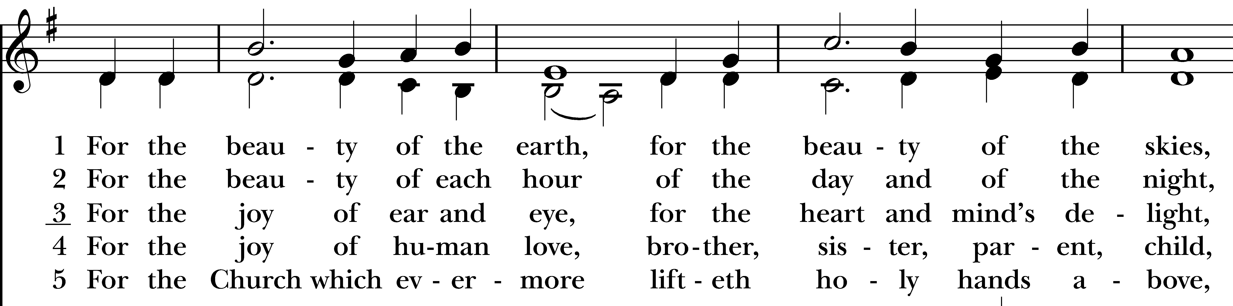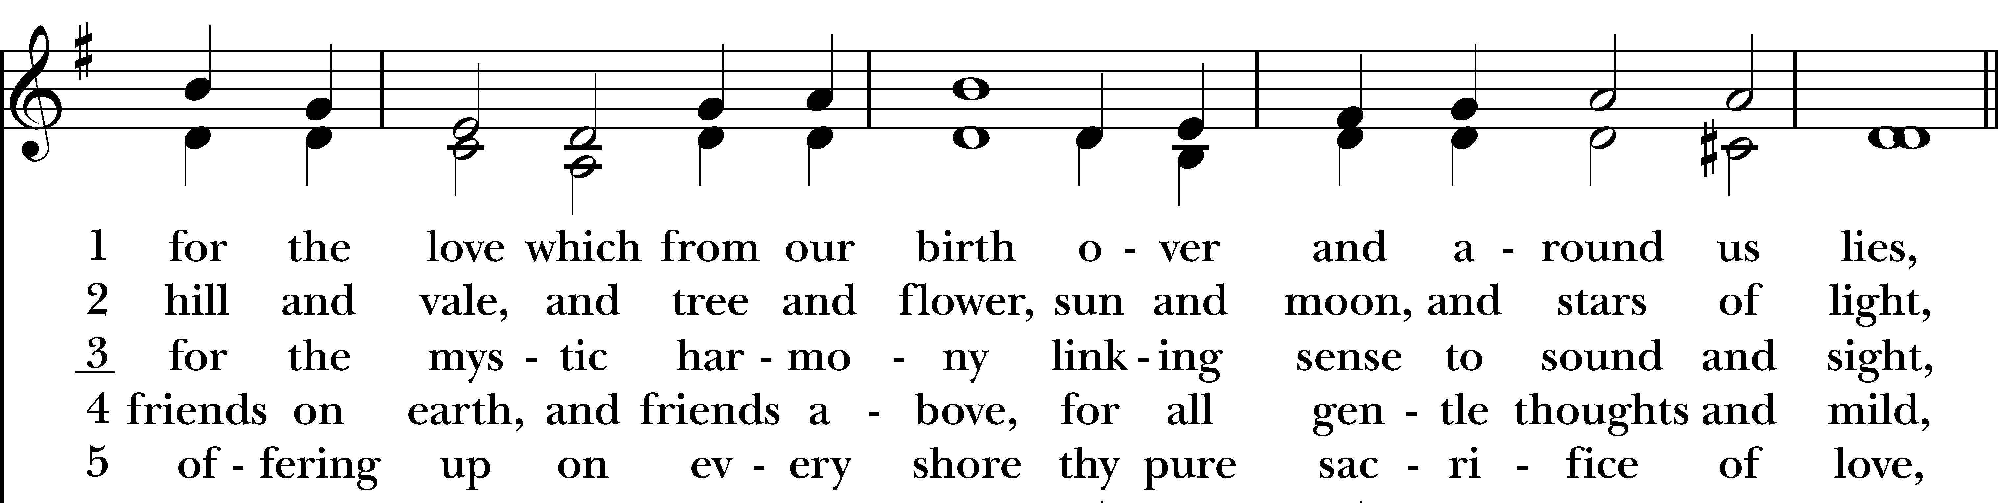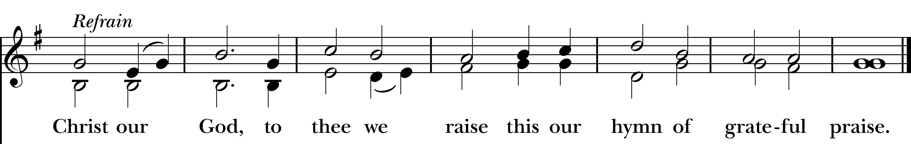
Reprinted/streamed with permission via One License and RiteSong. All rights reserved.

Prayer After Communion

Let us pray. God of abundance, you have fed us with the bread of life and cup of salvation; you have united us with Christ and one another; and you have made us one with all your people in heaven and on earth. Now send us forth in the power of your Spirit, that we may proclaim your redeeming love to the world and continue for ever in the risen life of Christ our Savior. Amen.

A Franciscan Blessing Rev. Katy

May God bless you with discomfort at easy answers, half truths, and superficial relationships,
so that you may live deep within your heart.

May God bless you with anger at injustice, oppression, and exploitation of people,
so that you may work for justice, freedom, and peace.

May God bless you with tears to shed for those who suffer from pain, rejection, starvation, and war,
so that you may reach out your hand to comfort them and to turn their pain into joy.

And may God bless you with enough foolishness to believe that you can make a difference in this world,
so that you can do what others claim cannot be done. Amen.

Recessional Hymn “All creatures of our God and King” Hymnal #400
(verse 1, 4 & 7)
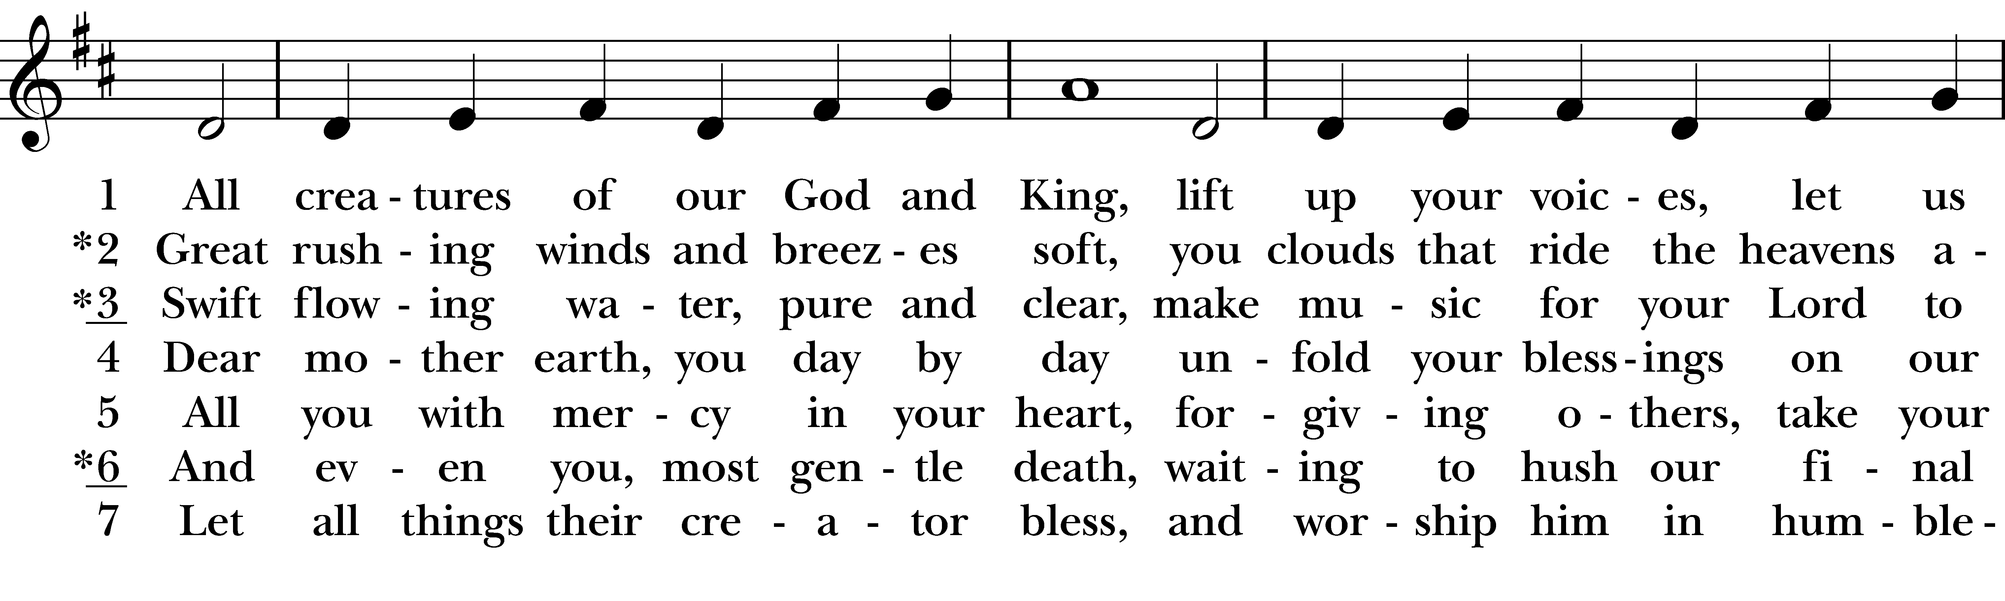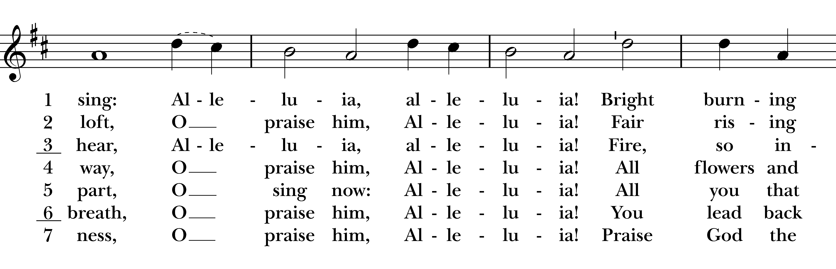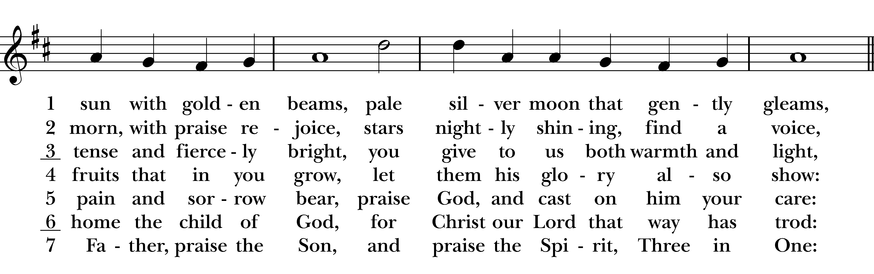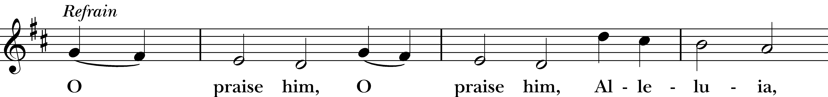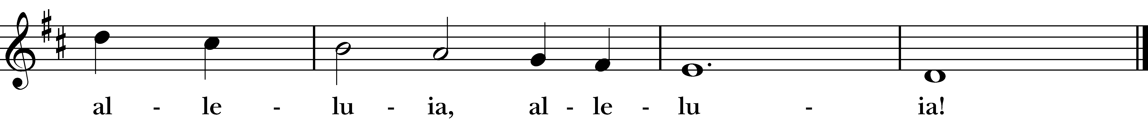
Reprinted/streamed with permission via One License and RiteSong. All rights reserved.

Dismissal

Celebrant: Our worship is ended. Our Service begins. Go in peace to love & serve the Lord. Alleluia, alleluia!
People: Thanks be to God. Alleluia, alleluia!
Announcements for October 4th, 2026

COFFEE HOUR: Sign-up to host an upcoming coffee hour! Sign-up sheet is in the narthex.

SOCKTOBER: We are collecting socks for the month of October for the Greater Bridgeport Ministry Network, who is hosting their annual sock collection for food pantries, shelters & the homeless in the Greater Bridgeport community. Please bring new socks and leave in the back pew.

PIANO CONCERT: Sunday, October 11th at 3pm at Christ Church Redding’s Parish Hall (184 Cross Hwy, Redding). The concert is free (donations accepted), followed by a reception.

SAVE THE DATE: Our annual “Chasing the Legend” 5K will be held Saturday, 10/24. Please let Vicki know if you are available to help.

GIFT CARDS to gas stations & grocery stores are always needed. Thank you for your continued generosity.

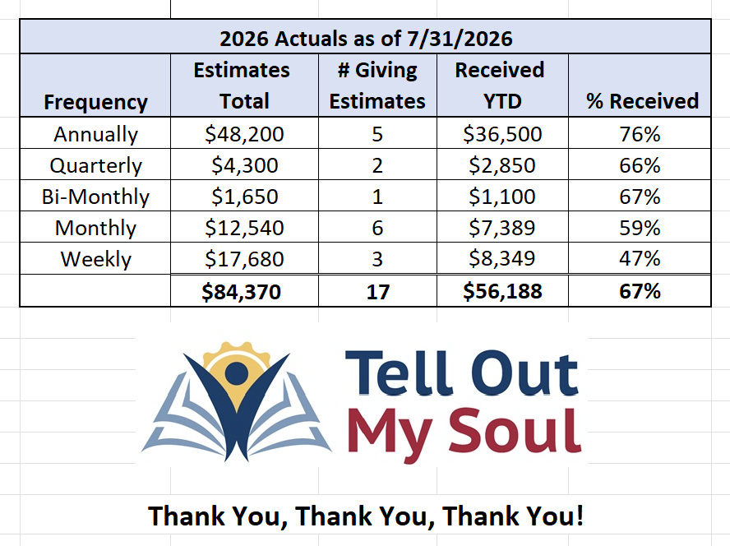
Music Minister: Tracy Carlucci

Choir Members: Amy Strachan, Andy Verrocchi, Bob Ellwanger, David McCann, Diane McCann, Marina Philips, Katie Tressler, Vicki MarkAnthony

Christ Church Nursery School: Maggie Supple, Director, www.ccnseaston.com
Vestry: Jim Swann, Jr. Warden; Bob Ellwanger, Treasurer; Amy Bailas, Clerk

Vestry Members: Russ Bailas, Marina Philips, Claire Wilkes, Peg Ellwanger

Diocesan Delegates: Diane McCann, Bob Ellwanger; Alternate: Deborah Swann
UPCOMING WORSHIP SCHEDULE

Sundays at 9:30 am:

October 11th: Indigenous Peoples Day, Morning Prayer – Vicki MarkAnthony

October 18th: Morning Prayer – Andy Hathaway

October 25th: Eucharist – Rev. Katy Piazza

November 1st: All Saints Day, Eucharist – Rev. Katy Piazza

Christ Church – Parish Office Hours:

Mondays & Wednesdays: 9:30-1:30

59 Church Rd, Easton, CT
(203) 268-3569

christchurcheaston@gmail.com
www.christchurcheaston.com

Priest-in-Charge: Katy Piazza

Senior Warden: Vicki MarkAnthony

Parish Administrator: Tracy Carlucci

