Sunday, November 30th, 2025: The First Sunday of Advent
Rev. Sandy Belcher, Supply Priest
Christ Church Easton

Celebrant: As we gather to worship, let us recognize that we gather on the ancestral lands and traditional territory of the (Aspetuck River Valley dwelling) Paugussett people.

Celebrant: Please stand as you are able and sing together our Processional Hymn, #61 “Sleepers wake! A voice astounds us” found in your hymnal.

Processional Hymn “‘Sleepers wake!’ A voice astounds us” Hymnal #61
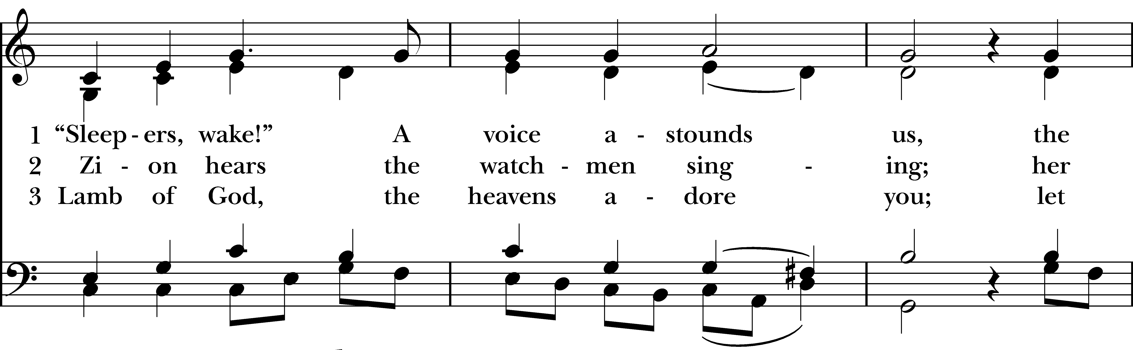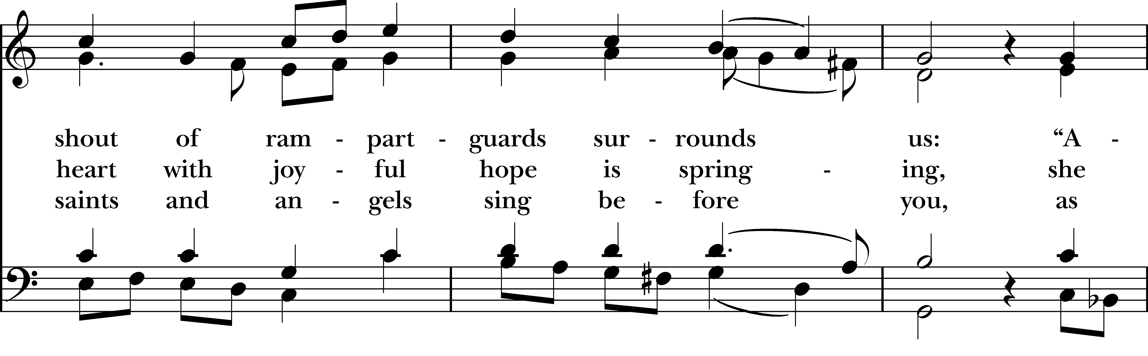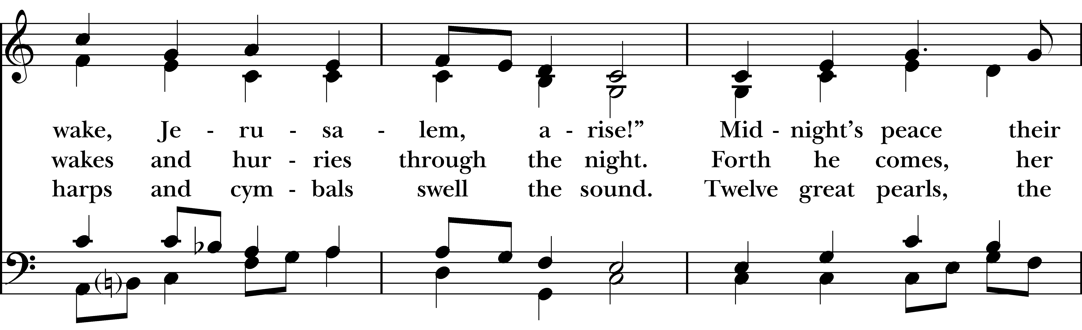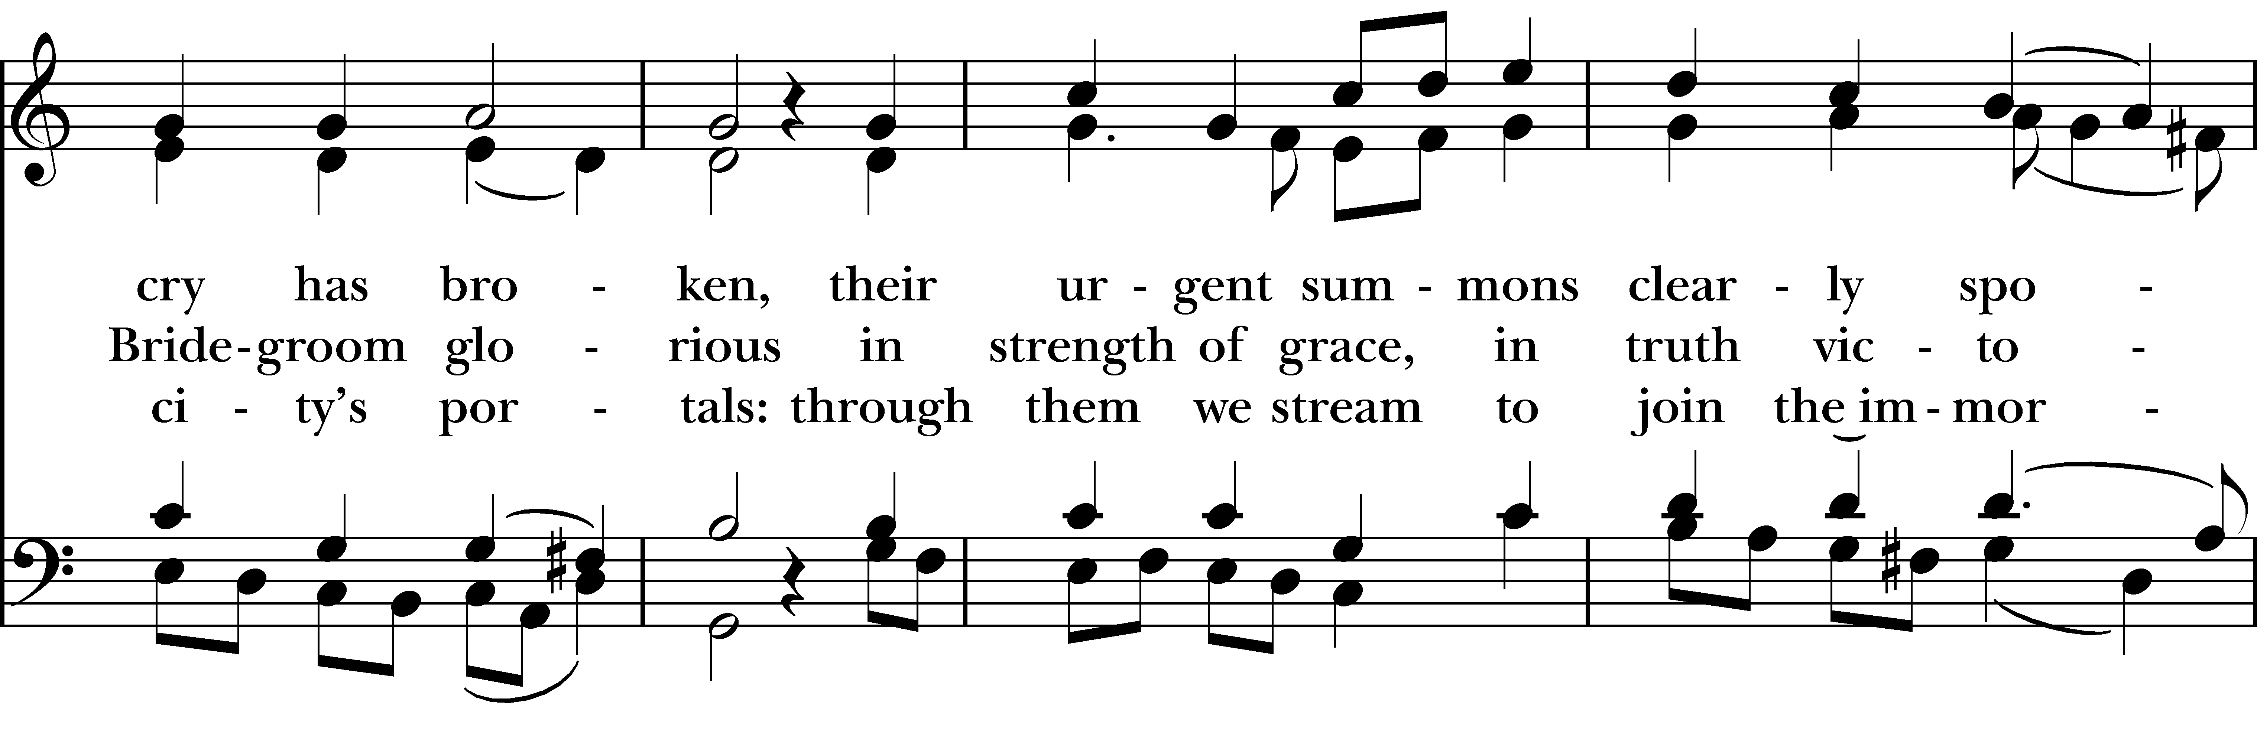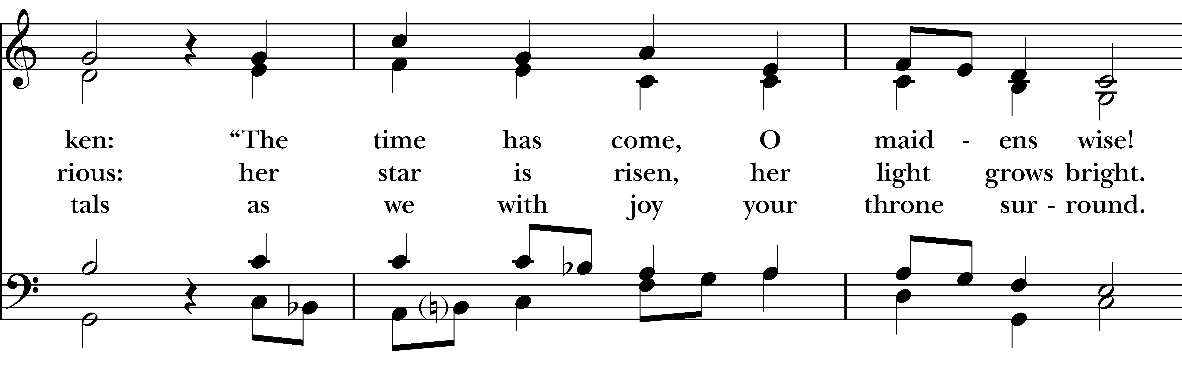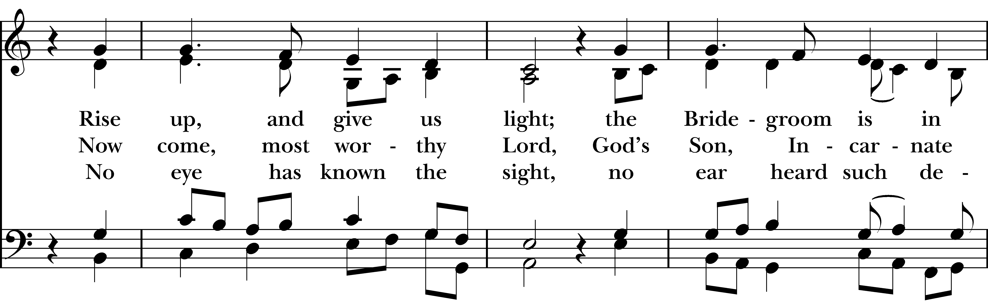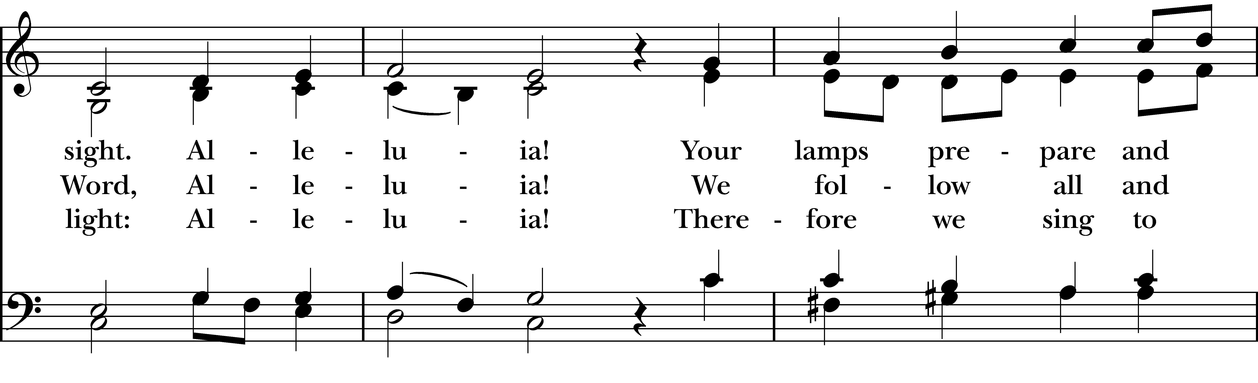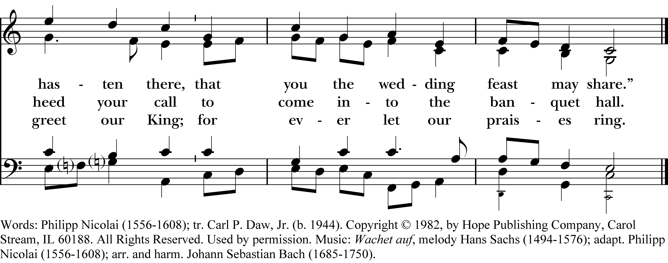
Reprinted/streamed with permission via One License and RiteSong. All rights reserved.
The Word of God BCP p. 355
Celebrant: Turning now to page 355 in the Book of Common Prayer.

Celebrant: Blessed be God: Father, Son, and Holy Spirit.
People: And blessed be his kingdom, now and for ever. Amen.

The Collect for Purity
Almighty God, to you all hearts are open, all desires known, and from you no secrets are hid: Cleanse the thoughts of our hearts by the inspiration of your Holy Spirit, that we may perfectly love you, and worthily magnify your holy Name; through Christ our Lord. Amen.

The Magnificat: The Song of Mary Pew Card/Hymnal #S242

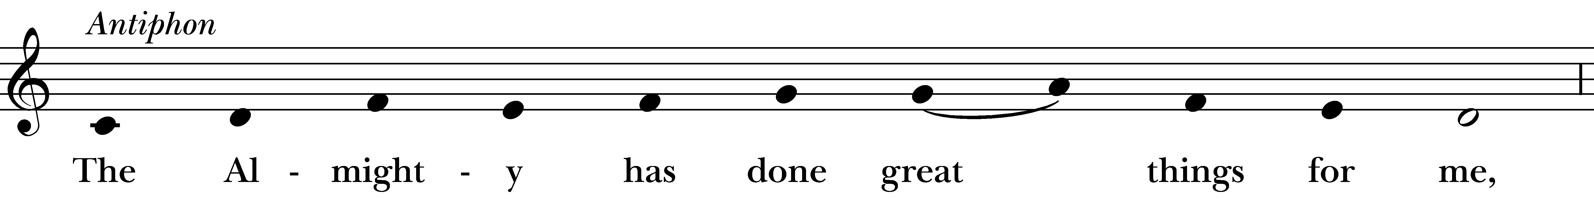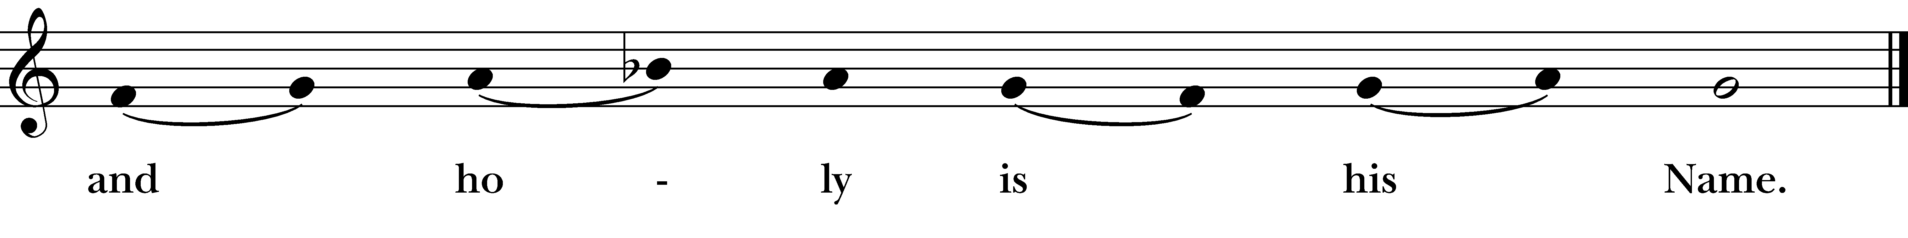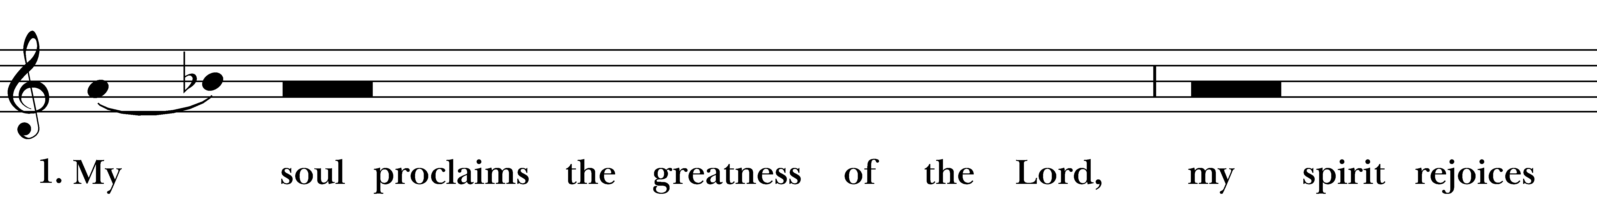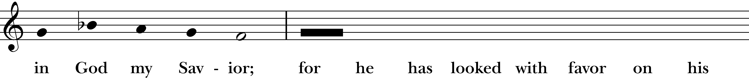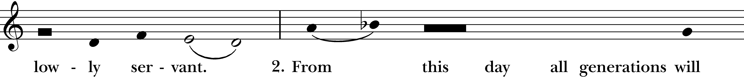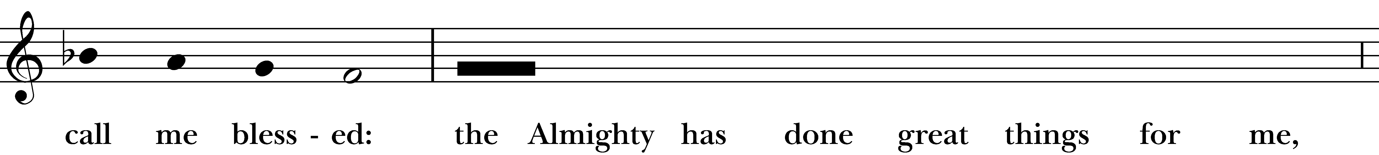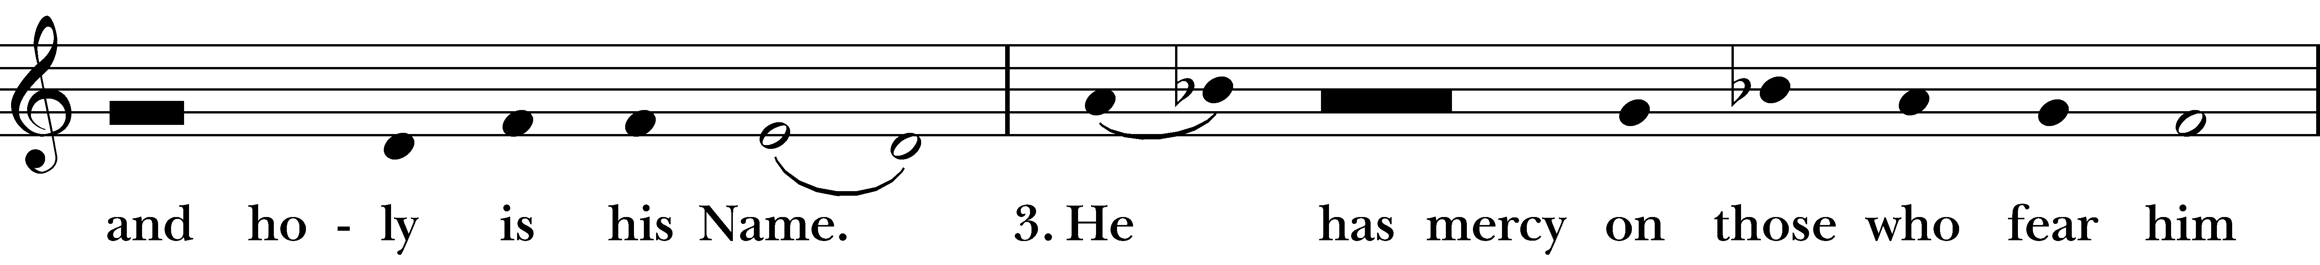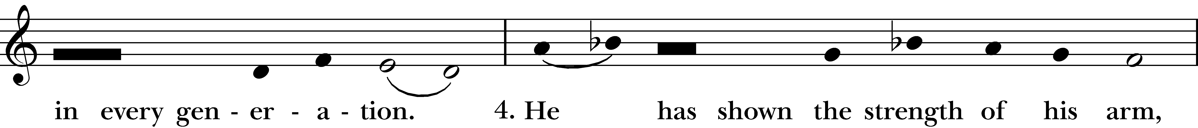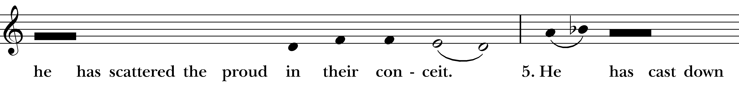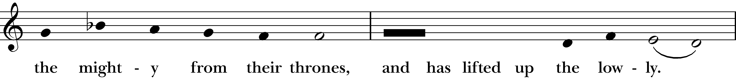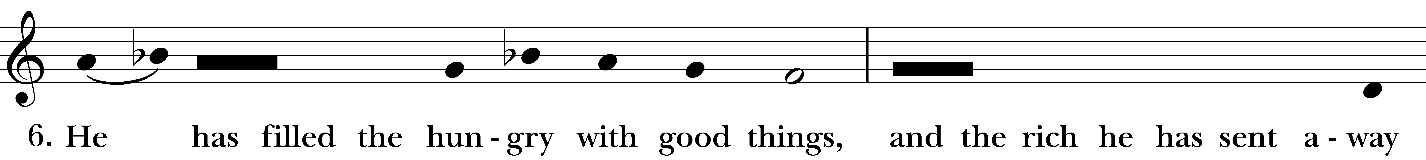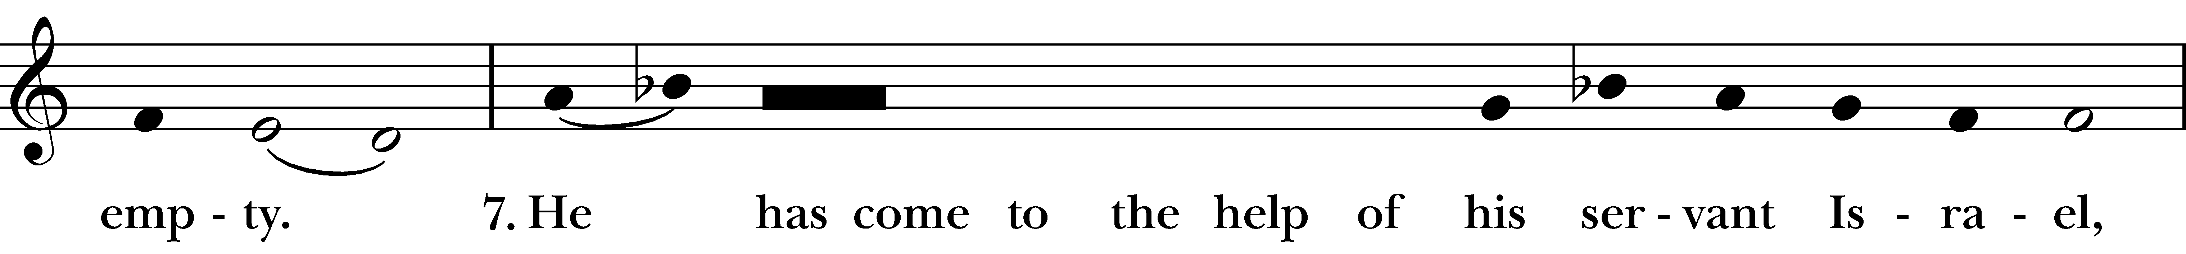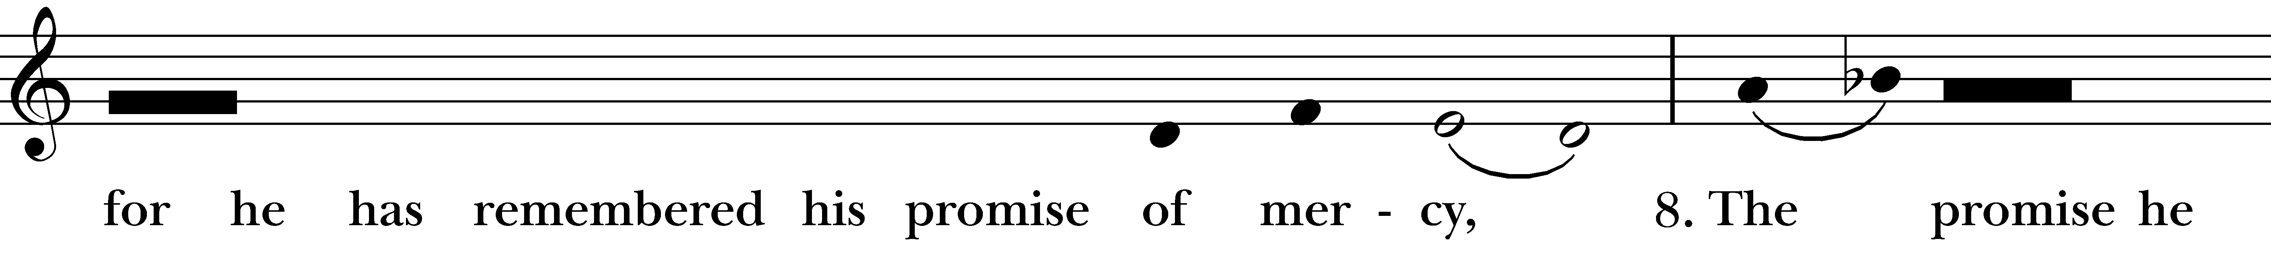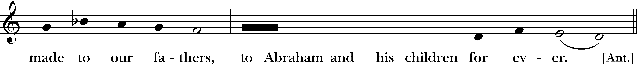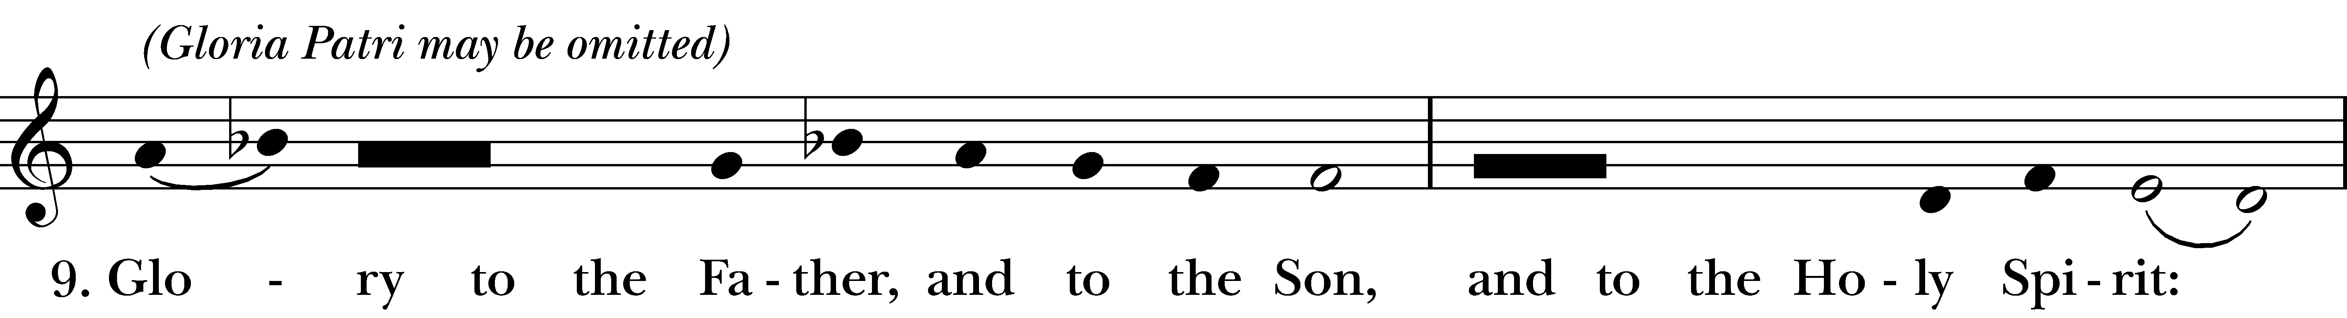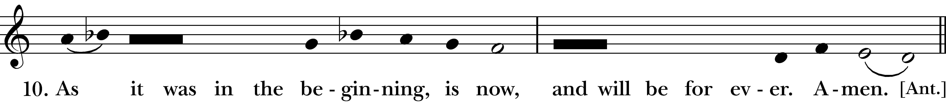
Reprinted/streamed with permission via One License and/or RiteSong. All rights reserved.

The Collect of the Day

Celebrant: The Lord be with you.
People: And also with you.
Let us pray. Almighty God, give us grace to cast away the works of darkness, and put on the armor of light, now in the time of this mortal life in which your Son Jesus Christ came to visit us in great humility; that in the last day, when he shall come again in his glorious majesty to judge both the living and the dead, we may rise to the life immortal; through him who lives and reigns with you and the Holy Spirit, one God, now and for ever. Amen.

The First Reading Isaiah 65:17-25
A Reading from the Book of the Prophet Isaiah.

The word that Isaiah son of Amoz saw concerning Judah and Jerusalem. In days to come the mountain of the Lord’s house shall be established as the highest of the mountains, and shall be raised above the hills; all the nations shall stream to it. Many peoples shall come and say, “Come, let us go up to the mountain of the LORD, to the house of the God of Jacob; that he may teach us his ways and that we may walk in his paths.” For out of Zion shall go forth instruction, and the word of the LORD from Jerusalem. He shall judge between the nations, and shall arbitrate for many peoples; they shall beat their swords into plowshares, and their spears into pruning hooks; nation shall not lift up sword against nation, neither shall they learn war any more. O house of Jacob, come, let us walk in the light of the LORD!

The Word of the Lord.
Thanks be to God.

Psalm 122 Psalm 122

I was glad when they said to me, *
“Let us go to the house of the LORD.”
Now our feet are standing *
within your gates, O Jerusalem.
Jerusalem is built as a city *
that is at unity with itself;
To which the tribes go up, the tribes of the LORD, *
the assembly of Israel, to praise the Name of the LORD.
For there are the thrones of judgment, *
the thrones of the house of David.
Pray for the peace of Jerusalem: *
“May they prosper who love you.
Peace be within your walls *
and quietness within your towers.
For my brethren and companions’ sake, *
I pray for your prosperity.
Because of the house of the LORD our God, *
I will seek to do you good.”

The Second Reading Romans 13:11-14
A Reading from the Letter to the Romans.

Besides this, you know what time it is, how it is now the moment for you to wake from sleep. For salvation is nearer to us now than when we became believers; the night is far gone, the day is near. Let us then lay aside the works of darkness and put on the armor of light; let us live honorably as in the day, not in reveling and drunkenness, not in debauchery and licentiousness, not in quarreling and jealousy. Instead, put on the Lord Jesus Christ, and make no provision for the flesh, to gratify its desires.

The Word of the Lord
Thanks be to God.

Celebrant: Please stand as you are able and sing together hymn #56, “O come, O come, Emmanuel.” We will sing verse 1 before the Gospel and verse 2 after.

Gospel Hymn “O come, O come, Emmanuel” Hymnal #56
(vs 1 before Gospel; vs 2 after)
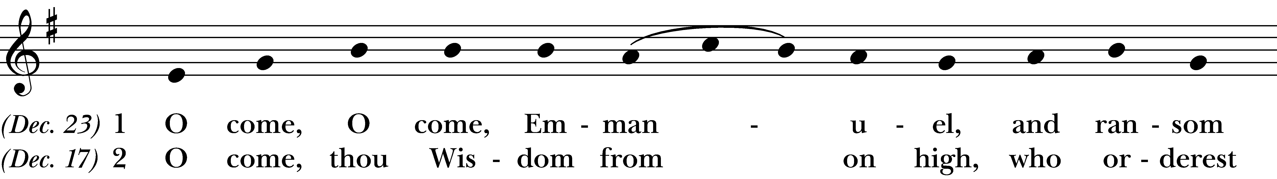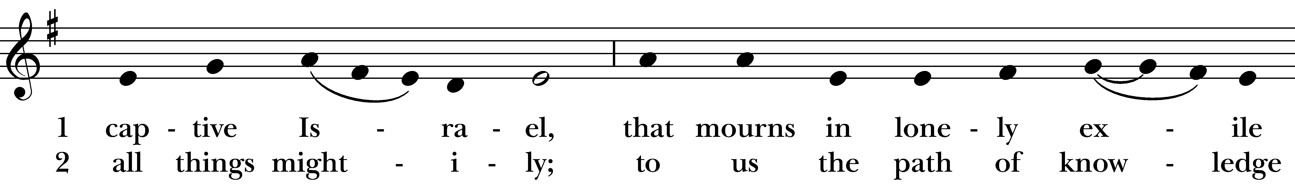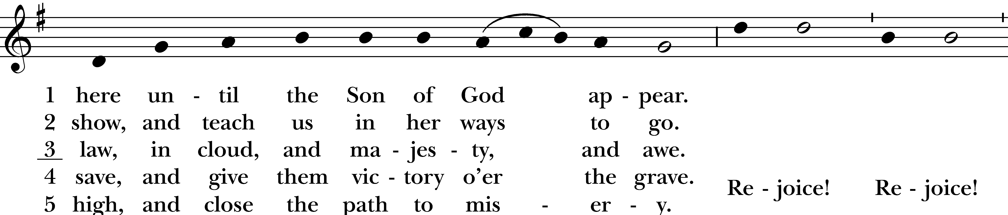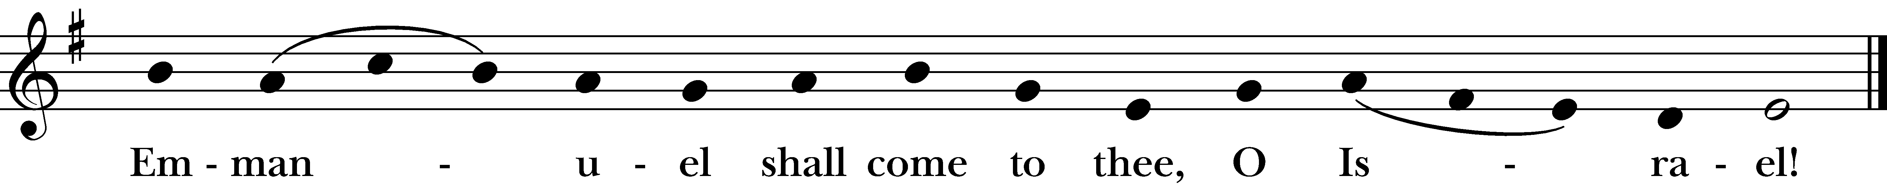
Reprinted/streamed with permission via One License and/or RiteSong. All rights reserved.
The Gospel Matthew 24:36-44

The Holy Gospel of our Lord Jesus Christ, according to Matthew.
Glory to you, Lord Christ.

“But about that day and hour no one knows, neither the angels of heaven, nor the Son, but only the Father. For as the days of Noah were, so will be the coming of the Son of Man. For as in those days before the flood they were eating and drinking, marrying and giving in marriage, until the day Noah entered the ark, and they knew nothing until the flood came and swept them all away, so too will be the coming of the Son of Man. Then two will be in the field; one will be taken and one will be left. Two women will be grinding meal together; one will be taken and one will be left. Keep awake therefore, for you do not know on what day your Lord is coming. But understand this: if the owner of the house had known in what part of the night the thief was coming, he would have stayed awake and would not have let his house be broken into. Therefore you also must be ready, for the Son of Man is coming at an unexpected hour.

The Gospel of the Lord.
Praise to you, Lord Christ.

Reflection Vicki MarkAnthony

Celebrant: Please stand as you are able for The Nicene Creed, found on page 358 of the Book of Common Prayer.

The Nicene Creed BCP p. 358

We believe in one God, the Father, the Almighty, maker of heaven and earth, of all that is, seen and unseen. We believe in one Lord, Jesus Christ, the only Son of God, eternally begotten of the Father, God from God, Light from Light, true God from true God, begotten, not made, of one Being with the Father. Through him all things were made.

For us and for our salvation, he came down from heaven: by the power of the Holy Spirit he became incarnate from the Virgin Mary, and was made man. For our sake he was crucified under Pontius Pilate; he suffered death and was buried. On the third day he rose again in accordance with the Scriptures; he ascended into heaven and is seated at the right hand of the Father. He will come again in glory to judge the living and the dead, and his kingdom will have no end.

We believe in the Holy Spirit, the Lord, the giver of life, who proceeds from the Father and the Son. With the Father and the Son he is worshiped and glorified. He has spoken through the Prophets. We believe in one holy catholic and apostolic Church. We acknowledge one baptism for the forgiveness of sins. We look for the resurrection of the dead, and the life of the world to come. Amen.

Prayers of the People for Advent

Celebrant: In this holy season of Advent, as we wait in hope for the coming of Christ, let us offer our prayers for the church, the world, and all in need, saying, “Come, Lord Jesus, and hear our prayer.”

Subdeacon: O Wisdom, coming forth from the mouth of the Most High, teach your Church to seek the light of your truth. Give us courage to proclaim your love and faithfulness in a world longing for good news. Come, Lord Jesus, and hear our prayer.

O Root of Jesse, standing as a sign among the peoples, bless the nations of the earth. Guide our leaders with your justice, and teach us to walk the paths of peace. Come, Lord Jesus, and hear our prayer.

O Key of David, opening the gates of God’s eternal realm, free us from all that binds us—fear, despair, and division. Open our hearts to the stranger, the lonely, and division. Open our hearts to the stranger, the lonely, and the forgotten. Come, Lord Jesus, and hear our prayer.

O Dayspring, brightness of light everlasting, shine on all who sit in darkness and the shadow of death. Comfort the sick, the grieving, and those who struggle in mind, body, or spirit. Come, Lord Jesus, and hear our prayer.

O Emmanuel, God with us, we give thanks for your presence among us and for the blessings of this life.
Come, Lord Jesus, and hear our prayer.

We remember before you all who have died, trusting in your promise of resurrection. Gather us with them into the joy of your kingdom. Come, Lord Jesus, and hear our prayer.

We pray for all those on our parish prayer list … Come, Lord Jesus, and hear our prayer.

Celebrant: God of hope, as we await the coming of your Son, kindle in us the fire of your love. Make us signs of your Advent in the world, so that all creation may be renewed in your light; through Jesus Christ our Lord. Amen.

The Confession of Sin BCP p. 360

Celebrant: Turning now to page 360 in the Book of Common Prayer, let us confess our sins to God.

Most merciful God, we confess that we have sinned against you in thought, word, and deed,
by what we have done, and by what we have left undone. We have not loved you with our whole heart; we have not loved our neighbors as ourselves. We are truly sorry and we humbly repent. For the sake of our Savior Jesus Christ, have mercy on us and forgive us; that we may delight in your will, and walk in your ways, to the glory of your Name. Amen.

Almighty God have mercy on you, forgive you all your sins through our Lord Jesus Christ, strengthen you in all goodness, and by the power of the Holy Spirit keep you in eternal life. Amen.

The Peace

Celebrant: The peace of the Lord be always with you.
People: And also with you.

Announcements
The Holy Communion

Walk in love, as Christ loved us and gave himself for us, an offering and sacrifice to God. Ephesians 5:2

Offertory Anthem Christ Church Choir

Celebrant: Please stand as you are able and turn to page 367 in the Book of Common Prayer.

Eucharistic Prayer B BCP p. 367

Celebrant: The Lord be with you.
People: And also with you.
Celebrant: Lift up your hearts.
People: We lift them to the Lord.
Celebrant: Let us give thanks to the Lord our God.
People: It is right to give him thanks and praise.

It is right, and a good and joyful thing, always and everywhere to give thanks to you, Father Almighty, Creator of heaven and earth.
Because you sent your beloved Son to redeem us from sin and death, and to make us heirs in him of everlasting life; that when he shall come again in power and great triumph to judge the world, we may without shame or fear rejoice to behold his appearing.
Therefore we praise you, joining our voices with Angels and Archangels and with all the company of heaven, who for ever sing this hymn to proclaim the glory of your Name:
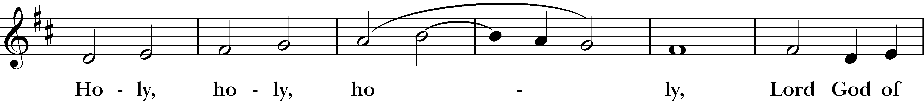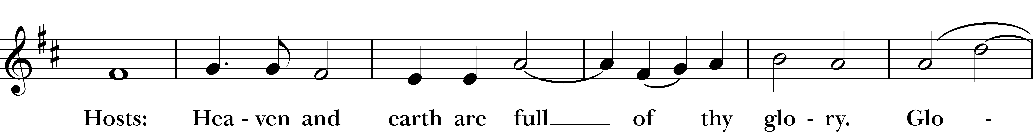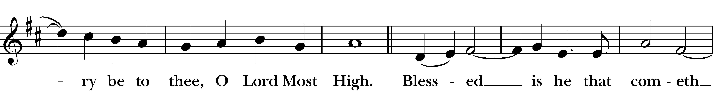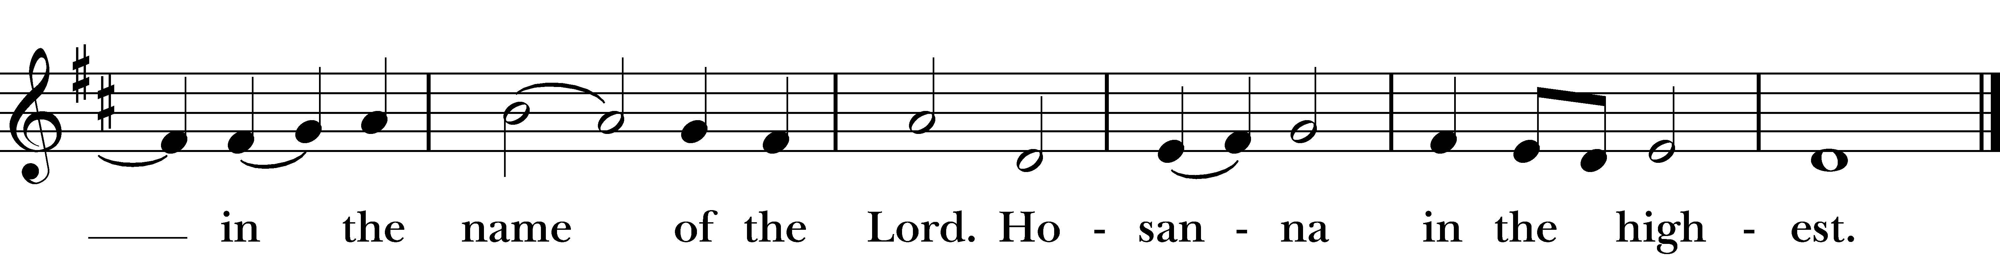

Reprinted/streamed with permission via One License and/or RiteSong. All rights reserved.
We give thanks to you, O God, for the goodness and love which you have made known to us in creation; in the calling of Israel to be your people; in your Word spoken through the prophets; and above all in the Word made flesh, Jesus, your Son. For in these last days you sent him to be incarnate from the Virgin Mary, to be the Savior and Redeemer of the world. In him, you have delivered us from evil, and made us worthy to stand before you. In him, you have brought us out of error into truth, out of sin into righteousness, out of death into life.
On the night before he died for us, our Lord Jesus Christ took bread; and when he had given thanks to you, he broke it, and gave it to his disciples, and said, “Take, eat: This is my Body, which is given for you. Do this for the remembrance of me.”
After supper he took the cup of wine; and when he had given thanks, he gave it to them, and said, “Drink this, all of you: This is my Blood of the new Covenant, which is shed for you and for many for the forgiveness of sins. Whenever you drink it, do this for the remembrance of me.”
Fraction Anthem (sung): “The Bread which we break is the sharing of the body of Christ” (3x’s)

And now, as our Savior Christ has taught us, we are bold to say,

Our Father who art in heaven, hallowed be thy Name, thy kingdom come, thy will be done, on earth as it is in in heaven. Give us this day our daily bread. And forgive us our trespasses as we forgive those who trespass against us. And lead us not into temptation but deliver us from evil. For thine is the kingdom, the power, and the glory, for ever and ever. Amen.

The Breaking of the Bread

Celebrant: Christ our Passover is sacrificed for us.
People: Therefore let us keep the feast.
Celebrant: The Gifts of God for the People of God.

A Prayer for Spiritual Communion:

Let us pray. We believe that you are truly present in the Holy Sacrament, and we pray you to come into our hearts, praying especially with those at home who cannot at this time receive communion. I unite myself with you and embrace you with all my heart, my soul, and my mind. Let nothing separate me from you; let me serve you in this life until, by your grace, I come to your glorious kingdom and unending peace. Amen.

Communion Hymn “Prepare the way of the Lord” James E. Moore, Jr.

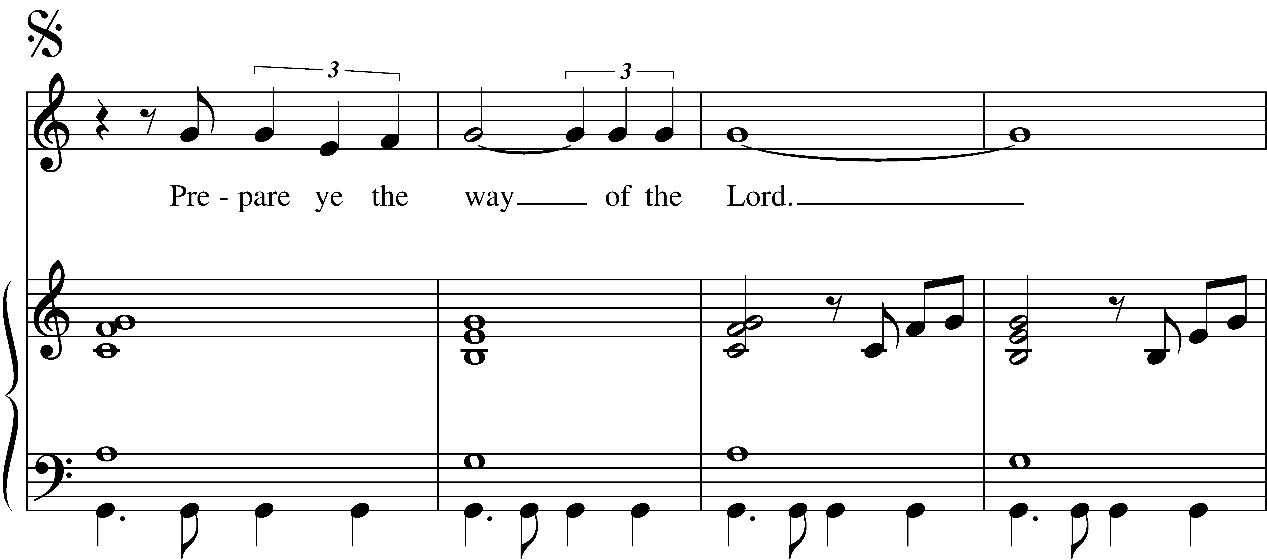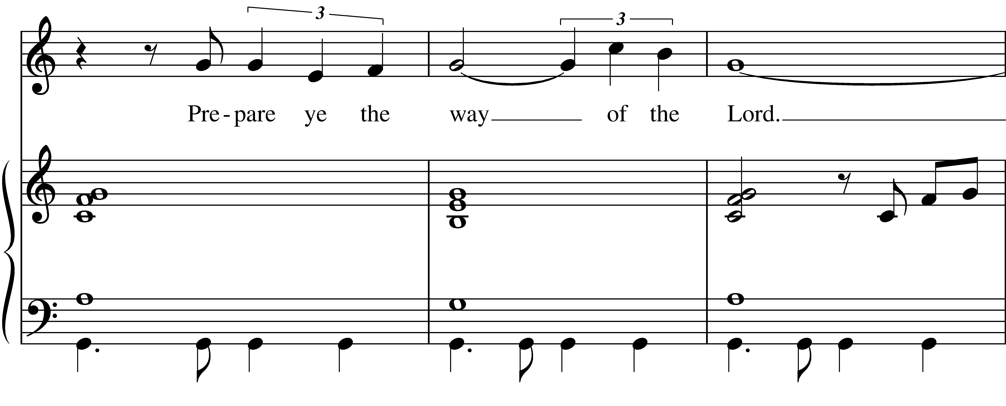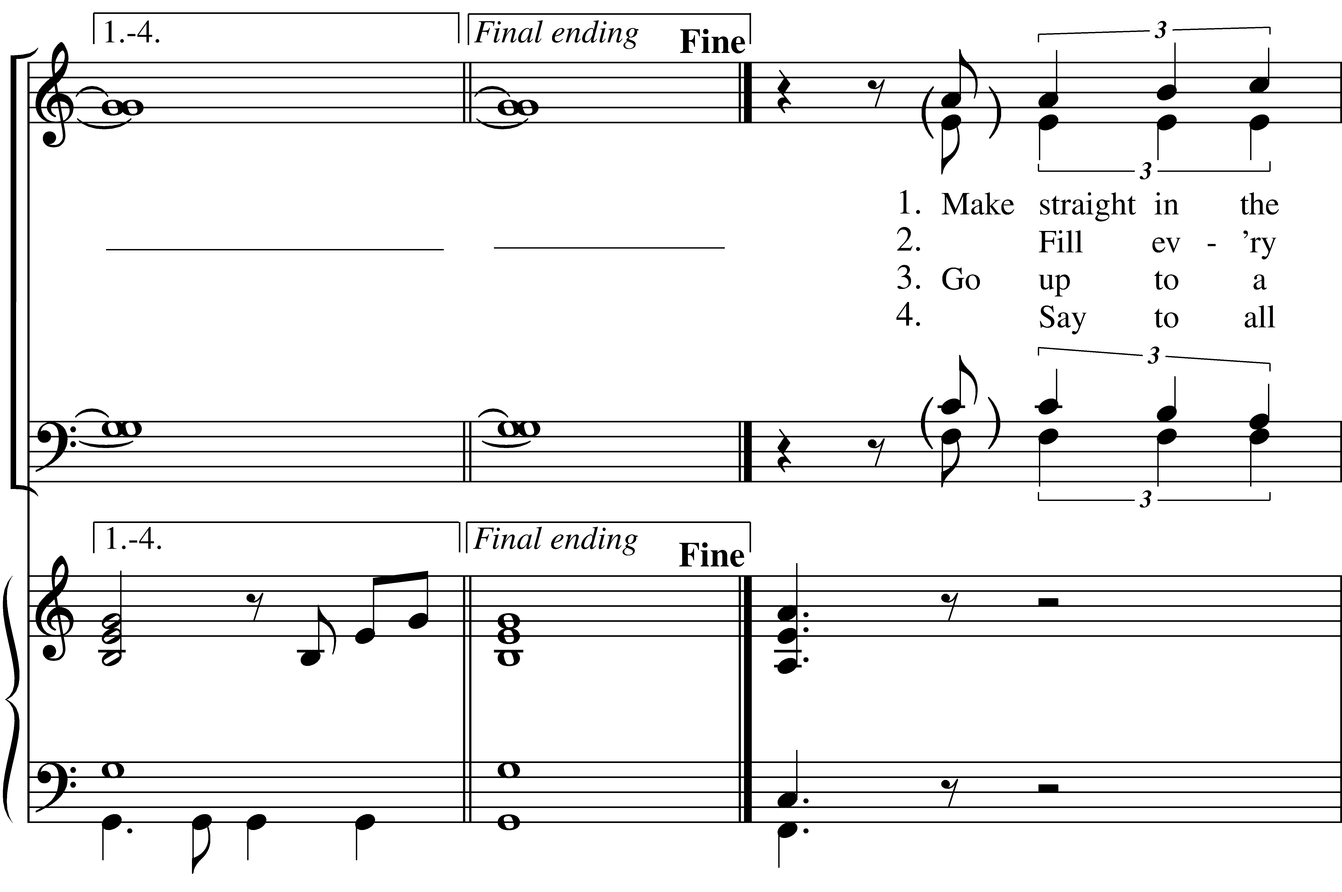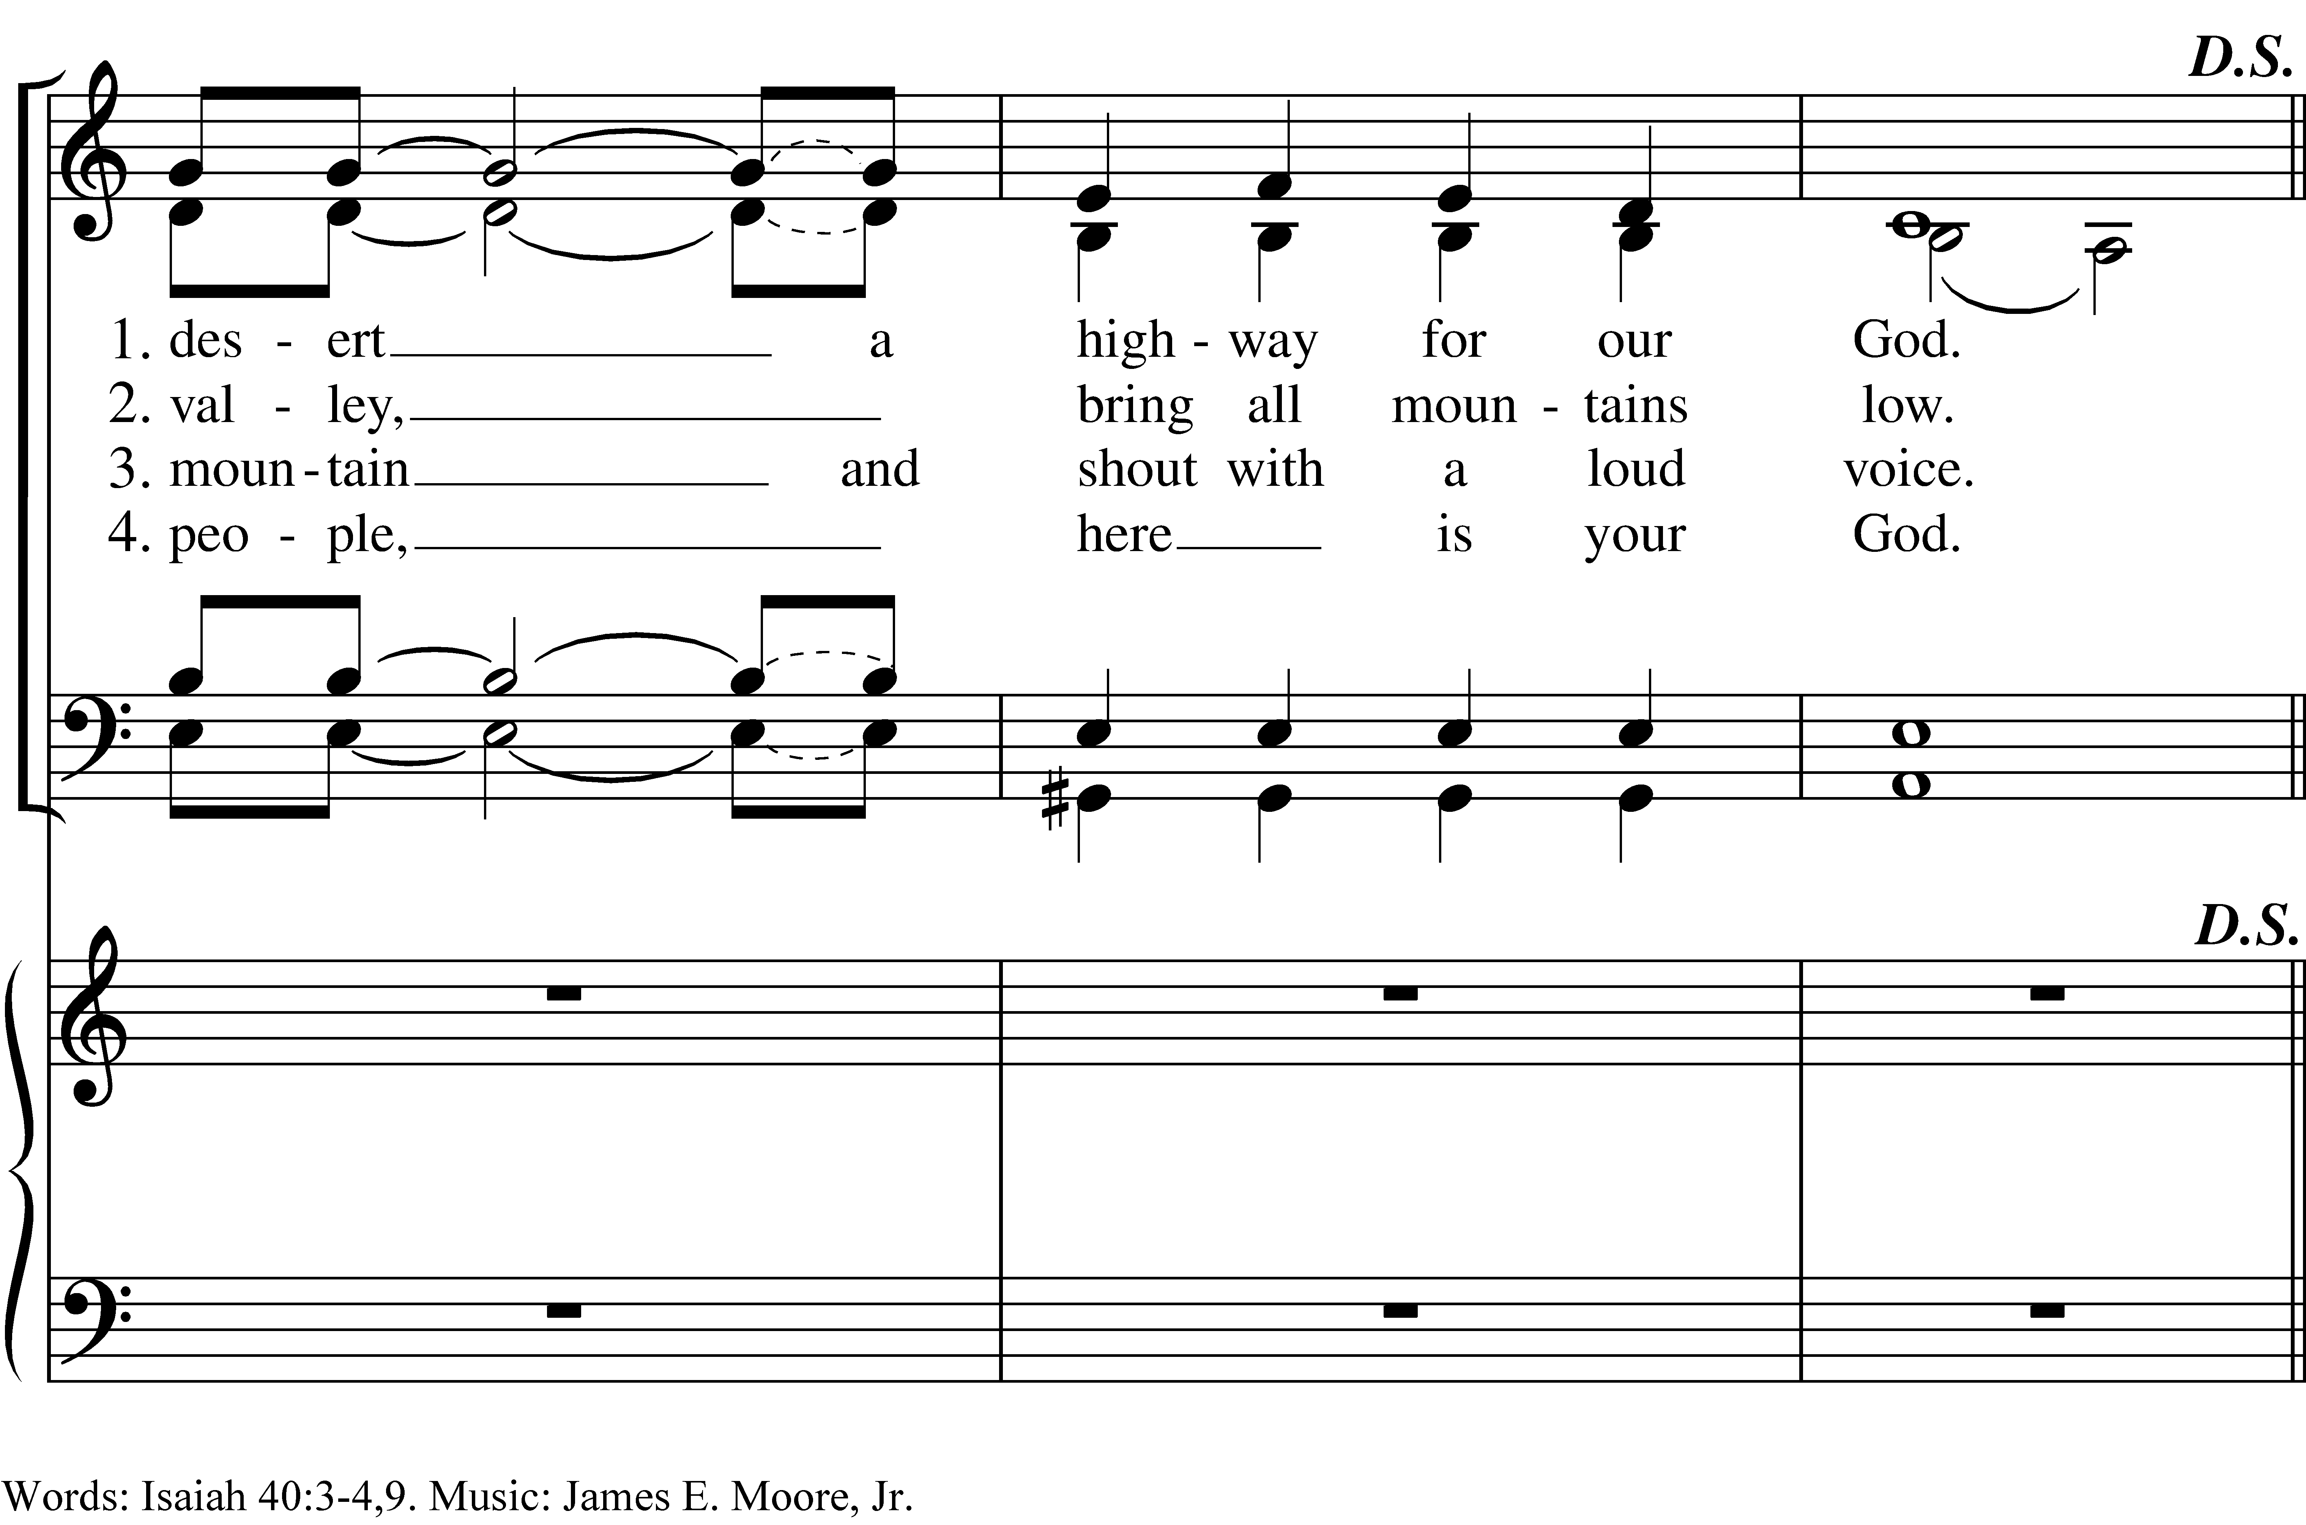
Reprinted/streamed with permission via RiteSong. All rights reserved.
Prayer After Communion BCP 365
Turning now to page 365 in the Book of Common Prayer, let us pray:
Eternal God, heavenly Father, you have graciously accepted us as living members of your Son our Savior Jesus Christ, and you have fed us with spiritual food in the Sacrament of his Body and Blood.
Send us now into the world in peace, and grant us strength and courage to love and serve you with gladness and singleness of heart; through Christ our Lord. Amen.
Blessing Rev. Sandy

Celebrant: Please stand as you are able and sing together our Recessional Hymn, #482, “Lord of all hopefulness.”

Closing Hymn “The King shall come when morning dawns” Hymnal #73
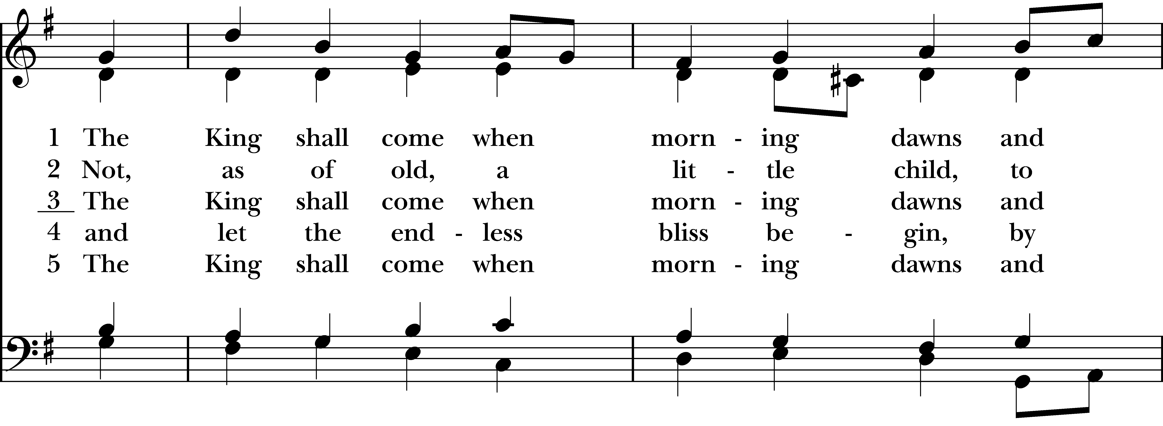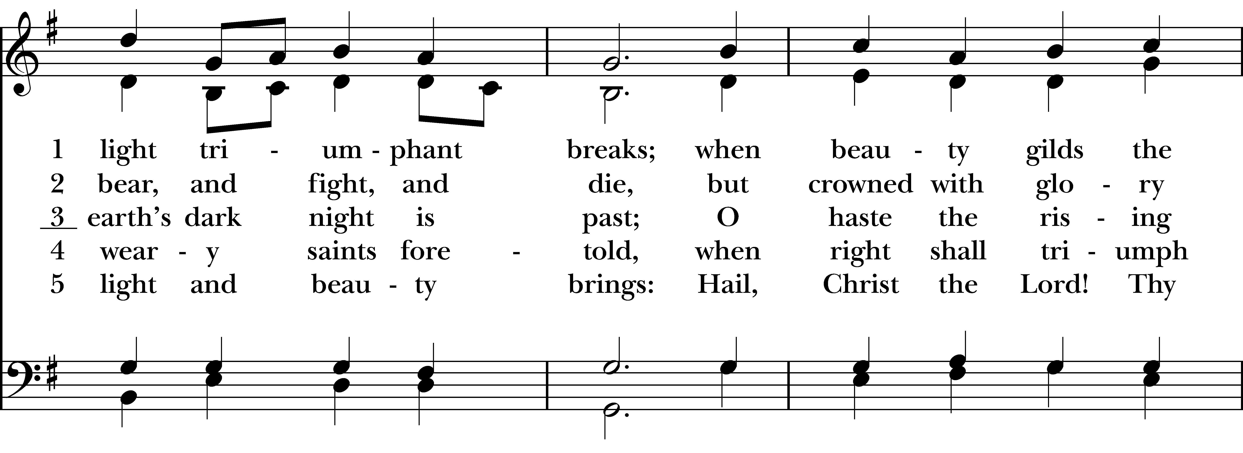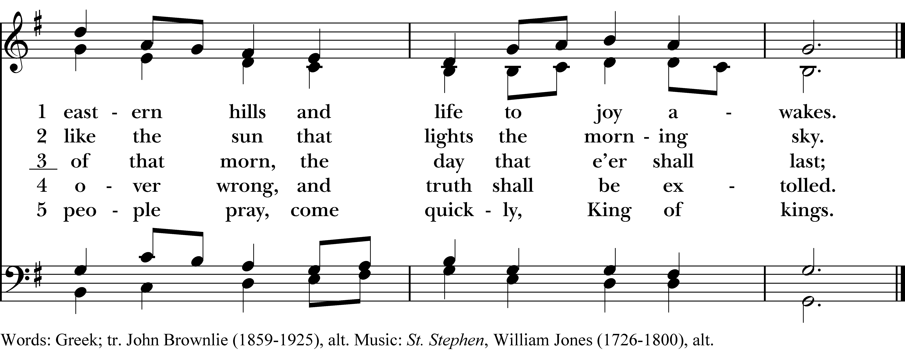
Reprinted/streamed with permission via One License and RiteSong. All rights reserved.
Dismissal
Celebrant: Our worship is ended. Our Service begins. Go in peace to love and serve the Lord.
People: Thanks be to God.

Announcements for November 30th, 2025

NAME TAGS: A reminder to please wear your name tag each week, found in the back of the church.

COFFEE HOUR: Please consider signing up to provide refreshments for an upcoming Sunday.

STEWARDSHIP SEASON: Stewardship Season wraps up today! Please submit your pledge forms to the office as soon as possible or hand them in during the Offertory on the offering plate.

DIAPER DRIVE: Our annual “Baby Shower for Jesus” starts today. Donations of diapers and wipes can be left in the back pews throughout the month of December. Thank you!

ADVENT BIBLE STUDY: Three remaining dates on Wednesday 12/3, 12/10 & 12/17 at 7 pm on Zoom. We are reading A Child is Born by Amy-Jill Levine. Please email Vicki for the Zoom link.

TREE LIGHTING: Saturday, 12/6 at 5 pm with bonfire, caroling and bake sale benefiting the Lakota children of the Cheyenne River Episcopal Mission. Volunteers are needed to bake for the bake sale. Come early at 4:00 for “Cookies with Santa,” downstairs at CCNS!

PAGEANT REHEARSALS: Sunday, 12/14 & 12/21 after service at 10:45 am. Please email the office or let Vicki know if your child would like to participate.

GIFT CARDS to gas stations & grocery stores are always needed. With the holidays upon us, gift cards to big box stores like Target and Walmart are also needed. Thank you for your continued generosity.

UPCOMING WORSHIP DATES – Sunday Services @ 9:30 am

Sunday, 12/7: Eucharist – 2nd Sunday of Advent – Rev. Katy Piazza

Sunday, 12/14: Eucharist – 3rd Sunday of Advent – Fr. Jean Rock

Sunday, 12/21: Eucharist – 4th Sunday of Advent – Rev. Katy Piazza

Sunday, 12/24: Eucharist – Christmas Eve Service & Pageant @ 4 pm – Rev. Katy Piazza
Vestry: Jim Swann, Jr. Warden; Bob Ellwanger, Treasurer; Peg Ellwanger, Clerk

Vestry Members: Russ Bailas, Amy Bailas, Marina Philips, Claire Wilkes

Diocesan Delegates: Diane McCann, Bob Ellwanger; Alternate: Deborah Swann
Music Minister: Tracy Carlucci

Choir Members: Amy Strachan, Andy Verrocchi, Bob Ellwanger, David McCann, Diane McCann, Marina Philips, Katie Tressler, Vicki MarkAnthony

Christ Church Nursery School: Maggie Supple, Director www.ccnseaston.com
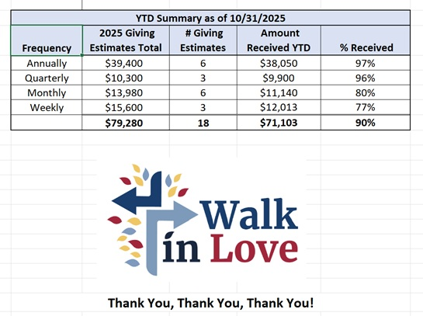
Christ Church – Parish Office Hours:
Mondays & Wednesdays: 9:30-1:30

59 Church Rd, Easton, CT
(203) 268-3569

christchurcheaston@gmail.com
www.christchurcheaston.com

Priest-in-Charge: Katy Piazza

Senior Warden: Vicki MarkAnthony

Parish Administrator: Tracy Carlucci

