**Sunday, October 5th, 2025**

**The Blessing of the Animals &**

**The Feast of St. Francis**

**Rev. Katy Piazza, Priest-in-Charge**

**Christ Church Easton**

*Why do we bless pets on this day?*

*St. Francis of Assisi lived in Italy in the 12th century. Having grown up in a wealthy family, he renounced his wealth and worldly possessions and lived very simply. When Francis spoke, everyone listened, including the animals. He told the animals that Jesus loved them too. There is a story of a wolf who lived in the town of Gubbio. The wolf came into the town each evening, frightening the inhabitants or eating them. Francis went to speak to “Brother Wolf” and found out that the wolf was hungry. Francis explained that that was not reason enough to eat people and their pets or to terrorize them. The wolf became very gentle, the people fed him and he gave the children in the town rides on his back.*

*Francis also brought us the Christmas creche. In the town of Gubbio, he built a small outdoor stable and put people in the stable to portray Mary, Joseph, the shepherds, the angels. Then he added the animals - cow, donkey, sheep, etc. When asked, Francis said, “Surely the animals praised the new Messiah just as the shepherds and angels did.” And so in honor of this blessed saint of the church we gather today with our animals - our pets, our service animals, police dogs and horses, zoo animals and all God’s creatures and give thanks for what they do for us and for what they mean to us.*

*Welcome to Christ Church Easton!*

*Whether you are a newcomer, visitor, or longtime member, we bid you a warm welcome!*

*Please join us for coffee hour following service. Sign up for our email list at www.christchurcheaston.com*

**A Service of Holy Word & Holy Eucharist**

*Celebrant:* As we gather to worship, let us recognize that we gather on the ancestral lands and traditional territory of the (Aspetuck River Valley dwelling) Paugussett people.

**Opening Hymn “All things bright and beautiful” Hymnal #405**

*Reprinted/streamed with permission via One License and/or RiteSong. All rights reserved.*

**The Collect of the Day**

*Celebrant:* Bless the Lord, all you his creatures.

People: Bless the Lord, in heaven and on earth.

*Celebrant:* Most high, omnipotent, good Lord, grant your people grace to renounce gladly the vanities

of this world; that, following the way of blessed Francis, we may for love of you delight in Christ our Lord, who lives and reigns with you and the Holy Spirit, one God, for ever and ever. **Amen.**

**Gloria in Excelsis**

**Glory to God in the highest, and peace to his people on earth. Lord God, heavenly King,  
 almighty God and Father, we worship you, we give you thanks, we praise you for your glory.**

**Lord Jesus Christ, only Son of the Father, Lord God, Lamb of God, you take away the sin of the world:**

**have mercy on us; you are seated at the right hand of the Father: receive our prayer.**

**For you alone are the Holy One, you alone are the Lord, you alone are the Most High, Jesus Christ,**

**with the Holy Spirit, in the glory of God the Father. Amen.**

**Old Testament Reading Genesis 9:8-17**

A Reading from the Book of Genesis.

Then God said to Noah and to his sons with him, “Behold, I establish my covenant with you and your descendants after you, and with every living creature that is with you, the birds, the cattle, and every beast of the earth with you, as many as came out of the ark.I establish my covenant with you, that never again shall all flesh be cut off by the waters of a flood, and never again shall there be a flood to destroy the earth.” And God said, “This is the sign of the covenant which I make between me and you and every living creature that is with you, for all future generations: I set my bow in the cloud, and it shall be a sign of the covenant between me and the earth. When I bring clouds over the earth and the bow is seen in the clouds, I will remember my covenant which is between me and you and every living creature of all flesh; and the waters shall never again become a flood to destroy all flesh. When the bow is in the clouds, I will look upon it and remember the everlasting covenant between God and every living creature of all flesh that is upon the earth.” God said to Noah, “This is the sign of the covenant which I have established between me and all flesh that is upon the earth.”

The Word of the Lord.

**Thanks be to God.**

**The Psalm Psalm 121**

*Let us pray the psalm responsively at the asterisk.*

I lift up my eyes to the hills; *  
**from where is my help to come?**

My help comes from the Lord, *  
**the maker of heaven and earth.**

He will not let your foot be moved *  
**and he who watches over you will not fall asleep.**

Behold, he who keeps watch over Israel *  
**shall neither slumber nor sleep;**

The Lord himself watches over you; * **the Lord is your shade at your right hand,**

So that the sun shall not strike you by day, *  
**nor the moon by night.**

The Lord shall preserve you from all evil; *  
**it is he who shall keep you safe.**

The Lord shall watch over your going out and your coming in, *  
**from this time forth for evermore.**

Gospel Hymn  **“I sing the almighty power of God”** *(vs 1-2 before, vs 3 after)*  **Hymnal #398**

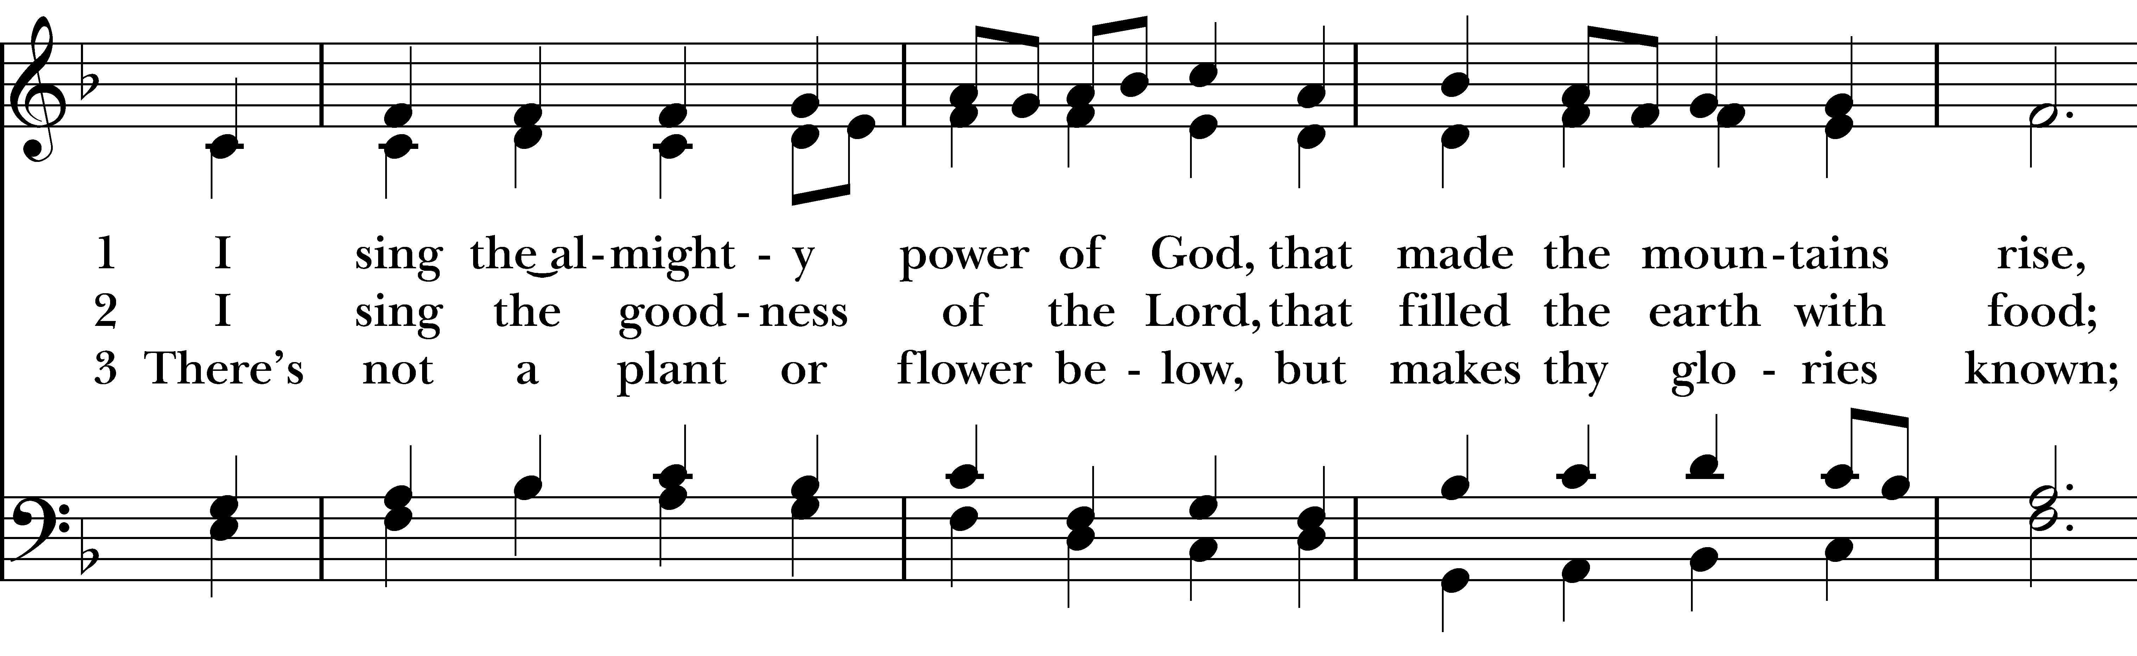  
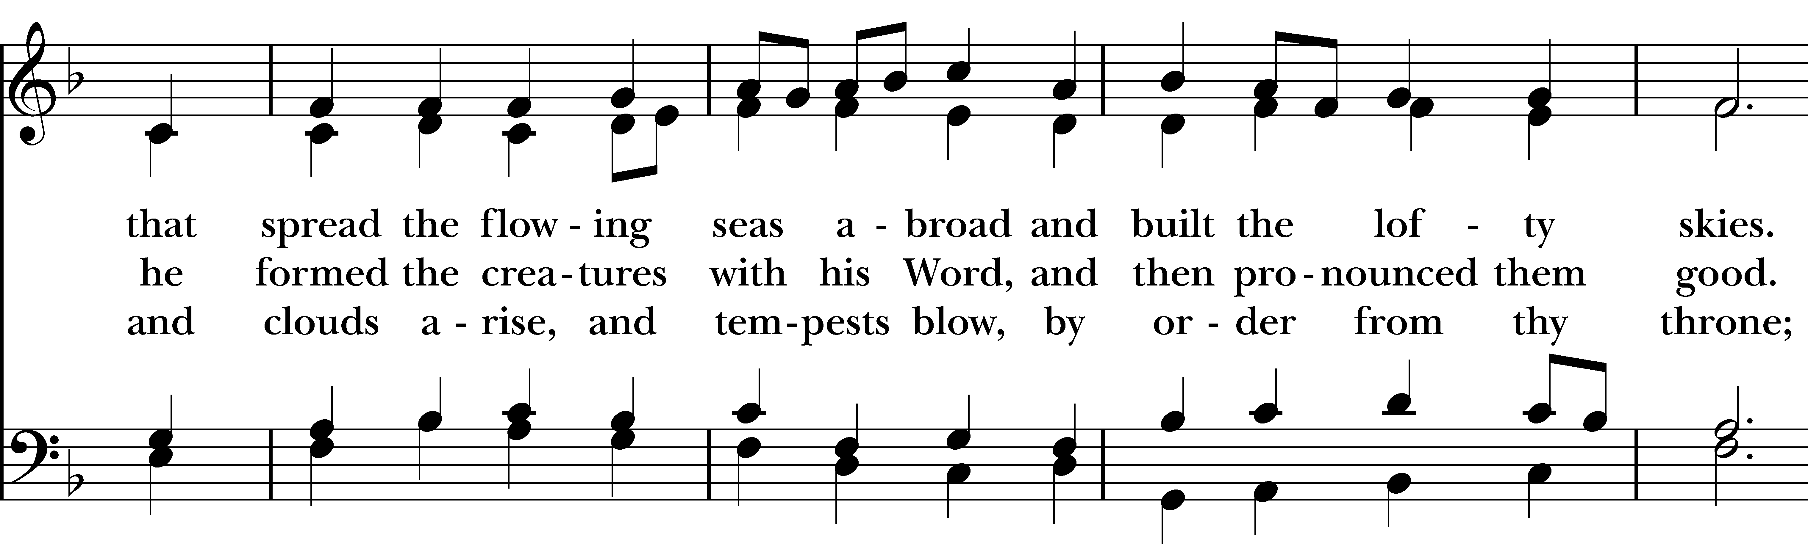  
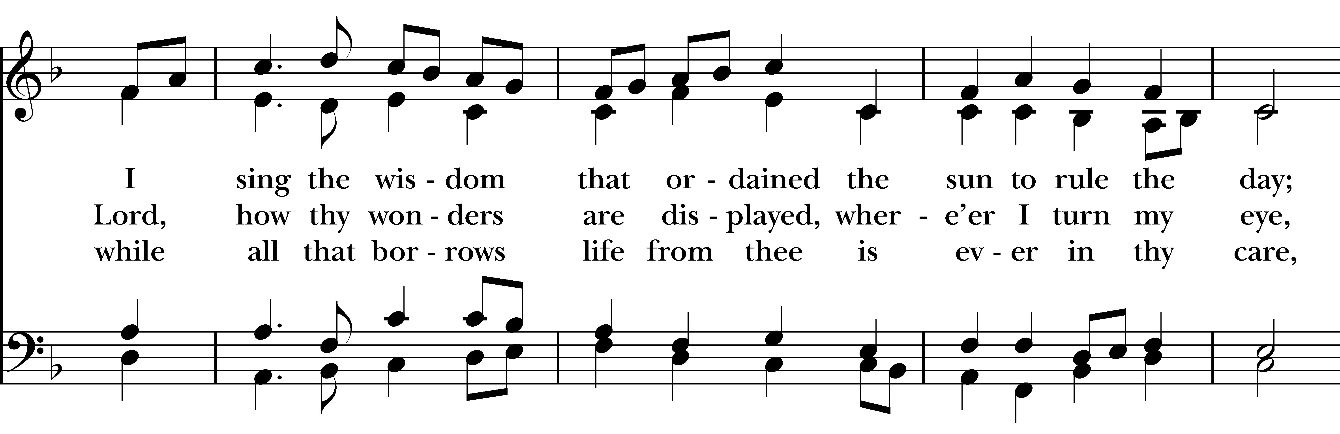  
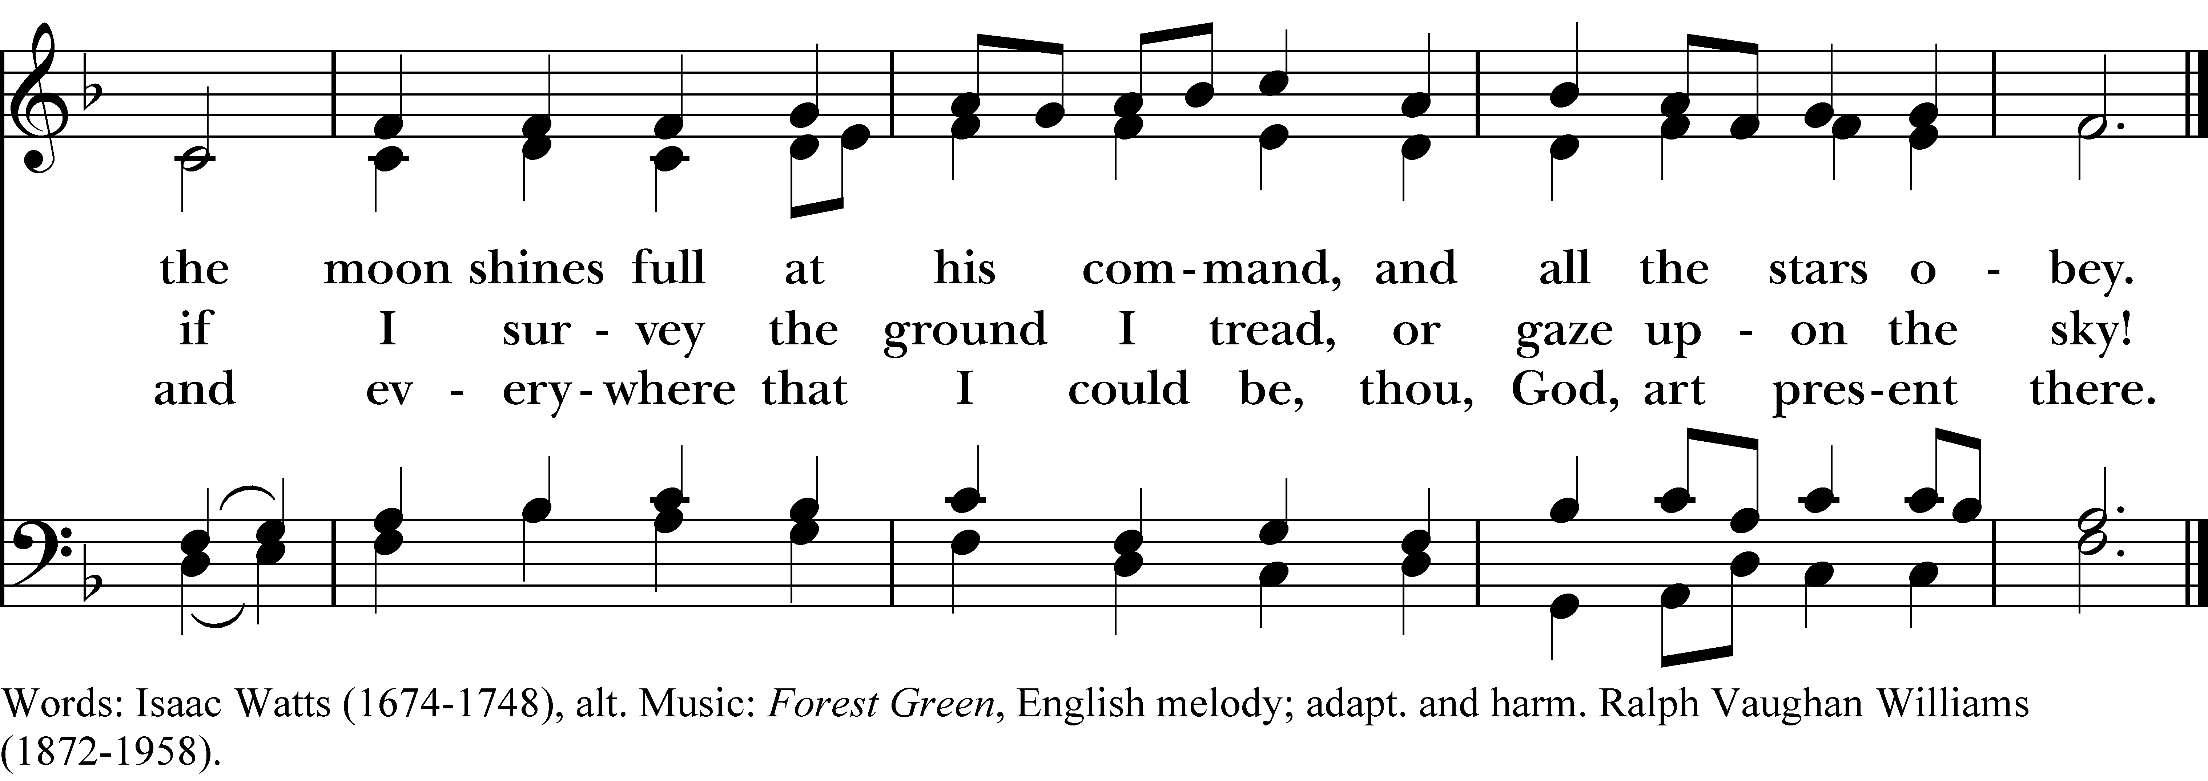

*Reprinted/streamed with permission via One License and/or RiteSong. All rights reserved.*

**The Gospel Matthew 11:25-30**

*The Holy Gospel of our Lord Jesus Christ, according to Matthew.***Glory to you, Lord Christ.**

At that time Jesus said, I thank you, Father, Lord of heaven and earth, because you have hidden these things from the wise and the intelligent and have revealed them to infants; yes, Father, for such was your gracious will.All things have been handed over to me by my Father, and no one knows the Son except the Father, and no one knows the Father except the Son and anyone to whom the Son chooses to reveal him.

“Come to me, all you who are weary and are carrying heavy burdens, and I will give you rest. Take my yoke upon you, and learn from me, for I am gentle and humble in heart, and you will find rest for your souls. For my yoke is easy, and my burden is light.”

The Gospel of the Lord. **Praise to you, Lord Christ.**

**The Sermon Rev. Katy Piazza**

**The Prayers of the People**

*Let us give thanks to God, our Creator, for all the gifts that we have been given.*

We thank you, God: **for the sun and moon, the stars and planets.**

We thank you, God: **for wind and cloud, rain and sun.**

We thank you, God: **for water - to drink, to play in, to bathe in and for baptism.**

We thank you, God: **for fire that gives us light in darkness and warmth.**

We thank you, God: **for Mother Earth who feeds us and protects us. We thank you for flowers, trees, grass, bushes.**

We thank you, God: **for our pets you have entrusted to us. They bring us such joy, they calm us, make us laugh, play with us and keep us safe.**

We thank you, God: **for all the animals on the earth.**

Heavenly Father, our human ties with our friends of other species is a wonderful and special gift from you. We now ask you to grant our special animal companions your care and healing power to take away any suffering they have. Give us, their human friends, new understanding of our responsibilities and connection to your creatures. **Amen.**

**The Blessing of the Animals**

**The Peace**

*Celebrant:* The peace of the Lord be always with you.

**People: And also with you.**

**Announcements**

*A Note about Communion: Christ’s table welcomes all. Simply extend a hand to receive the Eucharist. (Gluten free wafers are available for those who require them). If you would like to receive a blessing instead, simply cross your arms at your chest. If you prefer an individual cup of wine, please let the subdeacon know.*

**The Holy Communion**

Walk in love, as Christ loved us and gave himself for us, an offering and sacrifice to God. *Ephesians 5:2*

**Offertory Anthem “All God’s Creatures Have a Place in the Choir” Katie Tressler**

**Eucharistic Prayer C**

*Celebrant:* The Lord be with you.

**People: And also with you.**

*Celebrant:* Lift up your hearts.

**People: We lift them to the Lord.**

*Celebrant:* Let us give thanks to the Lord our God.

**People: It is right to give God thanks and praise.**

God of all power, Ruler of the Universe, you are worthy of glory and praise. Glory to you for ever and ever.

At your command all things came to be: the vast expanse of interstellar space, galaxies, suns, the planets in their courses, and this fragile earth, our island home. By your will they were created and have their being.

From the primal elements you brought forth the human race, and blessed us with memory, reason, and skill. You made us the rulers of creation. But we turned against you, and betrayed your trust; and we turned against one another. Have mercy, Lord, for we are sinners in your sight.

Again and again, you called us to return. Through prophets and sages you revealed your righteous Law. And in the fullness of time you sent your only Son, born of a woman, to fulfill your Law, to open for us the way of freedom and peace. By his blood, he reconciled us. By his wounds, we are healed.

And therefore we praise you, joining with the heavenly chorus, with prophets, apostles, and martyrs, and with all those in every generation who have looked to you in hope, to proclaim with them your glory, in their unending hymn.

**Holy, holy, holy Lord, God of power and might,**

**Heaven and earth are full of your glory. Hosanna in the highest.**

**Blessed is he who comes in the name of the Lord. Hosanna in the highest.**

And so, Father, we who have been redeemed by him, and made a new people by water and the Spirit, now bring before you these gifts. Sanctify them by your Holy Spirit to be the Body and Blood of Jesus Christ our Lord.

On the night he was betrayed he took bread, said the blessing, broke the bread, and gave it to his friends, and said, “Take, eat: This is my Body, which is given for you. Do this for the remembrance of me.”

After supper, he took the cup of wine, gave thanks, and said, “Drink this, all of you: This is my Blood of the new Covenant, which is shed for you and for many for the forgiveness of sins. Whenever you drink it, do this for the remembrance of me.”

Remembering now his work of redemption, and offering to you this sacrifice of thanksgiving, We celebrate his death and resurrection, as we await the day of his coming.

Lord God of our Fathers: God of Abraham, Isaac, and Jacob; God and Father of our Lord Jesus Christ: Open our eyes to see your hand at work in the world about us. Deliver us from the presumption of coming to this Table for solace only, and not for strength; for pardon only, and not for renewal. Let the grace of this Holy Communion make us one body, one spirit in Christ, that we may worthily serve the world in his name. Risen Lord, be known to us in the breaking of the Bread.

Accept these prayers and praises, Father, through Jesus Christ our great High Priest, to whom, with you and the Holy Spirit, your Church gives honor, glory, and worship, from generation to generation, **AMEN.**

And now, as our Savior Christ has taught us, we are bold to say,

**Our Father who art in heaven, hallowed be thy Name, thy kingdom come, thy will be done, on earth as it is in in heaven. Give us this day our daily bread. And forgive us our trespasses as we forgive those who trespass against us. And lead us not into temptation but deliver us from evil. For thine is the kingdom, the power, and the glory, for ever and ever. Amen.**

**The Breaking of the Bread**

*Celebrant:* Alleluia. Christ our Passover is sacrificed for us;

**People: Therefore let us keep the feast. Alleluia.**

*Celebrant:* The Gifts of God for the People of God.

**A Prayer for Spiritual Communion:**

*Let us pray.* **We believe that you are truly present in the Holy Sacrament, and we pray you to come into our hearts, praying especially with those at home who cannot at this time receive communion. I unite myself with you and embrace you with all my heart, my soul, and my mind. Let nothing separate me from you; let me serve you in this life until, by your grace, I come to your glorious kingdom and unending peace. Amen.**

**Communion Hymn “Make me a channel of your peace” Sebastian Temple**

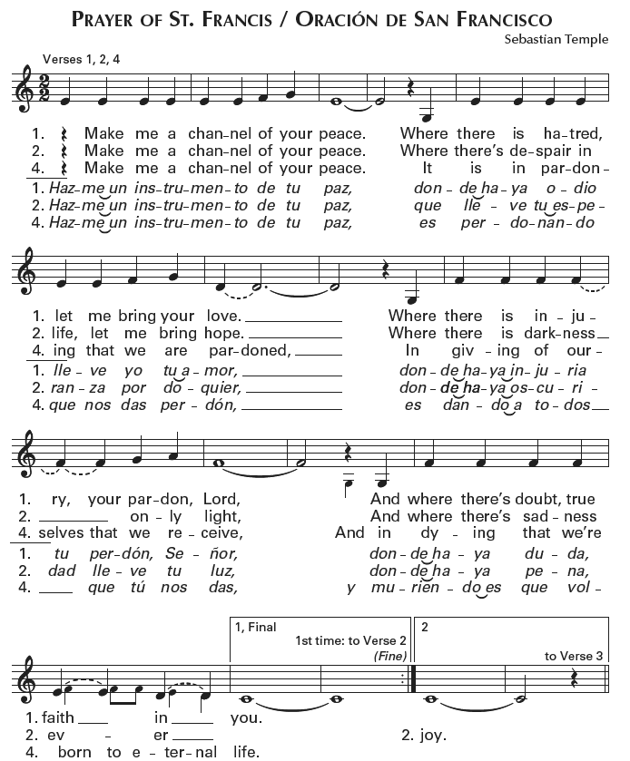

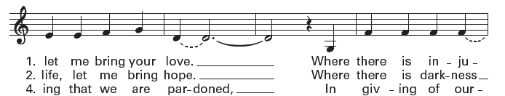

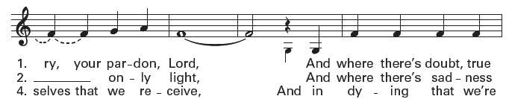



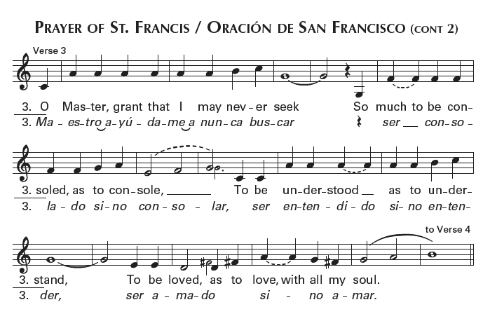



**Prayer After Communion**

*Let us pray.* **God of abundance, you have fed us with the bread of life and cup of salvation; you have united us with Christ and one another; and you have made us one with all your people in heaven and on earth. Now send us forth in the power of your Spirit, that we may proclaim your redeeming love to the world and continue for ever in the risen life of Christ our Savior. Amen.**

**Blessing**

May you be instruments of God’s peace. Where there is hatred, sow love; where there is injury, pardon; where there is discord, union; where there is doubt, faith; where there is despair, hope; where there is darkness, light; where there is sadness, joy; and may the Blessing of God Almighty, Father, Son, and Holy Spirit, be upon you now and forever. **Amen.**

**Recessional Hymn “All creatures of our God and King” Hymnal #400**

*(verse 1, 4 & 7)*

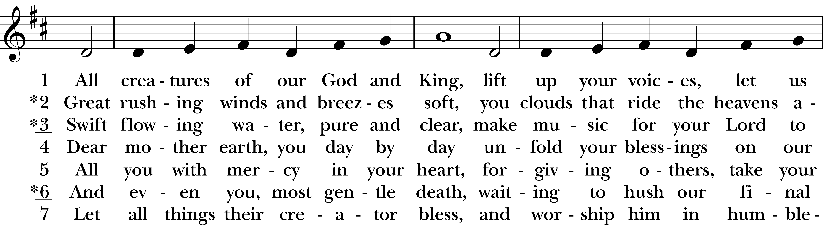  
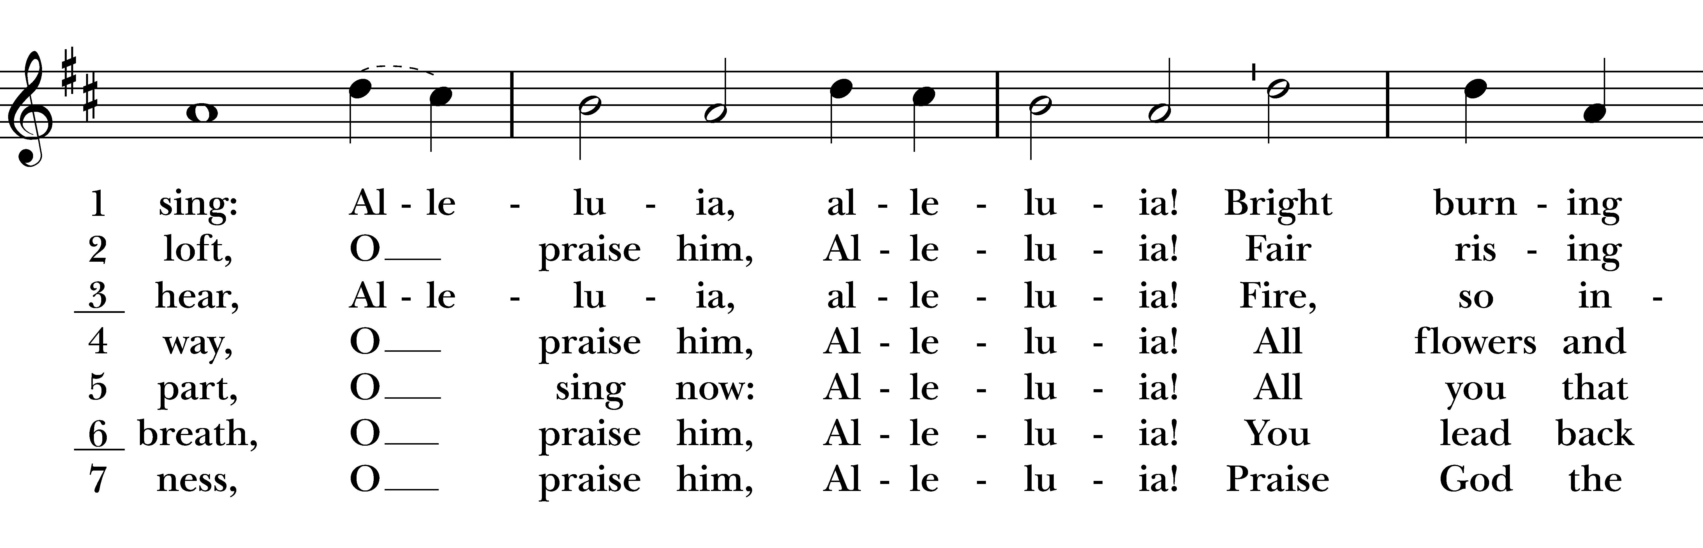  
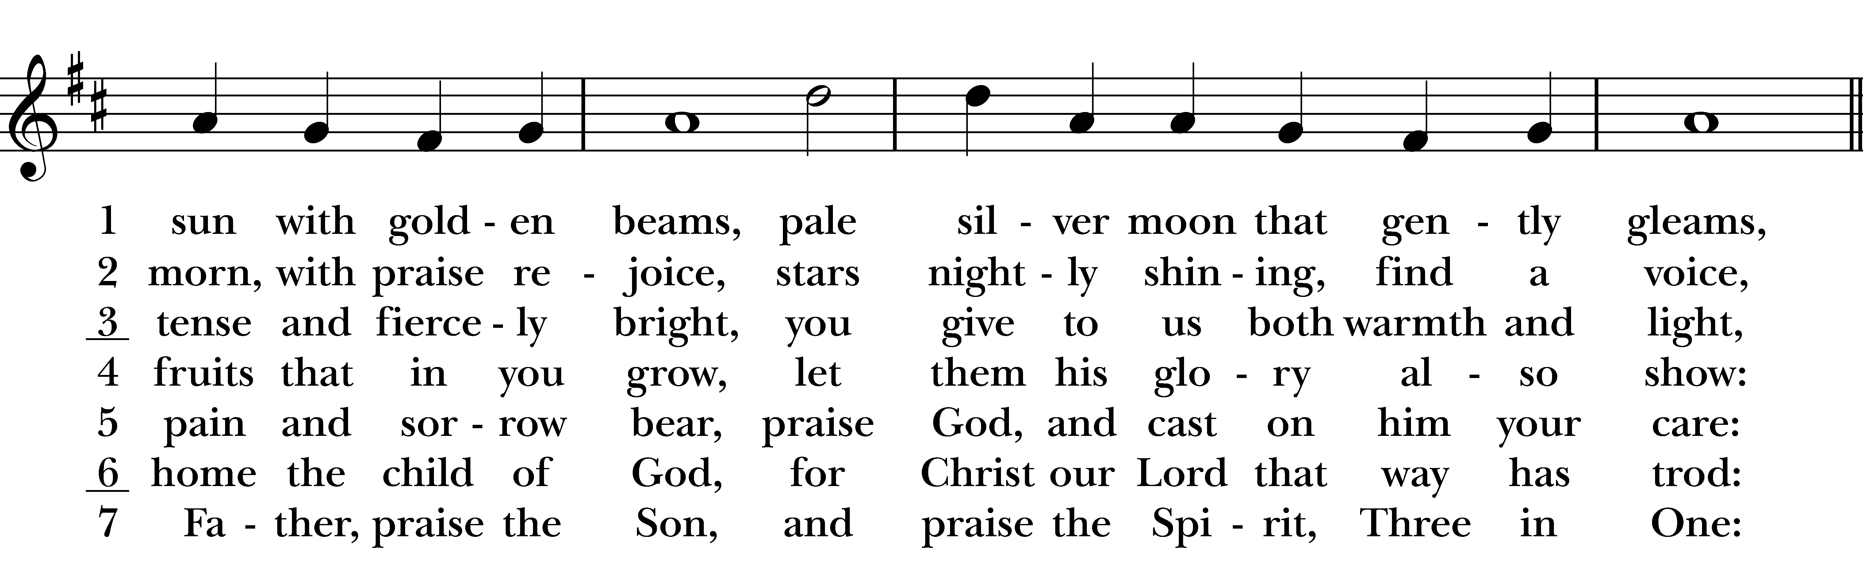  
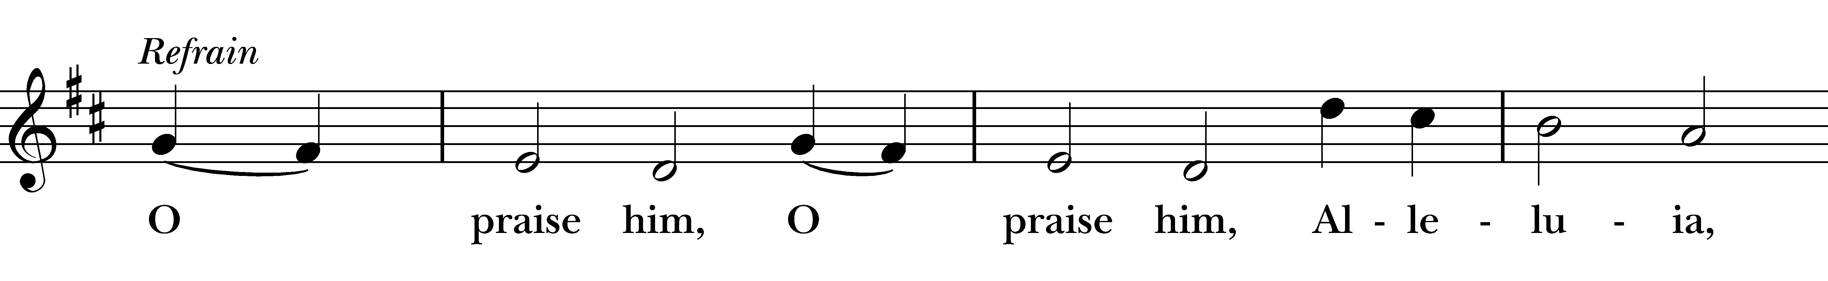  
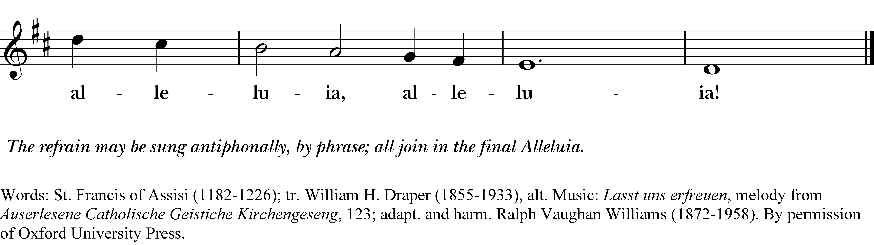

*Reprinted/streamed with permission via One License and RiteSong. All rights reserved.*

**Dismissal**

Go in peace to love and serve the Lord. Alleluia, alleluia. **Thanks be to God. Alleluia, alleluia.**

**Announcements for October 5th, 2025**

**COFFEE HOUR:** Please consider signing up for an upcoming Sunday.

**SOCKTOBER:** We are collecting socks for the month of October for the Greater Bridgeport Ministry Network, who is hosting their annual sock collection for food pantries, shelters & the homeless in the Greater Bridgeport community. Please bring new socks and leave in the back pews.

**UKRAINE AID INTERNATIONAL:** Supplies are desperately needed for Ukraine, including for Easton’s sister city, Sviatohirsk. Purchase items on their Amazon wishlist: [www.tinyurl.com/ukraineaidwishlist](http://www.tinyurl.com/ukraineaidwishlist)

**OCTOBER BOOK CLUB:** We are reading *Living Buddha, Living Christ* by Thich Nhat Hanh. Zoom discussions on Wednesdays at 7 pm throughout October. Contact Vicki for the link.

**CCGB READ & DISCUSS:** *Baptized in Tear Gas by Elle Dowd.* Anti-racism book discussion, hosted by the Council of Churches of Greater Bridgeport. Zoom Monday 10/6 at 6:30 pm and/or Tuesday 10/7 at 10 am.

**BRAVER ANGELS: DEPOLARIZING WITHIN:** WorkshopSat, 10/18, 1:00-4:30 pm, Easton Public Library.

**ANNUAL 5K RACE:** Saturday, 10/25 at Christ Church. We need volunteers to contribute to the bake sale and to help with race registration that morning.

**VESTRY MEETING:** Tuesday, 10/28 at 7 pm on Zoom. All are welcome. Email Vicki for the Zoom link.

**GIFT CARDS** to gas stations/grocery stores are always needed. Thank you for your continued generosity.

**UPCOMING WORSHIP DATES**

***All services at 9:30 am***

**Sunday, 10/12: Morning Prayer & Indigenous Peoples Day (Andy Hathaway)**

**Sunday, 10/19: Eucharist (Rev. Stephen Nagy)**

**Sunday, 10/26: Eucharist** (Rev. Katy Piazza)

**Sunday, 11/2: Eucharist** (Fr. Jean Rock)

**Christ Church – Parish Office:**

(203) 268-3569 | [christchurcheaston@gmail.com](mailto:christchurcheaston@gmail.com)

59 Church Rd, Easton, CT | [www.christchurcheaston.com](http://www.christchurcheaston.com)

**Senior Warden:** Vicki MarkAnthony

**Parish Administrator:** Tracy Carlucci

**Music Minister:** Tracy Carlucci

**Choir Members:** Amy Strachan, Andy Verrocchi, Bob Ellwanger, David McCann, Diane McCann, Marina Philips, Katie Tressler, Vicki MarkAnthony

**Christ Church Nursery School**: Maggie Supple, Director [www.ccnseaston.com](http://www.ccnseaston.com)

**Vestry:** Jim Swann, Jr. Warden; Bob Ellwanger, Treasurer; Peg Ellwanger, Clerk

**Vestry Members**: Russ Bailas, Amy Bailas, Marina Philips, Claire Wilkes

**Diocesan Delegates:** Diane McCann, Bob Ellwanger; Alternate: Deborah Swann