**The Holy Baptism of Wesley Martin Matos**

**Sunday, May 25, 2025: The Sixth Sunday of Easter**

**Rev. John Branson, Supply Priest**

**Christ Church Easton**

*Celebrant:* As we gather to worship, let us recognize that we gather on the ancestral lands and traditional territory of the (Aspetuck River Valley dwelling) Paugussett people.

**Processional Hymn “Jesus shall reign where’er the sun” Hymnal #544**

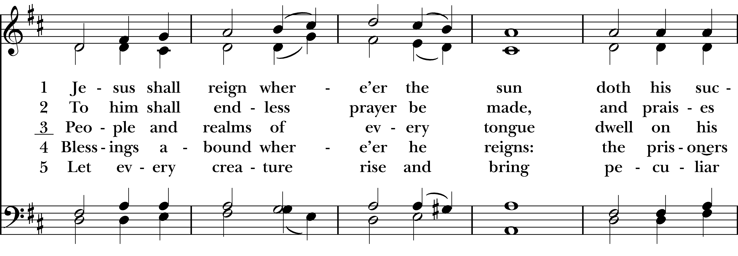  
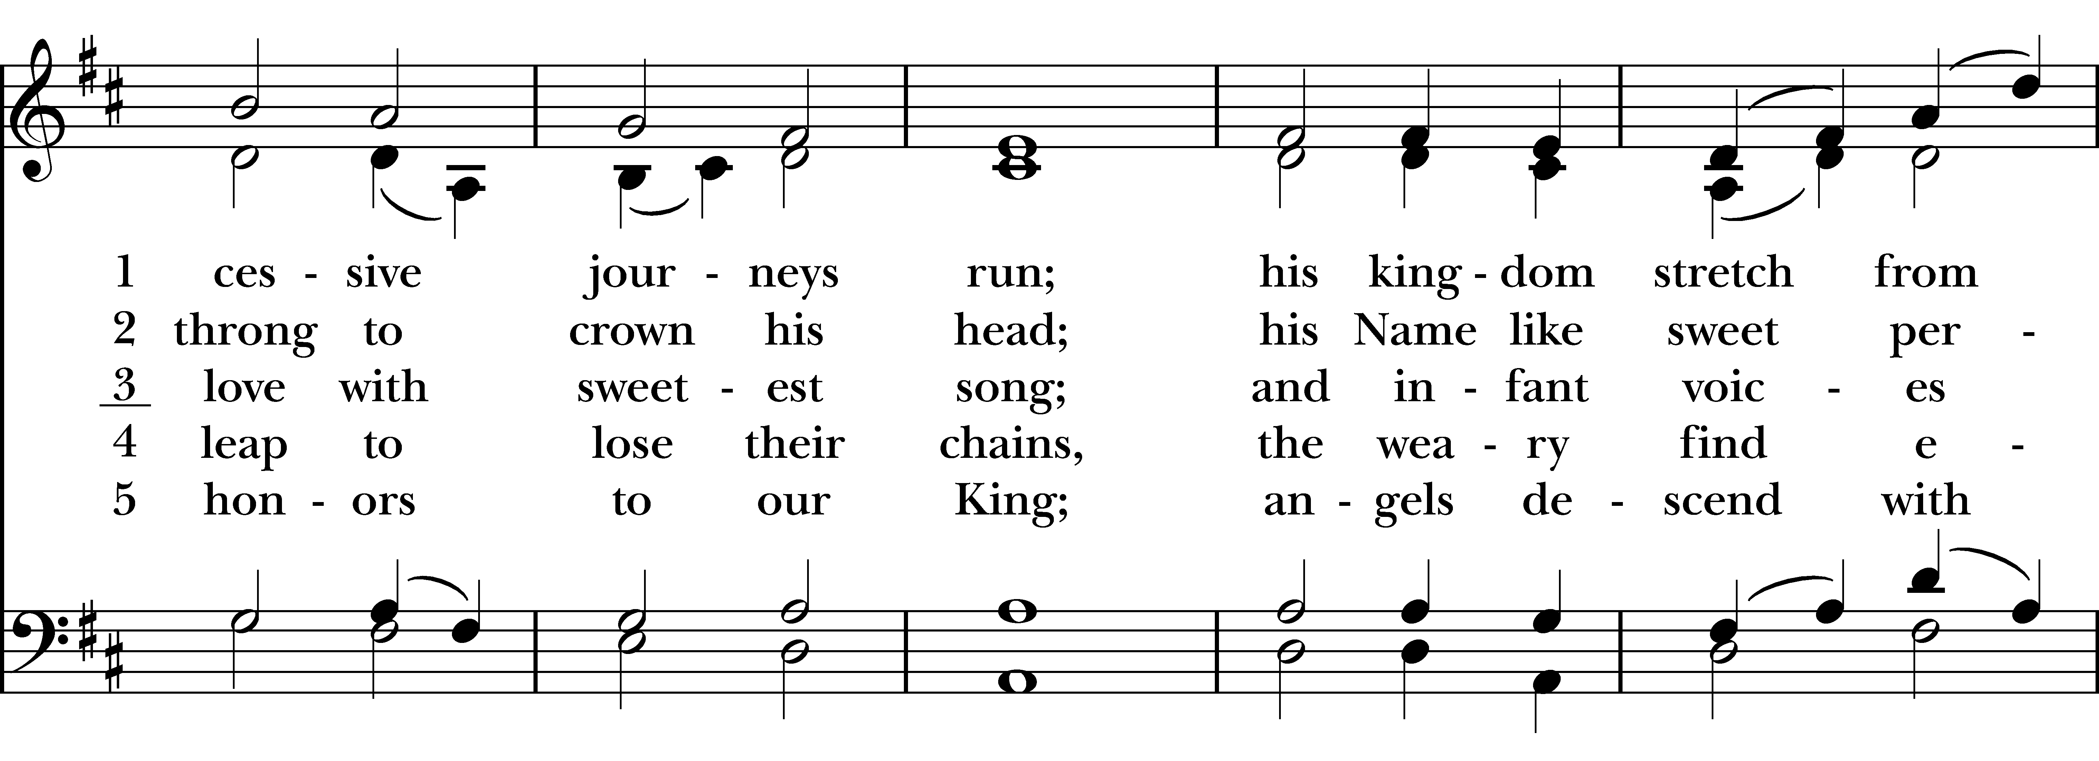  
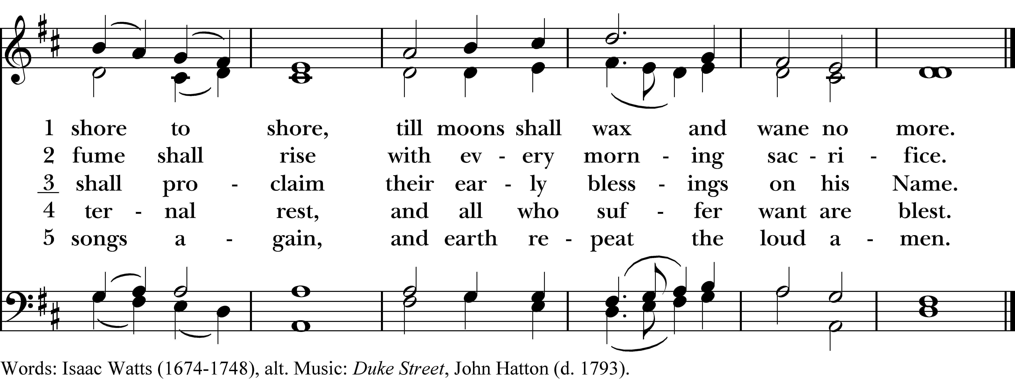

**Opening Acclamation**

Alleluia. Christ is risen.   
The Lord is risen indeed. Alleluia.

There is one Body and one Spirit;  
There is one hope in God’s call to us;

One Lord, one Faith, one Baptism;  
One God and Father of all.

**The Collect of the Day**

The Lord be with you.

And also with you.  
Let us pray.

O God, you have prepared for those who love you such good things as surpass our understanding: Pour into our hearts such love towards you, that we, loving you in all things and above all things, may obtain your promises, which exceed all that we can desire; through Jesus Christ our Lord, who lives and reigns with you and the Holy Spirit, one God, for ever and ever. Amen.

**The First Reading Acts 16:9-15**

A Reading from the Acts of the Apostles.

During the night Paul had a vision: there stood a man of Macedonia pleading with him and saying, “Come over to Macedonia and help us.” When he had seen the vision, we immediately tried to cross over to Macedonia, being convinced that God had called us to proclaim the good news to them. We set sail from Troas and took a straight course to Samothrace, the following day to Neapolis, and from there to Philippi, which is a leading city of the district of Macedonia and a Roman colony. We remained in this city for some days. On the sabbath day we went outside the gate by the river, where we supposed there was a place of prayer; and we sat down and spoke to the women who had gathered there. A certain woman named Lydia, a worshiper of God, was listening to us; she was from the city of Thyatira and a dealer in purple cloth. The Lord opened her heart to listen eagerly to what was said by Paul. When she and her household were baptized, she urged us, saying, “If you have judged me to be faithful to the Lord, come and stay at my home.” And she prevailed upon us.

The Word of the Lord.  
Thanks be to God.

**Psalm 67**

May God be merciful to us and bless us, *  
**show us the light of his countenance and come to us.**

Let your ways be known upon earth, *  
**your saving health among all nations.**

Let the peoples praise you, O God; *  
**let all the peoples praise you.**

Let the nations be glad and sing for joy, *  
**for you judge the peoples with equity and guide all the nations upon earth.**

Let the peoples praise you, O God; *  
**let all the peoples praise you.**

The earth has brought forth her increase; *  
**may God, our own God, give us his blessing.**

May God give us his blessing, *  
**and may all the ends of the earth stand in awe of him.**

**The Second Reading Revelation 21:10,22-22:5**

A Reading from the Book of Revelation.

And in the spirit he carried me away to a great, high mountain and showed me the holy city Jerusalem coming down out of heaven from God. I saw no temple in the city, for its temple is the Lord God the Almighty and the Lamb. And the city has no need of sun or moon to shine on it, for the glory of God is its light, and its lamp is the Lamb. The nations will walk by its light, and the kings of the earth will bring their glory into it. Its gates will never be shut by day—and there will be no night there. People will bring into it the glory and the honor of the nations. But nothing unclean will enter it, nor anyone who practices abomination or falsehood, but only those who are written in the Lamb’s book of life.

Then the angel showed me the river of the water of life, bright as crystal, flowing from the throne of God and of the Lamb through the middle of the street of the city. On either side of the river is the tree of life with its twelve kinds of fruit, producing its fruit each month; and the leaves of the tree are for the healing of the nations. Nothing accursed will be found there any more. But the throne of God and of the Lamb will be in it, and his servants will worship him; they will see his face, and his name will be on their foreheads. And there will be no more night; they need no light of lamp or sun, for the Lord God will be their light, and they will reign forever and ever.

The Word of the Lord. **Thanks be to God.**

Gospel Hymn “How wondrous and great thy works, God of praise!” *(vs 1 before/vs 2 after)* Hymnal #533

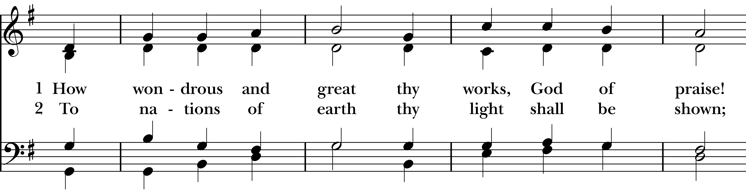  
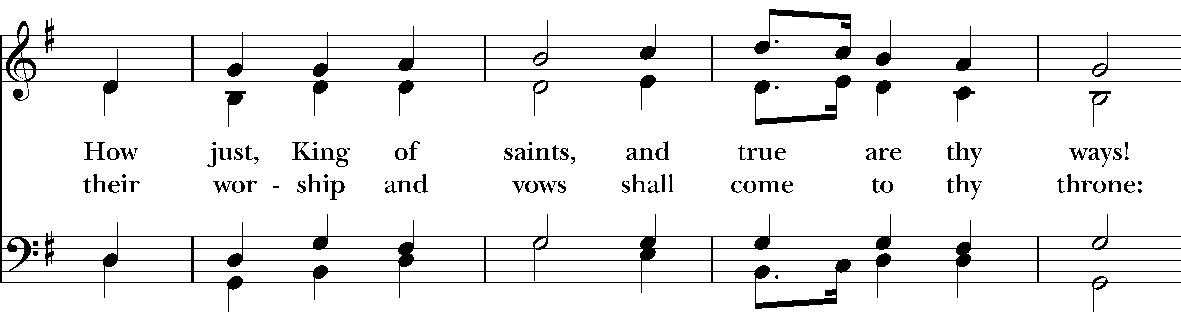  
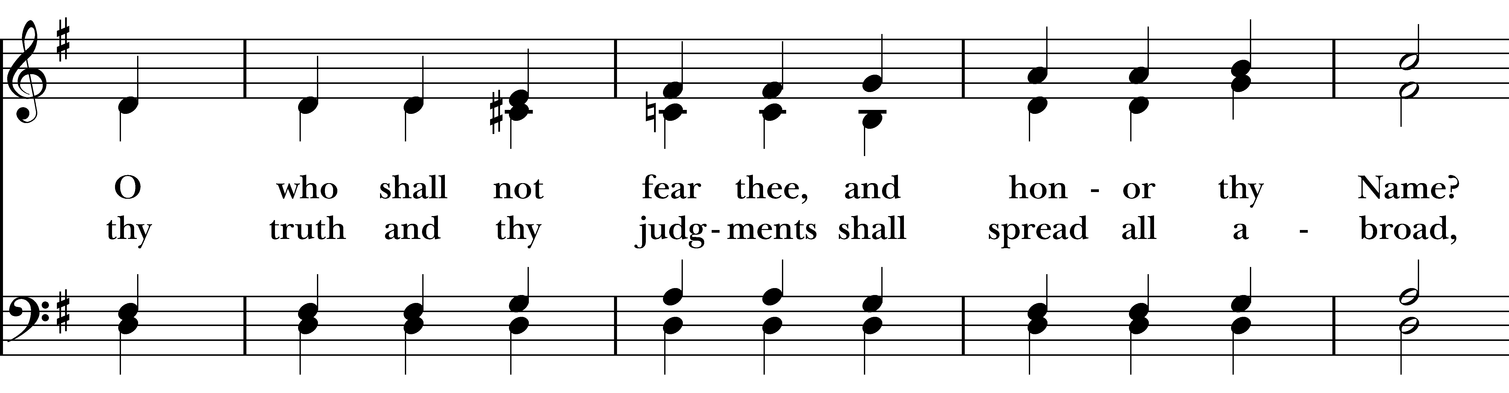  
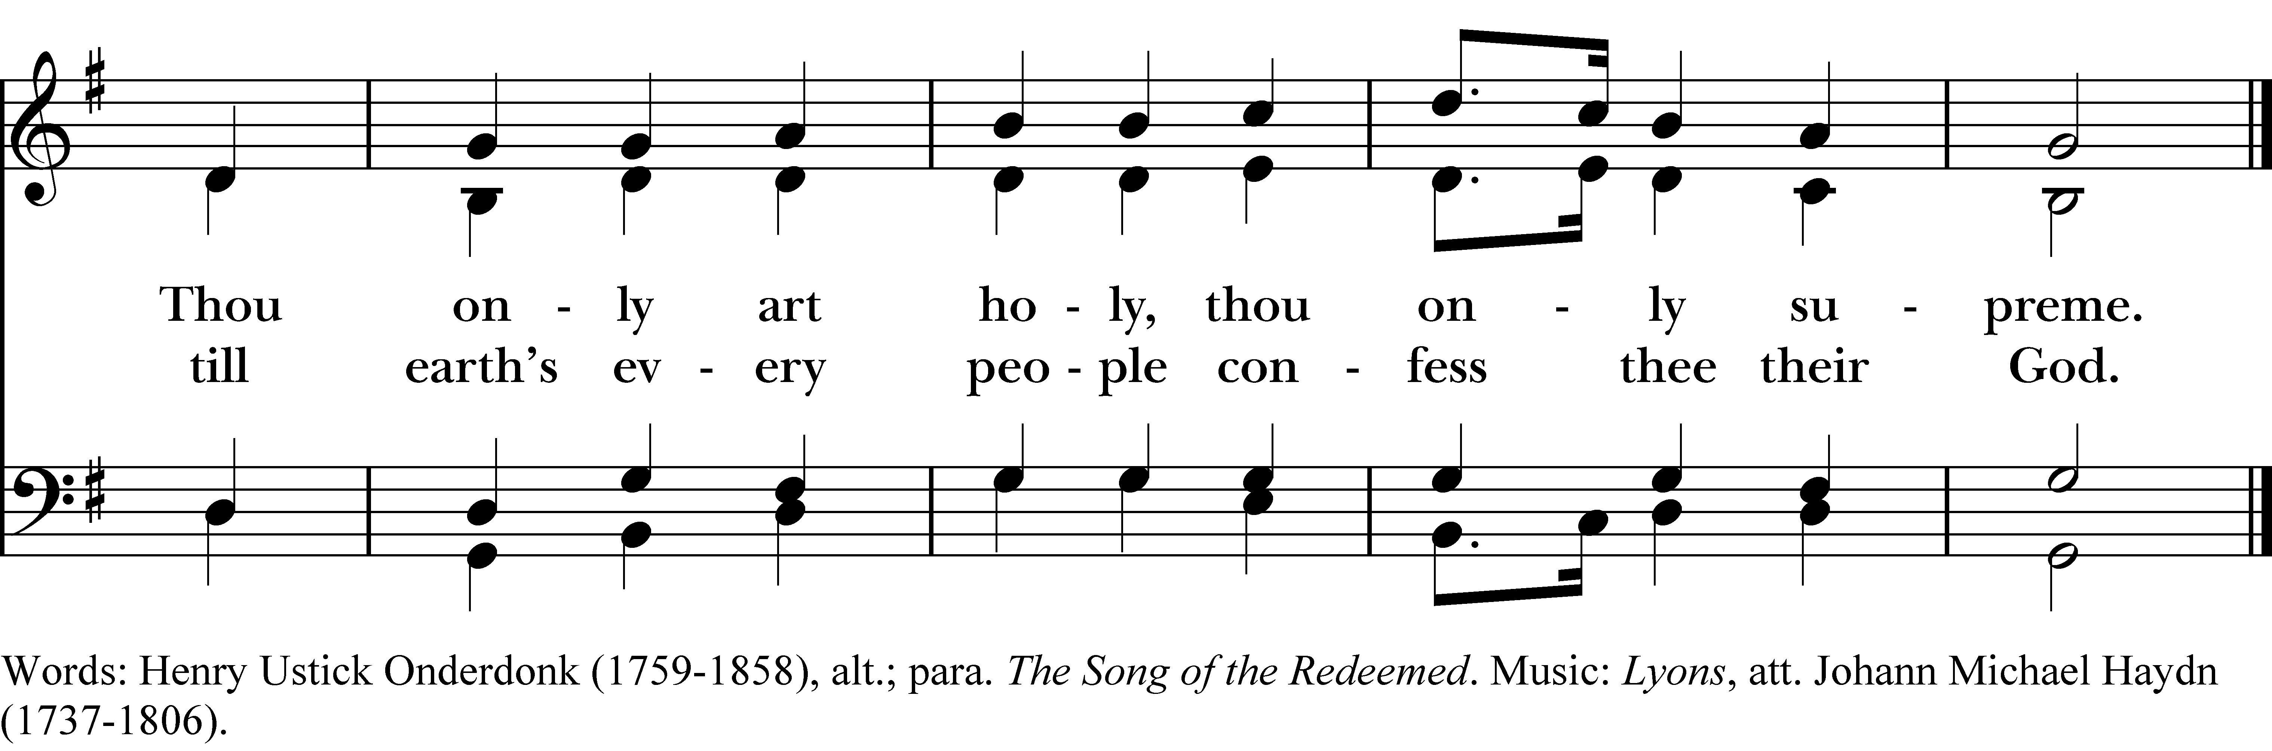

**The Gospel John 14:23-29**

The Holy Gospel of our Lord Jesus Christ, according to Saint John.  
Glory to you, Lord Christ.

Jesus answered him, “Those who love me will keep my word, and my Father will love them, and we will come to them and make our home with them. Whoever does not love me does not keep my words; and the word that you hear is not mine, but is from the Father who sent me.

”I have said these things to you while I am still with you. But the Advocate, the Holy Spirit, whom the Father will send in my name, will teach you everything, and remind you of all that I have said to you. Peace I leave with you; my peace I give to you. I do not give to you as the world gives. Do not let your hearts be troubled, and do not let them be afraid.

You heard me say to you, “I am going away, and I am coming to you.’ If you loved me, you would rejoice that I am going to the Father, because the Father is greater than I. And now I have told you this before it occurs, so that when it does occur, you may believe.

The Gospel of the Lord.  
Praise to you, Lord Christ.

**The Sermon Rev. John Branson**

## The Presentation of the Candidate

The Candidate(s) for Holy Baptism will now be presented.

*Parents & Godparents:* **I present Wesley Martin Matos to receive the Sacrament of Baptism.**

Will you be responsible for seeing that the child you present is brought up in the Christian faith and life?

*Parents & Godparents:* I will, with God’s help.

Will you by your prayers and witness help this child to grow into the full stature of Christ?

*Parents & Godparents:* I will, with God’s help.

Do you renounce Satan and all the spiritual forces of wickedness that rebel against God?

*Parents & Godparents:* I renounce them.

Do you renounce the evil powers of this world which corrupt and destroy the creatures of God?

*Parents & Godparents:* I renounce them.

Do you renounce all sinful desires that draw you from the love of God?

*Parents & Godparents:* I renounce them.

Do you turn to Jesus Christ and accept him as your Savior?

*Parents & Godparents:* I do.

Do you put your whole trust in his grace and love?

*Parents & Godparents:* I do.

Do you promise to follow and obey him as your Lord?

*Parents & Godparents:* I do.

Will you who witness these vows do all in your power to support this child in his life in Christ?

*All*:We will.

Let us join with Wesley who is committing to himself to Christ and renew our own baptismal covenant.

**The Baptismal Covenant**

Do you believe in God the Father? I believe in God, the Father almighty, creator of heaven and earth.

Do you believe in Jesus Christ, the Son of God? I believe in Jesus Christ, his only Son, our Lord, He was conceived by the power of the Holy Spirit and born of the Virgin Mary. He suffered under Pontius Pilate, was crucified, died, and was buried. He descended to the dead. On the third day he rose again. He ascended into heaven, and is seated at the right hand of the Father. He will come again to judge the living and the dead.

Do you believe in God the Holy Spirit? I believe in the Holy Spirit, the holy catholic Church, the communion of saints, the forgiveness of sins, the resurrection of the body, and the life everlasting.

Will you continue in the apostles’ teaching and fellowship, in the breaking of the bread, and in the prayers? I will, with God’s help.

Will you persevere in resisting evil, and, whenever you fall into sin, repent and return to the Lord? I will, with God’s help.

Will you proclaim by word and example the Good News of God in Christ? I will, with God’s help.

Will you seek and serve Christ in all persons, loving your neighbor as yourself? I will, with God’s help.

Will you strive for justice and peace among all people, and respect the dignity of every human being? I will, with God’s help.

Will you cherish the wondrous works of God, and protect the beauty and integrity of all creation? I will, with God’s help.

**Prayers for the Candidate**

Let us now pray for this child who is to receive the Sacrament of new birth.

Deliver him O Lord, from the way of sin and death.

Lord, hear our prayer.

Open his heart to your grace and truth.

Lord, hear our prayer.

Fill him with your holy and life-giving Spirit.

Lord, hear our prayer.

Keep him in the faith and communion of your holy Church.

Lord, hear our prayer.

Teach him to love others in the power of the Spirit.

Lord, hear our prayer.

Send him into the world in witness to your love.

Lord, hear our prayer.

Bring him to the fullness of your peace and glory.

Lord, hear our prayer.

We also pray for all those in need, especially those on our parish prayer list.

Lord, hear our prayer.

Grant, O Lord, that all who are baptized into the death of Jesus Christ your Son may live in the power of his resurrection and look for him to come again in glory; who lives and reigns now and forever. Amen.

**Thanksgiving over the Water**

The Lord be with you.

And also with you.  
Let us give thanks to the Lord our God.  
It is right to give our thanks and praise.

We thank you, Almighty God, for the gift of water. Over it the Holy Spirit moved in the beginning of creation. Through it you led the children of Israel out of their bondage in Egypt into the land of promise. In it your Son Jesus received the baptism of John and was anointed by the Holy Spirit as the Messiah, the Christ, to lead us, through his death and resurrection, from the bondage of sin into everlasting life.

We thank you, Father, for the water of Baptism. In it we are buried with Christ in his death. By it we share in his resurrection. Through it we are reborn by the Holy Spirit. Therefore in joyful obedience to your Son, we bring into his fellowship those who come to him in faith, baptizing them in the Name of the Father, and of the Son, and of the Holy Spirit.

Now sanctify this water, we pray you, by the power of your Holy Spirit, that those who here are cleansed from sin and born again may continue for ever in the risen life of Jesus Christ our Savior.

To him, to you, and to the Holy Spirit, be all honor and glory, now and for ever. Amen.

**The Baptism**

Wesley Martin Matos, I baptize you in the Name of the Father, and of the Son, and of the Holy Spirit. Amen.

Let us pray. Heavenly Father, we thank you that by water and the Holy Spirit you have bestowed upon this your servant the forgiveness of sin, and have raised him to the new life of grace. Sustain him, O Lord, in your Holy Spirit. Give him an inquiring and discerning heart, the courage to will and to persevere, a spirit to know and to love you, and the gift of joy and wonder in all your works. Amen.

Wesley, you are sealed by the Holy Spirit in Baptism and marked as Christ’s own for ever. Amen.

Let us welcome the newly baptized.

We receive you into the household of God. Confess the faith of Christ crucified, proclaim his resurrection, and share with us in his eternal priesthood.

The Peace

The peace of the Lord be always with you.  
 And also with you.

**The Holy Communion**

Walk in love, as Christ loved us and gave himself for us, an offering and sacrifice to God. *Ephesians 5:2*

**Offertory Anthem “Down to the River to Pray” Traditional, arr. by Lloyd Larson**

**The Great Thanksgiving: Eucharistic Prayer A**

The Lord be with you.  
And also with you.  
Lift up your hearts.  
We lift them to the Lord.  
Let us give thanks to the Lord our God.  
It is right to give God thanks and praise.

It is right, and a good and joyful thing, always and everywhere to give thanks to you, Father Almighty, Creator of heaven and earth.

But chiefly are we bound to praise you for the glorious resurrection of your Son Jesus Christ our Lord; for he is the true Paschal Lamb, who was sacrificed for us, and has taken away the sin of the world. By his death he has destroyed death, and by his rising to life again he has won for us everlasting life.

Therefore we praise you, joining our voices with Angels and Archangels and with all the company of heaven, who for ever say this hymn to proclaim the glory of your Name:

**Holy, Holy, Holy Lord, God of power and might, heaven and earth are full of your glory. Hosanna in the highest. Blessed is he who comes in the name of the Lord. Hosanna in the highest.**

Holy and gracious Father: In your infinite love you made us for yourself, and, when we had fallen into sin and become subject to evil and death, you, in your mercy, sent Jesus Christ, your only and eternal Son, to share our human nature, to live and die as one of us, to reconcile us to you, the God and Father of all.

He stretched out his arms upon the cross, and offered himself, in obedience to your will, a perfect sacrifice for the whole world.

On the night he was handed over to suffering and death, our Lord Jesus Christ took bread; and when he had given thanks to you, he broke it, and gave it to his disciples, and said, “Take, eat: This is my Body, which is given for you. Do this for the remembrance of me.”

After supper he took the cup of wine; and when he had given thanks, he gave it to them, and said, “Drink this, all of you: This is my Blood of the new Covenant, which is shed for you and for many for the forgiveness of sins. Whenever you drink it, do this for the remembrance of me.”

Therefore we proclaim the mystery of faith:  
Christ has died. Christ is risen. Christ will come again.

We celebrate the memorial of our redemption, O Father, in this sacrifice of praise and thanksgiving. Recalling his death, resurrection, and ascension, we offer you these gifts.

Sanctify them by your Holy Spirit to be for your people the Body and Blood of your Son, the holy food and drink of new and unending life in him. Sanctify us also that we may faithfully receive this holy Sacrament, and serve you in unity, constancy, and peace; and at the last day bring us with all your saints into the joy of your eternal kingdom.

All this we ask through your Son Jesus Christ: By him, and with him, and in him, in the unity of the Holy Spirit all honor and glory is yours, Almighty Father, now and for ever. Amen.

And now, as our Savior Christ has taught us, we are bold to say,

Our Father, who art in heaven, hallowed be thy Name. Thy kingdom come, thy will be done, on earth as it is in heaven. Give us this day our daily bread. And forgive us our trespasses, as we forgive those who trespass against us. And lead us not into temptation, but deliver us from evil. For thine is the kingdom, and the power, and the glory, for ever and ever. **Amen.**

The Breaking of the Bread

Alleluia. Christ our Passover is sacrificed for us;  
Therefore let us keep the feast. Alleluia.

The Gifts of God for the People of God.

**Communion Hymn “You’re called by name, forever loved” Rosalind Brown & Kevin R. Hackett**

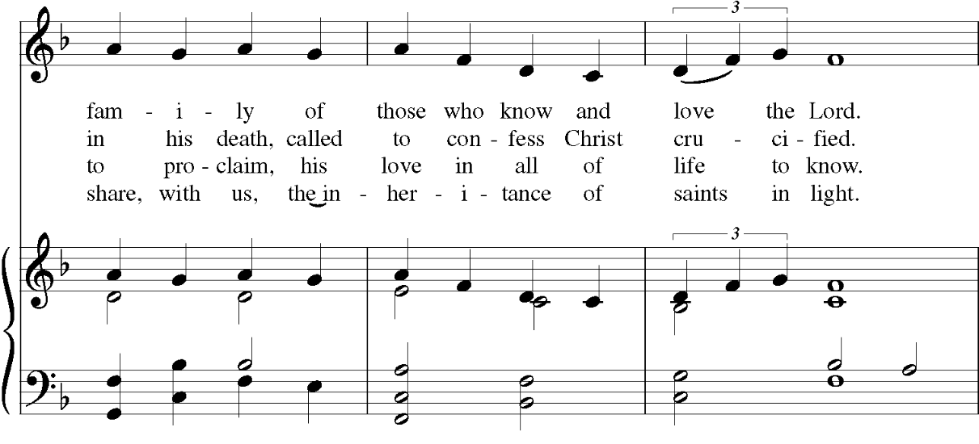

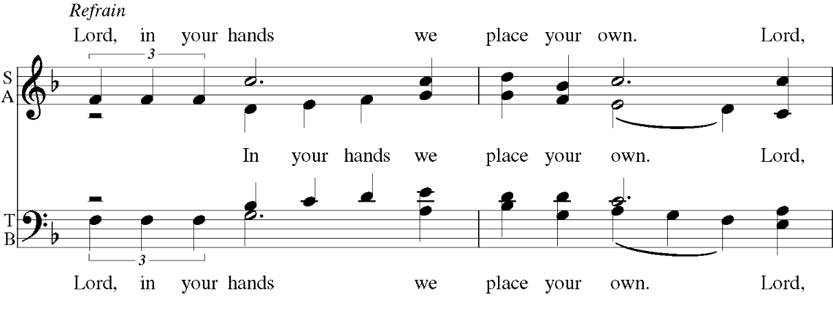

**Prayer After Communion**

Eternal God, heavenly Father, you have graciously accepted us as living members of your Son our Savior Jesus Christ, and you have fed us with spiritual food in the Sacrament of his Body and Blood. Send us now into the world in peace, and grant us strength and courage  
to love and serve you with gladness and singleness of heart; through Christ our Lord. **Amen.**

**Blessing Rev. John Branson**

**Recessional Hymn “Child of blessing, child of promise”**

**Dismissal**

Go in peace to love and serve the Lord. Alleluia, alleluia.  
 Thanks be to God. Alleluia, alleluia.

**Announcements for May 25th, 2025**

**CONCERTS ON THE HILL: Sundays, 6/22 - 7/27 at 6:00. Sponsors and volunteers needed!**

**MAY BOOK CLUB: Last book club meeting for May this Wednesday at 7pm on Zoom.**

**VESTRY MEETING:** Tuesday, 5/27 at 7pm on Zoom. Email Vicki for the link. All are welcome to attend.

**FARMHOUSE FLEA MARKET: Saturday, 5/31, 10 am–4 pm. Info: www.christchurcheaston.com/events.**

**UPCOMING WORSHIP DATES:**

**Sunday, 6/1 @ 9:30 am: Eucharist (Rev. John Branson)**

**Sunday, 6/8 @ 10:00 am: Pentecost Service @ St. John’s Episcopal**

**(Located at 768 Fairfield Ave, Bridgeport. *No service at Christ Church this day!)***

**Sunday, 6/15 @ 9:30 am: Morning Prayer (Jim Swann)**

**Sunday, 6/22 @ 9:30 am: Eucharist (Rev. John Branson)**

**PARISH OFFICE:**

(203) 268-3569 | [christchurcheastonct@gmail.com](mailto:christchurcheastonct@gmail.com)

59 Church Road, Easton, CT | [www.christchurcheaston.com](http://www.christchurcheaston.com)

Senior Warden: Vicki MarkAnthony | Parish Administrator: Tracy Carlucci

Vestry: Jim Swann, Jr. Warden; Bob Ellwanger, Treasurer; Peg Ellwanger, Clerk

Vestry Members: Russ Bailas, Amy Bailas, Marina Philips, Claire Wilkes

Diocesan Delegates: Diane McCann, Bob Ellwanger

Diocesan Alternate Delegate: Deborah Swann

Music Minister: Tracy Carlucci

Choir Members: Amy Strachan, Andy Verrocchi, Bob Ellwanger, David McCann,

Diane McCann, Marina Philips, Katie Tressler, Vicki MarkAnthony

Christ Church Nursery School: Maggie Supple, Director | [www.ccnseaston.com](http://www.ccnseaston.com)