**Morning Prayer: Sunday, August 17th, 2025**

**The Tenth Sunday after Pentecost**

Christ Church Easton

*As we gather to worship, let us recognize that we gather on the ancestral lands and traditional territory of the Aspetuck River Valley dwelling Paugussett people.*

I was glad when they said to me, “Let us go to the house of the Lord.” *Psalm 122:1*

**Opening Hymn**  “**Morning Has Broken”**

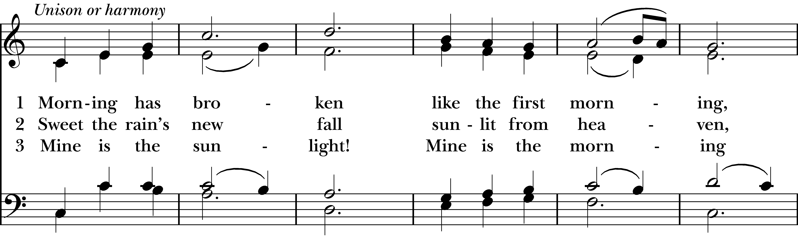  
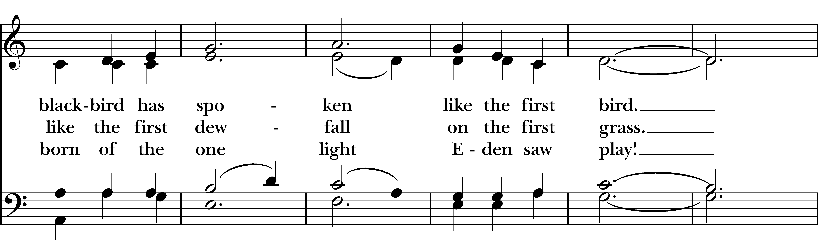  
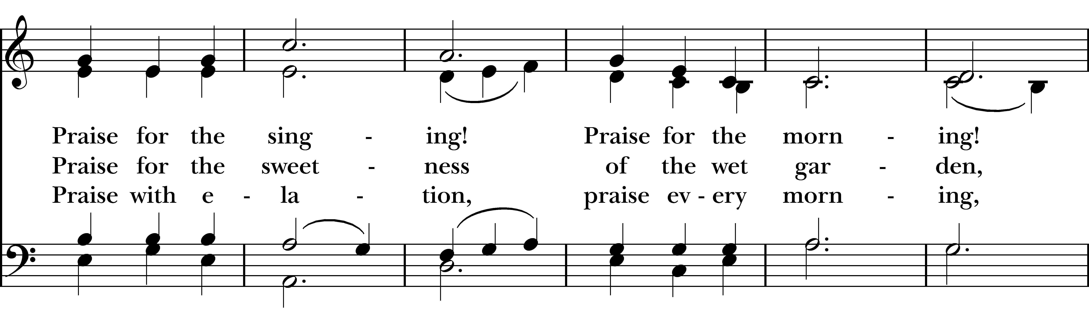  
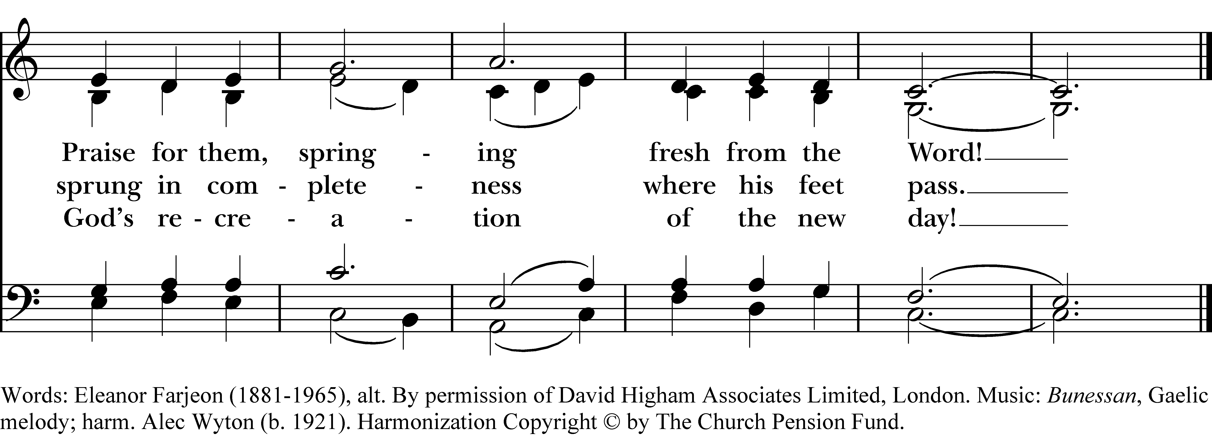

*Reprinted/streamed with permission via One License and RiteSong. All rights reserved.*

**Confession of Sin**

Let us confess our sins to God. *[Silence may be kept]*

**God of all mercy, we confess that we have sinned against you, opposing your will in our lives.  
We have denied your goodness in each other, in ourselves, and in the world you have created. We repent of the evil that enslaves us, the evil we have done, and the evil done on our behalf. Forgive, restore, and strengthen us through our Savior Jesus Christ, that we may abide in your love and serve only your will.**

Almighty God have mercy on us, forgive us all our sins through the grace of Jesus Christ, strengthen us in all goodness, and by the power of the Holy Spirit keep us in eternal life. **Amen.**

**Invitatory and Psalter**

Officiant: O God, let our mouth proclaim your praise.

**People: And your glory all the day long**.

Praise to the holy and undivided Trinity, one God: as it was in the beginning, is now, and will be for ever. **Amen. Alleluia.**

**Psalm 95: Venite**

Come, let us sing to the Lord; *  
    **let us shout for joy to the Rock of our salvation.**  
Let us come before his presence with thanksgiving *  
    **and raise a loud shout to him with psalms.**

For the Lord is a great God, *  
    **and a great King above all gods.**  
In his hand are the caverns of the earth, *  
    **and the heights of the hills are his also.**The sea is his, for he made it, *  
    **and his hands have molded the dry land.**

Come, let us bow down, and bend the knee, *  
    **and kneel before the Lord our Maker.** **For he is our God,**  
and we are the people of his pasture and the sheep of his hand. *  
    **Oh, that today you would hearken to his voice!**

**Psalm Appointed: Psalm 80** *Psalm 80:1-2,8-18*

Hear, O Shepherd of Israel, leading Joseph like a flock; *  
**shine forth, you that are enthroned upon the cherubim.**

In the presence of Ephraim, Benjamin, and Manasseh, *  
**stir up your strength and come to help us.**

You have brought a vine out of Egypt; *  
**you cast out the nations and planted it.**

You prepared the ground for it; *  
**it took root and filled the land.**

The mountains were covered by its shadow *  
**and the towering cedar trees by its boughs.**

You stretched out its tendrils to the Sea *  
**and its branches to the River.**

Why have you broken down its wall, *  
**so that all who pass by pluck off its grapes?**

The wild boar of the forest has ravaged it, *  
**and the beasts of the field have grazed upon it.**

Turn now, O God of hosts, look down from heaven; behold and tend this vine; *  
**preserve what your right hand has planted.**

They burn it with fire like rubbish; *  
**at the rebuke of your countenance let them perish.**

Let your hand be upon the man of your right hand, *  
**and son of man you have made so strong for yourself.**

And so will we never turn away from you; *  
**give us life, that we may call upon your Name.**

Restore us, O LORD God of hosts; *  
**show the light of your countenance, and we shall be saved.**

**Glory to the Father, and to the Son, and to the Holy Spirit; as it was in the beginning, is now, and will**

**be for ever. Amen. Alleluia**.

**The Reading Isaiah 5:1-7**

A Reading from the Book of the Prophet Isaiah.

Let me sing for my beloved my love-song concerning his vineyard: My beloved had a vineyard on a very fertile hill. He dug it and cleared it of stones, and planted it with choice vines; he built a watchtower in the midst of it, and hewed out a wine vat in it; he expected it to yield grapes, but it yielded wild grapes. And now, inhabitants of Jerusalem and people of Judah, judge between me and my vineyard. What more was there to do for my vineyard that I have not done in it? When I expected it to yield grapes, why did it yield wild grapes? And now I will tell you what I will do to my vineyard. I will remove its hedge, and it shall be devoured; I will break down its wall, and it shall be trampled down. I will make it a waste; it shall not be pruned or hoed, and it shall be overgrown with briers and thorns; I will also command the clouds that they rain no rain upon it. For the vineyard of the LORD of hosts is the house of Israel, and the people of Judah are his pleasant planting; he expected justice, but saw bloodshed; righteousness, but heard a cry!

Hear what the Spirit is saying to God’s people. **Thanks be to God.**

**The Gospel Luke 12:49-56**

The Holy Gospel of our Lord Jesus Christ, according to Luke. **Glory to you, Lord Christ.**

“I came to bring fire to the earth, and how I wish it were already kindled! I have a baptism with which to be baptized, and what stress I am under until it is completed! Do you think that I have come to bring peace to the earth? No, I tell you, but rather division! From now on five in one household will be divided, three against two and two against three; they will be divided: father against son and son against father, mother against daughter and daughter against mother, mother-in-law against her daughter-in-law and daughter-in-law against mother-in-law.”

He also said to the crowds, “When you see a cloud rising in the west, you immediately say, ‘It is going to rain’; and so it happens. And when you see the south wind blowing, you say, ‘There will be scorching heat’; and it happens. You hypocrites! You know how to interpret the appearance of earth and sky, but why do you not know how to interpret the present time?

The Gospel of the Lord. **Praise to you, Lord Christ.**

**Hymn-Sing:**

**Lord of All Hopefulness**

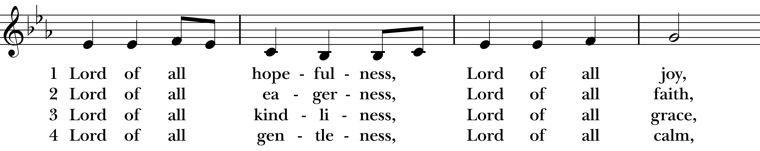  
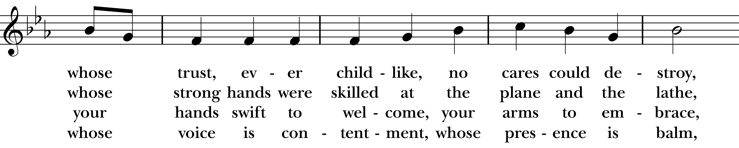  
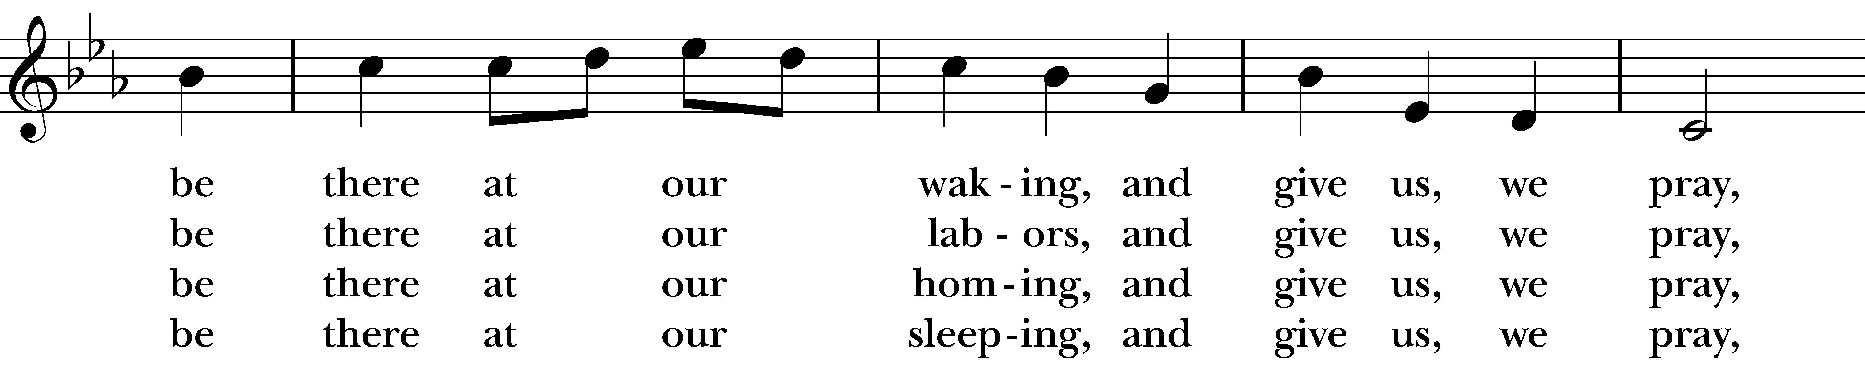  
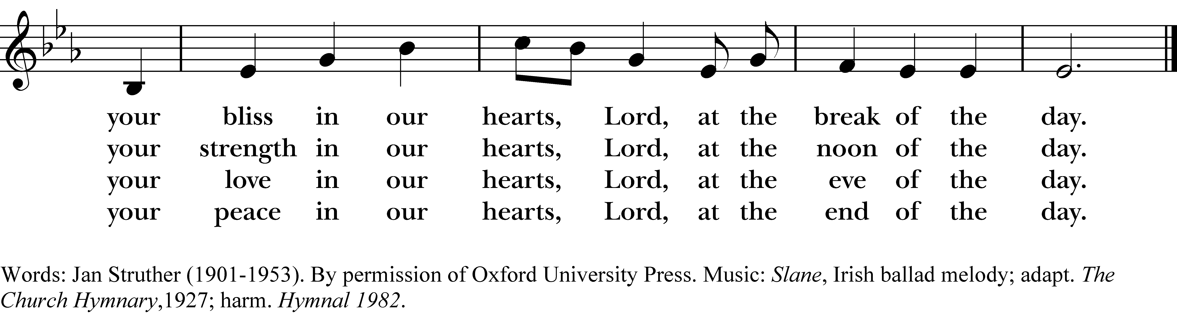

**Amazing Grace**

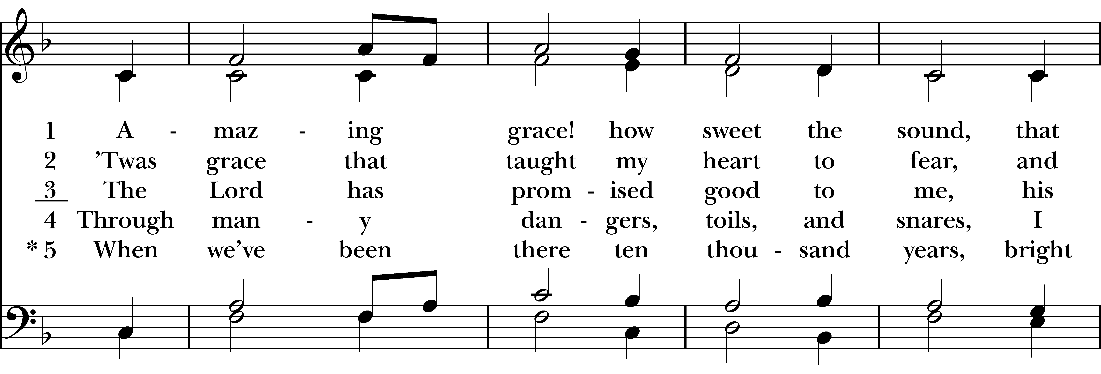  
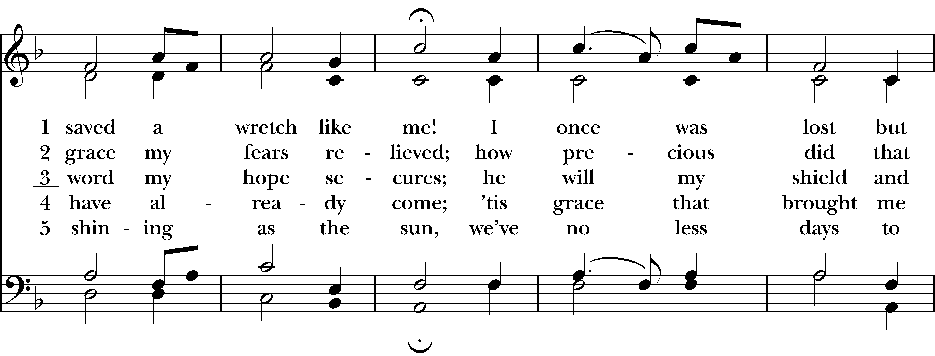  
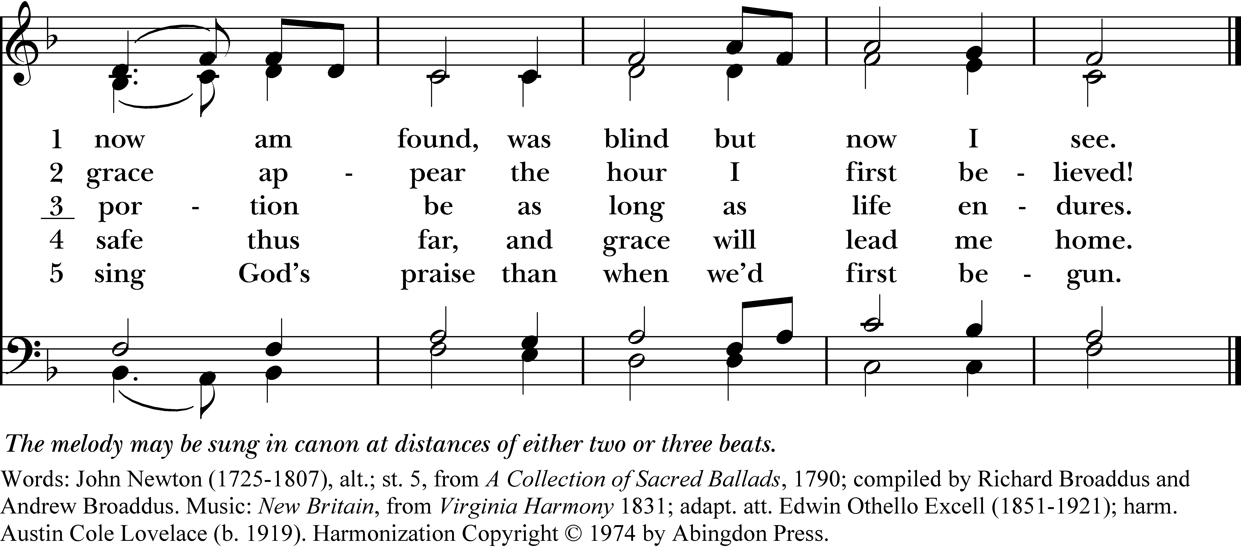

**Go Tell it on the Mountain**

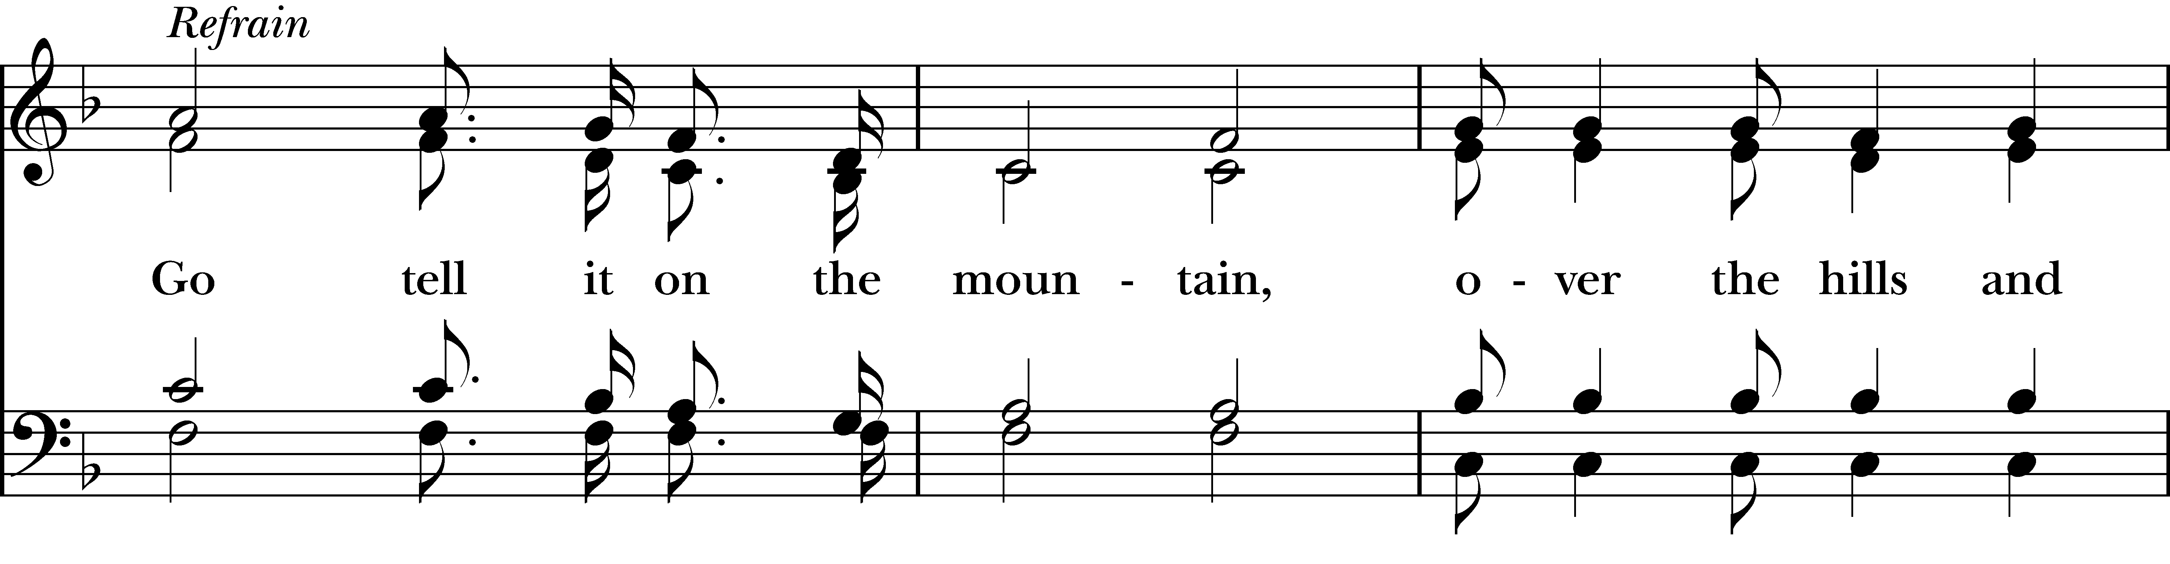  
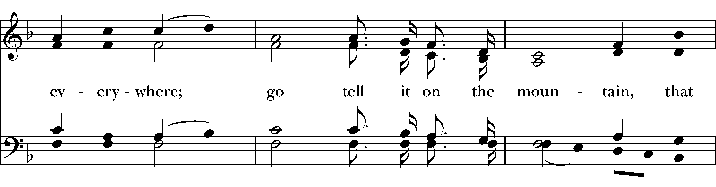  
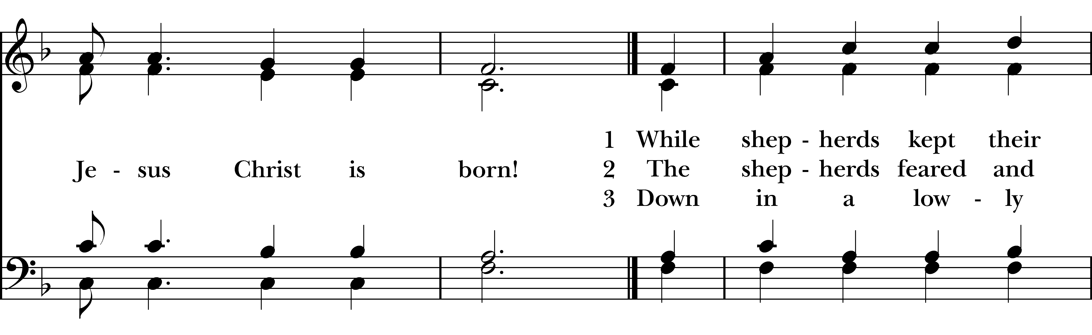  
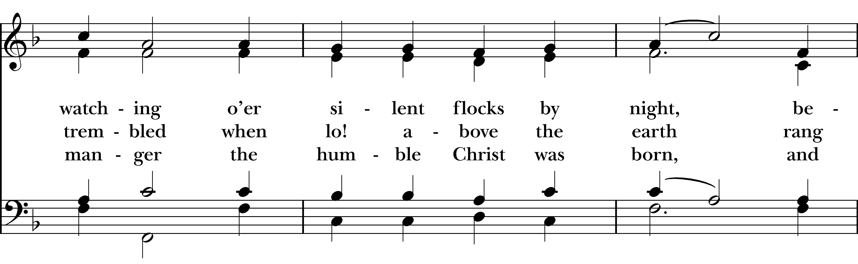  
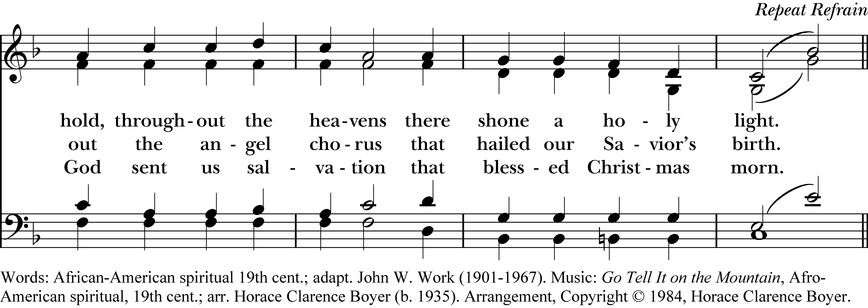

**On Christ the Solid Rock**

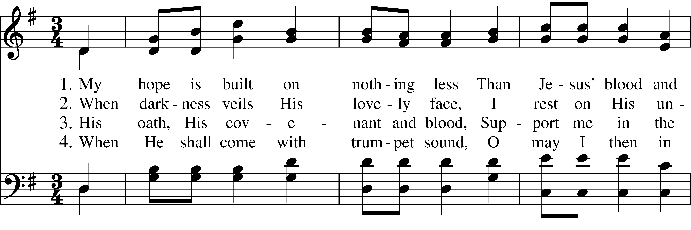  
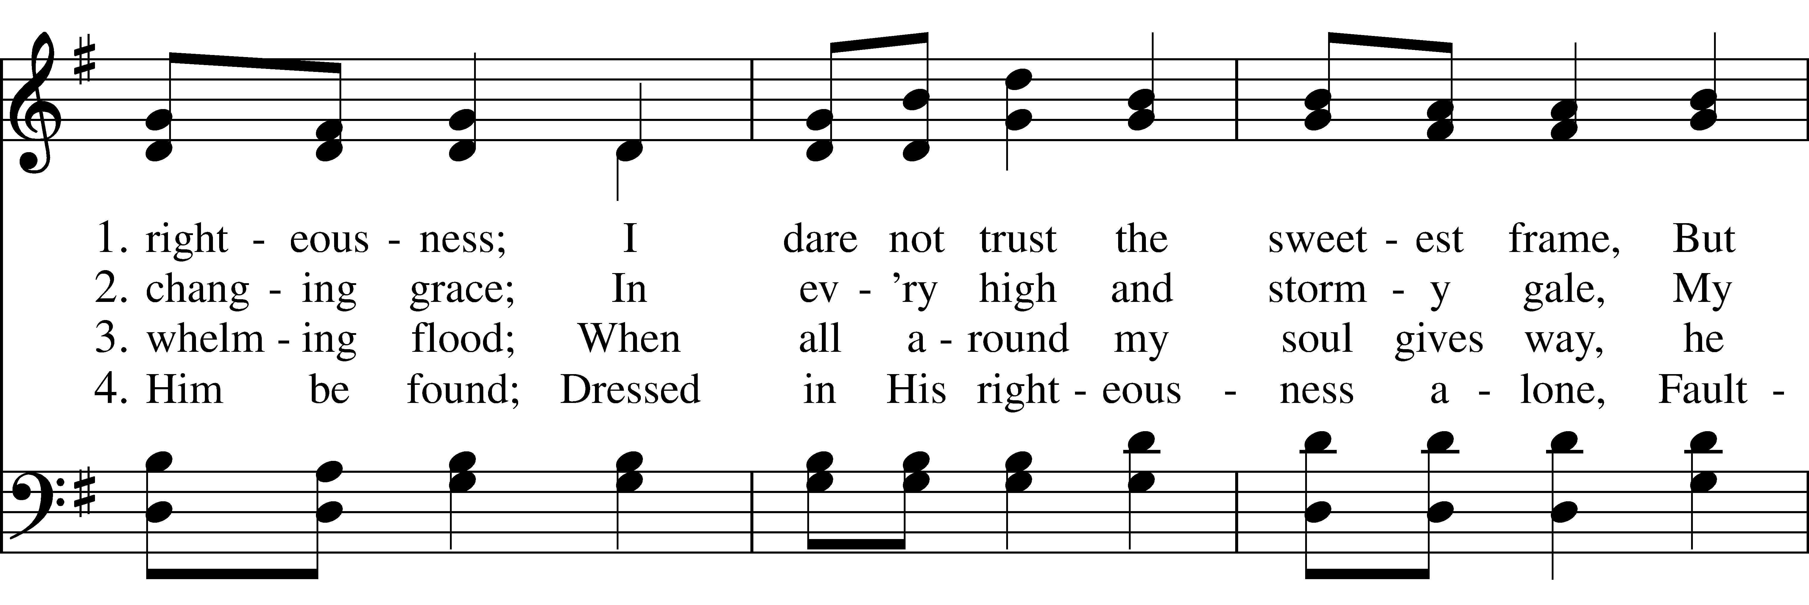  
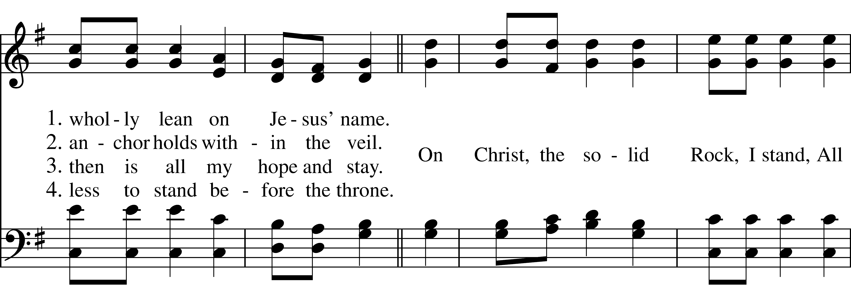  
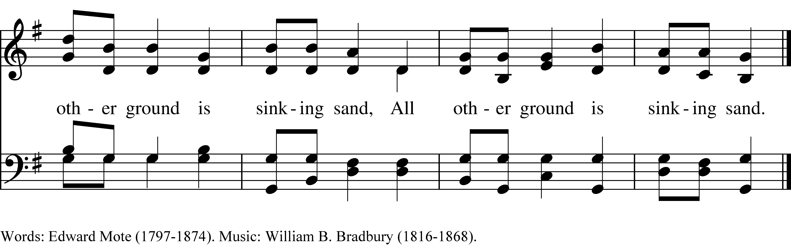

**It Is Well with My Soul**

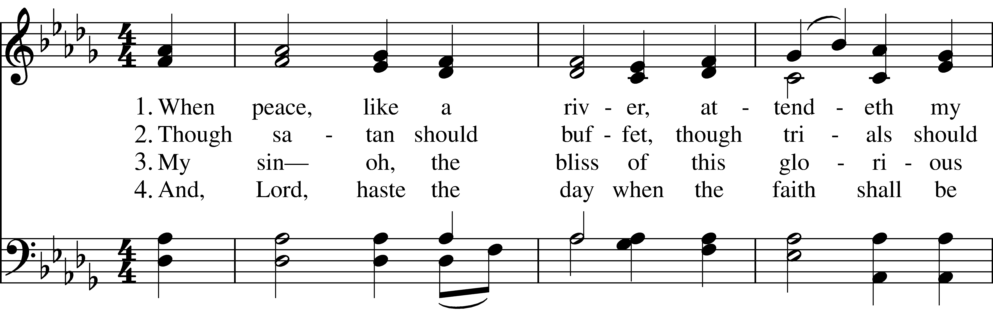  
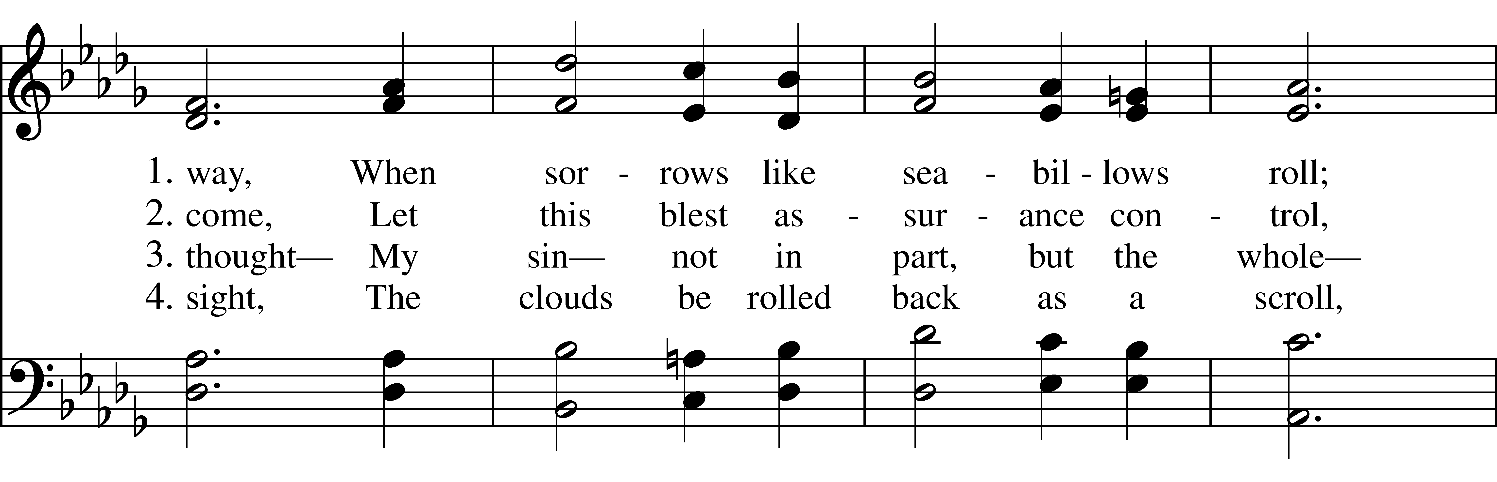  
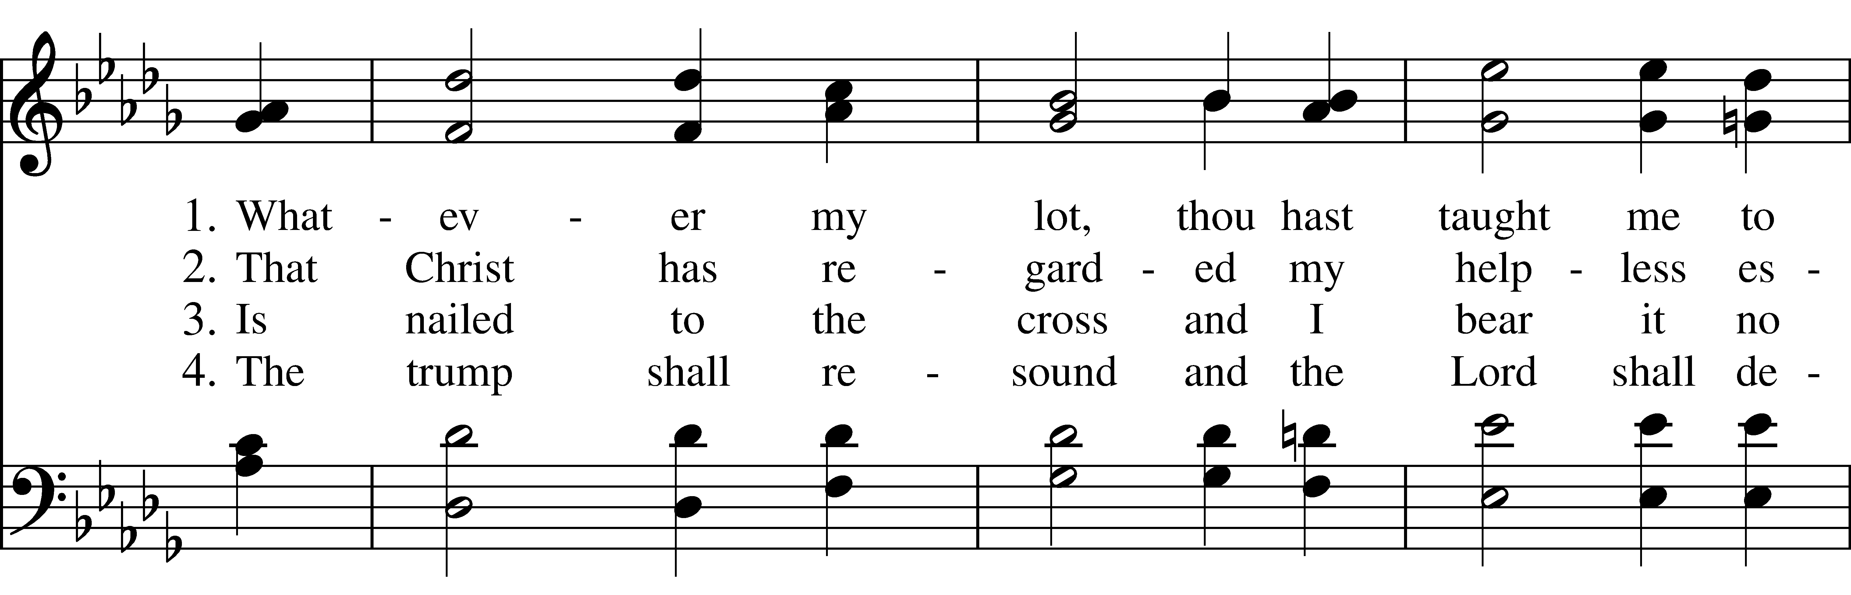  
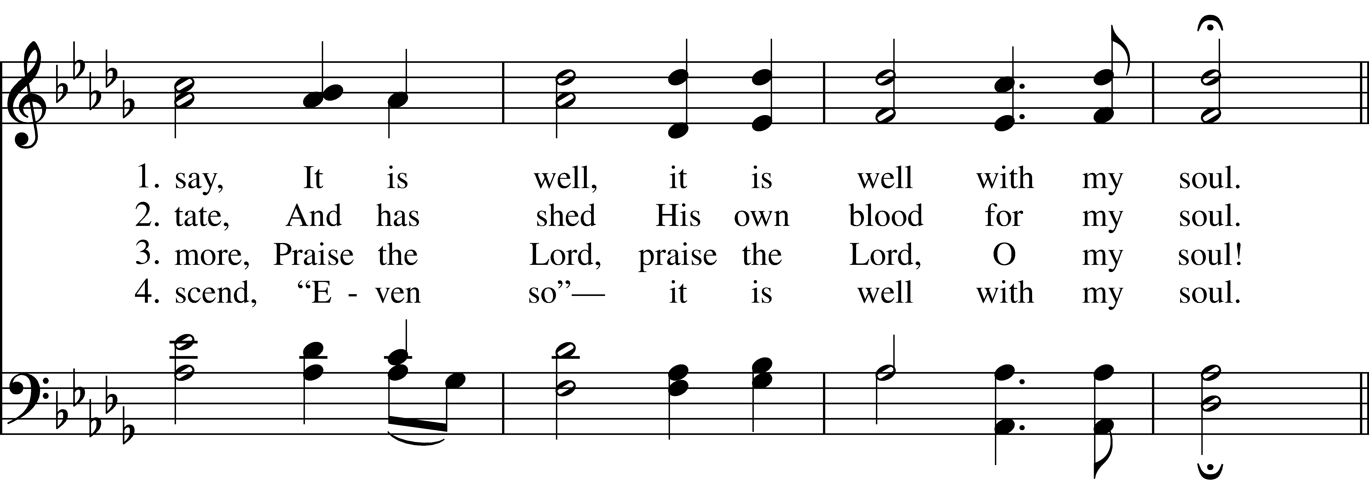  
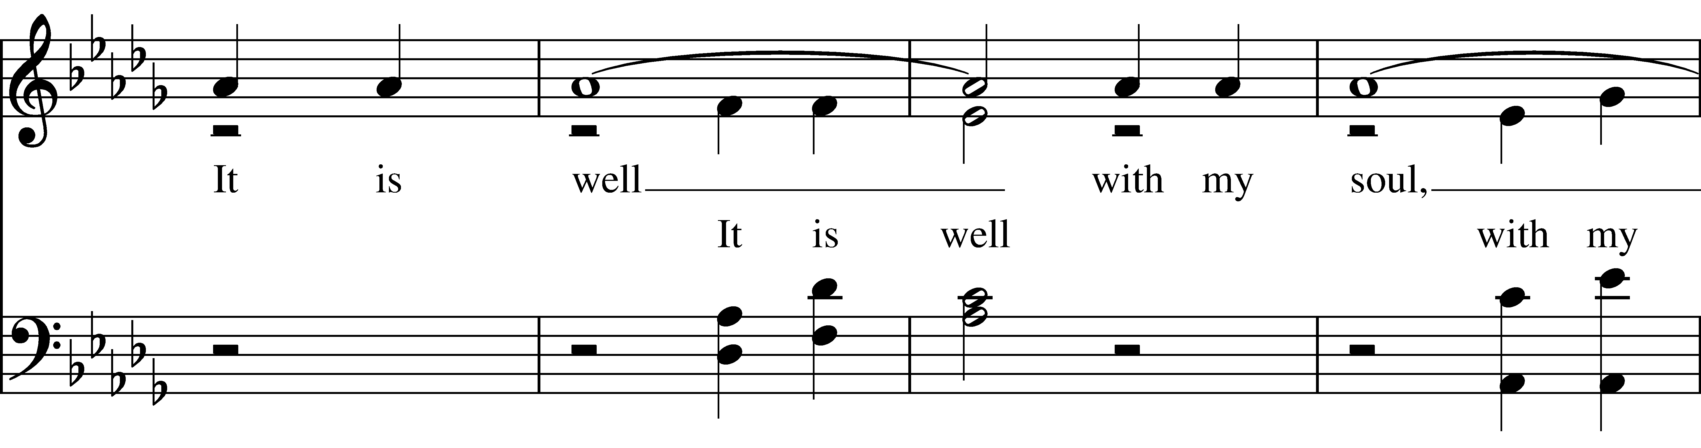  
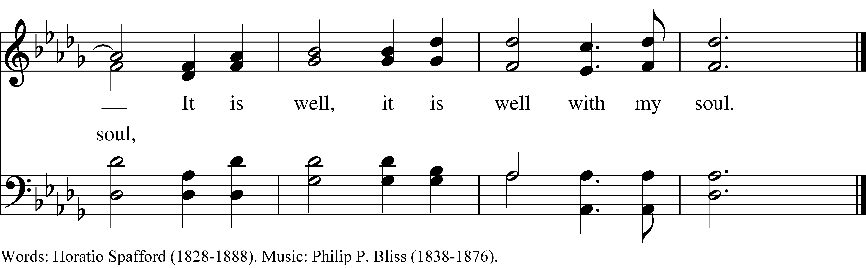

**How Can I Keep from Singing**

**Day by Day**

Apostles’ Creed

***(All):*** I believe in God, the Father almighty, creator of heaven and earth. I believe in Jesus Christ, God’s only son, our Lord, who was conceived by the Holy Spirit, born of the Virgin Mary, suffered under Pontius Pilate, was crucified, died, and was buried; he descended to the dead. On the third day he rose again; he ascended into heaven, he is seated at the right hand of the Father, and he will come again to judge the living and the dead. I believe in the Holy Spirit, the holy catholic Church, the communion of saints, the forgiveness of sins, the resurrection of the body, and the life everlasting. Amen.

*Officiant:* The Lord be with you.

**People: And also with you.**

*Officiant:* Let us pray.

**Lord’s Prayer**

***(All):*** Our Father, who art in heaven, hallowed be thy Name, thy kingdom come, thy will be done, on earth as it is in heaven. Give us this day our daily bread. And forgive us our trespasses, as we forgive those who trespass against us. And lead us not into temptation, but deliver us from evil. For thine is the kingdom, and the power, and the glory, for ever and ever. Amen.

**Suffrages A**

V.    Show us your mercy, O Lord;  
**R.    And grant us your salvation.**V.    Clothe your ministers with righteousness;  
**R.    Let your people sing with joy.**V.    Give peace, O Lord, in all the world;  
**R.    For only in you can we live in safety.**

V.    Lord, keep this nation under your care;  
**R.    And guide us in the way of justice and truth.**V.    Let your way be known upon earth;  
**R.    Your saving health among all nations.**V.    Let not the needy, O Lord, be forgotten;  
**R.    Nor the hope of the poor be taken away.**V.    Create in us clean hearts, O God;  
**R.    And sustain us with your Holy Spirit**

**Collect of the Day**

Almighty God, you have given your only Son to be for us a sacrifice for sin, and also an example of godly life: Give us grace to receive thankfully the fruits of his redeeming work, and to follow daily in the blessed steps of his most holy life; through Jesus Christ your Son our Lord, who lives and reigns with you and the Holy Spirit, one God, now and for ever. **Amen.**

**Prayers of the People: Form VI**

In Peace, we pray to you, Lord God.

For all people in their daily life and work;  
**For our families, friends, and neighbors, and for those who are alone.**

For this community, the nation, and the world;   
**For all who work for justice, freedom, and peace.**

For the just and proper use of your creation;  
**For the victims of hunger, fear, injustice, and oppression**.

For all who are in danger, sorrow, or any kind of trouble;  
**For those who minister to the sick, the friendless, and the needy.**

For the peace and unity of the Church of God;  
**For all who proclaim the Gospel, and all who seek the Truth.**

For Sean our Presiding Bishop, and Jeffrey and Laura our Bishops; and for all bishops and other ministers; **For all who serve God in his Church.**

For the special needs and concerns of this congregation *[Silence. The People may add their own petitions]* We pray especially for those on our parish prayer list …

Hear us, Lord; **For your mercy is great.**

We thank you, Lord, for all the Blessings of this life. *[Silence. The People may add their own thanksgivings]*

We will exalt you, O God our King; **And praise your Name for ever and ever.**

We pray for all who have died that they may have a place in your eternal kingdom. Lord, let your loving-kindness be upon them; **Who put their trust in you.**

We pray to you also for the forgiveness of our sins. [Silence may be kept]

Heavenly Father, you have promised to hear what we ask in the Name of your Son: Accept and fulfill our petitions, we pray, not as we ask in our ignorance, nor as we deserve in our sinfulness, but as you know and love us in your Son Jesus Christ our Lord. **Amen.**

**Offering and Announcements**

**A Prayer of St. Chrysostom**

***(All):*** Almighty God, you have given us grace at this time with one accord to make our common supplication to you; and you have promised through your well-beloved Son that when two or three are gathered together in his Name you will be in the midst of them: Fulfill now, O Lord, our desires & petitions as may be best for us; granting us in this world knowledge of your truth, and in the age to come life everlasting. **Amen.**

**Recessional Hymn “I’ll Fly Away”**

**Blessing**

Go forth into the world in peace. Be of good courage, hold fast to all that is good. Render to no one evil for evil. As far as it depends on you, live peaceably with all, but make no peace with oppression. Remember that life is short, and we don’t have much time to gladden the hearts of those who travel with us along the way. So be quick to love; make haste to be kind. And the God of compassion will go with you. Amen.

***People:* Thanks be to God.**

**Announcements for August 17th, 2025**

**COFFEE HOUR:** Please consider signing up for an upcoming Sunday.

**GIFT CARDS** to gas stations/grocery stores are always needed. Thank you for your continued generosity.

**UPCOMING WORSHIP DATES**

**Sunday, 8/24 @ 9:00 am: Eucharist (Rev. Isabel Geller)**

**Sunday, 8/31 @ 9:00 am: Morning Prayer (Andy Hathaway)**

**Sunday, 9/7 @ 9:30 am: Eucharist (rev. Isabel Geller)**

**Sunday, 9/14 @ 9:30 am: Morning Prayer (Deborah Swann)**

**Christ Church – Parish Office:**

(203) 268-3569 | christchurcheastonct@gmail.com

59 Church Road, Easton, CT | [www.christchurcheaston.com](http://www.christchurcheaston.com)

Senior Warden: Vicki MarkAnthony | Parish Administrator: Tracy Carlucci

Vestry: Jim Swann, Jr. Warden; Bob Ellwanger, Treasurer; Peg Ellwanger, Clerk

Vestry Members: Russ Bailas, Amy Bailas, Marina Philips, Claire Wilkes

Diocesan Delegates: Diane McCann, Bob Ellwanger | Diocesan Alternate Delegate: Deborah Swann

Music Minister: Tracy Carlucci

Choir Members: Amy Strachan, Andy Verrocchi, Bob Ellwanger, David McCann,

Diane McCann, Marina Philips, Katie Tressler, Vicki MarkAnthony

Christ Church Nursery School: Maggie Supple, Director | [www.ccnseaston.com](http://www.ccnseaston.com)