Morning Prayer: Sunday, December 28th, 2025
The First Sunday after Christmas
Christ Church Easton

Officiant: As we gather to worship, let us recognize that we gather on the ancestral lands and traditional territory of the (Aspetuck River Valley dwelling) Paugussett people.

“Behold, I bring you good news of a great joy, which will come to all the people; for unto you is born this day in the city of David, a Savior, who is Christ the Lord.” Luke 2:10, 11

Please stand as you are able and sing together our Opening Hymn, “Angels we have heard on high.”

Opening Hymn “Angels we have heard on high”
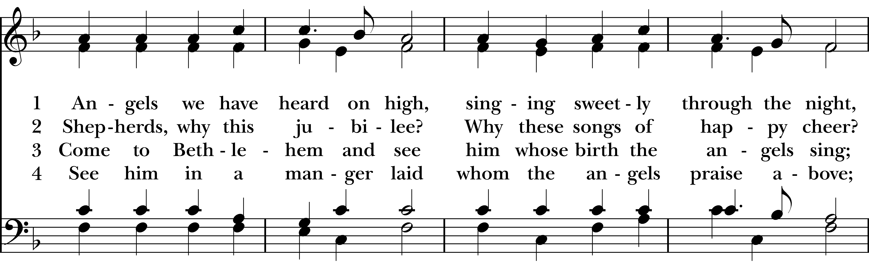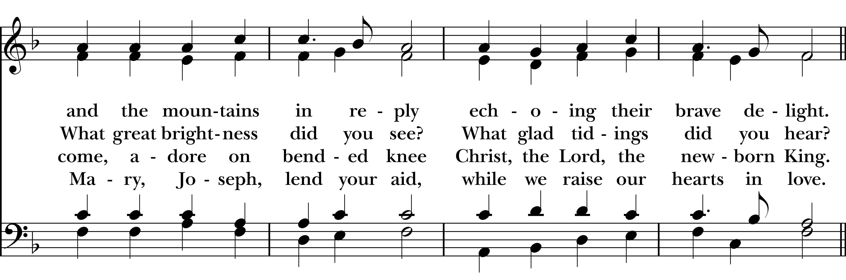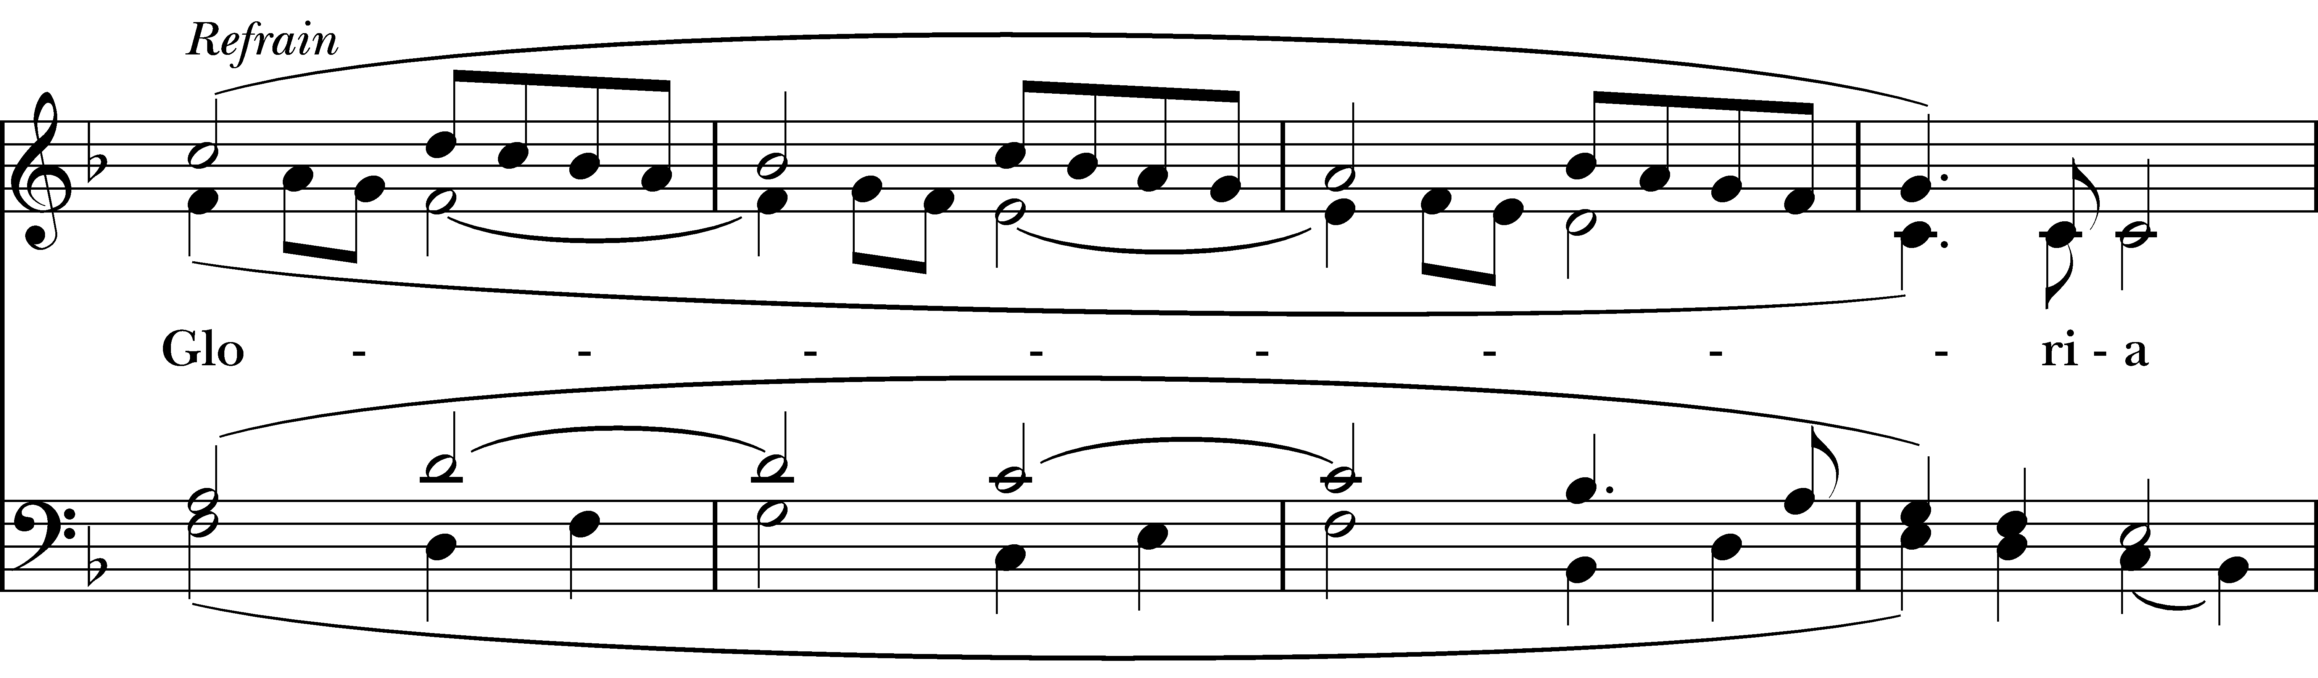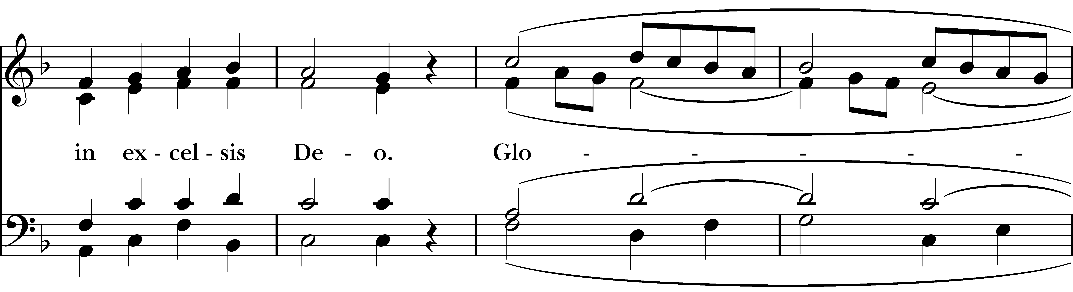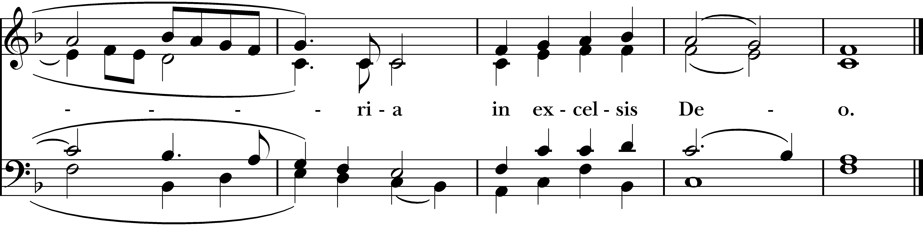
Reprinted/streamed with permission via One License and RiteSong. All rights reserved.
Confession of Sin
Let us confess our sins to God.

God of all mercy, we confess that we have sinned against you, opposing your will in our lives.
We have denied your goodness in each other, in ourselves, and in the world you have created. We repent of the evil that enslaves us, the evil we have done, and the evil done on our behalf. Forgive, restore, and strengthen us through our Savior Jesus Christ, that we may abide in your love and serve only your will.
Almighty God have mercy on us, forgive us all our sins through the grace of Jesus Christ, strengthen us in all goodness, and by the power of the Holy Spirit keep us in eternal life. Amen.
Invitatory and Psalter
Officiant: O God, let our mouth proclaim your praise.
People: And your glory all the day long.

Praise to the holy and undivided Trinity, one God: as it was in the beginning, is now, and will be for ever. Amen. Alleluia.

The Earth is the Lord’s for he made it. Come let us adore Him. Alleluia.

Psalm 95: Venite

Come, let us sing to the Lord; *
let us shout for joy to the Rock of our salvation.
Let us come before his presence with thanksgiving *
and raise a loud shout to him with psalms.
For the Lord is a great God, *
and a great King above all gods.
In his hand are the caverns of the earth, *
and the heights of the hills are his also.
The sea is his, for he made it, *
and his hands have molded the dry land.
Come, let us bow down, and bend the knee, *
and kneel before the Lord our Maker. For he is our God,
and we are the people of his pasture and the sheep of his hand. *
Oh, that today you would hearken to his voice!

The Psalm Appointed: Psalm 147

Hallelujah! How good it is to sing praises to our God! *
how pleasant it is to honor him with praise!
The LORD rebuilds Jerusalem; *
he gathers the exiles of Israel.
He heals the brokenhearted *
and binds up their wounds.
He counts the number of the stars *
and calls them all by their names.
Great is our LORD and mighty in power; *
there is no limit to his wisdom.
The LORD lifts up the lowly, *
but casts the wicked to the ground.
Sing to the LORD with thanksgiving; *
make music to our God upon the harp.
He covers the heavens with clouds *
and prepares rain for the earth;
He makes grass to grow upon the mountains *
and green plants to serve mankind.
He provides food for flocks and herds *
and for the young ravens when they cry.
He is not impressed by the might of a horse; *
he has no pleasure in the strength of a man;
But the LORD has pleasure in those who fear him, *
in those who await his gracious favor.
Worship the LORD, O Jerusalem; *
praise your God, O Zion;
For he has strengthened the bars of your gates; *
he has blessed your children within you.
He has established peace on your borders; *
he satisfies you with the finest wheat.
He sends out his command to the earth, *
and his word runs very swiftly.
He gives snow like wool; *
he scatters hoarfrost like ashes.
He scatters his hail like bread crumbs; *
who can stand against his cold?
He sends forth his word and melts them; *
he blows with his wind, and the waters flow.
He declares his word to Jacob, *
his statutes and his judgments to Israel.
He has not done so to any other nation; *
to them he has not revealed his judgments. Hallelujah!

Glory to the Father, and to the Son, and to the Holy Spirit; as it was in the beginning, is now, and will
be for ever. Amen. Alleluia.

The First Reading Isaiah 61:10-62:3
A Reading from the Book of the Prophet Isaiah.

I will greatly rejoice in the LORD, my whole being shall exult in my God; for he has clothed me with the garments of salvation, he has covered me with the robe of righteousness, as a bridegroom decks himself with a garland, and as a bride adorns herself with her jewels. For as the earth brings forth its shoots, and as a garden causes what is sown in it to spring up, so the Lord GOD will cause righteousness and praise to spring up before all the nations.

For Zion’s sake I will not keep silent, and for Jerusalem’s sake I will not rest, until her vindication shines out like the dawn, and her salvation like a burning torch. The nations shall see your vindication, and all the kings your glory; and you shall be called by a new name that the mouth of the LORD will give. You shall be a crown of beauty in the hand of the LORD, and a royal diadem in the hand of your God.

The Word of the Lord.
Thanks be to God.
The Second Reading Galatians 3:23-25; 4:4-7

A Reading from the Letter to the Galatians.

Now before faith came, we were imprisoned and guarded under the law until faith would be revealed. Therefore the law was our disciplinarian until Christ came, so that we might be justified by faith. But now that faith has come, we are no longer subject to a disciplinarian, But when the fullness of time had come, God sent his Son, born of a woman, born under the law, in order to redeem those who were under the law, so that we might receive adoption as children. And because you are children, God has sent the Spirit of his Son into our hearts, crying, “Abba! Father!” So you are no longer a slave but a child, and if a child then also an heir, through God.

The Word of the Lord
Thanks be to God.

The Gospel John 1:1-18
A Reading from the Gospel of John.

In the beginning was the Word, and the Word was with God, and the Word was God. He was in the beginning with God. All things came into being through him, and without him not one thing came into being. What has come into being in him was life, and the life was the light of all people.

The light shines in the darkness, and the darkness did not overcome it. There was a man sent from God, whose name was John. He came as a witness to testify to the light, so that all might believe through him. He himself was not the light, but he came to testify to the light. The true light, which enlightens everyone, was coming into the world. He was in the world, and the world came into being through him; yet the world did not know him. He came to what was his own, and his own people did not accept him. But to all who received him, who believed in his name, he gave power to become children of God, who were born, not of blood or of the will of the flesh or of the will of man, but of God. And the Word became flesh and lived among us, and we have seen his glory, the glory as of a father’s only son, full of grace and truth.

(John testified to him and cried out, “This was he of whom I said, ‘He who comes after me ranks ahead of me because he was before me.’”) From his fullness we have all received, grace upon grace. The law indeed was given through Moses; grace and truth came through Jesus Christ. No one has ever seen God. It is God the only Son, who is close to the Father’s heart, who has made him known.

The Gospel of the Lord.
Praise to you, Lord Christ.

Reflection Molly Adams

Officiant: Please join in singing hymn #105, “God rest ye merry, gentlemen.”

Post-Reflection Hymn “God rest you merry, gentlemen”

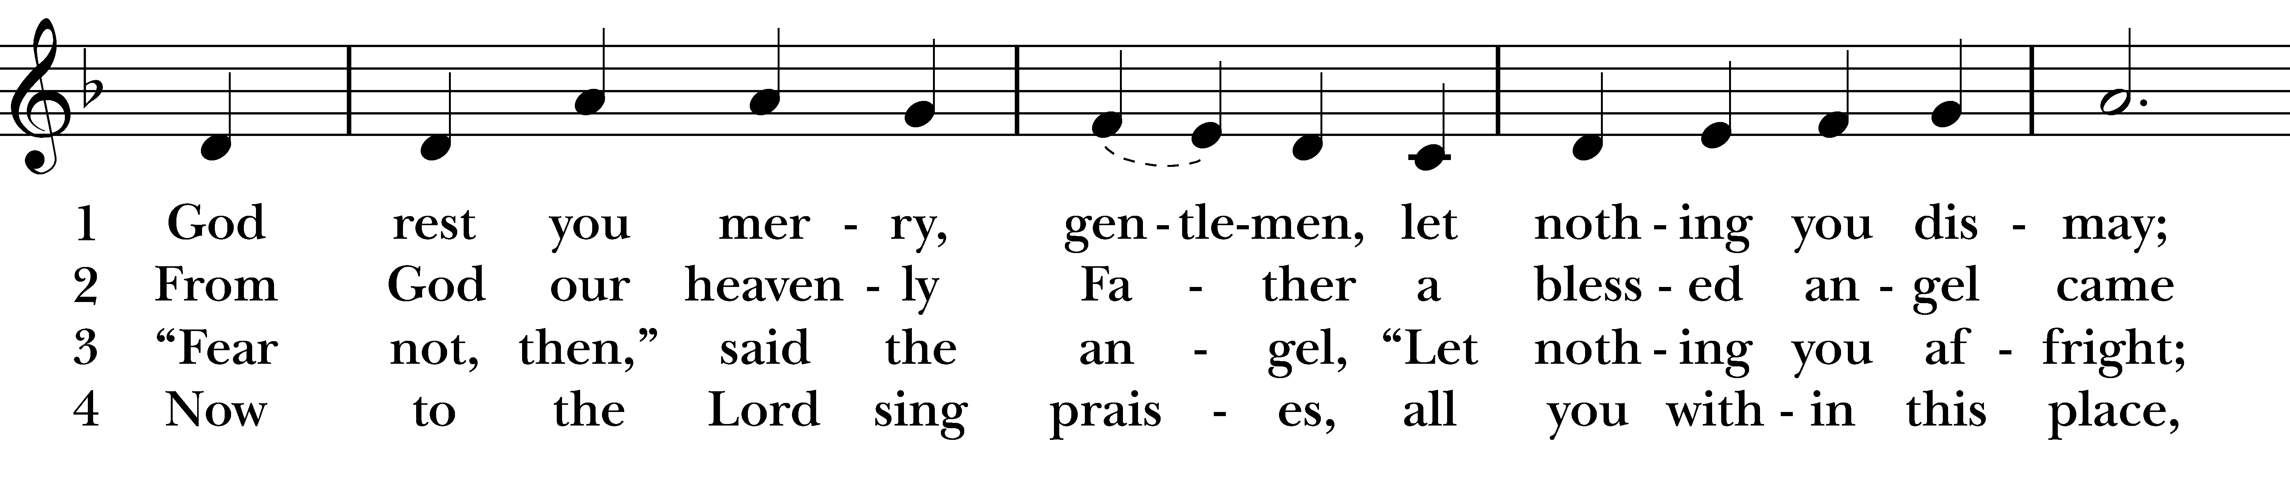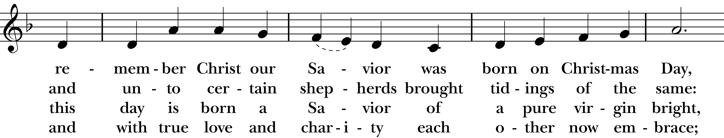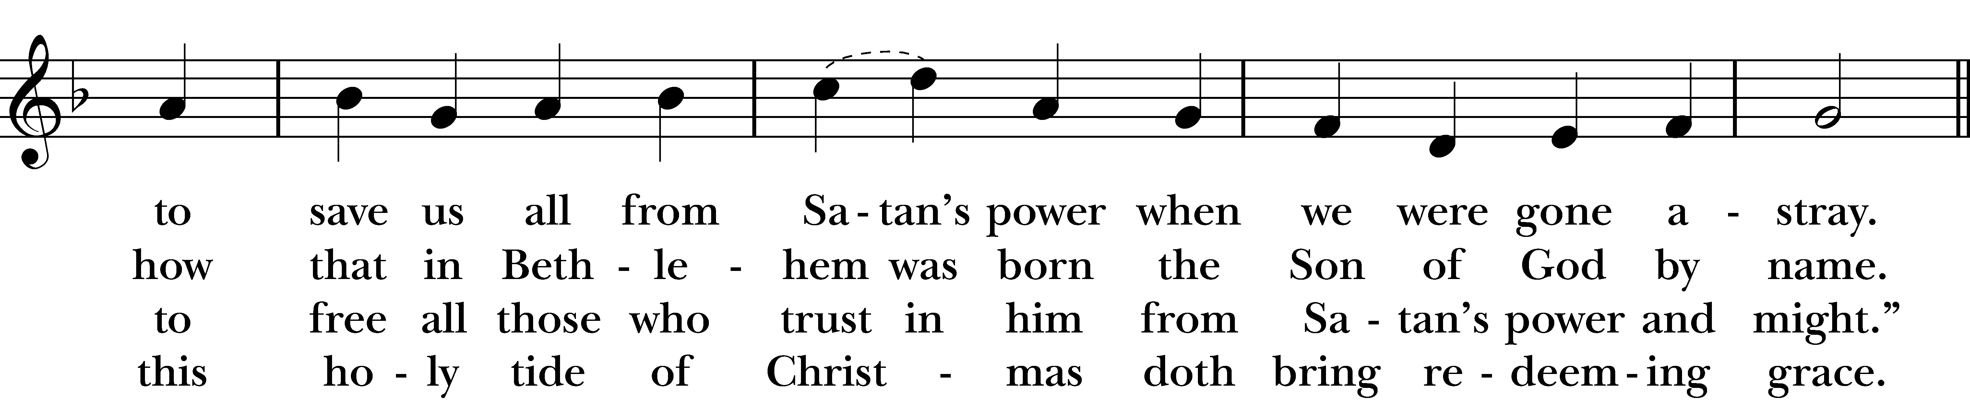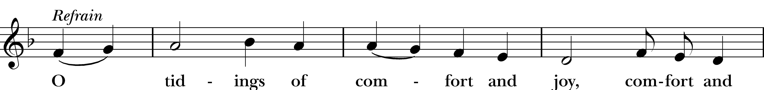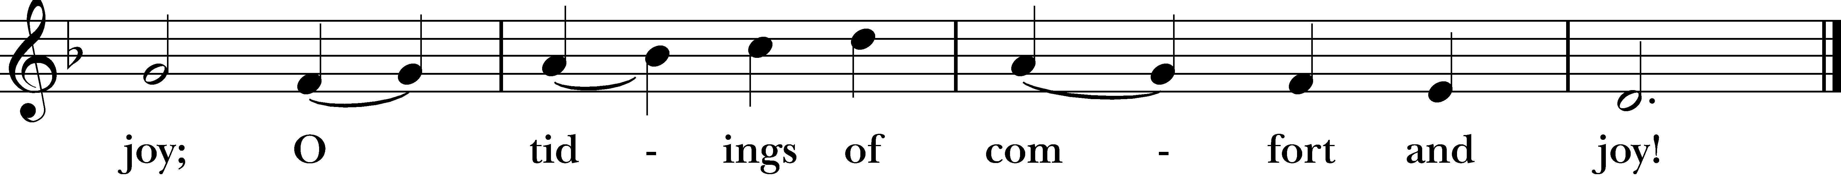
Reprinted/streamed with permission via One License and RiteSong. All rights reserved.

Apostles’ Creed Officiant: Please stand as you are able for The Apostles Creed

I believe in God, the Father almighty, creator of heaven and earth. I believe in Jesus Christ, God’s only son, our Lord, who was conceived by the Holy Spirit, born of the Virgin Mary, suffered under Pontius Pilate, was crucified, died, and was buried; he descended to the dead. On the third day he rose again; he ascended into heaven, he is seated at the right hand of the Father, and he will come again to judge the living and the dead. I believe in the Holy Spirit, the holy catholic Church, the communion of saints, the forgiveness of sins, the resurrection of the body, and the life everlasting. Amen.

Officiant: The Lord be with you.
People: And also with you.
Officiant: Let us pray.

Lord’s Prayer

Our Father, who art in heaven, hallowed be thy Name, thy kingdom come, thy will be done, on earth as it is in heaven. Give us this day our daily bread. And forgive us our trespasses, as we forgive those who trespass against us. And lead us not into temptation, but deliver us from evil. For thine is the kingdom, and the power, and the glory, for ever and ever. Amen.

Suffrages A

V. Show us your mercy, O Lord;
R. And grant us your salvation.
V. Clothe your ministers with righteousness;
R. Let your people sing with joy.
V. Give peace, O Lord, in all the world;
R. For only in you can we live in safety.
V. Lord, keep this nation under your care;
R. And guide us in the way of justice and truth.
V. Let your way be known upon earth;
R. Your saving health among all nations.
V. Let not the needy, O Lord, be forgotten;
R. Nor the hope of the poor be taken away.
V. Create in us clean hearts, O God;
R. And sustain us with your Holy Spirit.

The Collect of the Day

Officiant: The Lord be with you.
People: And also with you.
Let us pray. Almighty God, you have poured upon us the new light of your incarnate Word: Grant that this light, enkindled in our hearts, may shine forth in our lives; through Jesus Christ our Lord, who lives and reigns with you, in the unity of the Holy Spirit, one God, now and for ever. Amen.

Prayers of the People: Form VI

In Peace, we pray to you Lord God. For all people in their daily life and work; For our families, friends, and neighbors, and for those who are alone.

For this community, the nation, and the world; For all who work for justice, freedom, and peace.
For the just and proper use of your creation; For the victims of hunger, fear, injustice, and oppression.
For all who are in danger, sorrow, or any kind of trouble; For those who minister to the sick, the friendless, and the needy.
For the peace and unity of the Church of God; For all who proclaim the Gospel, and all who seek the Truth.
For Sean our Presiding Bishop, and Jeffrey and Laura our Bishops; and for all bishops and other ministers; For all who serve God in his Church.
For the special needs and concerns of this congregation, including those on our parish prayer list …
Hear us, Lord; For your mercy is great.
We will exalt you, O God our King; And praise your Name for ever and ever.
We pray for all who have died that they may have a place in your eternal kingdom. Lord, let your loving-kindness be upon them; Who put their trust in you.
We thank you, Lord, for all the blessings of this life. Amen.

Prayer of St. Chrysostom

Let us pray: Almighty God, you have given us grace at this time with one accord to make our common supplication to you; and you have promised through your well-beloved Son that when two or three are gathered together in his Name you will be in the midst of them: Fulfill now, O Lord, our desires & petitions as may be best for us; granting us in this world knowledge of your truth, and in the age to come life everlasting. Amen.
Officiant: Please stand as you are able and sing our closing hymn, “Hark! The herald angels sing.”

Closing Hymn “Hark! The herald angels sing”

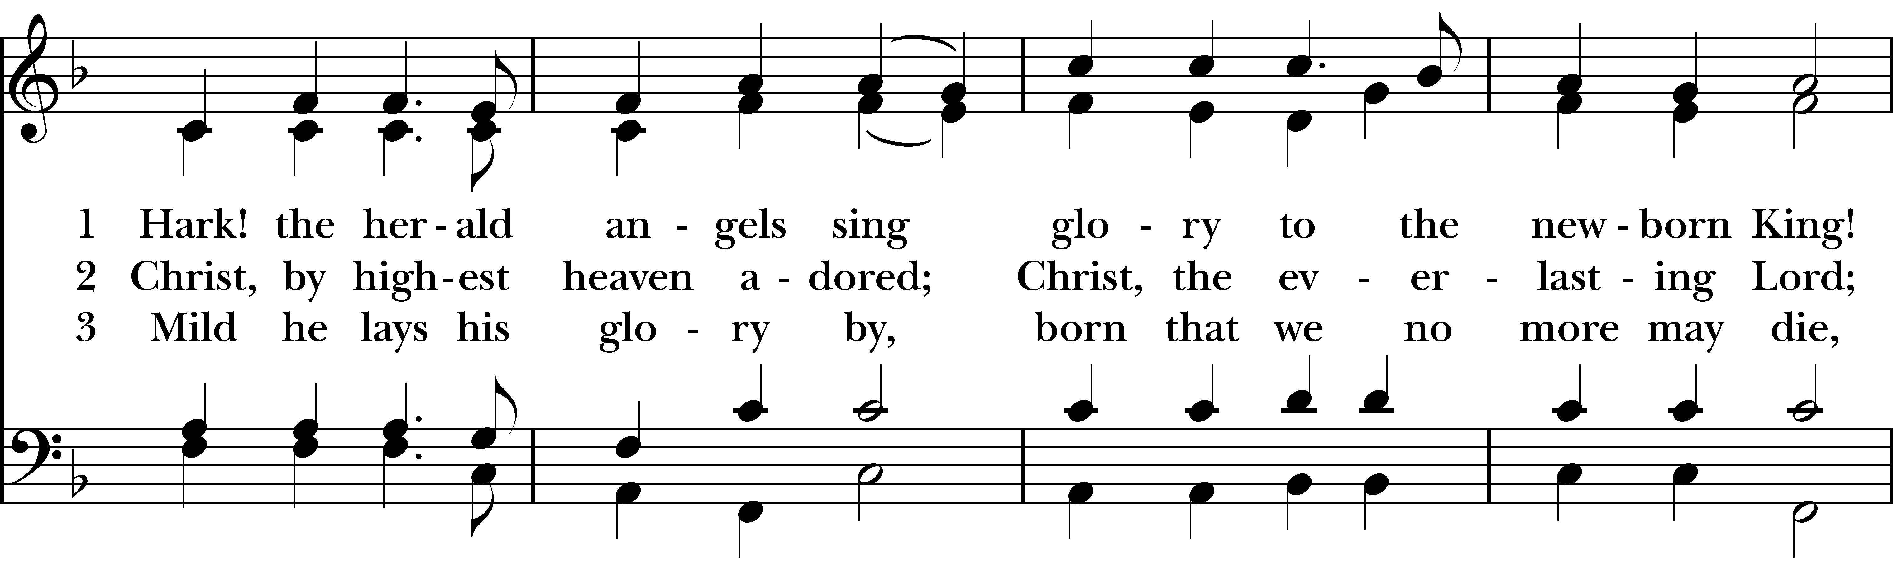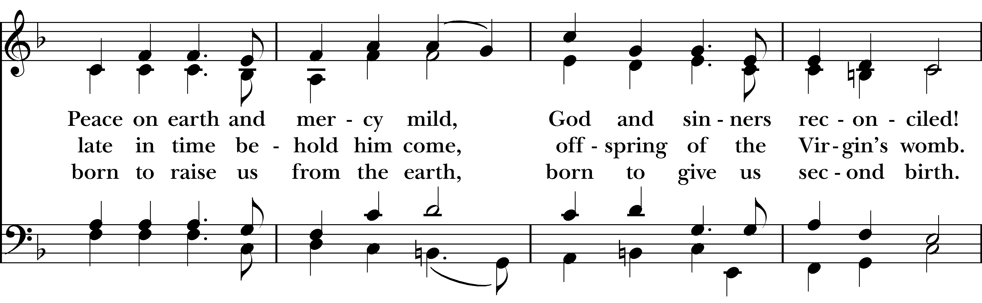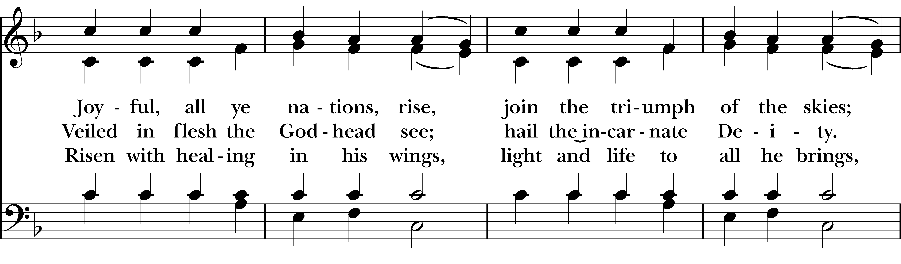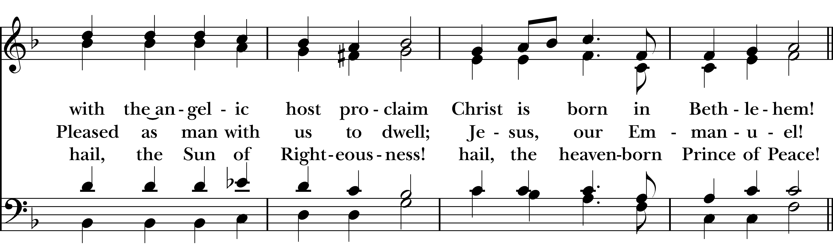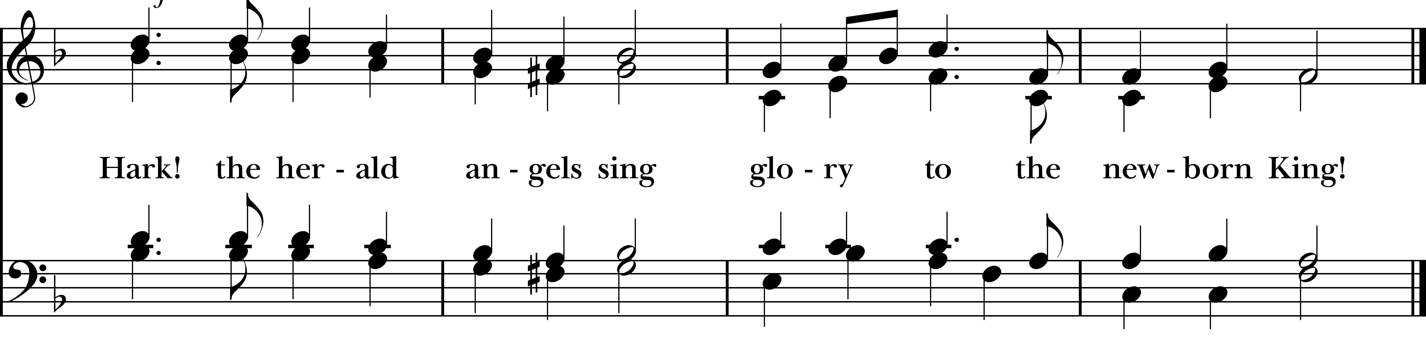

Dismissal

Officiant: Our worship is ended. Our Service begins. Let us go in peace to love & serve the Lord.
People: Thanks be to God.

Welcome to Christ Church Easton!

Whether you are a newcomer, visitor, or longtime member, we bid you a warm welcome!
Please join us for coffee hour following service.
Sign up for our email list at www.christchurcheaston.com
Announcements for December 28th, 2025

NAME TAGS: A reminder to please wear your name tag each week, found in the back of the church.

COFFEE HOUR: Please consider signing up to provide refreshments for an upcoming Sunday.

DIAPER DRIVE: Donations of diapers and wipes can be left in the back pews throughout the month of December for our annual “Baby Shower for Jesus.” Thank you!

SPECIAL HOLIDAY MEDITATION: Today from 3:00-4:00pm, led by Deborah Swann. Held in-person here at Christ Church. All are welcome.

GIFT CARDS to gas stations & grocery stores are always needed. Thank you for your continued generosity.

Vestry: Jim Swann, Jr. Warden; Bob Ellwanger, Treasurer; Peg Ellwanger, Clerk

Vestry Members: Russ Bailas, Amy Bailas, Marina Philips, Claire Wilkes

Diocesan Delegates: Diane McCann, Bob Ellwanger; Alternate: Deborah Swann
UPCOMING WORSHIP DATES – Sunday Services @ 9:30 am

Sunday, 1/4: Eucharist – Rev. Katy Piazza

Sunday, 1/11: Morning Prayer – Andy Hathaway

Sunday, 1/18: Eucharist – Rev. Katy Piazza

Sunday, 1/25: Morning Prayer – Deborah Swann
Christ Church – Parish Office Hours:
Mondays & Wednesdays: 9:30-1:30

59 Church Rd, Easton, CT
(203) 268-3569

christchurcheaston@gmail.com
www.christchurcheaston.com

Priest-in-Charge: Katy Piazza

Senior Warden: Vicki MarkAnthony

Parish Administrator: Tracy Carlucci
Music Minister: Tracy Carlucci

Choir Members: Amy Strachan, Andy Verrocchi, Bob Ellwanger, David McCann, Diane McCann, Marina Philips, Katie Tressler, Vicki MarkAnthony

Christ Church Nursery School: Maggie Supple, Director www.ccnseaston.com

