Sunday of the Passion: Palm Sunday, March 29th, 2026
Liturgy of the Palms
Rev. Katy Piazza, Priest-in-Charge
Christ Church Easton

Opening Anthem
The people gather outside so that all may process into the church. The following is sung, all standing:

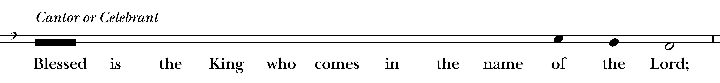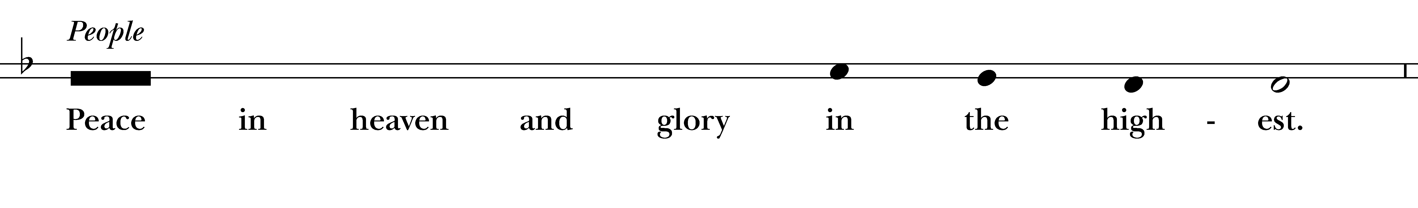
Celebrant Let us pray.
Assist us mercifully with your help, O Lord God of our salvation, that we may enter with joy upon the contemplation of those mighty acts, whereby you have given us life and immortality; through Jesus Christ our Lord. Amen.

The First Gospel Reading Matthew 21:1-11
A Reading from the Gospel According to Matthew.
When they had come near Jerusalem and had reached Bethphage, at the Mount of Olives, Jesus sent two disciples, saying to them, “Go into the village ahead of you, and immediately you will find a donkey tied, and a colt with her; untie them and bring them to me. If anyone says anything to you, just say this, ‘The Lord needs them.’ And he will send them immediately.” This took place to fulfill what had been spoken through the prophet, saying, “Tell the daughter of Zion, Look, your king is coming to you, humble, and mounted on a donkey, and on a colt, the foal of a donkey.” The disciples went and did as Jesus had directed them; they brought the donkey and the colt, and put their cloaks on them, and he sat on them. A very large crowd spread their cloaks on the road, and others cut branches from the trees and spread them on the road. The crowds that went ahead of him and that followed were shouting, “Hosanna to the Son of David! Blessed is the one who comes in the name of the Lord! Hosanna in the highest heaven!” When he entered Jerusalem, the whole city was in turmoil, asking, “Who is this?” The crowds were saying, “This is the prophet Jesus from Nazareth in Galilee.”

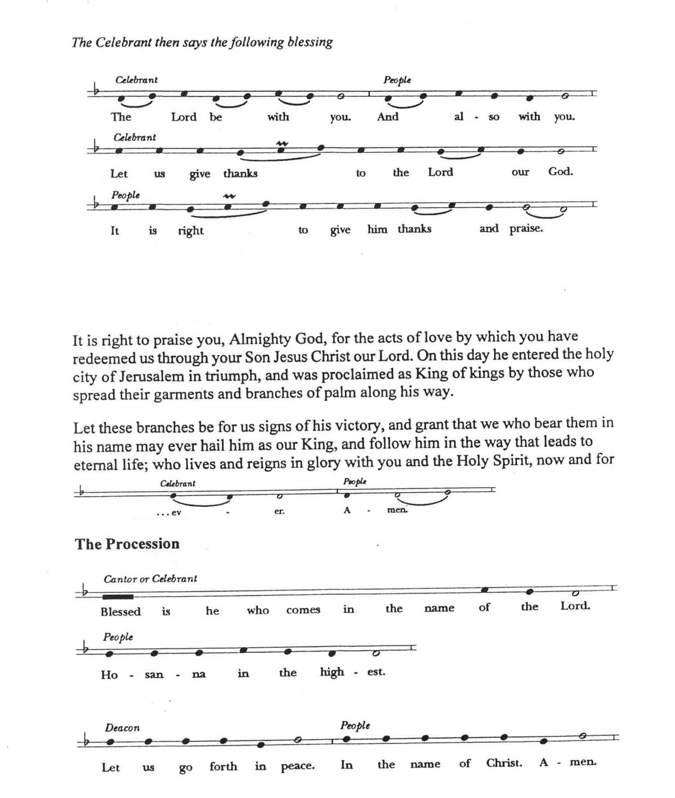

It is right to praise you, Almighty God, for the acts of love by which you have redeemed us through your Son Jesus Christ our Lord. On this day he entered the holy city of Jerusalem in triumph, and was proclaimed as King of kings by those who spread their garments and branches of palm along his way. Let these branches be for us signs of his victory, and grant that we who bear them in his name may ever hail him as our King, and follow him in the way that leads to eternal life; who lives and reigns in glory with you and the Holy Spirit, now and for
The Procession
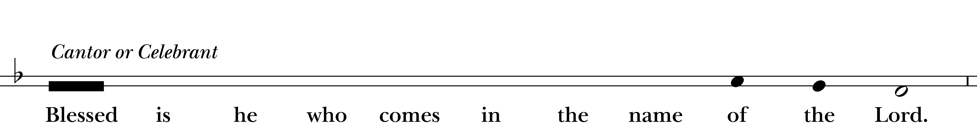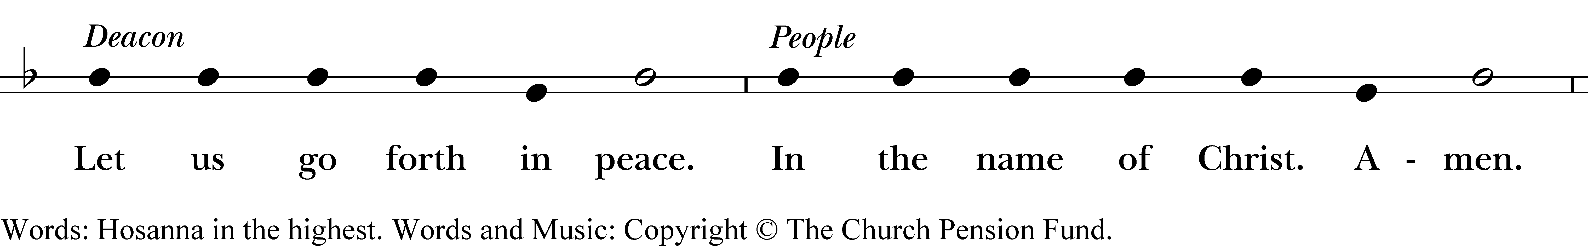

The people process into church, all waving palm branches above their heads and singing:

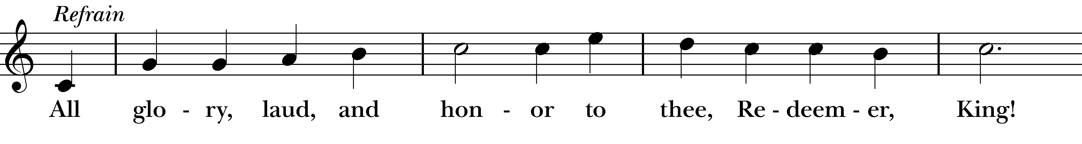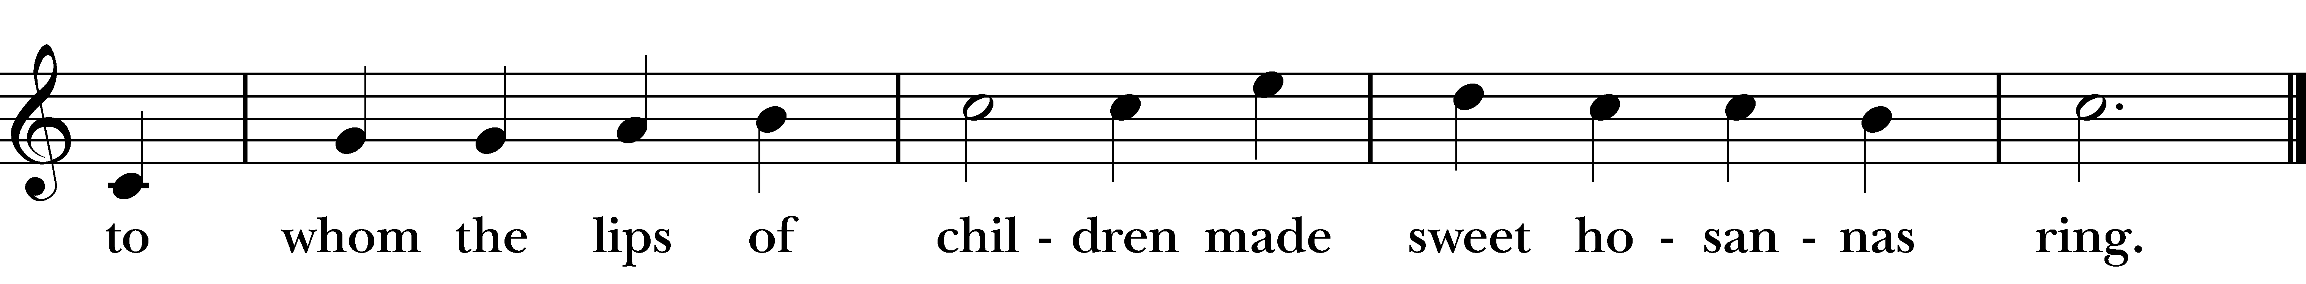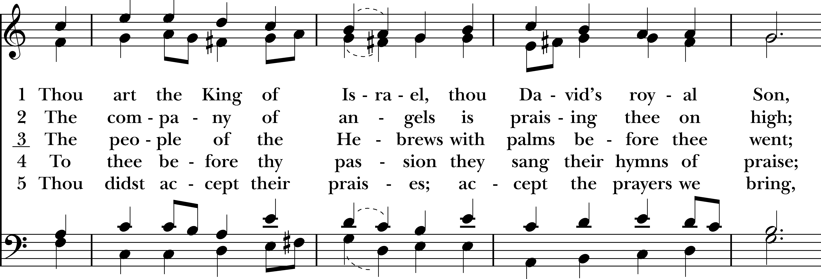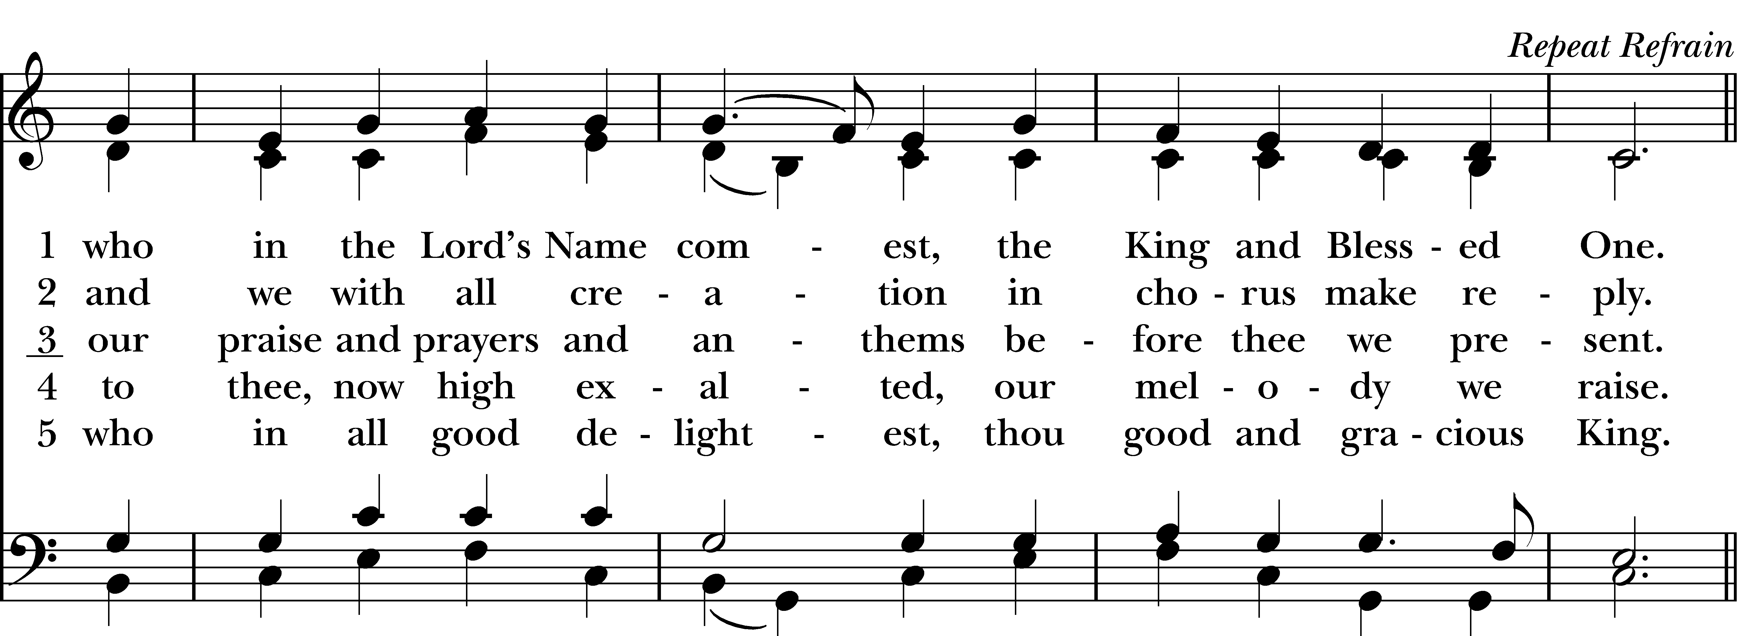
Sermon Rev. Katy
The Collect of the Day
Almighty and everliving God, in your tender love for the human race you sent your Son our Savior Jesus Christ to take upon him our nature, and to suffer death upon the cross, giving us the example of his great humility: Mercifully grant that we may walk in the way of his suffering, and also share in his resurrection; through Jesus Christ our Lord, who lives and reigns with you and the Holy Spirit, one God, for ever and ever. Amen.
Hymn “Ride on, King Jesus” Christ Church Choir
Soloist: Dan Tressler

The First Reading Isaiah 50:4-9a
A Reading from the Book of the Prophet Isaiah.
The Lord GOD has given me the tongue of a teacher, that I may know how to sustain the weary with a word. Morning by morning he wakens—wakens my ear to listen as those who are taught. The Lord GOD has opened my ear, and I was not rebellious, I did not turn backward. I gave my back to those who struck me, and my cheeks to those who pulled out the beard; I did not hide my face from insult and spitting. The Lord GOD helps me; therefore I have not been disgraced; therefore I have set my face like flint, and I know that I shall not be put to shame; he who vindicates me is near. Who will contend with me? Let us stand up together. Who are my adversaries? Let them confront me. It is the Lord GOD who helps me; who will declare me guilty? All of them will wear out like a garment; the moth will eat them up.
The Word of the Lord.
Thanks by to God.

Psalm 31 Psalm 31:9-16

Have mercy on me, O LORD, for I am in trouble; *
my eye is consumed with sorrow, and also my throat and my belly.
For my life is wasted with grief, and my years with sighing; *
my strength fails me because of affliction, and my bones are consumed.
I have become a reproach to all my enemies and even to my neighbors, a dismay to those of my acquaintance; *
when they see me in the street they avoid me.
I am forgotten like a dead man, out of mind; *
I am as useless as a broken pot.
For I have heard the whispering of the crowd; fear is all around; *
they put their heads together against me; they plot to take my life.
But as for me, I have trusted in you, O LORD. *
I have said, “You are my God.
My times are in your hand; *
rescue me from the hand of my enemies, and from those who persecute me.
Make your face to shine upon your servant, *
and in your loving-kindness save me.”

The Nicene Creed

We believe in one God, the Father, the Almighty, maker of heaven and earth, of all that is, seen and unseen. We believe in one Lord, Jesus Christ, the only Son of God, eternally begotten of the Father, God from God, Light from Light, true God from true God, begotten, not made, of one Being with the Father. Through him all things were made.

For us and for our salvation, he came down from heaven: by the power of the Holy Spirit he became incarnate from the Virgin Mary, and was made man. For our sake he was crucified under Pontius Pilate; he suffered death and was buried. On the third day he rose again in accordance with the Scriptures; he ascended into heaven and is seated at the right hand of the Father. He will come again in glory to judge the living and the dead, and his kingdom will have no end.

We believe in the Holy Spirit, the Lord, the giver of life, who proceeds from the Father and the Son. With the Father and the Son he is worshiped and glorified. He has spoken through the Prophets. We believe in one holy catholic and apostolic Church. We acknowledge one baptism for the forgiveness of sins. We look for the resurrection of the dead, and the life of the world to come. Amen.

The Prayers of the People By Richard J. Fairchild
Loving God, there is so much darkness in our lives, and we hide from you. Take our hands and lead us out of the shadows of our fears. Help us to change our hearts. Let us recognize the fullness of your love, which will fill our lives. God of power and mercy, give us the spirit of prayer and repentance – with burning love for you and all mankind.

Lord, hear our prayer, and in Your Love, answer.

Forgive us for failing to see Christ in the poor, the distressed and the troublesome. Help us, Lord, should this be a time in our lives when we feel oppressed by the evil one – lead us on our journey – and bring us safe to the other side.

Lord, hear our prayer, and in Your Love, answer.

Lord God, there are many among us who faced barren times – wilderness times in their lives. Help us to minister your loving presence to them in those times so that they may come through the wilderness and enter the promised land. Help us to bring food to the hungry, water to the thirsty, shelter to the homeless, courage to those who faint, and hope to those who are tempted to despair.

Lord, hear our prayer, and in Your Love, answer.

Lord God, in this time of impending conflict between nations – this time when we are being tested to see if we will do justice as well as love mercy – we pray for guidance – and for your light to lead the way of the rulers of our nation and the nations about us.

Lord, hear our prayer, and in Your Love, answer.

Lord God, hear our prayers for those among us who are in need – those whom we name before you now from our parish prayer list…

We ask these things through Jesus Christ. Amen.

Confession of Sin From the Anglican BCP

Celebrant: Let us say together,
Father eternal, giver of light and grace, we have sinned against you and against our neighbor, in what we have thought, in what we have said and done, through ignorance, through weakness, through our own deliberate fault. We have wounded your love and marred your image in us. We are sorry and ashamed and repent of all our sins. For the sake of your Son Jesus Christ, who died for us, forgive us all that is past and lead us out from darkness to walk as children of light. Amen.
Almighty God have mercy on you, forgive you all your sins through our Lord Jesus Christ, strengthen you in all goodness, and by the power of the Holy Spirit keep you in eternal life. Amen.
The Peace
Celebrant The peace of the Lord be always with you.
People And also with you.
Announcements

The Holy Communion
Walk in love, as Christ loved us and gave himself for us, an offering and sacrifice to God. Ephesians 5:2

Offertory Anthem “Requiem: Pie Jesu” Christ Church Choir
By John Rutter Soloist: Amy Strachan

“Pie Jesu Domine, dona eis requiem, requiem aeternam dona eis, Domine, dona eis requiem”
(Merciful Lord Jesus, grant them rest, eternal rest, grant them, Lord, grant them rest)

Celebrant The Lord be with you.
People And also with you.
Celebrant Lift up your hearts.
People We lift them to the Lord.
Celebrant Let us give thanks to the Lord our God.
People It is right to give God thanks and praise.
It is right, and a good and joyful thing, always and everywhere to give thanks to you, Father Almighty, Creator of heaven and earth. Through Jesus Christ our Lord. For our sins he was lifted high upon the cross, that he might draw the whole world to himself; and, by his suffering and death, he became the source of eternal salvation for all who put their trust in him. Therefore we praise you, joining our voices with Angels and Archangels and with all the company of heaven, who for ever sing this hymn to proclaim the glory of your Name:
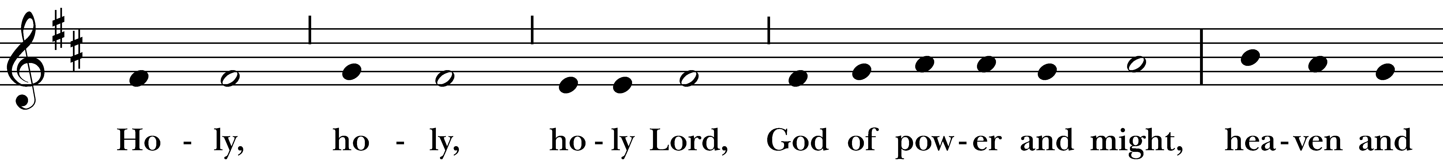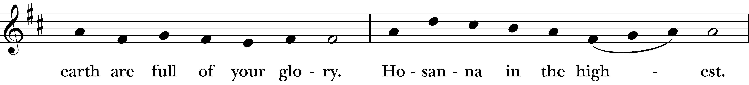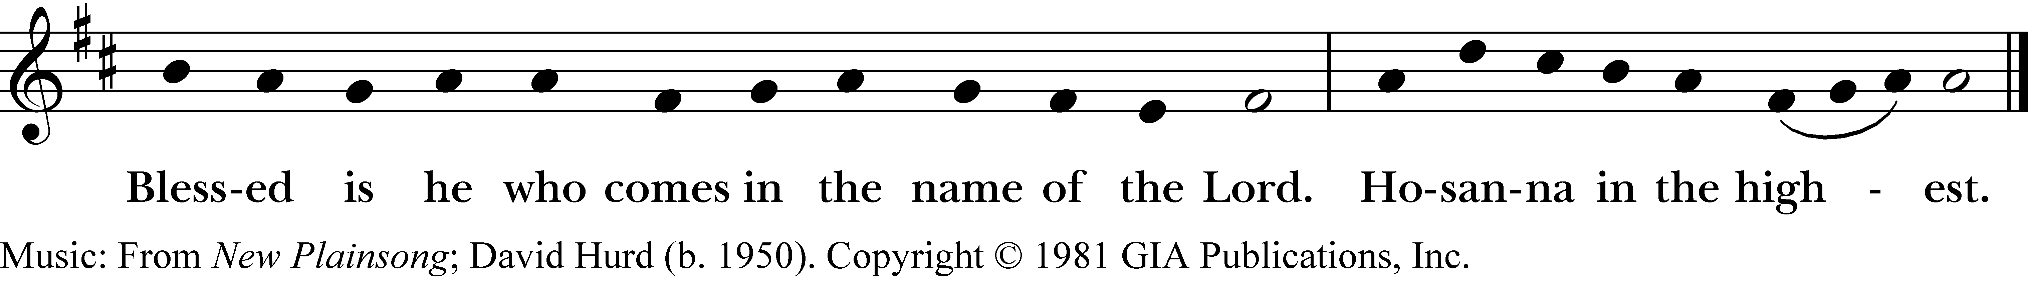
Reprinted/streamed with permission via One License and/or RiteSong. All rights reserved.
And now, as our Savior Christ has taught us, we are bold to say,
Our Father, who art in heaven, hallowed be thy Name, thy kingdom come, thy will be done, on earth as it is in heaven. Give us this day our daily bread. And forgive us our trespasses, as we forgive those who trespass against us. And lead us not into temptation, but deliver us from evil. For thine is the kingdom, and the power, and the glory, for ever and ever. Amen.

The Breaking of the Bread

Celebrant We break this bread to share in the body of Christ.
People Though we are many, we are one body, because we all share in one bread.

Fraction Anthem

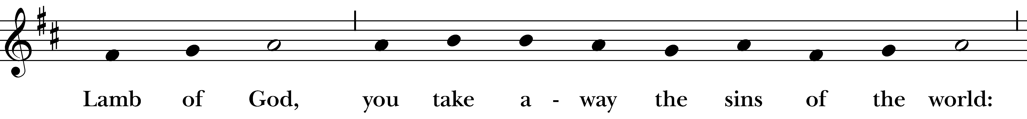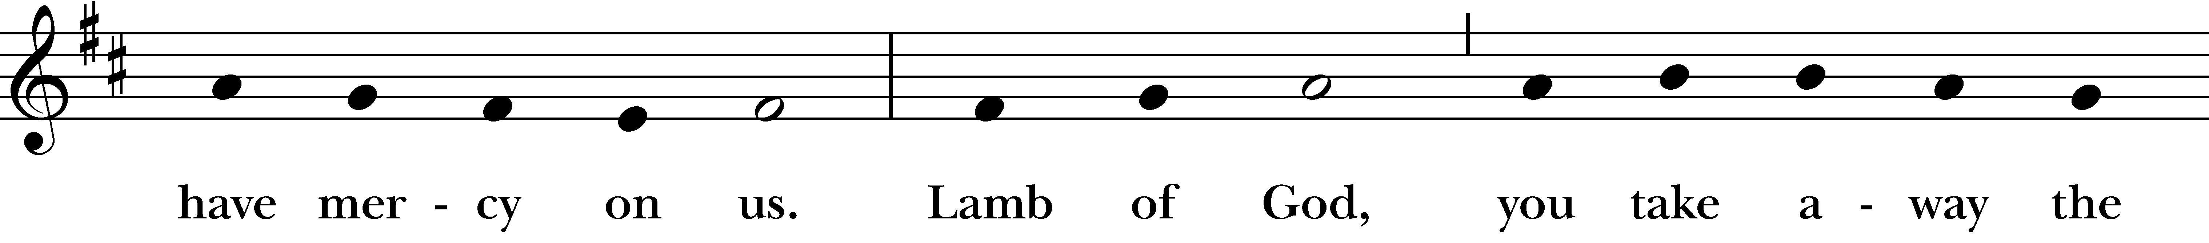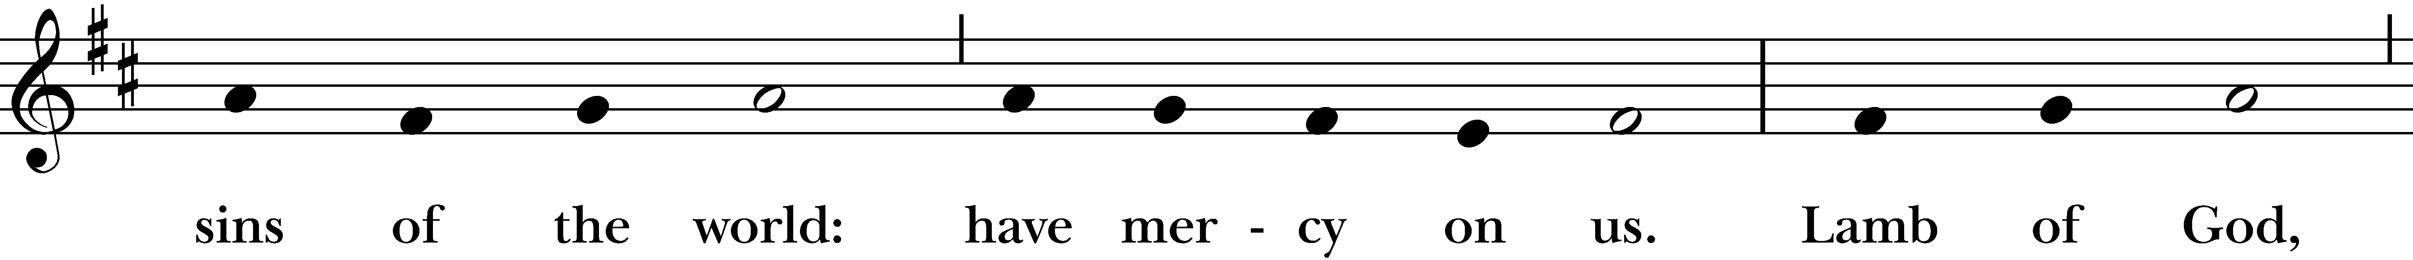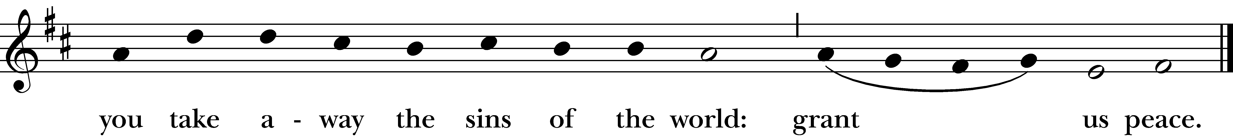
Reprinted/streamed with permission via One License and/or RiteSong. All rights reserved.

Celebrant The Gifts of God for the People of God. Take them in remembrance that Christ died for you, and feed on him in your hearts by faith, with thanksgiving.

A Prayer for Spiritual Communion:

Let us pray. We believe that you are truly present in the Holy Sacrament, and we pray you to come into our hearts, praying especially with those at home who cannot at this time receive communion. I unite myself with you and embrace you with all my heart, my soul, and my mind. Let nothing separate me from you; let me serve you in this life until, by your grace, I come to your glorious kingdom and unending peace. Amen.

Communion Hymn “O, sacred head, sore wounded” Hymnal #168

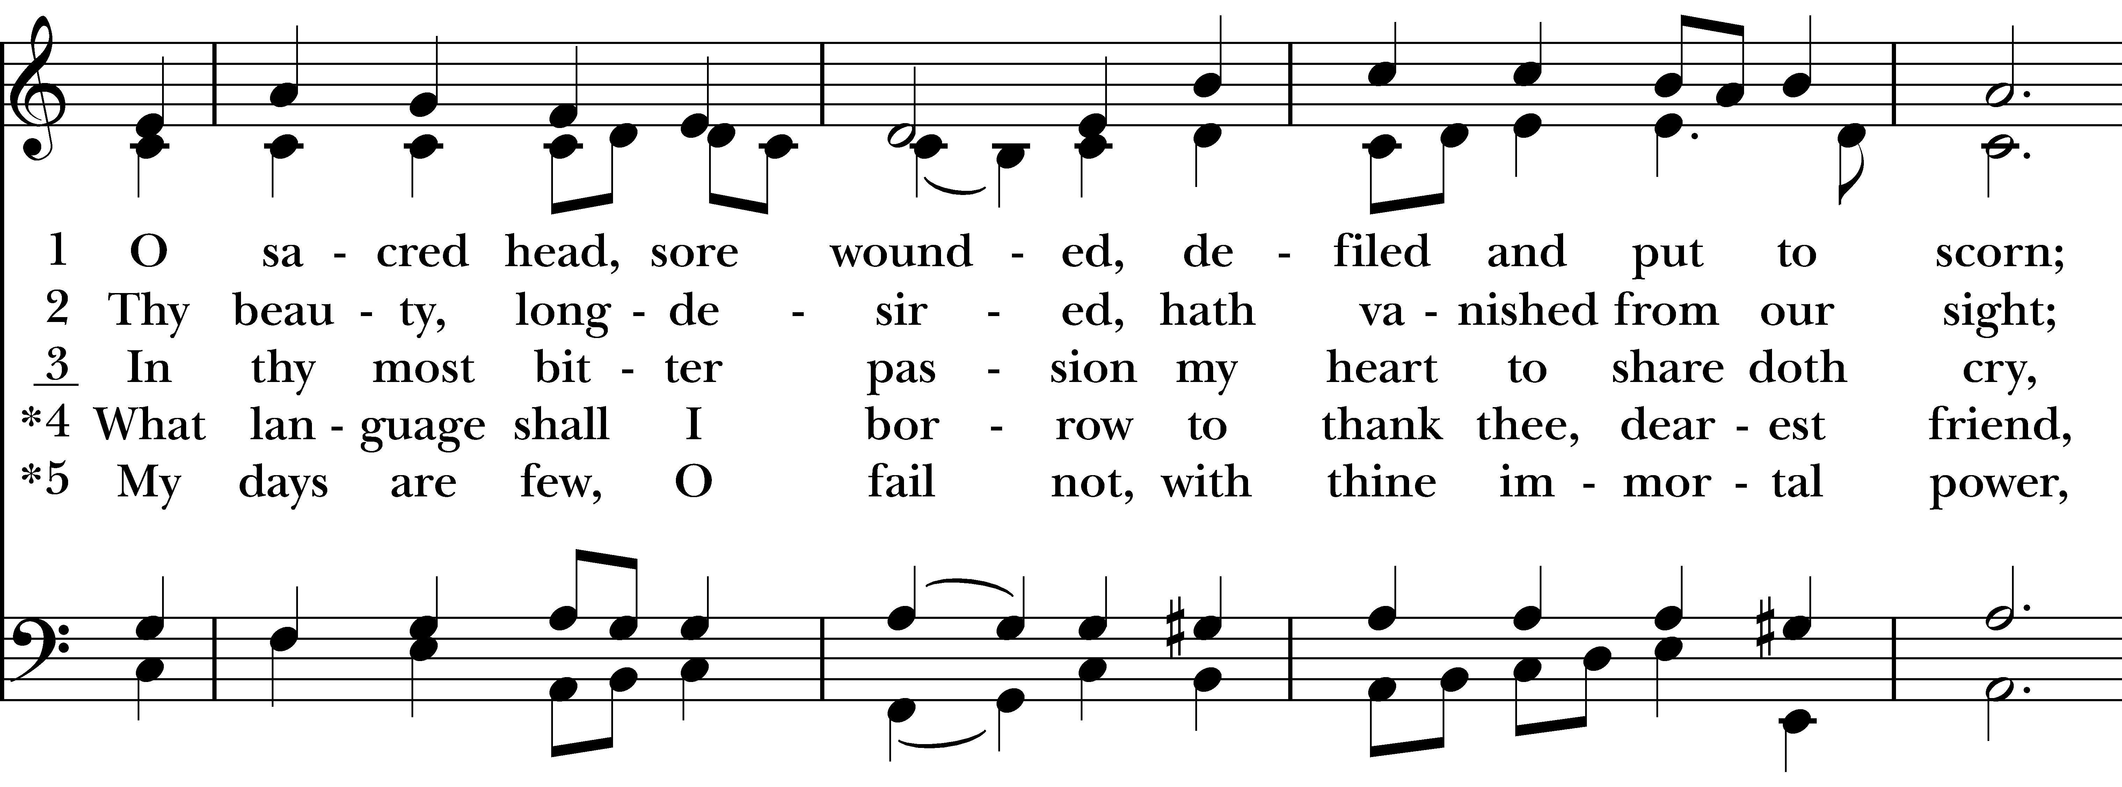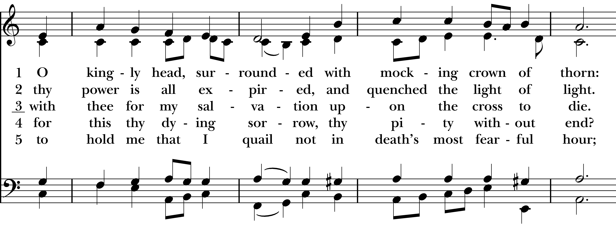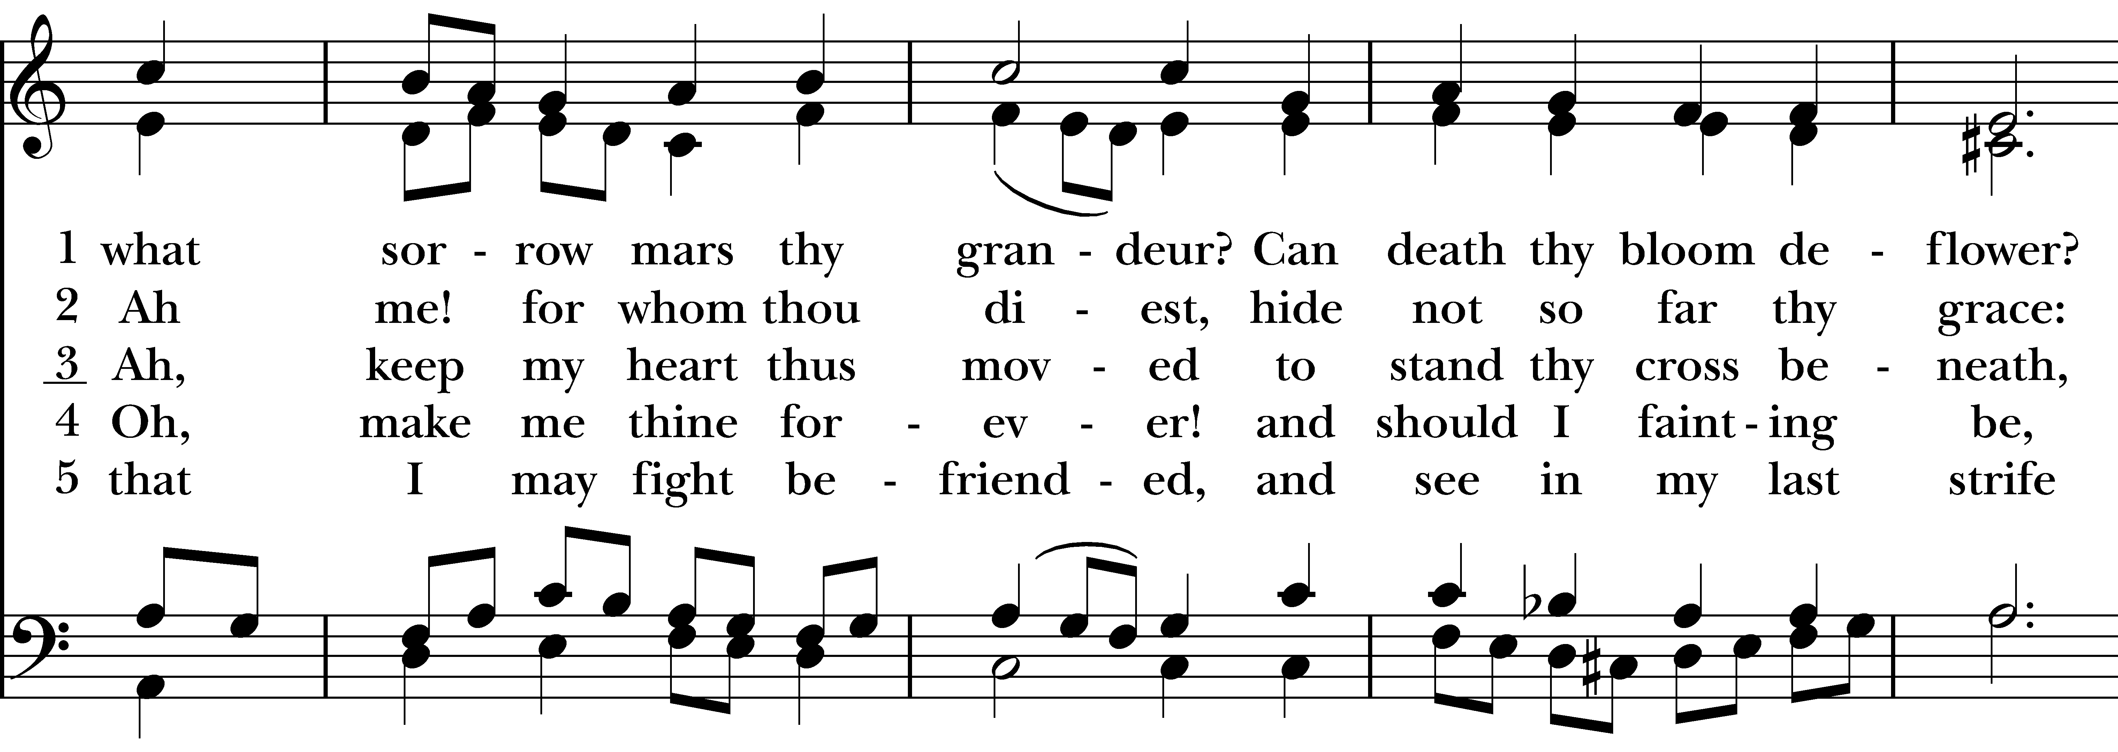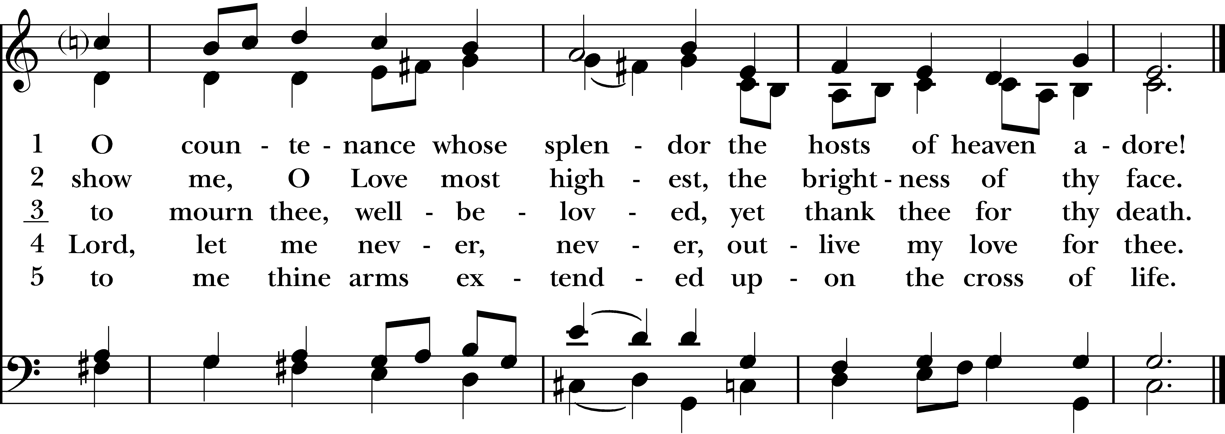

Post Communion Prayer

Eternal God, heavenly Father, you have graciously accepted us as living members of your Son our Savior Jesus Christ, and you have fed us with spiritual food in the Sacrament of his Body and Blood. Send us now into the world in peace, and grant us strength and courage to love and serve you with gladness and singleness of heart; through Christ our Lord. Amen.

The Passion According to Matthew
Please remain seated.

The congregation plays the role of the “Assembly,” a conflation of the priests and scribes, the leaders and the people, who often speak with one voice.

The Passion of our Lord Jesus Christ according to Saint Matthew.

NARRATOR: One of the twelve, who was called Judas Iscariot, went to the chief priests and said,

JUDAS: “What will you give me if I betray Jesus to you?”

NARRATOR: They paid him thirty pieces of silver. And from that moment he began to look for an opportunity to betray him. On the first day of Unleavened Bread the disciples came to Jesus, saying,

DISCIPLES: “Where do you want us to make the preparations for you to eat the Passover?”

NARRATOR: He said,

JESUS: “Go into the city to a certain man, and say to him, ‘The Teacher says, My time is near; I will keep the Passover at your house with my disciples.’”

NARRATOR: So the disciples did as Jesus had directed them, and they prepared the Passover meal.

When it was evening, he took his place with the twelve; and while they were eating, he said,

JESUS: “Truly I tell you, one of you will betray me.”

NARRATOR: And they became greatly distressed and began to say to him one after another,

DISCIPLES: “Surely not I, Lord?”

NARRATOR: He answered,

JESUS: “The one who has dipped his hand into the bowl with me will betray me. The Son of Man goes as it is written of him, but woe to that one by whom the Son of Man is betrayed! It would have been better for that one not to have been born.”

NARRATOR: Judas, who betrayed him, said,

JUDAS: “Surely not I, Rabbi?”

NARRATOR: He replied,

JESUS: “You have said so.”

NARRATOR: While they were eating, Jesus took a loaf of bread, and after blessing it he broke it, gave it to the disciples, and said,

JESUS: “Take, eat; this is my body.”

NARRATOR: Then he took a cup, and after giving thanks he gave it to them, saying,

JESUS: “Drink from it, all of you; for this is my blood of the covenant, which is poured out for many for the forgiveness of sins. I tell you, I will never again drink of this fruit of the vine until that day when I drink it new with you in my Father's kingdom.”

NARRATOR: When they had sung the hymn, they went out to the Mount of Olives. Then Jesus said to them,

JESUS: “You will all become deserters because of me this night; for it is written, ‘I will strike the shepherd, and the sheep of the flock will be scattered.’ But after I am raised up, I will go ahead of you to Galilee.”

NARRATOR: Peter said to him,

PETER: “Though all become deserters because of you, I will never desert you.”

NARRATOR: Jesus said to him,

JESUS: “Truly I tell you, this very night, before the cock crows, you will deny me three times.”

NARRATOR: Peter said to him,

PETER: “Even though I must die with you, I will not deny you.”

NARRATOR: And so said all the disciples. Then Jesus went with them to a place called Gethsemane; and he said to his disciples,

JESUS: “Sit here while I go over there and pray.”

NARRATOR: He took with him Peter and the two sons of Zebedee, and began to be grieved and agitated. Then he said to them,

JESUS: “I am deeply grieved, even to death; remain here, and stay awake with me.”

NARRATOR: And going a little farther, he threw himself on the ground and prayed,

JESUS: “My Father, if it is possible, let this cup pass from me; yet not what I want but what you want.”

NARRATOR: Then he came to the disciples and found them sleeping; and he said to Peter,

JESUS: “So, could you not stay awake with me one hour? Stay awake and pray that you may not come into the time of trial; the spirit indeed is willing, but the flesh is weak.”

NARRATOR: Again he went away for the second time and prayed,

JESUS: “My Father, if this cannot pass unless I drink it, your will be done.”

NARRATOR: Again he came and found them sleeping, for their eyes were heavy. So leaving them again, he went away and prayed for the third time, saying the same words. Then he came to the disciples and said to them,

JESUS: “Are you still sleeping and taking your rest? See, the hour is at hand, and the Son of Man is betrayed into the hands of sinners. Get up, let us be going. See, my betrayer is at hand.”

NARRATOR: While he was still speaking, Judas, one of the twelve, arrived; with him was a large crowd with swords and clubs, from the chief priests and the elders of the people. Now the betrayer had given them a sign, saying,

JUDAS: “The one I will kiss is the man; arrest him.”

NARRATOR: At once he came up to Jesus and said,

JUDAS: “Greetings, Rabbi!”

NARRATOR: and kissed him. Jesus said to him,

JESUS: “Friend, do what you are here to do.”
NARRATOR: Then they came and laid hands on Jesus and arrested him. Suddenly, one of those with Jesus put his hand on his sword, drew it, and struck the slave of the high priest, cutting off his ear. Then Jesus said to him,

JESUS: “Put your sword back into its place; for all who take the sword will perish by the sword. Do you think that I cannot appeal to my Father, and he will at once send me more than twelve legions of angels? But how then would the scriptures be fulfilled, which say it must happen in this way?”

NARRATOR: At that hour Jesus said to the crowds,

JESUS: “Have you come out with swords and clubs to arrest me as though I were a bandit? Day after day I sat in the temple teaching, and you did not arrest me. But all this has taken place, so that the scriptures of the prophets may be fulfilled.”

NARRATOR: Then all the disciples deserted him and fled. Those who had arrested Jesus took him to Caiaphas the high priest, in whose house the scribes and the elders had gathered. But Peter was following him at a distance, as far as the courtyard of the high priest; and going inside, he sat with the guards in order to see how this would end. Now the chief priests and the whole council were looking for false testimony against Jesus so that they might put him to death, but they found none, though many false witnesses came forward. At last two came forward and said,

ASSEMBLY: “This fellow said, ‘I am able to destroy the temple of God and to build it in three days.’”

NARRATOR: The high priest stood up and said,

HIGH PRIEST: “Have you no answer? What is it that they testify against you?”

NARRATOR: But Jesus was silent. Then the high priest said to him,

HIGH PRIEST: “I put you under oath before the living God, tell us if you are the Messiah, the Son of God.”

NARRATOR: Jesus said to him,

JESUS: “You have said so. But I tell you, From now on you will see the Son of Man seated at the right hand of Power and coming on the clouds of heaven.”

NARRATOR: Then the high priest tore his clothes and said,

HIGH PRIEST: “He has blasphemed! Why do we still need witnesses? You have now heard his blasphemy. What is your verdict?”

NARRATOR: They answered,

ASSEMBLY: “He deserves death.”
NARRATOR: Then they spat in his face and struck him; and some slapped him, saying,

ASSEMBLY: “Prophesy to us, you Messiah! Who is it that struck you?”

NARRATOR: Now Peter was sitting outside in the courtyard. A servant-girl came to him and said,

SERVANT GIRL: “You also were with Jesus the Galilean.”

NARRATOR: But he denied it before all of them, saying,

PETER: “I do not know what you are talking about.”

NARRATOR: When he went out to the porch, another servant-girl saw him, and she said to the assembly,

SERVANT GIRL: “This man was with Jesus of Nazareth.”

NARRATOR: Again he denied it with an oath,

PETER: “I do not know the man.”

NARRATOR: After a little while the ASSEMBLY came up and said to Peter,

ASSEMBLY: “Certainly you are also one of them, for your accent betrays you.”

NARRATOR: Then he began to curse, and he swore an oath,

PETER: “I do not know the man!”

NARRATOR: At that moment the cock crowed. Then Peter remembered what Jesus had said:

JESUS: “Before the cock crows, you will deny me three times.”

NARRATOR: And he went out and wept bitterly.

When morning came, all the chief priests and the elders of the people conferred together against Jesus in order to bring about his death. They bound him, led him away, and handed him over to Pilate the governor.

When Judas, his betrayer, saw that Jesus was condemned, he repented and brought back the thirty pieces of silver to the chief priests and the elders. He said,

JUDAS: “I have sinned by betraying innocent blood.”

NARRATOR: But they said,

ASSEMBLY: “What is that to us? See to it yourself.”

NARRATOR: Throwing down the pieces of silver in the temple, he departed; and he went and hanged himself. But the chief priests, taking the pieces of silver, said,

ASSEMBLY: “It is not lawful to put them into the treasury, since they are blood money.”

NARRATOR: After conferring together, they used them to buy the potter's field as a place to bury foreigners. For this reason that field has been called the Field of Blood to this day. Then was fulfilled what had been spoken through the prophet Jeremiah, “And they took the thirty pieces of silver, the price of the one on whom a price had been set, on whom some of the people of Israel had set a price, and they gave them for the potter's field, as the Lord commanded me.”

Now Jesus stood before the governor; and the governor asked him,

PILATE: “Are you the King of the Jews?”

NARRATOR: Jesus said,

JESUS: “You say so.”

NARRATOR: But when he was accused by the chief priests and elders, he did not answer. Then Pilate said to him,

PILATE: “Do you not hear how many accusations they make against you?”

NARRATOR: But he gave him no answer, not even to a single charge, so that the governor was greatly amazed.

Now at the festival the governor was accustomed to release a prisoner for the crowd, anyone whom they wanted. At that time they had a notorious prisoner, called Jesus Barabbas. So after they had gathered, Pilate said to them,
PILATE: “Whom do you want me to release for you, Jesus Barabbas or Jesus who is called the Messiah?”

NARRATOR: For he realized that it was out of jealousy that they had handed him over. While he was sitting on the judgment seat, his wife sent word to him,

PILATE’S WIFE: “Have nothing to do with that innocent man, for today I have suffered a great deal because of a dream about him.”

NARRATOR: Now the chief priests and the elders persuaded the crowds to ask for Barabbas and to have Jesus killed. The governor again said to them,

PILATE: “Which of the two do you want me to release for you?”

NARRATOR: And they said,

ASSEMBLY: “Barabbas.”

NARRATOR: Pilate said to them,

PILATE: “Then what should I do with Jesus who is called the Messiah?”

NARRATOR: All of them said,

ASSEMBLY: “Let him be crucified!”

NARRATOR: Then he asked,

PILATE: “Why, what evil has he done?”

NARRATOR: But they shouted all the more,

ASSEMBLY: “Let him be crucified!”

NARRATOR: So when Pilate saw that he could do nothing, but rather that a riot was beginning, he took some water and washed his hands before the crowd, saying,

PILATE: “I am innocent of this man's blood; see to it yourselves.”

NARRATOR: Then the people as a whole answered,

ASSEMBLY: “His blood be on us and on our children!” *

*This scriptural verse, likely an editorial addition made later by the practicing community, has been used by Christians throughout history to label Jewish people “Christ-killers” and justify violence, hatred and persecution against them. PLEASE TAKE A MOMENT OF SILENCE TO LAMENT THE USE OF THIS SCRIPTURAL VERSE AND CHRISTIAN FAITH TO JUSTIFY ANTI-SEMETIC HATE AND VIOLENCE THROUGHOUT HISTORY AND STILL TODAY.

NARRATOR: So he released Barabbas for them; and after flogging Jesus, he handed him over to be crucified.

Then the soldiers of the governor took Jesus into the governor's headquarters, and they gathered the whole cohort around him. They stripped him and put a scarlet robe on him, and after twisting some thorns into a crown, they put it on his head. They put a reed in his right hand and knelt before him and mocked him, saying,

SOLDIERS: “Hail, King of the Jews!”

NARRATOR: They spat on him, and took the reed and struck him on the head. After mocking him, they stripped him of the robe and put his own clothes on him. Then they led him away to crucify him. (At the mention of Golgotha, the congregation should stand and remain standing for the remainder of the reading).

NARRATOR: As they went out, they came upon a man from Cyrene named Simon; they compelled this man to carry his cross. And when they came to a place called Golgotha (which means Place of a Skull), they offered him wine to drink, mixed with gall; but when he tasted it, he would not drink it. And when they had crucified him, they divided his clothes among themselves by casting lots; then they sat down there and kept watch over him. Over his head they put the charge against him, which read, "This is Jesus, the King of the Jews." Then two bandits were crucified with him, one on his right and one on his left. Those who passed by derided him, shaking their heads and saying,

ASSEMBLY: “You who would destroy the temple and build it in three days, save yourself! If you are the Son of God, come down from the cross.”

NARRATOR: In the same way the chief priests also, along with the scribes and elders, were mocking him, saying,

ASSEMBLY: “He saved others; he cannot save himself. He is the King of Israel; let him come down from the cross now, and we will believe in him. He trusts in God; let God deliver him now, if he wants to; for he said, ‘I am God's Son.’”

NARRATOR: The bandits who were crucified with him also taunted him in the same way.

From noon on, darkness came over the whole land until three in the afternoon. And about three o'clock Jesus cried with a loud voice,

JESUS: “Eli, Eli, lema sabachthani?”

NARRATOR: that is,

JESUS: “My God, my God, why have you forsaken me?”

NARRATOR: When some of the ASSEMBLY heard it, they said,

ASSEMBLY: “This man is calling for Elijah.”

NARRATOR: At once one of them ran and got a sponge, filled it with sour wine, put it on a stick, and gave it to him to drink. But the others said,

ASSEMBLY: “Wait, let us see whether Elijah will come to save him.”

NARRATOR: Then Jesus cried again with a loud voice and breathed his last. At that moment the curtain of the temple was torn in two, from top to bottom. The earth shook, and the rocks were split. The tombs also were opened, and many bodies of the saints who had fallen asleep were raised. After his resurrection they came out of the tombs and entered the holy city and appeared to many. Now when the centurion and those with him, who were keeping watch over Jesus, saw the earthquake and what took place, they were terrified and said,

CENTURION: “Truly this man was God's Son!”

NARRATOR: Many women were also there, looking on from a distance; they had followed Jesus from Galilee and had provided for him. Among them were Mary Magdalene, and Mary the mother of James and Joseph, and the mother of the sons of Zebedee.

When it was evening, there came a rich man from Arimathea, named Joseph, who was also a disciple of Jesus. He went to Pilate and asked for the body of Jesus; then Pilate ordered it to be given to him. So Joseph took the body and wrapped it in a clean linen cloth and laid it in his own new tomb, which he had hewn in the rock. He then rolled a great stone to the door of the tomb and went away. Mary Magdalene and the other Mary were there, sitting opposite the tomb.

The next day, that is, after the day of Preparation, the chief priests and the Pharisees gathered before Pilate and said,

ASSEMBLY: “Sir, we remember what that impostor said while he was still alive, ‘After three days I will rise again.’ Therefore command the tomb to be made secure until the third day; otherwise his disciples may go and steal him away, and tell the people, ‘He has been raised from the dead,’ and the last deception would be worse than the first.”

NARRATOR: Pilate said to them,

PILATE: “You have a guard of soldiers; go, make it as secure as you can.”

NARRATOR: So they went with the guard and made the tomb secure by sealing the stone.

Recessional Hymn “Were you there?” Hymnal #172

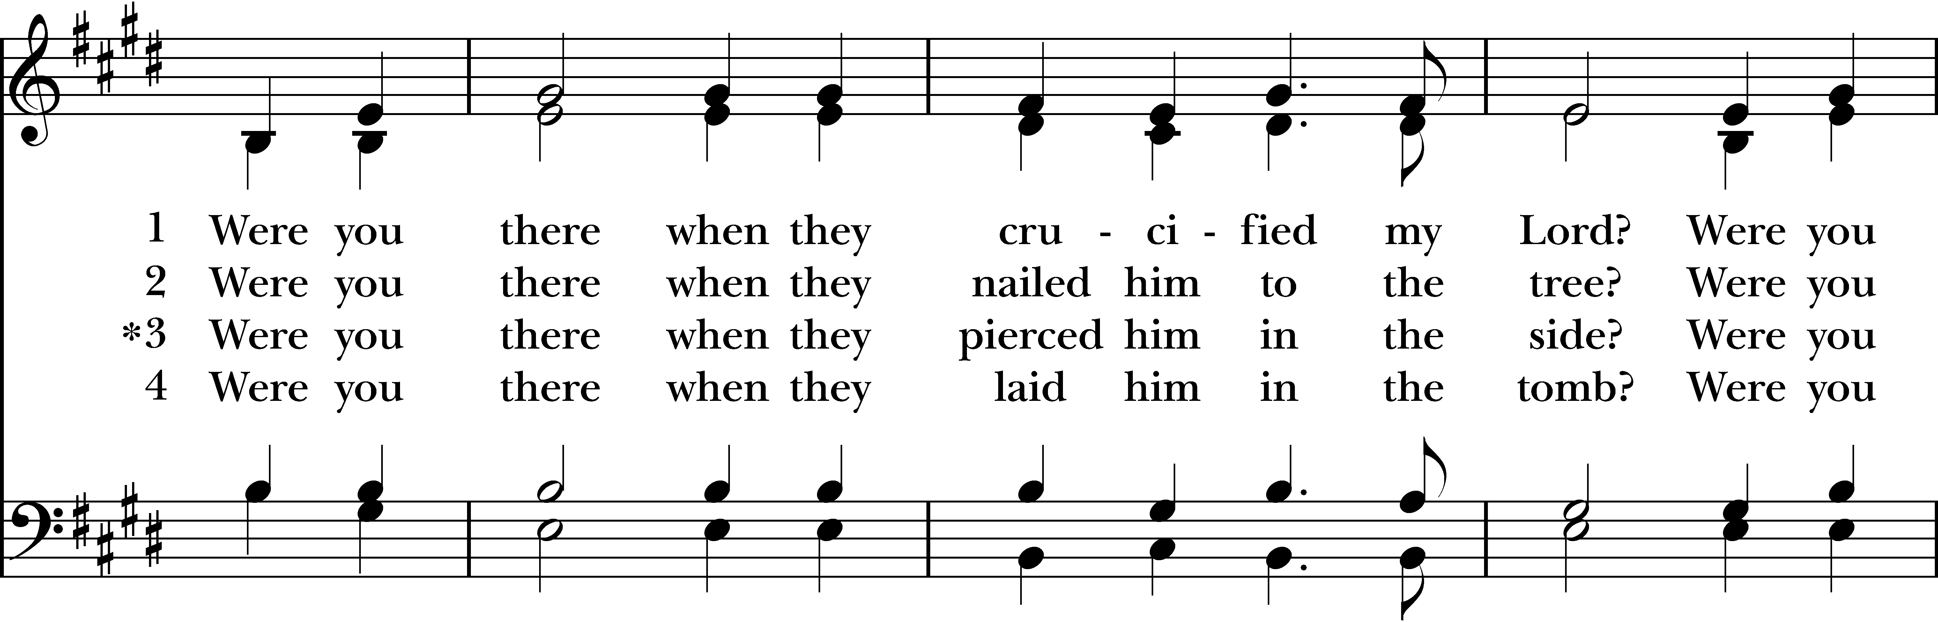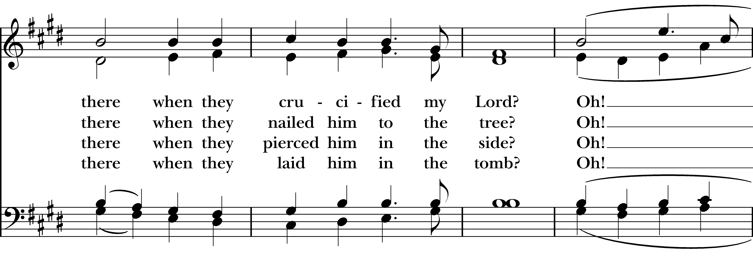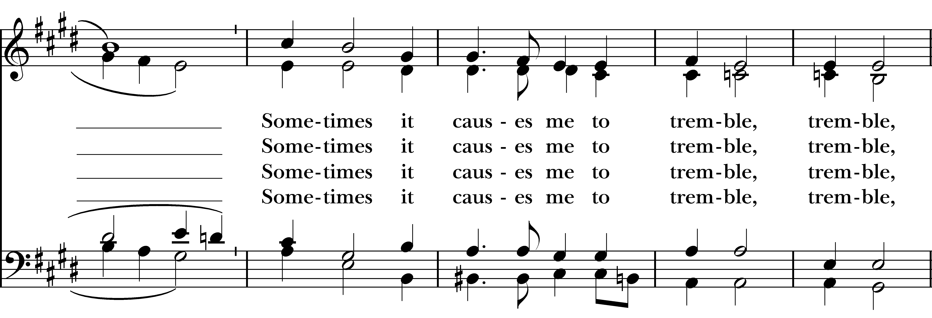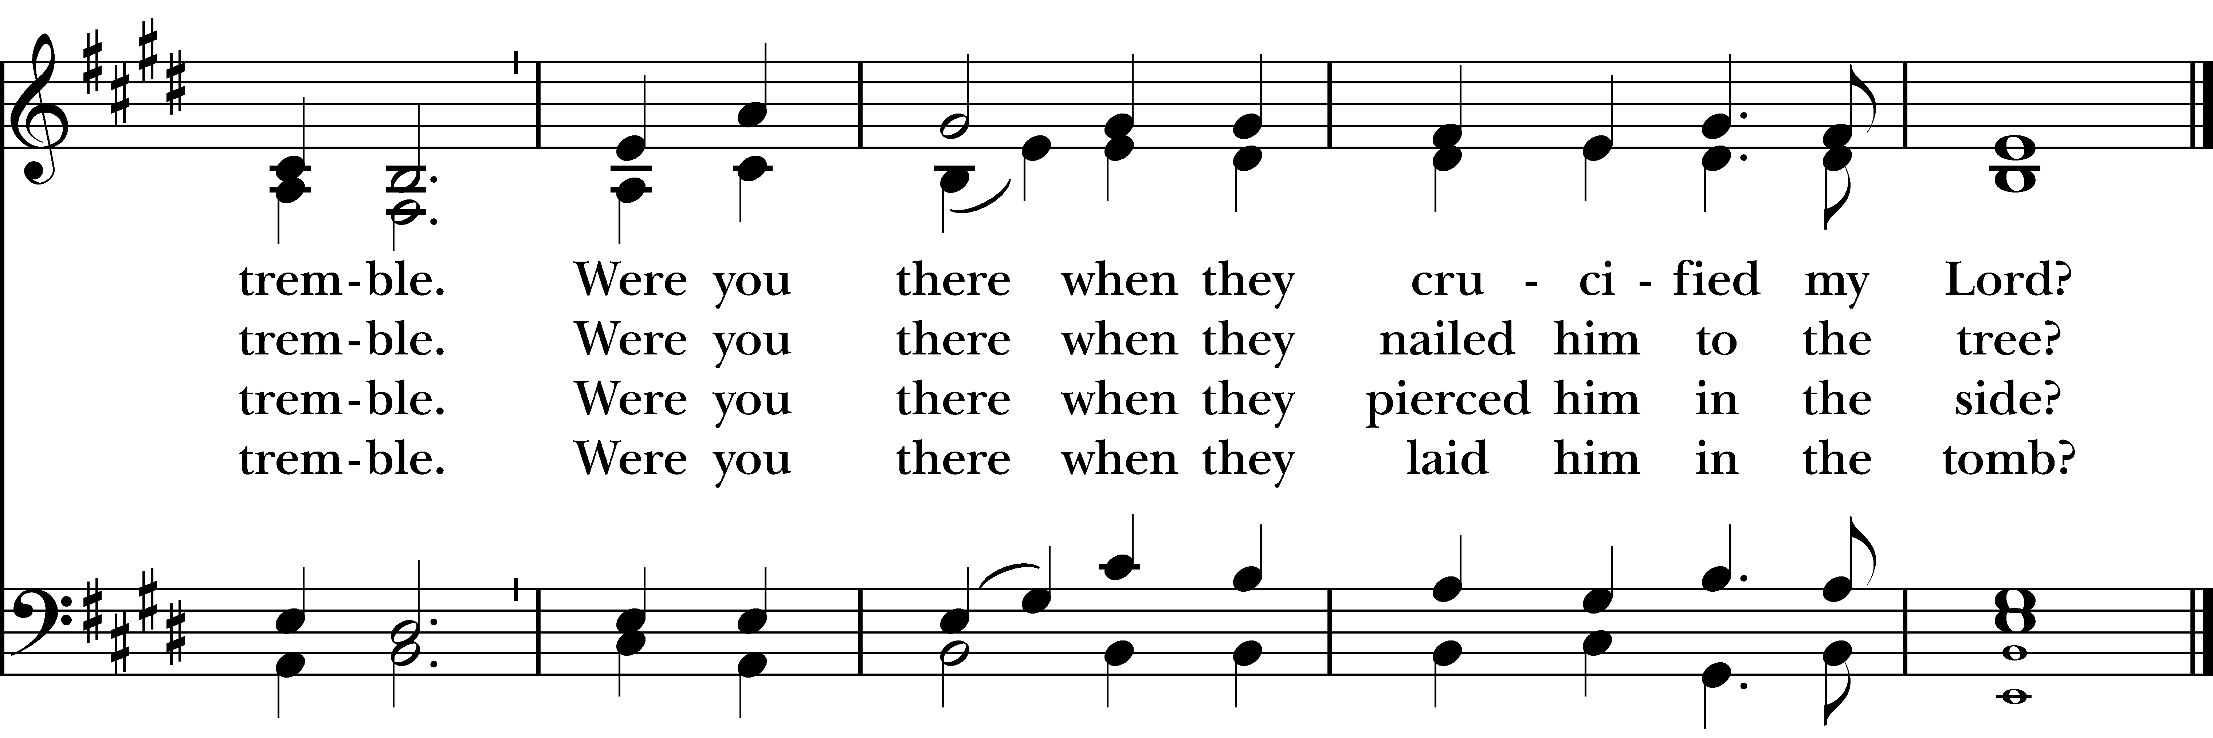

Announcements for March 29th, 2026

EASTER FLOWER ENVELOPES are due today. They can be found in the pews and in the narthex.

MAUNDY THURSDAY: Joint service on Thursday, 4/2 at Emmanuel Episcopal Parish Hall, Weston, at 6:00 pm. Agape service (dinner included). Sign-up to bring something if you can.

GOOD FRIDAY: Service here at noon. Joint service with Emmanuel Episcopal and St. John’s, officiated by Rev. Katy. Held indoors and outdoors.

HOLY SATURDAY: Volunteers needed to help decorate the church for Easter, 10 am – 12 pm. Contact Diane McCann if you are available to help.

COTH SPONSORS NEEDED: Forms are in the narthex. Please solicit any local businesses you frequent.


GIFT CARDS for grocery & gas are always needed. Thank you for your continued generosity.
Christ Church – Parish Office Hours:
Mondays & Wednesdays: 9:30-1:30

59 Church Rd, Easton, CT
(203) 268-3569

christchurcheaston@gmail.com
www.christchurcheaston.com

Priest-in-Charge: Katy Piazza

Senior Warden: Vicki MarkAnthony

Parish Administrator: Tracy Carlucci
UPCOMING WORSHIP DATES

Monday, Tuesday, Wednesday, 3/30 - 4/1
Holy Week Stations of the Cross @ 5 pm – Vicki MarkAnthony

Thursday, 4/2
Maundy Thursday at Emmanuel Parish Hall, Weston @ 6 pm – Rev. Katy Piazza

Friday, 4/3
Good Friday Service with Stations of the Cross @ 12 pm – Rev. Katy Piazza

Sunday, 4/5
Easter Sunday Eucharist @ 9:30 am – Rev. Katy Piazza

Sunday, 4/12
Morning Prayer @ 9:30 am – Molly Adams
Vestry: Jim Swann, Jr. Warden; Bob Ellwanger, Treasurer; Amy Bailas, Clerk

Vestry Members: Russ Bailas, Marina Philips, Claire Wilkes, Peg Ellwanger

Diocesan Delegates: Diane McCann, Bob Ellwanger; Alternate: Deborah Swann
Music Minister: Tracy Carlucci

Choir Members: Amy Strachan, Andy Verrocchi, Bob Ellwanger, David McCann, Diane McCann, Marina Philips, Katie Tressler, Vicki MarkAnthony

Christ Church Nursery School: Maggie Supple, Director www.ccnseaston.com

