Sunday, August 23rd, 2026
The Thirteenth Sunday after Pentecost
Rev. Sandy Belcher, Supply Priest
Christ Church Easton

Celebrant: As we gather to worship, let us recognize that we gather on the ancestral lands and traditional territory of the (Aspetuck River Valley dwelling) Paugussett people.

Opening Hymn “I come with joy to meet my Lord”

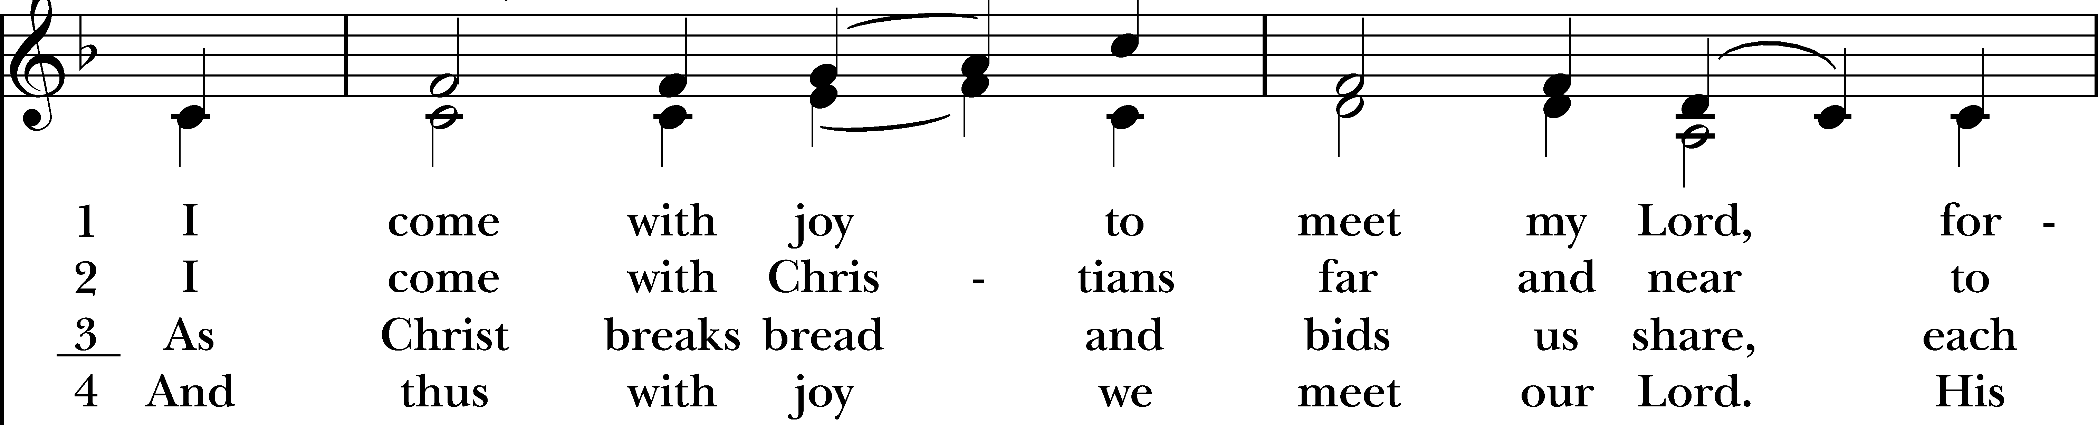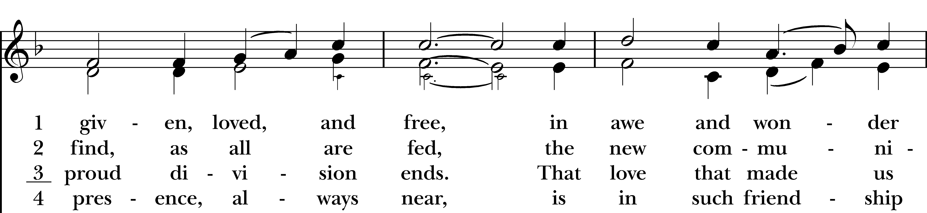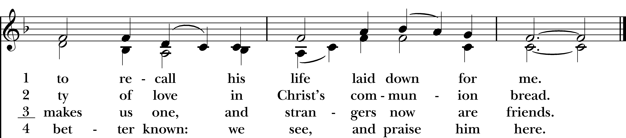
Reprinted/streamed with permission via One License and RiteSong. All rights reserved.

The Word of God

Celebrant: Alleluia. Christ is risen.
People: The Lord is risen indeed. Alleluia.

Collect for Purity

Almighty God, to you all hearts are open, all desires known, and from you no secrets are hid: Cleanse the thoughts of our hearts by the inspiration of your Holy Spirit, that we may perfectly love you, and worthily magnify your holy Name; through Christ our Lord. Amen.

Gloria in Excelsis

Glory to God in the highest, and peace to his people on earth. Lord God, heavenly King,
almighty God and Father, we worship you, we give you thanks, we praise you for your glory.
Lord Jesus Christ, only Son of the Father, Lord God, Lamb of God, you take away the sin of the world:
have mercy on us; you are seated at the right hand of the Father: receive our prayer.
For you alone are the Holy One, you alone are the Lord, you alone are the Most High, Jesus Christ,
with the Holy Spirit, in the glory of God the Father. Amen.

Collect of the Day

Celebrant: The Lord be with you.
People: And also with you.
Let us pray. Grant, O merciful God, that your Church, being gathered together in unity by your Holy Spirit, may show forth your power among all peoples, to the glory of your Name; through Jesus Christ our Lord, who lives and reigns with you and the Holy Spirit, one God, for ever and ever. Amen.

The First Reading Exodus 1:8-2:10
A Reading from the Book of Genesis.

Now a new king arose over Egypt, who did not know Joseph. He said to his people, “Look, the Israelite people are more numerous and more powerful than we. Come, let us deal shrewdly with them, or they will increase and, in the event of war, join our enemies and fight against us and escape from the land.” Therefore they set taskmasters over them to oppress them with forced labor. They built supply cities, Pithom and Rameses, for Pharaoh. But the more they were oppressed, the more they multiplied and spread, so that the Egyptians came to dread the Israelites. The Egyptians became ruthless in imposing tasks on the Israelites, and made their lives bitter with hard service in mortar and brick and in every kind of field labor. They were ruthless in all the tasks that they imposed on them.

The king of Egypt said to the Hebrew midwives, one of whom was named Shiphrah and the other Puah, “When you act as midwives to the Hebrew women, and see them on the birthstool, if it is a boy, kill him; but if it is a girl, she shall live.” But the midwives feared God; they did not do as the king of Egypt commanded them, but they let the boys live. So the king of Egypt summoned the midwives and said to them, “Why have you done this, and allowed the boys to live?” The midwives said to Pharaoh, “Because the Hebrew women are not like the Egyptian women; for they are vigorous and give birth before the midwife comes to them.” So God dealt well with the midwives; and the people multiplied and became very strong. And because the midwives feared God, he gave them families. Then Pharaoh commanded all his people, “Every boy that is born to the Hebrews you shall throw into the Nile, but you shall let every girl live.”

Now a man from the house of Levi went and married a Levite woman. The woman conceived and bore a son; and when she saw that he was a fine baby, she hid him three months. When she could hide him no longer she got a papyrus basket for him, and plastered it with bitumen and pitch; she put the child in it and placed it among the reeds on the bank of the river. His sister stood at a distance, to see what would happen to him.

The daughter of Pharaoh came down to bathe at the river, while her attendants walked beside the river. She saw the basket among the reeds and sent her maid to bring it. When she opened it, she saw the child. He was crying, and she took pity on him, “This must be one of the Hebrews’ children,” she said. Then his sister said to Pharaoh’s daughter, “Shall I go and get you a nurse from the Hebrew women to nurse the child for you?” Pharaoh’s daughter said to her, “Yes.” So the girl went and called the child’s mother. Pharaoh’s daughter said to her, “Take this child and nurse it for me, and I will give you your wages.” So the woman took the child and nursed it. When the child grew up, she brought him to Pharaoh’s daughter, and she took him as her son. She named him Moses, “because,” she said, “I drew him out of the water.”

Hear what the Spirit is saying to God’s people.
Thanks be to God.

The Psalm Psalm 124
If the Lord had not been on our side, *
let Israel now say;
If the Lord had not been on our side, *
when enemies rose up against us;
Then would they have swallowed us up alive *
in their fierce anger toward us;
Then would the waters have overwhelmed us *
and the torrent gone over us;
Then would the raging waters *
have gone right over us.
Blessed be the Lord! *
he has not given us over to be a prey for their teeth.
We have escaped like a bird from the snare of the fowler; *
the snare is broken, and we have escaped.
Our help is in the Name of the Lord, *
the maker of heaven and earth.

The Second Reading Romans 12:1-8
A Reading from the Letter to the Romans.

I appeal to you therefore, brothers and sisters, by the mercies of God, to present your bodies as a living sacrifice, holy and acceptable to God, which is your spiritual worship. Do not be conformed to this world, but be transformed by the renewing of your minds, so that you may discern what is the will of God-- what is good and acceptable and perfect.

For by the grace given to me I say to everyone among you not to think of yourself more highly than you ought to think, but to think with sober judgment, each according to the measure of faith that God has assigned. For as in one body we have many members, and not all the members have the same function, so we, who are many, are one body in Christ, and individually we are members one of another. We have gifts that differ according to the grace given to us: prophecy, in proportion to faith; ministry, in ministering; the teacher, in teaching; the exhorter, in exhortation; the giver, in generosity; the leader, in diligence; the compassionate, in cheerfulness.

Hear what the Spirit is saying to God’s people.
Thanks be to God.

The Gospel Matthew 16:13-20
The Holy Gospel of our Lord Jesus Christ, according to Matthew.
Glory to you, Lord Christ.

When Jesus came into the district of Caesarea Philippi, he asked his disciples, “Who do people say that the Son of Man is?” And they said, “Some say John the Baptist, but others Elijah, and still others Jeremiah or one of the prophets.” He said to them, “But who do you say that I am?” Simon Peter answered, “You are the Messiah, the Son of the living God.” And Jesus answered him, “Blessed are you, Simon son of Jonah! For flesh and blood has not revealed this to you, but my Father in heaven. And I tell you, you are Peter, and on this rock I will build my church, and the gates of Hades will not prevail against it. I will give you the keys of the kingdom of heaven, and whatever you bind on earth will be bound in heaven, and whatever you loose on earth will be loosed in heaven.” Then he sternly ordered the disciples not to tell anyone that he was the Messiah.

The Gospel of the Lord.
Praise to you, Lord Christ.

Reflection Molly Adams

Post-Reflection Hymn “On Christ the Solid Rock”

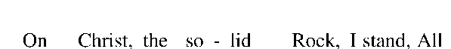
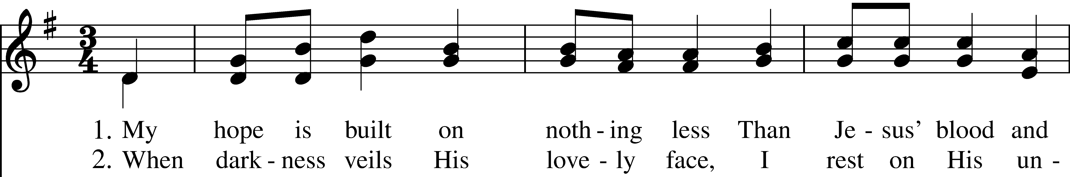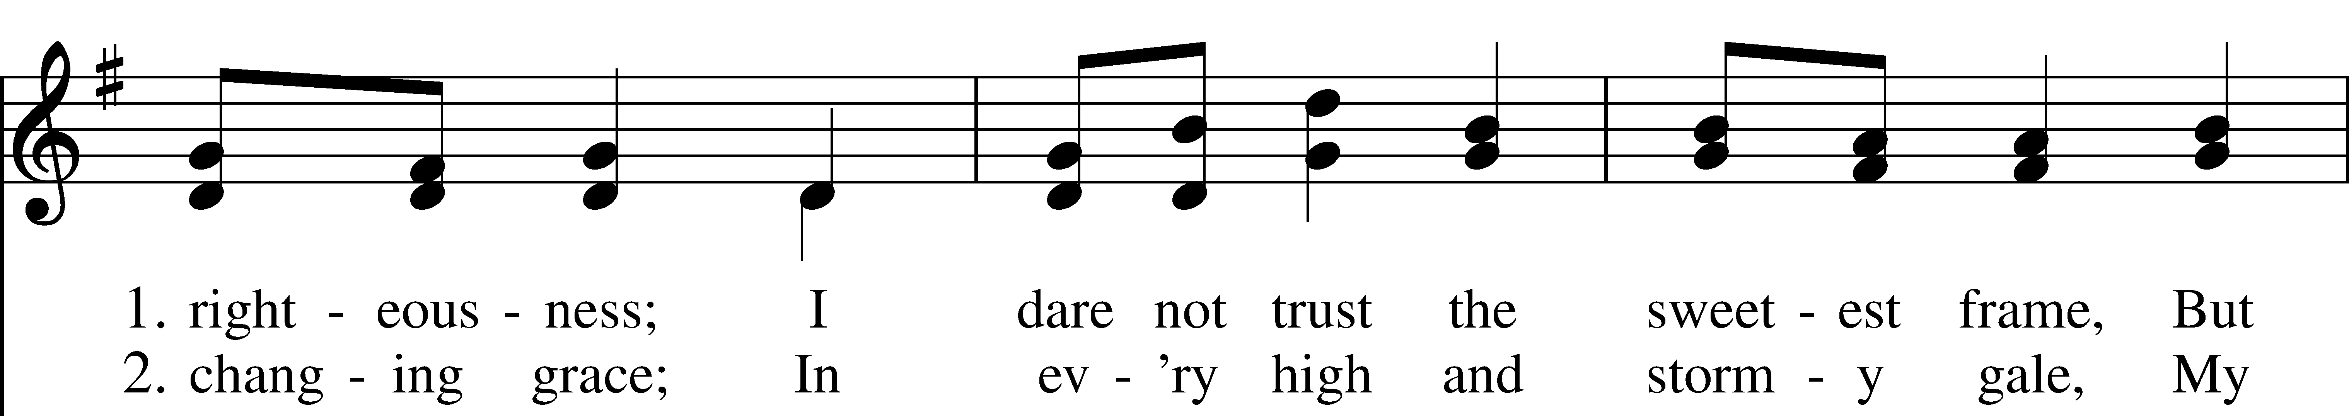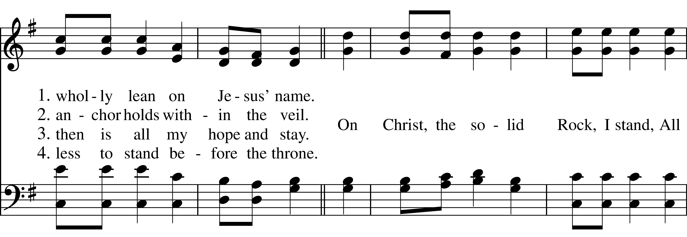
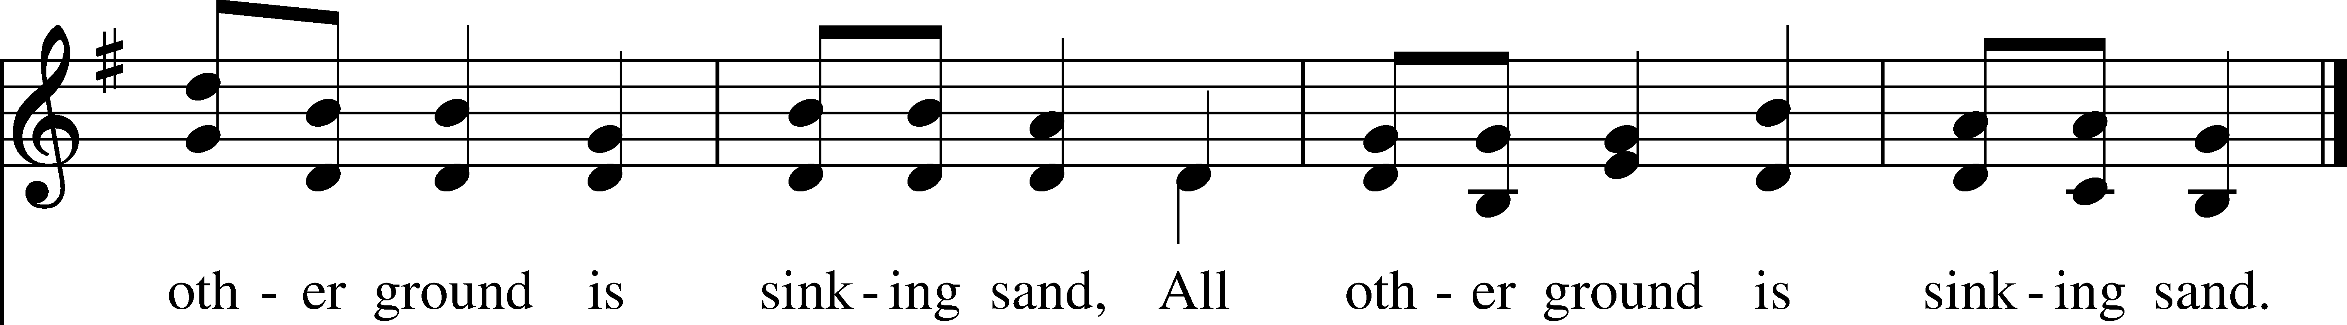

The Nicene Creed Enriching Our Worship Version

We believe in one God, the Father, the Almighty, maker of heaven and earth, of all that is, seen and unseen. We believe in one Lord, Jesus Christ, the only Son of God, eternally begotten of the Father, God from God, Light from Light, true God from true God, begotten, not made, of one Being with the Father. Through him all things were made.

For us and for our salvation, he came down from heaven: was incarnate of the Holy Spirit and the Virgin Mary and became truly human. For our sake he was crucified under Pontius Pilate; he suffered death and was buried. On the third day he rose again in accordance with the Scriptures; he ascended into heaven and is seated at the right hand of the Father. He will come again in glory to judge the living and the dead, and his kingdom will have no end.

We believe in the Holy Spirit, the Lord, the giver of life, who proceeds from the Father and the Son, who with the Father and the Son is worshiped and glorified, who has spoken through the prophets. We believe in one holy catholic and apostolic Church. We acknowledge one baptism for the forgiveness of sins. We look for the resurrection of the dead, and the life of the world to come. Amen.

The Prayers of the People: Form III

Father, we pray for your holy Catholic Church;
That we all may be one.

Grant that every member of the Church may truly and humbly serve you;
That your Name may be glorified by all people.

We pray for all bishops, priests, and deacons;
That they may be faithful ministers of your Word and Sacraments.

We pray for all who govern and hold authority in the nations of the world;
That there may be justice and peace on the earth.
Give us grace to do your will in all that we undertake;
That our works may find favor in your sight.

Have compassion on those who suffer from any grief or trouble;
That they may be delivered from their distress.

Give to the departed eternal rest.
Let light perpetual shine upon them.

We praise you for your saints who have entered into joy;
May we also come to share in your heavenly kingdom.

Let us pray for our own needs and those of others, especially those on our Parish Prayer List …

Celebrant: Heavenly Father, you have promised to hear what we ask in the Name of your Son: Accept and fulfill our petitions, we pray, not as we ask in our ignorance, nor as we deserve in our sinfulness, but as you know and love us in your Son Jesus Christ our Lord. Amen.

Litany for Our Times

Forgive us, O God, whenever we build cages where you have called us to build homes. May love set us free.

Forgive us whenever we choose comfort over compassion. May love set us free.

Forgive us whenever we remain silent because speaking the truth is costly. May love set us free.

Deliver us from every obedience that betrays love. May love set us free.

When laws demand what mercy forbids, grant us the perseverance to obey conscience before comfort and your love before every earthly power. May love set us free.

Keep us faithful to the nonviolent way of Christ, who overcame hatred not with hatred but with love. May love set us free.

Woe to those who build walls where you have called us to build tables, who teach us to fear the stranger instead of welcoming our neighbor, and who ask us to believe that another person’s suffering can become the price of our own security. May love set us free.

Strip away every lie that justifies cruelty. May love set us free.

Break the spell of indifference. May love set us free.

Teach those entrusted with power that no nation is made stronger by forgetting the sacredness of the human person, and that no law is worthy of honor when it denies the dignity you have given. May love set us free.

The Peace

Celebrant: The peace of the Lord be always with you.
People: And also with you.

Announcements Vicki MarkAnthony

The Holy Communion

Walk in love, as Christ loved us and gave himself for us, an offering and sacrifice to God. Ephesians 5:2

Offertory Hymn “God is Love, let heaven adore him”

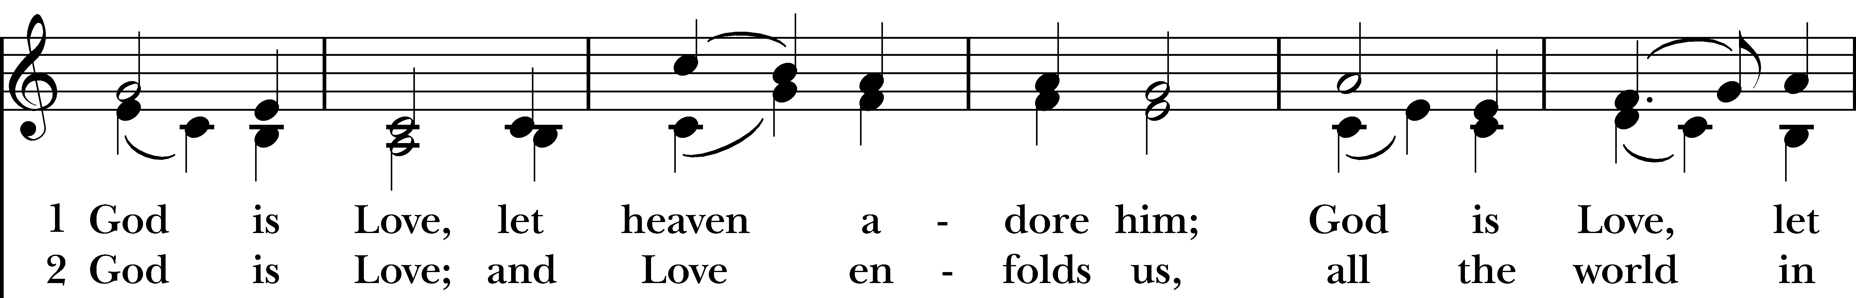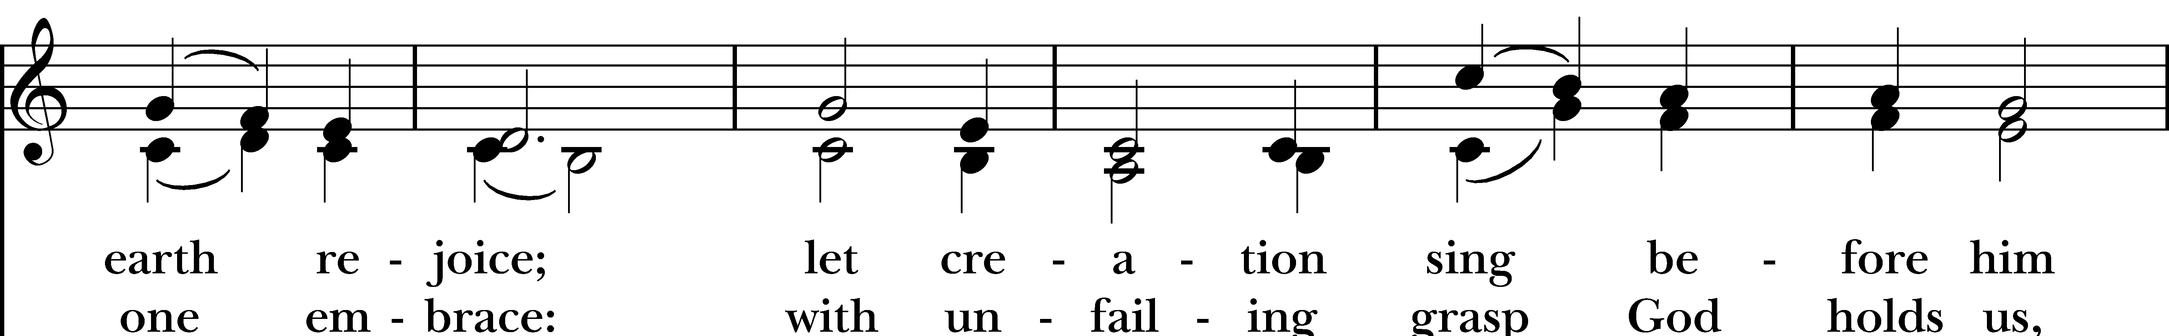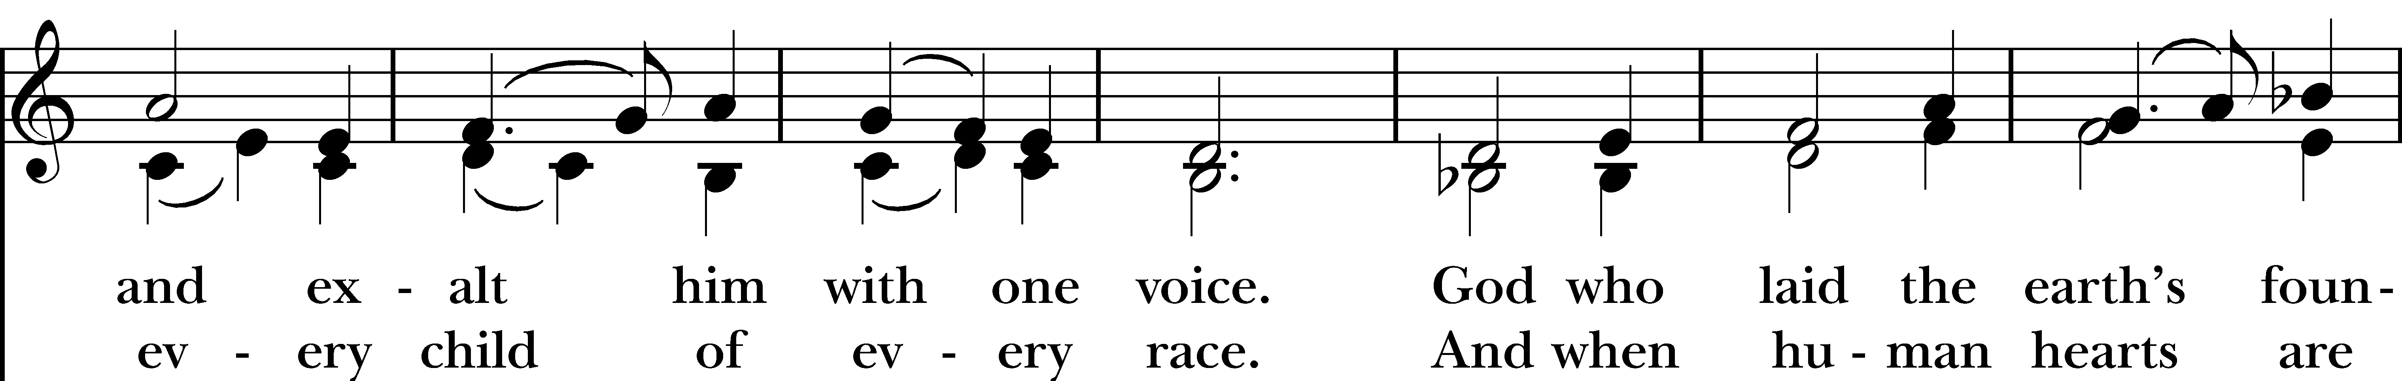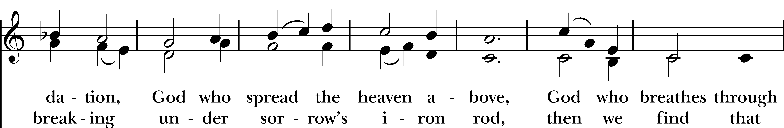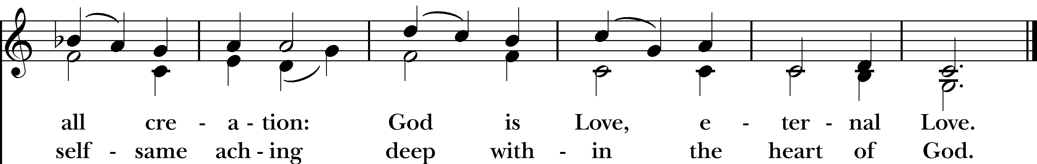
Reprinted/streamed with permission via One License and RiteSong. All rights reserved.

Eucharistic Prayer C

Celebrant: The Lord be with you.
People: And also with you.
Celebrant: Lift up your hearts.
People: We lift them to the Lord.
Celebrant: Let us give thanks to the Lord our God.
People: It is right to give our thanks and praise.

God of all power, Ruler of the Universe, you are worthy of glory and praise. Glory to you for ever and ever.

At your command all things came to be: the vast expanse of interstellar space, galaxies, suns, the planets in their courses, and this fragile earth, our island home. By your will they were created and have their being.

From the primal elements you brought forth the human race, and blessed us with memory, reason, and skill. You made us the rulers of creation. But we turned against you, and betrayed your trust; and we turned against one another. Have mercy, Lord, for we are sinners in your sight.

Again and again, you called us to return. Through prophets and sages you revealed your righteous Law. And in the fullness of time you sent your only Son, born of a woman, to fulfill your Law, to open for us the way of freedom and peace. By his blood, he reconciled us. By his wounds, we are healed.

And therefore we praise you, joining with the heavenly chorus, with prophets, apostles, and martyrs, and with all those in every generation who have looked to you in hope, to proclaim with them your glory, in their unending hymn:

Holy, Holy, Holy Lord, God of power and might, heaven and earth are full of your glory. Hosanna in the highest. Blessed is the one who comes in the name of the Lord. Hosanna in the highest.
And so, Father, we who have been redeemed by him, and made a new people by water and the Spirit, now bring before you these gifts. Sanctify them by your Holy Spirit to be the Body and Blood of Jesus Christ our Lord.

On the night he was betrayed he took bread, said the blessing, broke the bread, and gave it to his friends, and said, “Take, eat: This is my Body, which is given for you. Do this for the remembrance of me.”
After supper, he took the cup of wine, gave thanks, and said, “Drink this, all of you: This is my Blood of the new Covenant, which is shed for you and for many for the forgiveness of sins. Whenever you drink it, do this for the remembrance of me.”

Remembering now his work of redemption, and offering to you this sacrifice of thanksgiving, We celebrate his death and resurrection, as we await the day of his coming.

Lord God of our Fathers: God of Abraham, Isaac, and Jacob; God and Father of our Lord Jesus Christ: Open our eyes to see your hand at work in the world about us. Deliver us from the presumption of coming to this Table for solace only, and not for strength; for pardon only, and not for renewal. Let the grace of this Holy Communion make us one body, one spirit in Christ, that we may worthily serve the world in his name. Risen Lord, be known to us in the breaking of the Bread.

Accept these prayers and praises, Father, through Jesus Christ our great High Priest, to whom, with you and the Holy Spirit, your Church gives honor, glory, and worship, from generation to generation. AMEN.

And now, as our Savior Christ has taught us, we are bold to say,

Our Father who art in heaven, hallowed be thy Name, thy kingdom come, thy will be done, on earth as it is in in heaven. Give us this day our daily bread. And forgive us our trespasses as we forgive those who trespass against us. And lead us not into temptation but deliver us from evil. For thine is the kingdom, the power, and the glory, for ever and ever. Amen.

The Breaking of the Bread

Celebrant: Alleluia. Christ our Passover is sacrificed for us.
People: Therefore let us keep the feast. Alleluia.
Celebrant: The Gifts of God for the People of God.

A Prayer for Spiritual Communion

Let us pray: We believe that you are truly present in the Holy Sacrament, and we pray you to come into our hearts, praying especially with those at home who cannot at this time receive communion. I unite myself with you and embrace you with all my heart, my soul, and my mind. Let nothing separate me from you; let me serve you in this life until, by your grace, I come to your glorious kingdom and unending peace. Amen.

Communion Instrumental

Prayer After Communion

Let us pray: God of abundance, you have fed us with the bread of life and cup of salvation; you have united us with Christ and one another; and you have made us one with all your people in heaven and on earth. Now send us forth in the power of your Spirit, that we may proclaim your redeeming love to the world and continue for ever in the risen life of Christ our Savior. Amen.

Blessing Rev. Sandy

Closing Hymn “Lord, dismiss us with thy blessing”

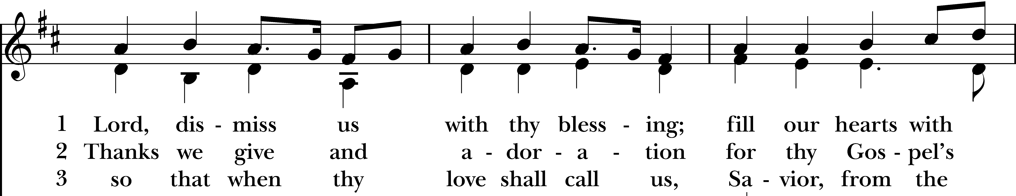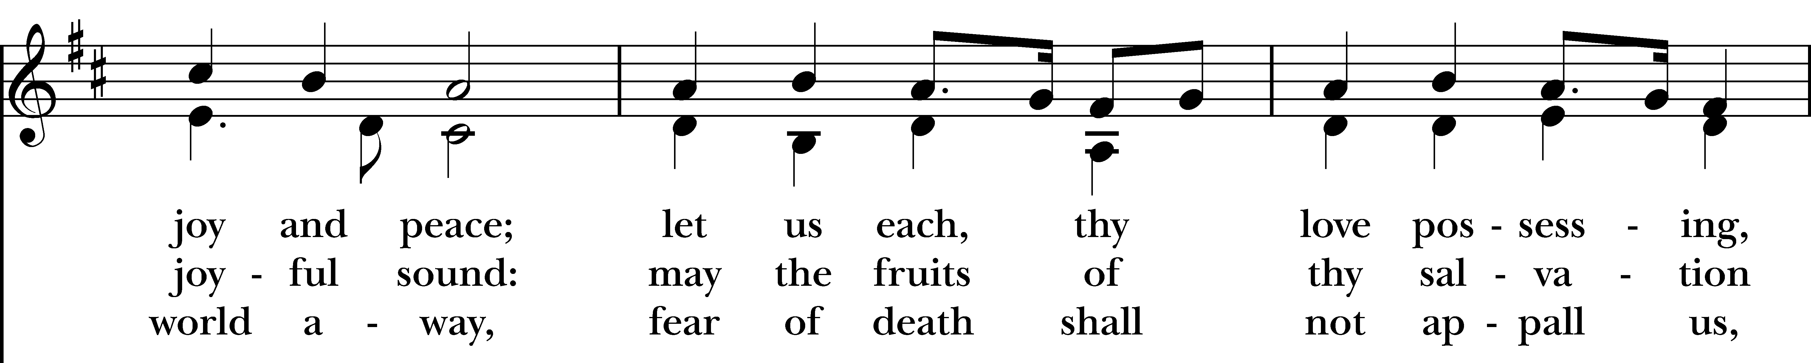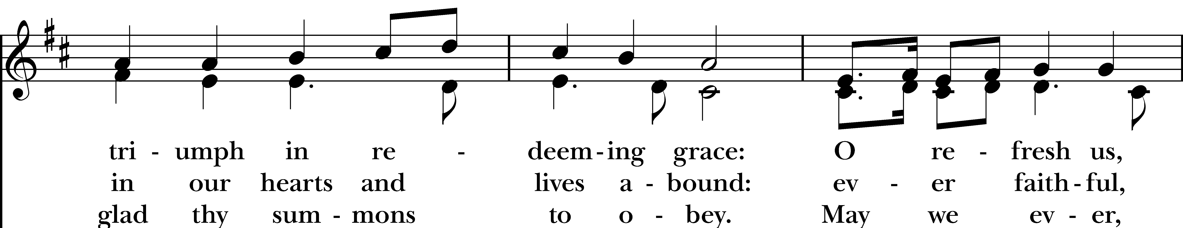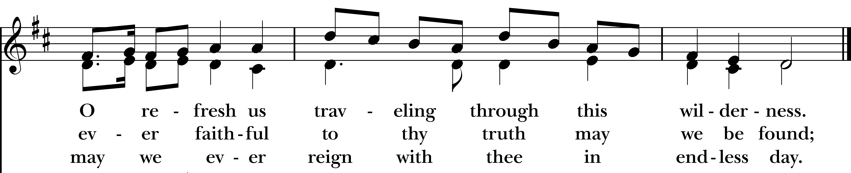
Reprinted/streamed with permission via One License and RiteSong. All rights reserved.

Dismissal

Celebrant: Our worship is ended. Our Service begins. Let us go in peace to love & serve the Lord. Alleluia, alleluia!
People: Thanks be to God. Alleluia, alleluia!
Announcements for August 23rd, 2026

COFFEE HOUR: Sign-up to host an upcoming coffee hour!

NEXT VESTRY MEETING: Tuesday, 8/25 on Zoom at 7pm. All are welcome. Email Vicki for the link.

SCHEDULE UPDATE: Our regular service schedule resumes on 9/13 with indoor services at 9:30 am.

GIFT CARDS to gas stations & grocery stores are always needed. Thank you for your continued generosity.

Welcome to Christ Church Easton!
Whether you are a newcomer, visitor, or longtime member, we bid you a warm welcome!
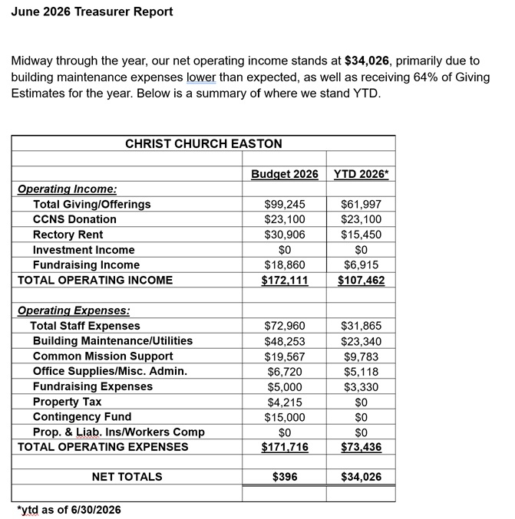
Please join us for coffee hour following service. Sign up for our email list at www.christchurcheaston.com.
UPCOMING SUNDAY WORSHIP

Outdoors at 9:00 am:

Sunday, 8/30: Morning Prayer – Andy Hathaway

Sunday, 9/6: Eucharist – Rev. Sandy Belcher

Indoors at 9:30 am:

Sunday, 9/13: Eucharist – Rev. Katy Piazza

Sunday, 9/20: Morning Prayer – Deborah Swann
Christ Church – Parish Office Hours:
Mondays & Wednesdays: 9:30-1:30

59 Church Rd, Easton, CT
(203) 268-3569

christchurcheaston@gmail.com
www.christchurcheaston.com

Priest-in-Charge: Katy Piazza

Senior Warden: Vicki MarkAnthony

Parish Administrator: Tracy Carlucci
Music Minister: Tracy Carlucci

Choir Members: Amy Strachan, Andy Verrocchi, Bob Ellwanger, David McCann, Diane McCann, Marina Philips, Katie Tressler, Vicki MarkAnthony

Christ Church Nursery School: Maggie Supple, Director www.ccnseaston.com
Vestry: Jim Swann, Jr. Warden; Bob Ellwanger, Treasurer; Amy Bailas, Clerk

Vestry Members: Russ Bailas, Marina Philips, Claire Wilkes, Peg Ellwanger

Diocesan Delegates: Diane McCann, Bob Ellwanger; Alternate: Deborah Swann

