Sunday, May 17th, 2026: The Seventh Sunday of Easter
Rev. Katy Piazza, Priest-in-Charge
Christ Church Easton

Celebrant: As we gather to worship, let us recognize that we gather on the ancestral lands and traditional territory of the (Aspetuck River Valley dwelling) Paugussett people.

Celebrant: Please stand as you are able and sing together “Praise the Lord through every nation,” #484 in the hymnal.

Processional Hymn “Praise the Lord through every nation” Hymnal #484

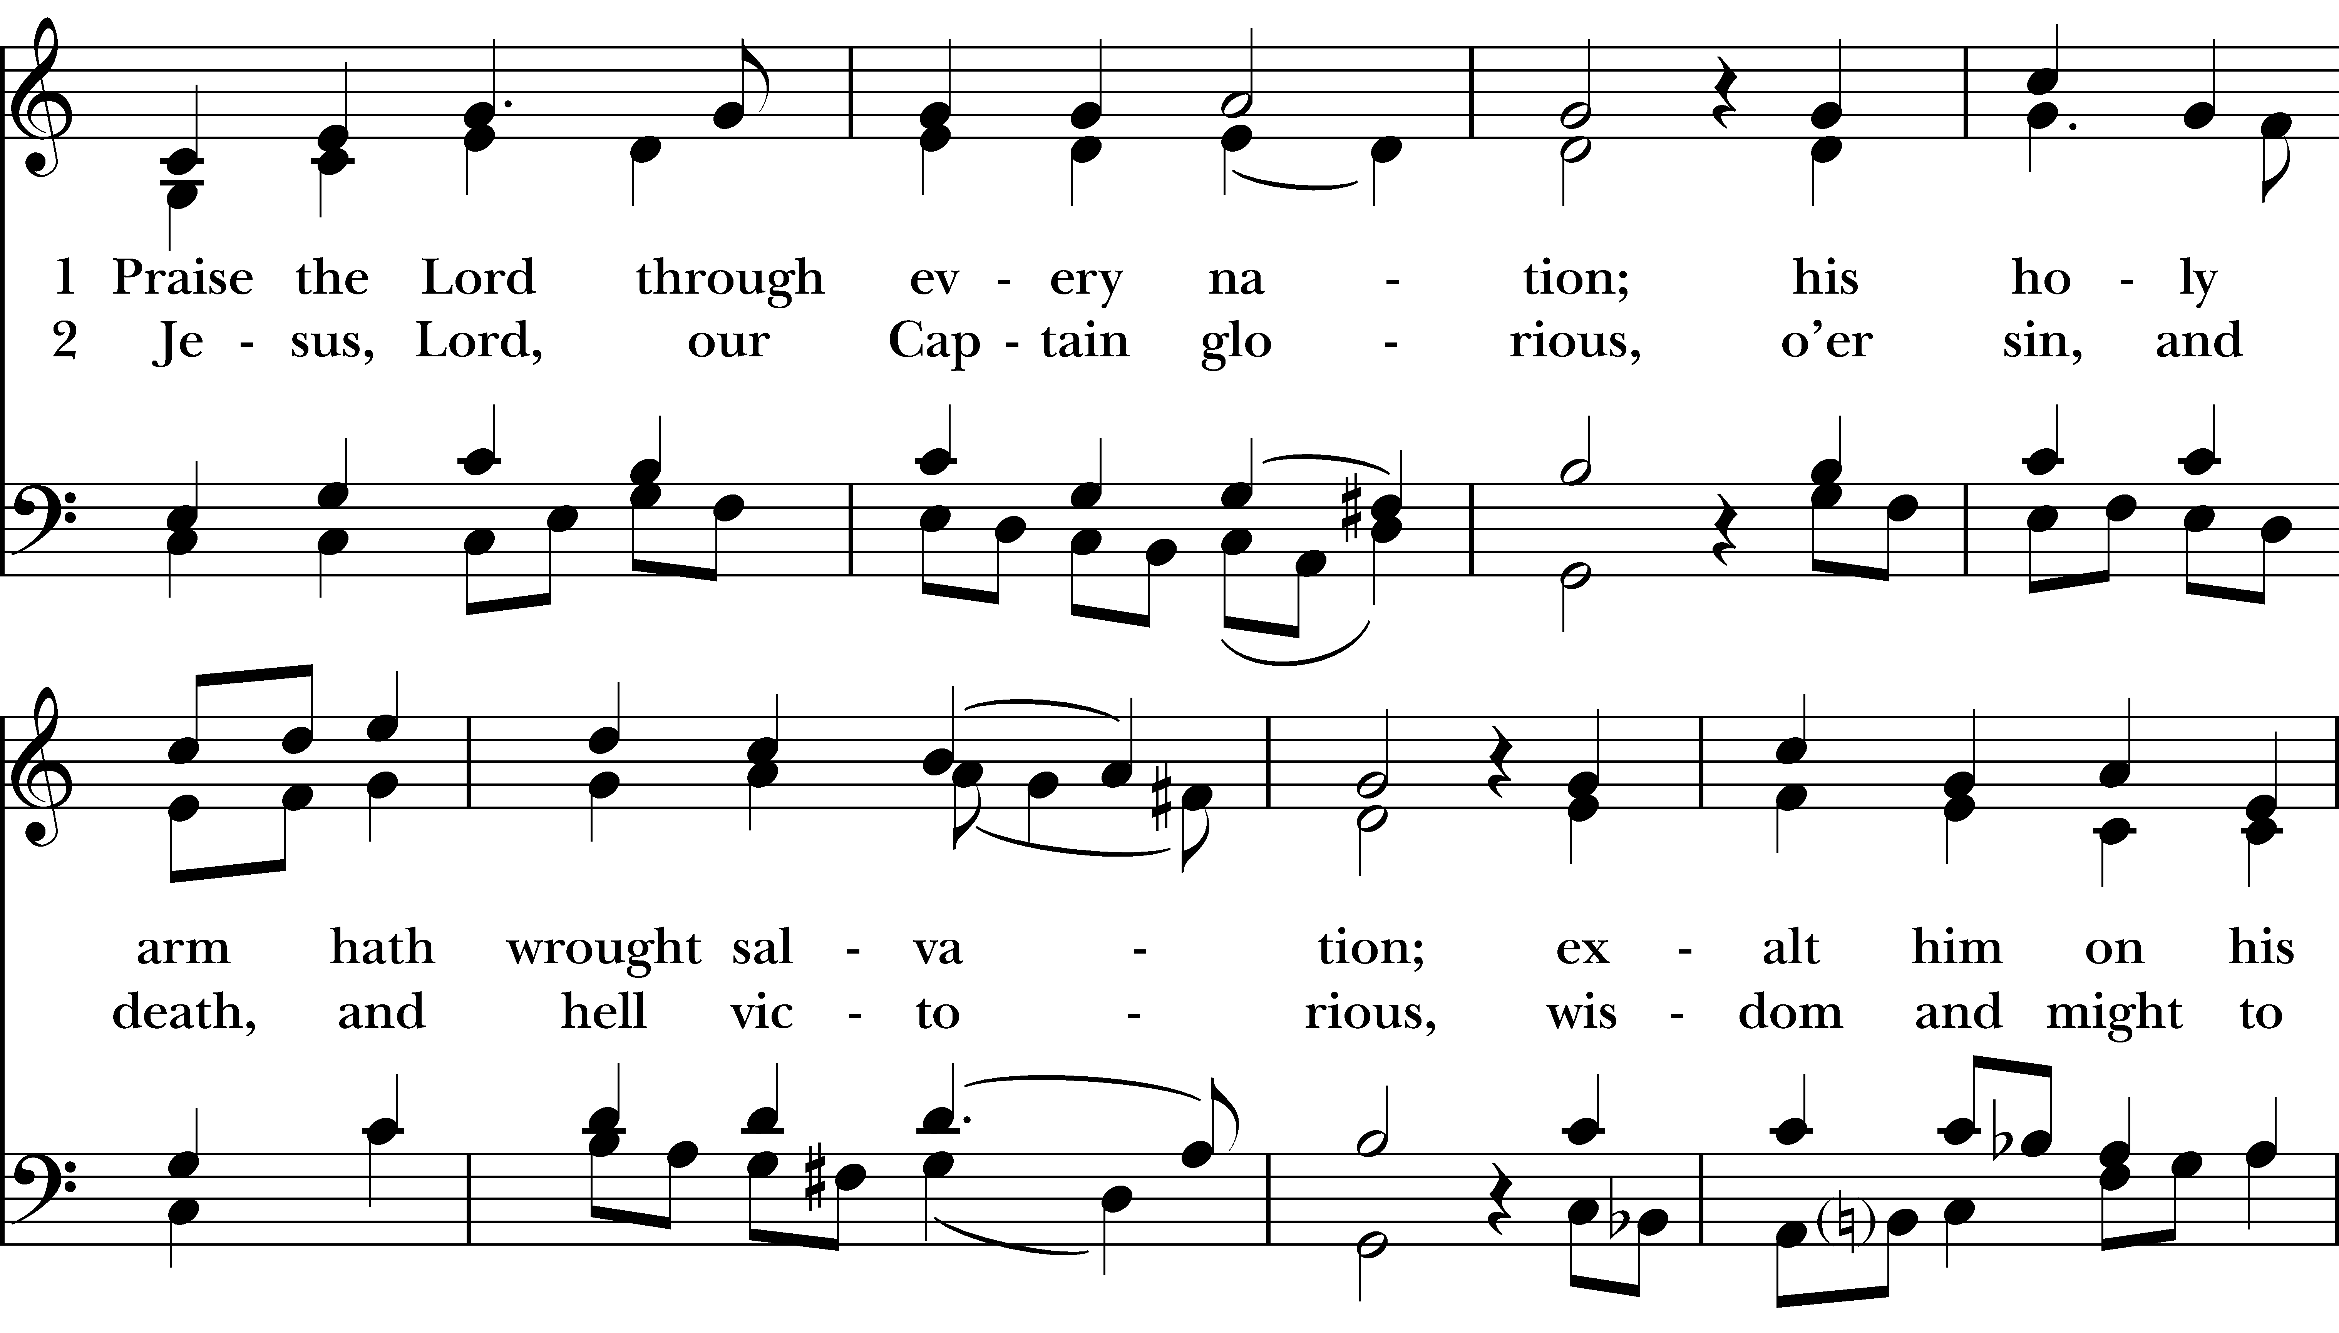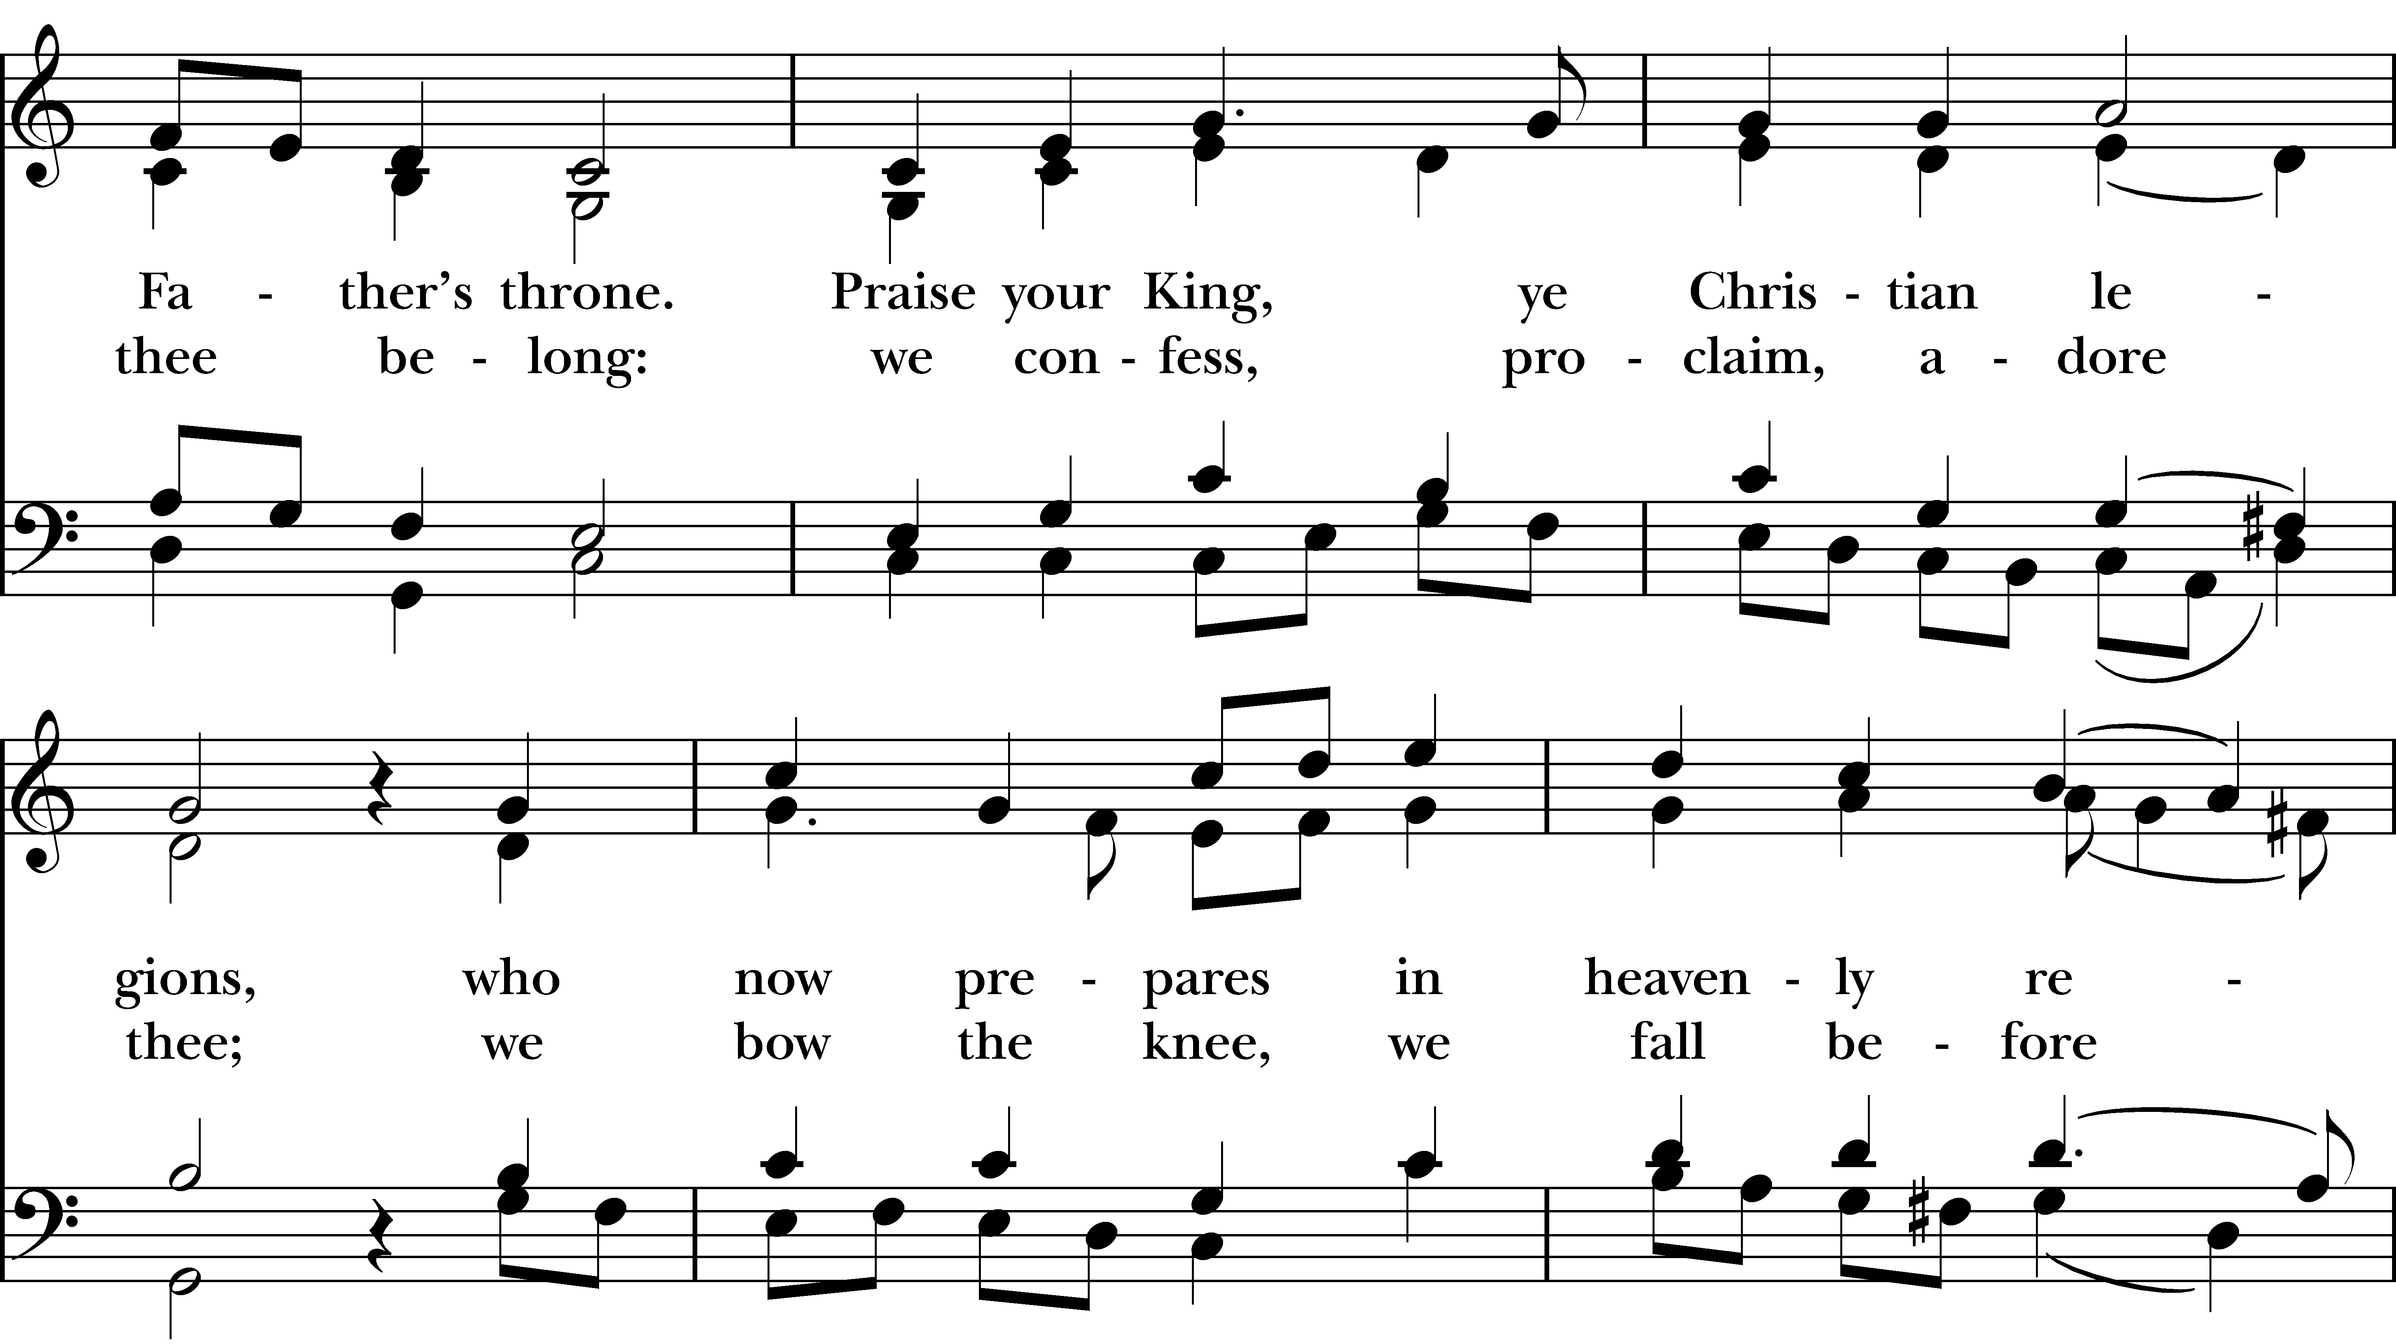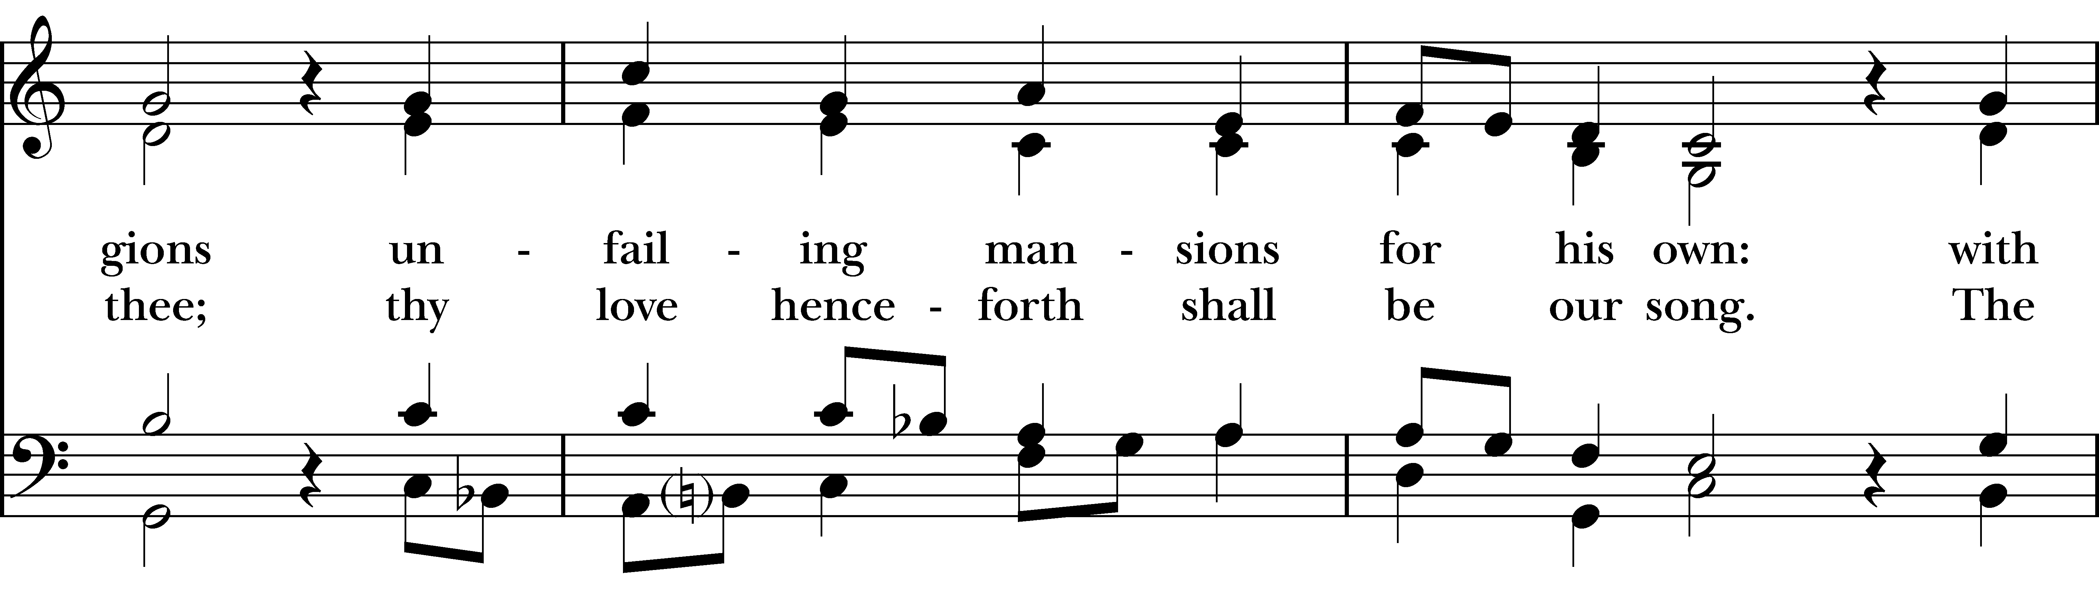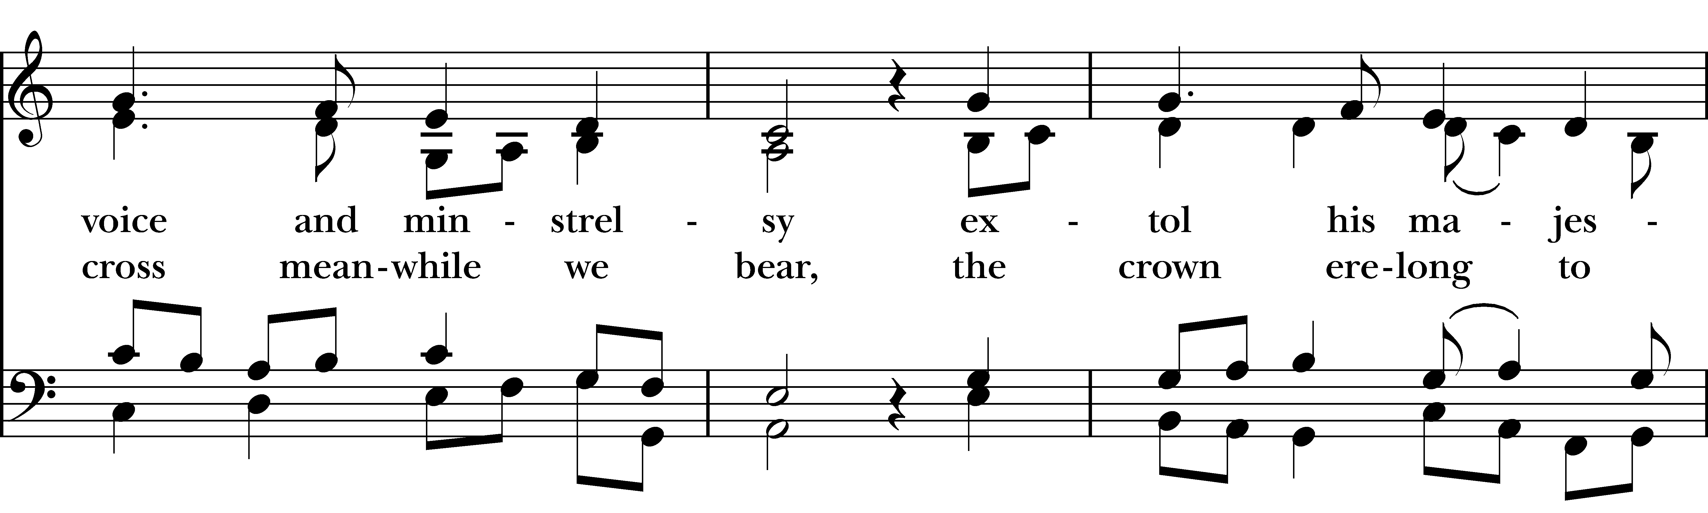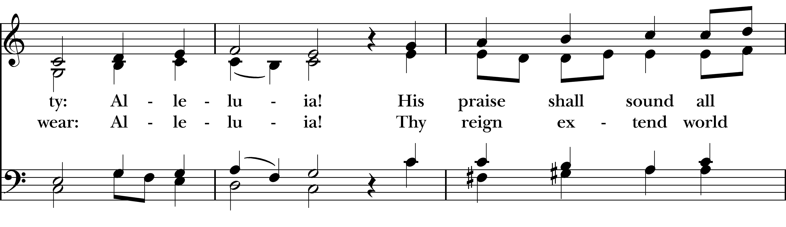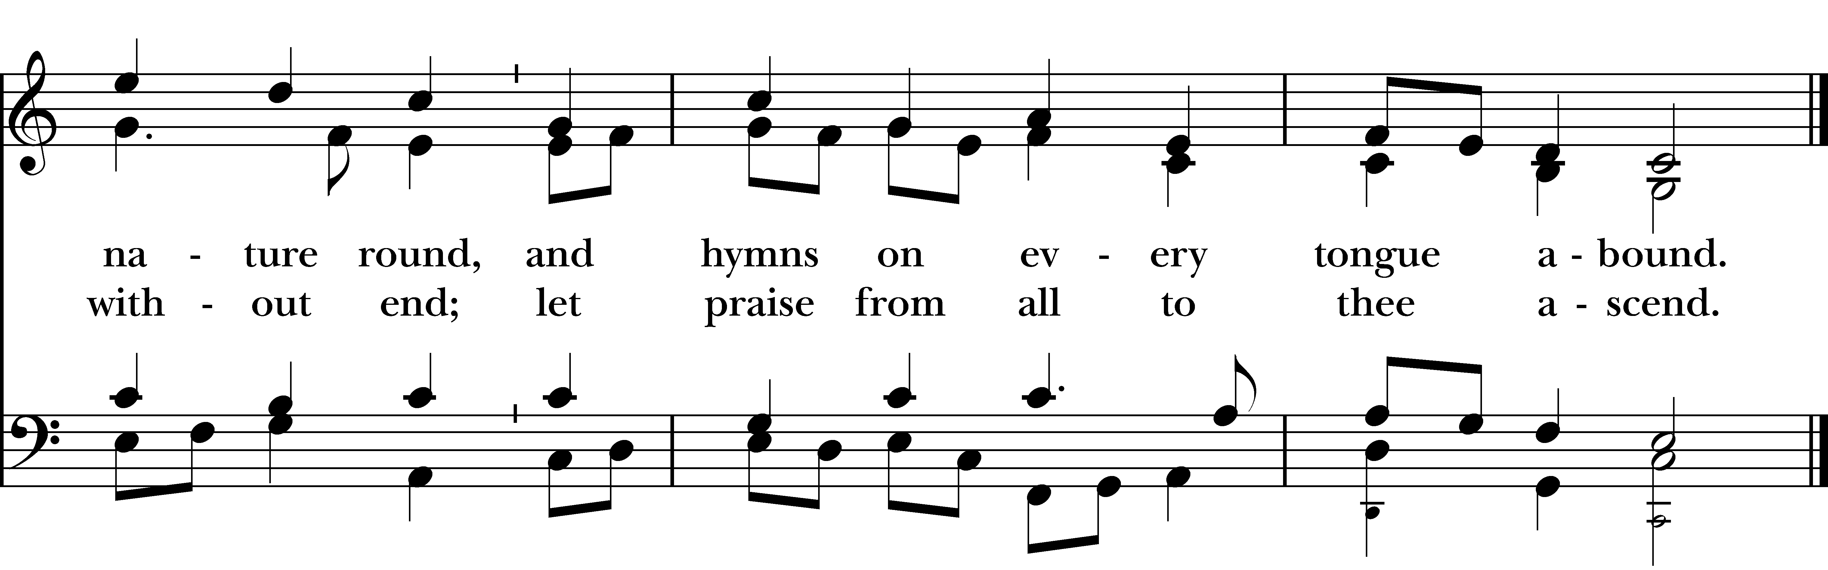
Reprinted/streamed with permission via One License and RiteSong. All rights reserved.
The Word of God BCP p. 355
Celebrant: Please turn to page 355 in the Book of Common Prayer.

Celebrant: Alleluia. Christ is risen.
People: The Lord is risen indeed. Alleluia.

The Collect for Purity
Almighty God, to you all hearts are open, all desires known, and from you no secrets are hid: Cleanse the thoughts of our hearts by the inspiration of your Holy Spirit, that we may perfectly love you, and worthily magnify your holy Name; through Christ our Lord. Amen.

Gloria Pew Card/Hymnal #S278

The Collect of the Day: Ascension Day

Celebrant: The Lord be with you.
People: And also with you.

Let us pray. Almighty God, whose blessed Son our Savior Jesus Christ ascended far above all heavens that he might fill all things: Mercifully give us faith to perceive that, according to his promise, he abides with his Church on earth, even to the end of the ages; through Jesus Christ our Lord, who lives and reigns with you and the Holy Spirit, one God, in glory everlasting. Amen.

The First Reading Acts 1:1-11
A Reading from the Acts of the Apostles.

In the first book, Theophilus, I wrote about all that Jesus did and taught from the beginning until the day when he was taken up to heaven, after giving instructions through the Holy Spirit to the apostles whom he had chosen. After his suffering he presented himself alive to them by many convincing proofs, appearing to them during forty days and speaking about the kingdom of God. While staying with them, he ordered them not to leave Jerusalem, but to wait there for the promise of the Father. “This,” he said, “is what you have heard from me; for John baptized with water, but you will be baptized with the Holy Spirit not many days from now.”

So when they had come together, they asked him, “Lord, is this the time when you will restore the kingdom to Israel?” He replied, “It is not for you to know the times or periods that the Father has set by his own authority. But you will receive power when the Holy Spirit has come upon you; and you will be my witnesses in Jerusalem, in all Judea and Samaria, and to the ends of the earth.” When he had said this, as they were watching, he was lifted up, and a cloud took him out of their sight. While he was going and they were gazing up toward heaven, suddenly two men in white robes stood by them. They said, “Men of Galilee, why do you stand looking up toward heaven? This Jesus, who has been taken up from you into heaven, will come in the same way as you saw him go into heaven.”

The Word of the Lord.
Thanks be to God.

The Psalm Psalm 47

Clap your hands, all you peoples; *
shout to God with a cry of joy.
For the LORD Most High is to be feared; *
he is the great King over all the earth.
He subdues the peoples under us, *
and the nations under our feet.
He chooses our inheritance for us, *
the pride of Jacob whom he loves.
God has gone up with a shout, *
the LORD with the sound of the ram’s-horn.
Sing praises to God, sing praises; *
sing praises to our King, sing praises.
For God is King of all the earth; *
sing praises with all your skill.
God reigns over the nations; *
God sits upon his holy throne.
The nobles of the peoples have gathered together *
with the people of the God of Abraham.
The rulers of the earth belong to God, *
and he is highly exalted.

The Second Reading Ephesians 1:15-23
A Reading from the Letter to the Ephesians.

I have heard of your faith in the Lord Jesus and your love toward all the saints, and for this reason I do not cease to give thanks for you as I remember you in my prayers. I pray that the God of our Lord Jesus Christ, the Father of glory, may give you a spirit of wisdom and revelation as you come to know him, so that, with the eyes of your heart enlightened, you may know what is the hope to which he has called you, what are the riches of his glorious inheritance among the saints, and what is the immeasurable greatness of his power for us who believe, according to the working of his great power. God put this power to work in Christ when he raised him from the dead and seated him at his right hand in the heavenly places, far above all rule and authority and power and dominion, and above every name that is named, not only in this age but also in the age to come. And he has put all things under his feet and has made him the head over all things for the church, which is his body, the fullness of him who fills all in all.

The Word of the Lord
Thanks be to God.

Celebrant: Please stand as you are able and sing together hymn #215 “See the Conqueror mounts in triumph.” We will sing verses 1-2 before the Gospel and verse 3 after.

Gospel Hymn “See the Conqueror mounts in triumph” Hymnal #215

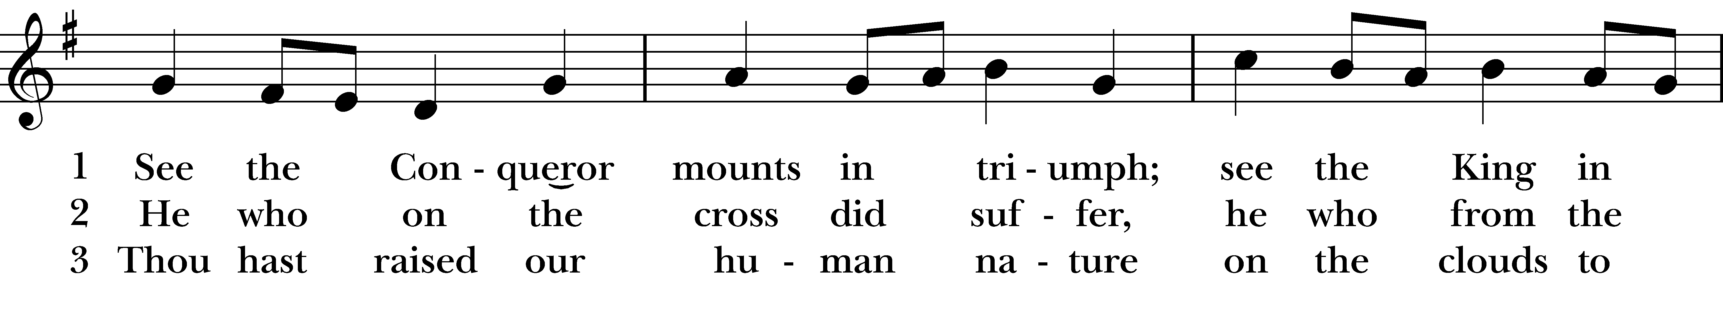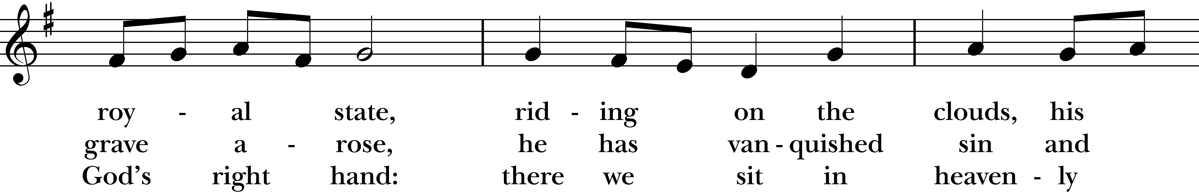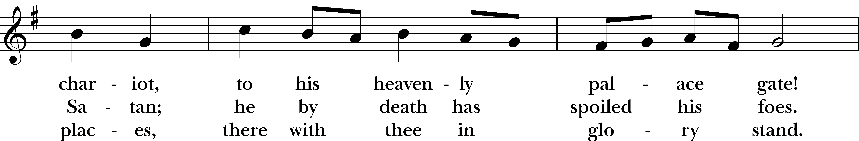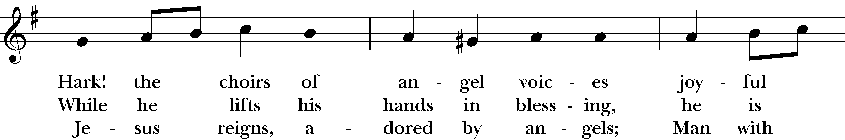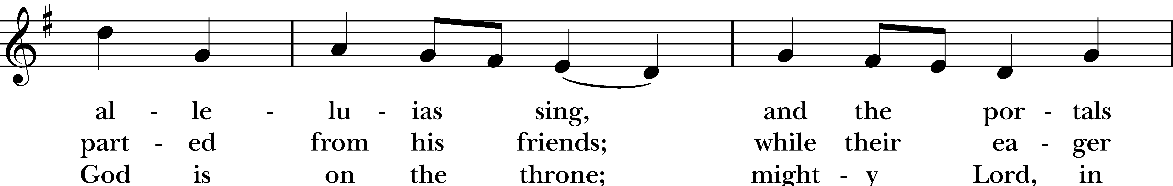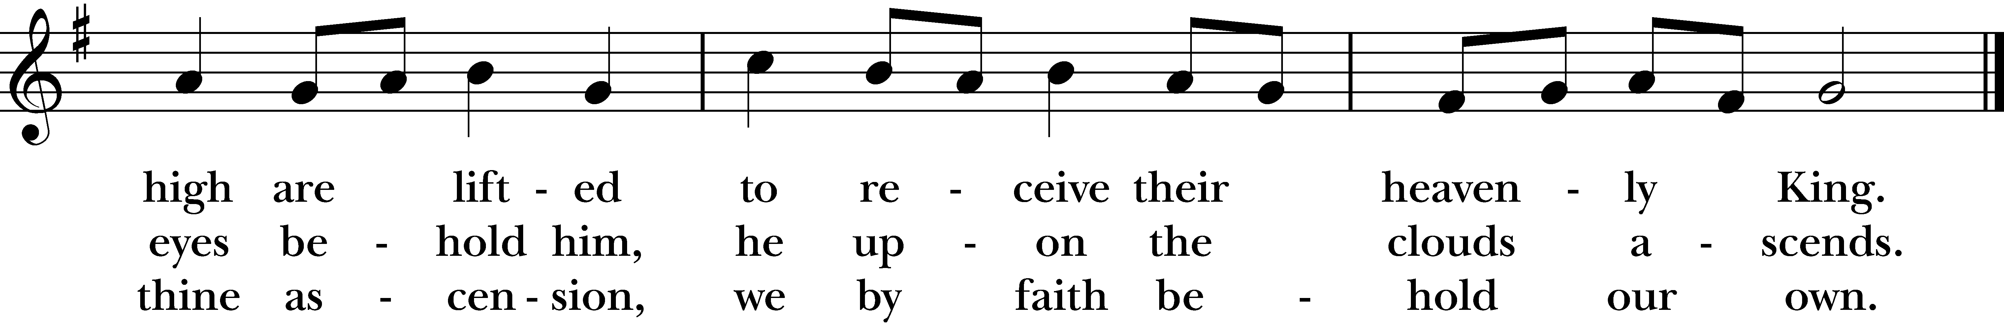
Reprinted/streamed with permission via One License and/or RiteSong. All rights reserved.
The Gospel Luke 24:44-53
The Holy Gospel of our Lord Jesus Christ, according to Luke.
Glory to you, Lord Christ.

Then he said to them, “These are my words that I spoke to you while I was still with you—that everything written about me in the law of Moses, the prophets, and the psalms must be fulfilled.” Then he opened their minds to understand the scriptures, and he said to them, “Thus it is written, that the Messiah is to suffer and to rise from the dead on the third day, and that repentance and forgiveness of sins is to be proclaimed in his name to all nations, beginning from Jerusalem. You are witnesses of these things. And see, I am sending upon you what my Father promised; so stay here in the city until you have been clothed with power from on high.”

Then he led them out as far as Bethany, and, lifting up his hands, he blessed them. While he was blessing them, he withdrew from them and was carried up into heaven. And they worshiped him, and returned to Jerusalem with great joy; and they were continually in the temple blessing God.

The Gospel of the Lord.
Praise to you, Lord Christ.

Sermon Rev. Katy Piazza

The Nicene Creed BCP p. 358
Celebrant: Please stand as you are able for The Nicene Creed, page 358 of the Book of Common Prayer.

We believe in one God, the Father, the Almighty, maker of heaven and earth, of all that is, seen and unseen. We believe in one Lord, Jesus Christ, the only Son of God, eternally begotten of the Father, God from God, Light from Light, true God from true God, begotten, not made, of one Being with the Father. Through him all things were made.

For us and for our salvation, he came down from heaven: by the power of the Holy Spirit he became incarnate from the Virgin Mary, and was made man. For our sake he was crucified under Pontius Pilate; he suffered death and was buried. On the third day he rose again in accordance with the Scriptures; he ascended into heaven and is seated at the right hand of the Father. He will come again in glory to judge the living and the dead, and his kingdom will have no end.

We believe in the Holy Spirit, the Lord, the giver of life, who proceeds from the Father and the Son. With the Father and the Son he is worshiped and glorified. He has spoken through the Prophets. We believe in one holy catholic and apostolic Church. We acknowledge one baptism for the forgiveness of sins. We look for the resurrection of the dead, and the life of the world to come. Amen.

Prayers of the People: Form III BCP p. 387
Subdeacon: The Prayers of the People are Form III, found on page 387 in the Book of Common Prayer.

Father, we pray for your holy Catholic Church;
That we all may be one.

Grant that every member of the Church may truly and humbly serve you;
That your Name may be glorified by all people.

We pray for all bishops, priests, and deacons;
That they may be faithful ministers of your Word and Sacraments.

We pray for all who govern and hold authority in the nations of the world;
That there may be justice and peace on the earth.

Give us grace to do your will in all that we undertake;
That our works may find favor in your sight.

Have compassion on those who suffer from any grief or trouble;
That they may be delivered from their distress.

Give to the departed eternal rest.
Let light perpetual shine upon them.

We praise you for your saints who have entered into joy;
May we also come to share in your heavenly kingdom.

Let us pray for our own needs and those of others. We pray especially for those on our parish prayer list…

Celebrant: O Lord our God, accept the fervent prayers of your people; in the multitude of your mercies, look with compassion upon us and all who turn to you for help; for you are gracious, O lover of souls, and to you we give glory, Father, Son, and Holy Spirit, now and for ever. Amen.

The Peace Please stand.

Celebrant: The peace of the Lord be always with you.
People: And also with you.

The Holy Communion

Walk in love, as Christ loved us and gave himself for us, an offering and sacrifice to God. Ephesians 5:2

Offertory Anthem Christ Church Choir

Eucharistic Prayer A BCP p. 361
Celebrant: Please stand as you are able and turn to page 361 in the Book of Common Prayer.

Celebrant: The Lord be with you.
People: And also with you.
Celebrant: Lift up your hearts.
People: We lift them to the Lord.
Celebrant: Let us give thanks to the Lord our God.
People: It is right to give him thanks and praise.

It is right, and a good and joyful thing, always and everywhere to give thanks to you, Father Almighty, Creator of heaven and earth.

Through your dearly beloved Son Jesus Christ our Lord. After his glorious resurrection he openly appeared to his disciples, and in their sight ascended into heaven, to prepare a place for us; that where he is, there we might also be, and reign with him in glory.

Therefore we praise you, joining our voices with Angels and Archangels and with all the company of heaven, who for ever sing this hymn to proclaim the glory of your Name:

Sanctus Pew Card/Hymnal #S125

Holy and gracious Father: In your infinite love you made us for yourself, and, when we had fallen into sin and become subject to evil and death, you, in your mercy, sent Jesus Christ, your only and eternal Son, to share our human nature, to live and die as one of us, to reconcile us to you, the God and Father of all.

He stretched out his arms upon the cross, and offered himself, in obedience to your will, a perfect sacrifice for the whole world.

On the night he was handed over to suffering and death, our Lord Jesus Christ took bread; and when he had given thanks to you, he broke it, and gave it to his disciples, and said, “Take, eat: This is my Body, which is given for you. Do this for the remembrance of me.”

After supper he took the cup of wine; and when he had given thanks, he gave it to them, and said, “Drink this, all of you: This is my Blood of the new Covenant, which is shed for you and for many for the forgiveness of sins. Whenever you drink it, do this for the remembrance of me.”

Therefore we proclaim the mystery of faith: Christ has died. Christ is risen. Christ will come again.

We celebrate the memorial of our redemption, O Father, in this sacrifice of praise and thanksgiving. Recalling his death, resurrection, and ascension, we offer you these gifts.

Sanctify them by your Holy Spirit to be for your people the Body and Blood of your Son, the holy food and drink of new and unending life in him. Sanctify us also that we may faithfully receive this holy Sacrament, and serve you in unity, constancy, and peace; and at the last day bring us with all your saints into the joy of your eternal kingdom.

All this we ask through your Son Jesus Christ: By him, and with him, and in him, in the unity of the Holy Spirit all honor and glory is yours, Almighty Father, now and for ever. AMEN.

And now, as our Savior Christ has taught us, we are bold to say,

Our Father who art in heaven, hallowed be thy Name, thy kingdom come, thy will be done, on earth as it is in in heaven. Give us this day our daily bread. And forgive us our trespasses as we forgive those who trespass against us. And lead us not into temptation but deliver us from evil. For thine is the kingdom, the power, and the glory, for ever and ever. Amen.

The Breaking of the Bread

Celebrant: Alleluia. Christ our Passover is sacrificed for us.
People: Therefore let us keep the feast. Alleluia.

Fraction Anthem Pew Card/Hymnal #S164

Celebrant: The Gifts of God for the People of God. Take them in remembrance that Christ died for you, and feed on him in your hearts by faith, with thanksgiving.

A Prayer for Spiritual Communion:

Let us pray. We believe that you are truly present in the Holy Sacrament, and we pray you to come into our hearts, praying especially with those at home who cannot at this time receive communion. I unite myself with you and embrace you with all my heart, my soul, and my mind. Let nothing separate me from you; let me serve you in this life until, by your grace, I come to your glorious kingdom and unending peace. Amen.

Communion Hymn “When Christ was lifted from the earth” Hymnal #603

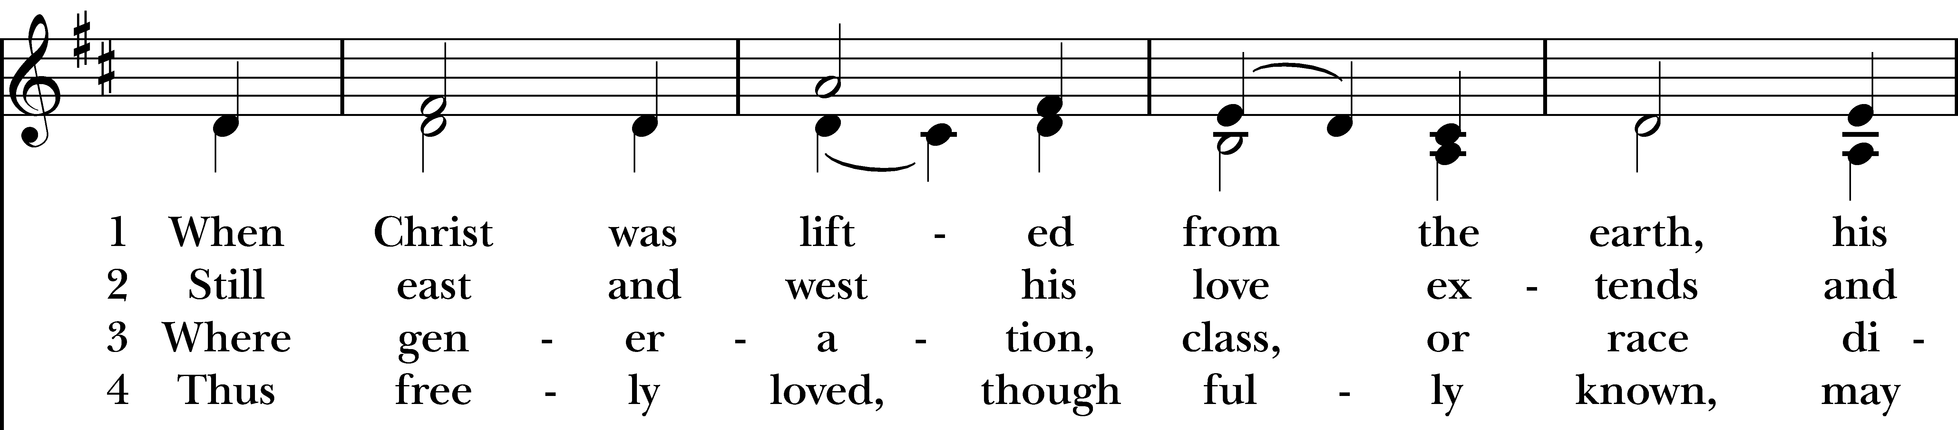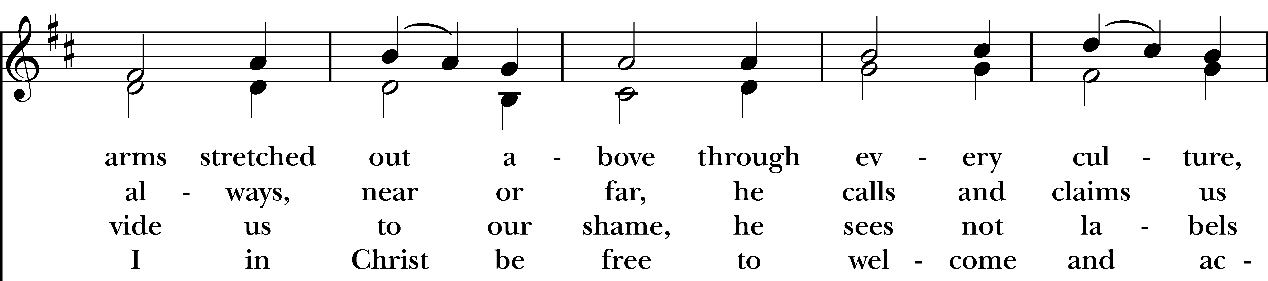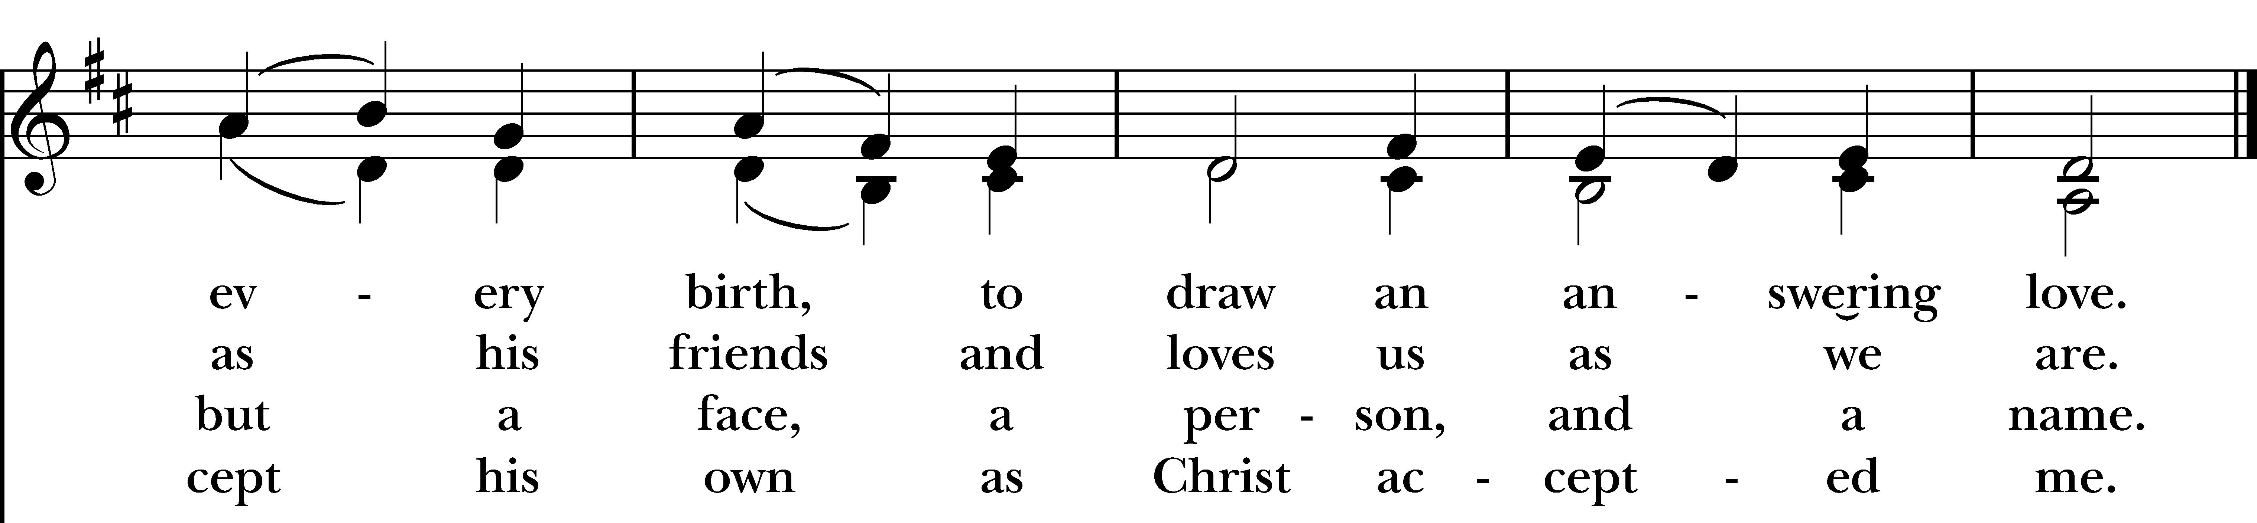

Prayer After Communion BCP p. 365
Celebrant: Turning now to page 365 in the Book of Common Prayer, let us pray:

Eternal God, heavenly Father, you have graciously accepted us as living members of your Son our Savior Jesus Christ, and you have fed us with spiritual food in the Sacrament of his Body and Blood.
Send us now into the world in peace, and grant us strength and courage to love and serve you with gladness and singleness of heart; through Christ our Lord. Amen.
Blessing Rev. Katy
Announcements Vicki MarkAnthony
Celebrant: Please stand as you are able and sing together, “Crown him with many crowns,” #494.

Recessional Hymn “Crown him with many crowns” Hymnal #494

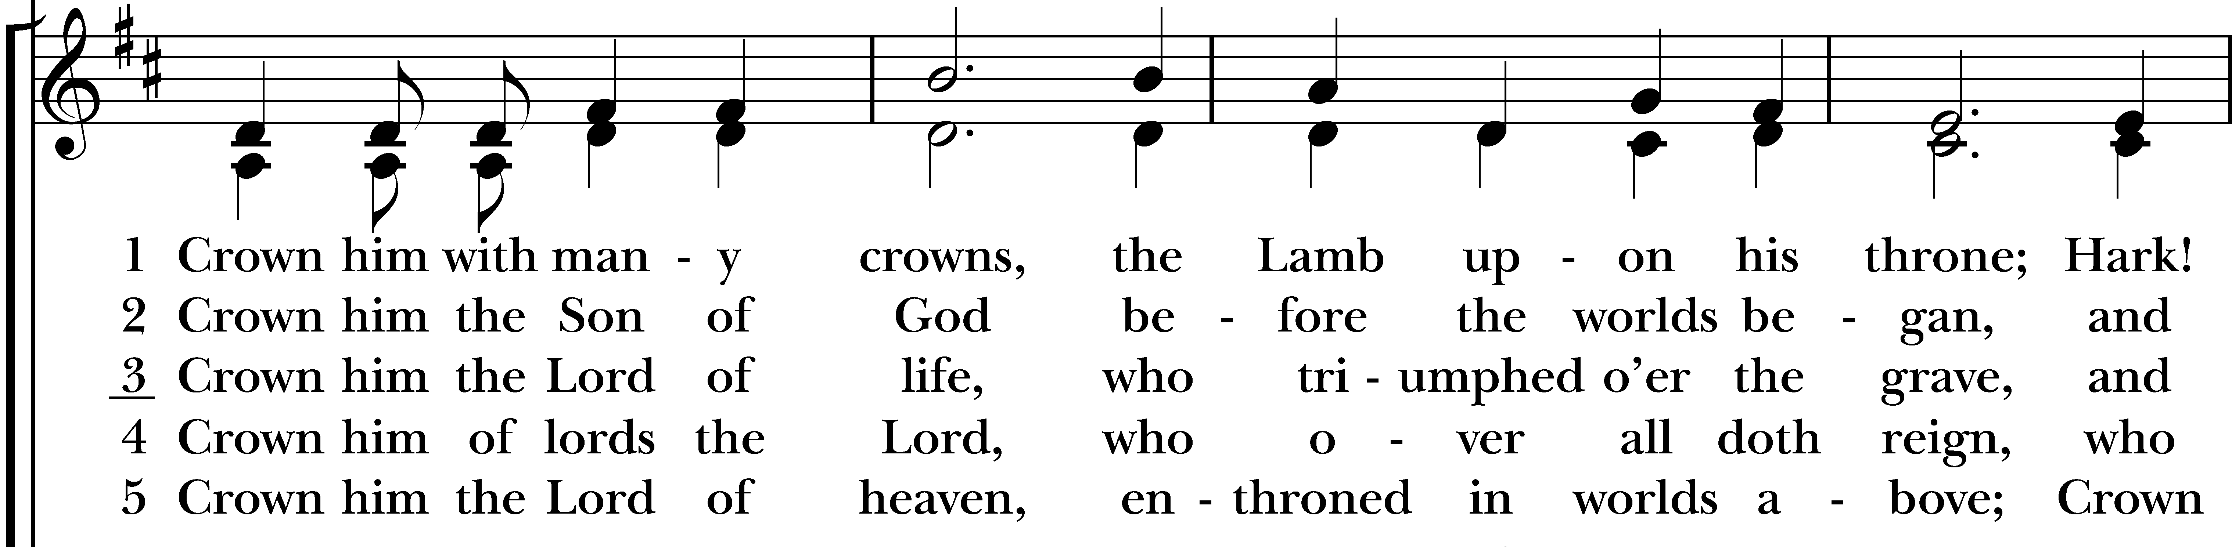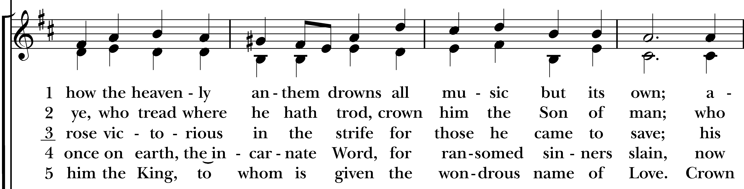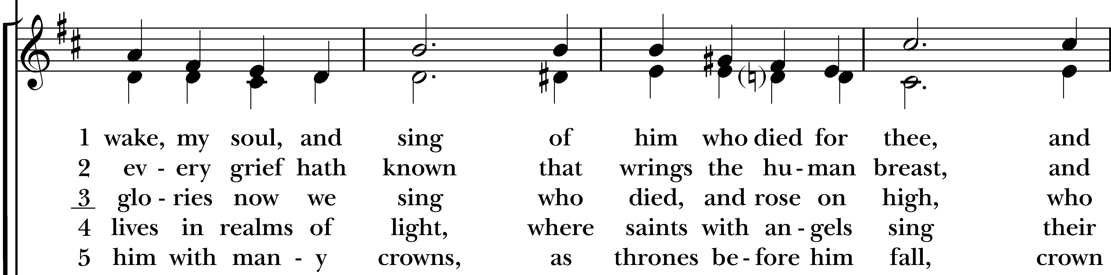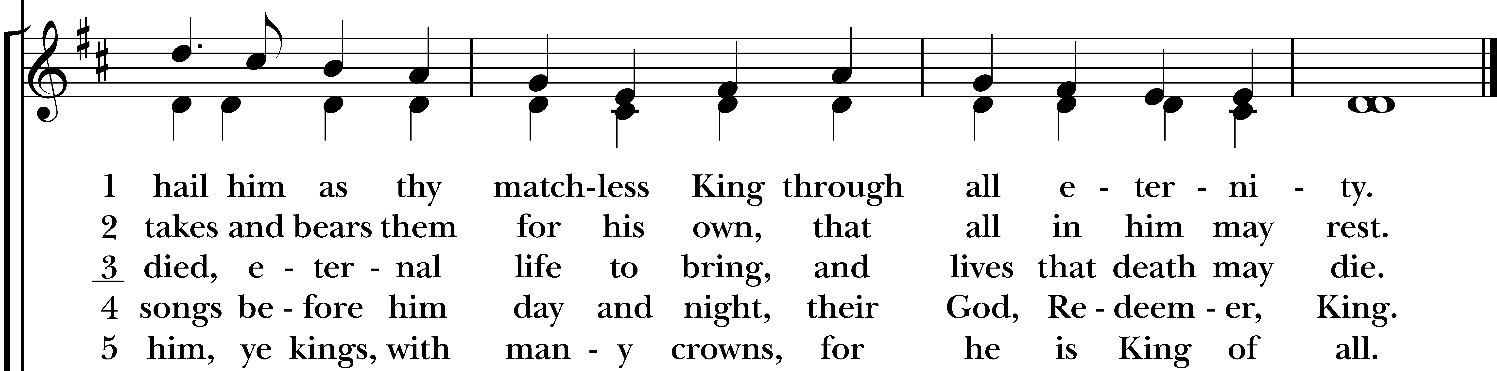
Reprinted/streamed with permission via RiteSong. All rights reserved.

Dismissal

Subdeacon: Our worship is ended. Our Service begins. Let us go in peace to love & serve the Lord. Alleluia, alleluia!

People: Thanks be to God. Alleluia, alleluia!
Announcements for May 17th, 2026

COFFEE HOUR: Please consider signing up to provide refreshments for an upcoming Sunday.

COTH SPONSORS NEEDED: Forms are in the narthex. Please solicit any local businesses you frequent.

PENTECOST: Sunday, May 24th at 10:00 am. We’ll be celebrating Pentecost at St. John’s Episcopal Church in Bridgeport (768 Fairfield Ave). No service here that day!

MEMORIAL DAY PARADE: Christ Church will be joining CCNS (Christ Church Nursery School) and marching in the parade for the first time! Meet at 9am at the Firehouse Green; parade starts at 9:30.

VESTRY MEETING: Wednesday, May 27th at 7pm via Zoom. All are welcome. Email Vicki for the Zoom link.

PRIDE FLAG RAISING: Monday, June 1st at 5:30 pm, Easton Town Hall. Please attend if you are able!

NEXT FAMILY SERVICE: Sunday, June 7th – save the date!

NOURISH BRIDGEPORT: Our next parish date of service at Nourish is Thursday, 6/18. Please contact Jim Swann to volunteer for kitchen prep and/or serving.

GIFT CARDS to gas stations & grocery stores are always needed. We are currently low on grocery store gift cards. Thank you for your continued generosity.

UPCOMING WORSHIP DATES – Sunday Services @ 9:30 am

Sunday, 5/24: Pentecost Service @ St. John’s, 10 am – 768 Fairfield Ave, Bridgeport

Sunday, 5/31: Morning Prayer & Trinity Sunday – Deborah Swann

Sunday, 6/7: Eucharist Service & Family Sunday – Rev. Katy Piazza

Sunday, 6/14: Morning Prayer – Molly Adams

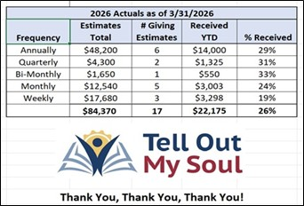
Music Minister: Tracy Carlucci

Choir Members: Amy Strachan, Andy Verrocchi, Bob Ellwanger, David McCann, Diane McCann, Marina Philips, Katie Tressler, Vicki MarkAnthony

Christ Church Nursery School: Maggie Supple, Director www.ccnseaston.com
Vestry: Jim Swann, Jr. Warden; Bob Ellwanger, Treasurer; Amy Bailas, Clerk

Vestry Members: Russ Bailas, Marina Philips, Claire Wilkes, Peg Ellwanger

Diocesan Delegates: Diane McCann, Bob Ellwanger; Alternate: Deborah Swann
Christ Church – Parish Office Hours:
Mondays & Wednesdays: 9:30-1:30

59 Church Rd, Easton, CT
(203) 268-3569

christchurcheaston@gmail.com
www.christchurcheaston.com

Priest-in-Charge: Katy Piazza

Senior Warden: Vicki MarkAnthony

Parish Administrator: Tracy Carlucci

