Sunday, October 25th, 2026
The Twenty-Second Sunday after Pentecost
Rev. Katy Piazza, Priest-in-Charge
Christ Church Easton

Celebrant: As we gather to worship, let us recognize that we gather on the ancestral lands and traditional territory of the (Aspetuck River Valley dwelling) Paugussett people.

Celebrant: Please stand as you are able and sing together, “Awake, my soul, and with the sun,” #11 in the hymnal.

Processional Hymn “Awake, my soul, and with the sun” Hymnal #11

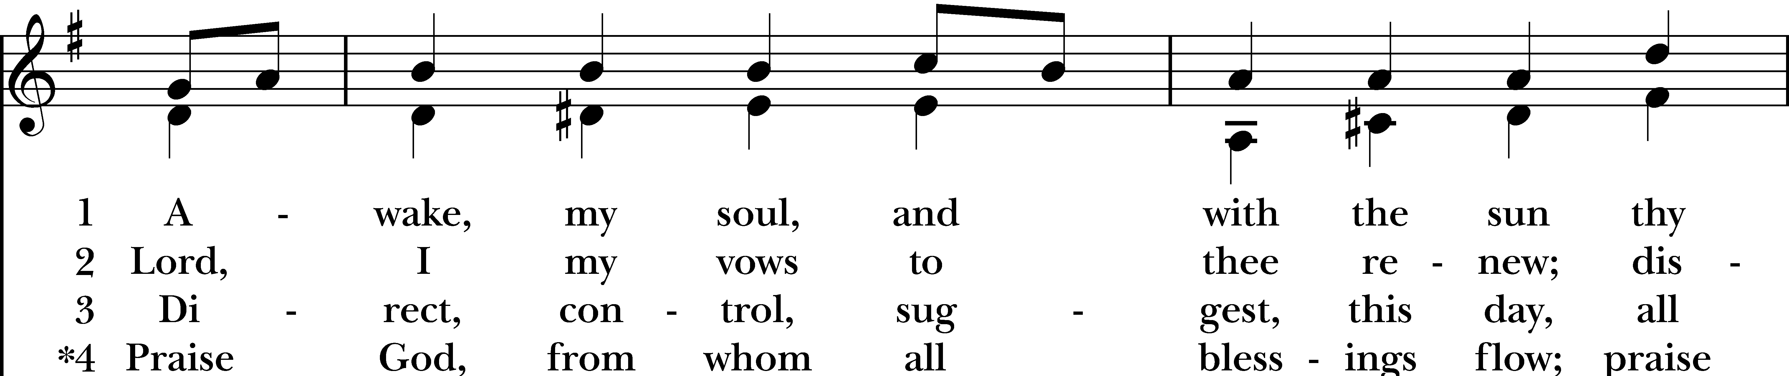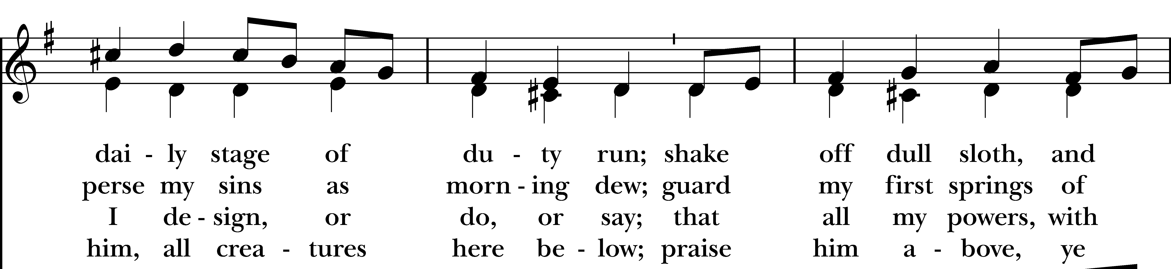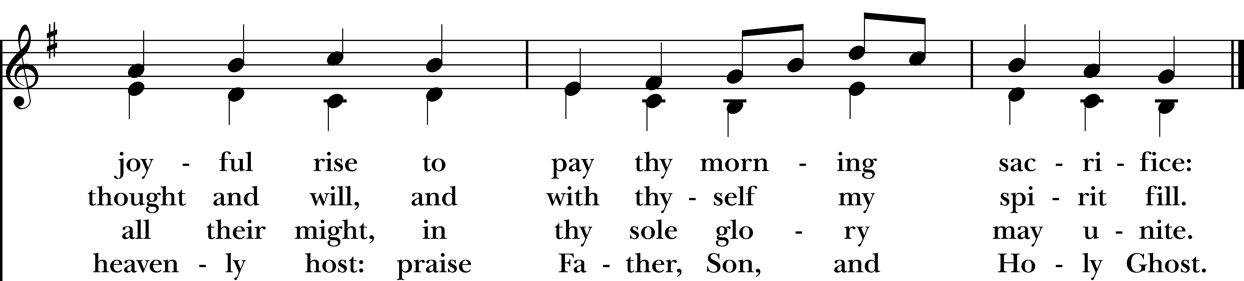
Reprinted/streamed with permission via One License and RiteSong. All rights reserved.

Celebrant: Please turn to page 355 in the Book of Common Prayer.

The Word of God BCP p. 355

Celebrant: Blessed be God: Father, Son, and Holy Spirit.
People: And blessed be his kingdom, now and for ever. Amen.

Collect for Purity

Almighty God, to you all hearts are open, all desires known, and from you no secrets are hid: Cleanse the thoughts of our hearts by the inspiration of your Holy Spirit, that we may perfectly love you, and worthily magnify your holy Name; through Christ our Lord. Amen.

Gloria in Excelsis Pew Card/Hymnal #S280

Collect of the Day

Celebrant: The Lord be with you.
People: And also with you.

Let us pray. Almighty and everlasting God, increase in us the gifts of faith, hope, and charity; and, that we may obtain what you promise, make us love what you command; through Jesus Christ our Lord, who lives and reigns with you and the Holy Spirit, one God, for ever and ever. Amen.

The First Reading Deuteronomy 34:1-12
A Reading from the Book of Deuteronomy.

Moses went up from the plains of Moab to Mount Nebo, to the top of Pisgah, which is opposite Jericho, and the Lord showed him the whole land: Gilead as far as Dan, all Naphtali, the land of Ephraim and Manasseh, all the land of Judah as far as the Western Sea, the Negeb, and the Plain—that is, the valley of Jericho, the city of palm trees—as far as Zoar. The Lord said to him, “This is the land of which I swore to Abraham, to Isaac, and to Jacob, saying, ‘I will give it to your descendants’; I have let you see it with your eyes, but you shall not cross over there.” Then Moses, the servant of the Lord, died there in the land of Moab, at the Lord’s command. He was buried in a valley in the land of Moab, opposite Beth-peor, but no one knows his burial place to this day. Moses was one hundred twenty years old when he died; his sight was unimpaired and his vigor had not abated. The Israelites wept for Moses in the plains of Moab thirty days; then the period of mourning for Moses was ended.

Joshua son of Nun was full of the spirit of wisdom, because Moses had laid his hands on him; and the Israelites obeyed him, doing as the Lord had commanded Moses.
Never since has there arisen a prophet in Israel like Moses, whom the Lord knew face to face. He was unequaled for all the signs and wonders that the Lord sent him to perform in the land of Egypt, against Pharaoh and all his servants and his entire land, and for all the mighty deeds and all the terrifying displays of power that Moses performed in the sight of all Israel.

The Word of the Lord.
Thanks be to God.

The Psalm Psalm 90:1-6, 13-17

Lord, you have been our refuge *
from one generation to another.
Before the mountains were brought forth, or the land and the earth were born, *
from age to age you are God.
You turn us back to the dust and say, *
“Go back, O child of earth.”
For a thousand years in your sight are like yesterday when it is past *
and like a watch in the night.
You sweep us away like a dream; *
we fade away suddenly like the grass.
In the morning it is green and flourishes; *
in the evening it is dried up and withered.
Return, O LORD; how long will you tarry? *
be gracious to your servants.
Satisfy us by your loving-kindness in the morning; *
so shall we rejoice and be glad all the days of our life.
Make us glad by the measure of the days that you afflicted us *
and the years in which we suffered adversity.
Show your servants your works *
and your splendor to their children.
May the graciousness of the LORD our God be upon us; *
prosper the work of our hands; prosper our handiwork.

The Second Reading 1 Thessalonians 2:1-8
A Reading from the First Letter to the Thessalonians.

You yourselves know, brothers and sisters, that our coming to you was not in vain, but though we had already suffered and been shamefully mistreated at Philippi, as you know, we had courage in our God to declare to you the gospel of God in spite of great opposition. For our appeal does not spring from deceit or impure motives or trickery, but just as we have been approved by God to be entrusted with the message of the gospel, even so we speak, not to please mortals, but to please God who tests our hearts. As you know and as God is our witness, we never came with words of flattery or with a pretext for greed; nor did we seek praise from mortals, whether from you or from others, though we might have made demands as apostles of Christ. But we were gentle among you, like a nurse tenderly caring for her own children. So deeply do we care for you that we are determined to share with you not only the gospel of God but also our own selves, because you have become very dear to us.

The Word of the Lord.
Thanks be to God.

Celebrant: Please stand as you are able and sing together “Plenty Good Room,” found in your bulletin. We will sing verses 1-2 before the Gospel and verse 3 after.

Gospel Hymn “Plenty Good Room” Bulletin
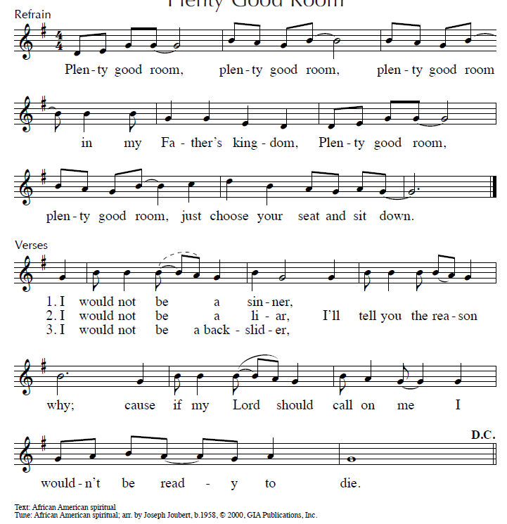
Reprinted/streamed with permission via One License and RiteSong. All rights reserved.

The Gospel Matthew 22:34-46
The Holy Gospel of our Lord Jesus Christ, according to Matthew.
Glory to you, Lord Christ.

When the Pharisees heard that Jesus had silenced the Sadducees, they gathered together, and one of them, a lawyer, asked him a question to test him. “Teacher, which commandment in the law is the greatest?” He said to him, “’You shall love the Lord your God with all your heart, and with all your soul, and with all your mind.’ This is the greatest and first commandment. And a second is like it: ‘You shall love your neighbor as yourself.’ On these two commandments hang all the law and the prophets.”

Now while the Pharisees were gathered together, Jesus asked them this question: “What do you think of the Messiah? Whose son is he?” They said to him, “The son of David.” He said to them, “How is it then that David by the Spirit calls him Lord, saying, ‘The Lord said to my Lord, “Sit at my right hand, until I put your enemies under your feet”’?

If David thus calls him Lord, how can he be his son?” No one was able to give him an answer, nor from that day did anyone dare to ask him any more questions.

The Gospel of the Lord.
Praise to you, Lord Christ.

Reflection Vicki MarkAnthony

Celebrant: Please stand as you are able for The Nicene Creed, page 358 of the Book of Common Prayer.

The Nicene Creed BCP p. 358

We believe in one God, the Father, the Almighty, maker of heaven and earth, of all that is, seen and unseen. We believe in one Lord, Jesus Christ, the only Son of God, eternally begotten of the Father, God from God, Light from Light, true God from true God, begotten, not made, of one Being with the Father. Through him all things were made.

For us and for our salvation, he came down from heaven: by the power of the Holy Spirit he became incarnate from the Virgin Mary, and was made man. For our sake he was crucified under Pontius Pilate; he suffered death and was buried. On the third day he rose again in accordance with the Scriptures; he ascended into heaven and is seated at the right hand of the Father. He will come again in glory to judge the living and the dead, and his kingdom will have no end.

We believe in the Holy Spirit, the Lord, the giver of life, who proceeds from the Father and the Son. With the Father and the Son he is worshiped and glorified. He has spoken through the Prophets. We believe in one holy catholic and apostolic Church. We acknowledge one baptism for the forgiveness of sins. We look for the resurrection of the dead, and the life of the world to come. Amen.

Subdeacon: The Prayers of the People are Form VI, found on page 392 in the Book of Common Prayer.

Prayers of the People: Form VI BCP p. 392

In peace, we pray to you, Lord God.

For all people in their daily life and work;
For our families, friends, and neighbors, and for those who are alone.

For this community, the nation, and the world;
For all who work for justice, freedom, and peace.

For the just and proper use of your creation;
For the victims of hunger, fear, injustice, and oppression.

For all who are in danger, sorrow, or any kind of trouble;
For those who minister to the sick, the friendless, and the needy.

For the peace and unity of the Church of God;
For all who proclaim the Gospel, and all who seek the Truth.

For Sean, our Presiding Bishop, Laura & Jeffery, our Bishops; and for all bishops and other ministers;
For all who serve God in his Church.

For the special needs and concerns of this congregation, including those on our parish prayer list…

Hear us, Lord; For your mercy is great.

We thank you, Lord, for all the blessings of this life.

We will exalt you, O *God* our King; And praise your Name for ever and ever.

We pray for all who have died, that they may have a place in your eternal kingdom.

Lord, let your loving-kindness be upon them; Who put their trust in you.

We pray to you also for the forgiveness of our sins.

Have mercy upon us, most merciful Father; in your compassion forgive us our sins, known and unknown, things done and left undone; and so uphold us by your Spirit, that we may live and serve you in newness of life, to the honor and glory of your Name; through Jesus Christ our Lord. Amen.

Celebrant: O Lord our God, accept the fervent prayers of your people; in the multitude of your mercies, look with compassion upon us and all who turn to you for help; for you are gracious, O lover of souls, and to you we give glory, Father, Son, and Holy Spirit, now and for ever. Amen.

Celebrant: Turning now to page 360 in the Book of Common Prayer, let us confess our sins to God.

The Confession of Sin BCP p. 360

Most merciful God, we confess that we have sinned against you in thought, word, and deed,
by what we have done, and by what we have left undone. We have not loved you with our whole heart; we have not loved our neighbors as ourselves. We are truly sorry and we humbly repent. For the sake of your Son Savior Jesus Christ, have mercy on us and forgive us; that we may delight in your will, and walk in your ways, to the glory of your Name. Amen.

Almighty God have mercy on you, forgive you all your sins through our Lord Jesus Christ, strengthen you in all goodness, and by the power of the Holy Spirit keep you in eternal life. Amen.

The Peace Please stand.

Celebrant: The peace of the Lord be always with you.
People: And also with you.

The Holy Communion

Walk in love, as Christ loved us and gave himself for us, an offering and sacrifice to God. Ephesians 5:2

Offertory Anthem “A Jubilant Song” Mary Lynn Lightfoot

Cantate Domino canticum novum omnis terra Sung by the choir
Sing to the Lord a new jubilant song, all the earth

Eucharistic Prayer C BCP p. 369
Celebrant: Please stand as you are able and turn to page 369 in the Book of Common Prayer.

Celebrant: The Lord be with you.
People: And also with you.
Celebrant: Lift up your hearts.
People: We lift them to the Lord.
Celebrant: Let us give thanks to the Lord our God.
People: It is right to give our thanks and praise.

God of all power, Ruler of the Universe, you are worthy of glory and praise. Glory to you for ever and ever.

At your command all things came to be: the vast expanse of interstellar space, galaxies, suns, the planets in their courses, and this fragile earth, our island home. By your will they were created and have their being.
From the primal elements you brought forth the human race, and blessed us with memory, reason, and skill. You made us the rulers of creation. But we turned against you, and betrayed your trust; and we turned against one another. Have mercy, Lord, for we are sinners in your sight.

Again and again, you called us to return. Through prophets and sages you revealed your righteous Law. And in the fullness of time you sent your only Son, born of a woman, to fulfill your Law, to open for us the way of freedom and peace. By his blood, he reconciled us. By his wounds, we are healed.

And therefore we praise you, joining with the heavenly chorus, with prophets, apostles, and martyrs, and with all those in every generation who have looked to you in hope, to proclaim with them your glory, in their unending hymn:

Sanctus Pew Card

And so, Father, we who have been redeemed by him, and made a new people by water and the Spirit, now bring before you these gifts. Sanctify them by your Holy Spirit to be the Body and Blood of Jesus Christ our Lord.

On the night he was betrayed he took bread, said the blessing, broke the bread, and gave it to his friends, and said, “Take, eat: This is my Body, which is given for you. Do this for the remembrance of me.”
After supper, he took the cup of wine, gave thanks, and said, “Drink this, all of you: This is my Blood of the new Covenant, which is shed for you and for many for the forgiveness of sins. Whenever you drink it, do this for the remembrance of me.”

Remembering now his work of redemption, and offering to you this sacrifice of thanksgiving, We celebrate his death and resurrection, as we await the day of his coming.

Lord God of our Fathers: God of Abraham, Isaac, and Jacob; God and Father of our Lord Jesus Christ: Open our eyes to see your hand at work in the world about us. Deliver us from the presumption of coming to this Table for solace only, and not for strength; for pardon only, and not for renewal. Let the grace of this Holy Communion make us one body, one spirit in Christ, that we may worthily serve the world in his name. Risen Lord, be known to us in the breaking of the Bread.
Accept these prayers and praises, Father, through Jesus Christ our great High Priest, to whom, with you and the Holy Spirit, your Church gives honor, glory, and worship, from generation to generation.

(Sung): Amen Pew Card

And now, as our Savior Christ has taught us, we are bold to say,

Our Father who art in heaven, hallowed be thy Name, thy kingdom come, thy will be done, on earth as it is in in heaven. Give us this day our daily bread. And forgive us our trespasses as we forgive those who trespass against us. And lead us not into temptation but deliver us from evil. For thine is the kingdom, the power, and the glory, for ever and ever. Amen.

The Breaking of the Bread

Celebrant: Alleluia. Christ our Passover is sacrificed for us.
People: Therefore let us keep the feast. Alleluia.
Celebrant: The Gifts of God for the People of God.

A Prayer for Spiritual Communion

Let us pray: We believe that you are truly present in the Holy Sacrament, and we pray you to come into our hearts, praying especially with those at home who cannot at this time receive communion. I unite myself with you and embrace you with all my heart, my soul, and my mind. Let nothing separate me from you; let me serve you in this life until, by your grace, I come to your glorious kingdom and unending peace. Amen.

Invitation to the Table

Celebrant: This is the table, not of the Church but of Jesus Christ. It is made ready for those who love God and who want to love God more. So come: You who have much faith and you who have little. Come, You who have been here often and you who have not been for a long time. Come, You who have tried to follow and you who have failed. Come, it is Christ who invites you to be known and fed here.

Communion Hymn “Jesu, Jesu, fill us with your love” Hymnal #602

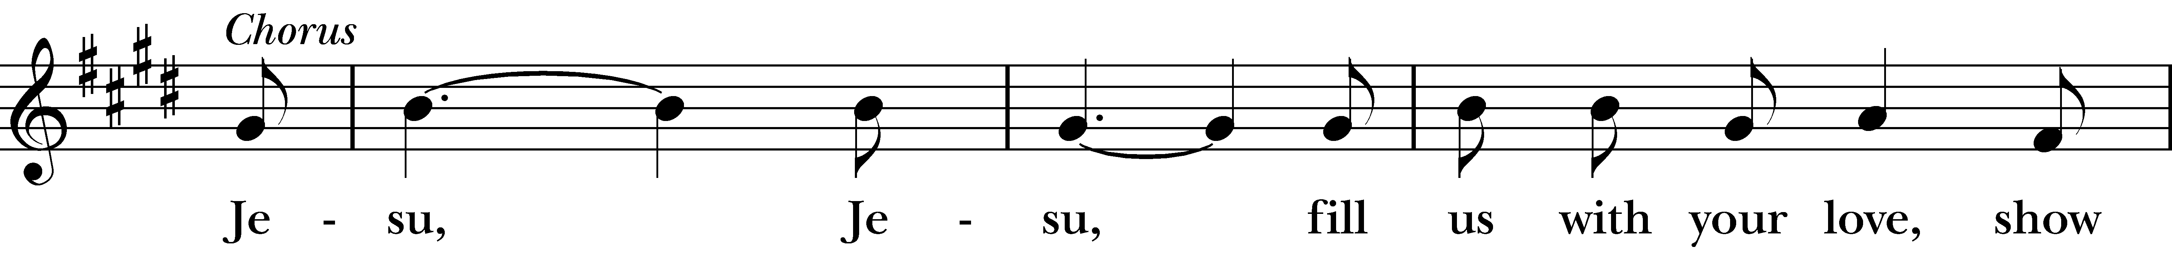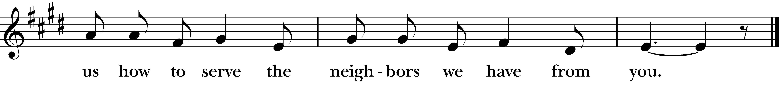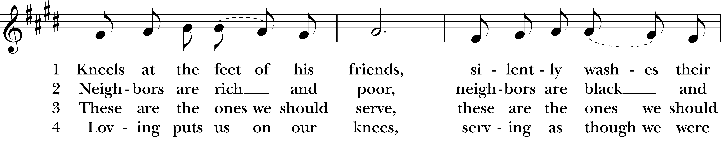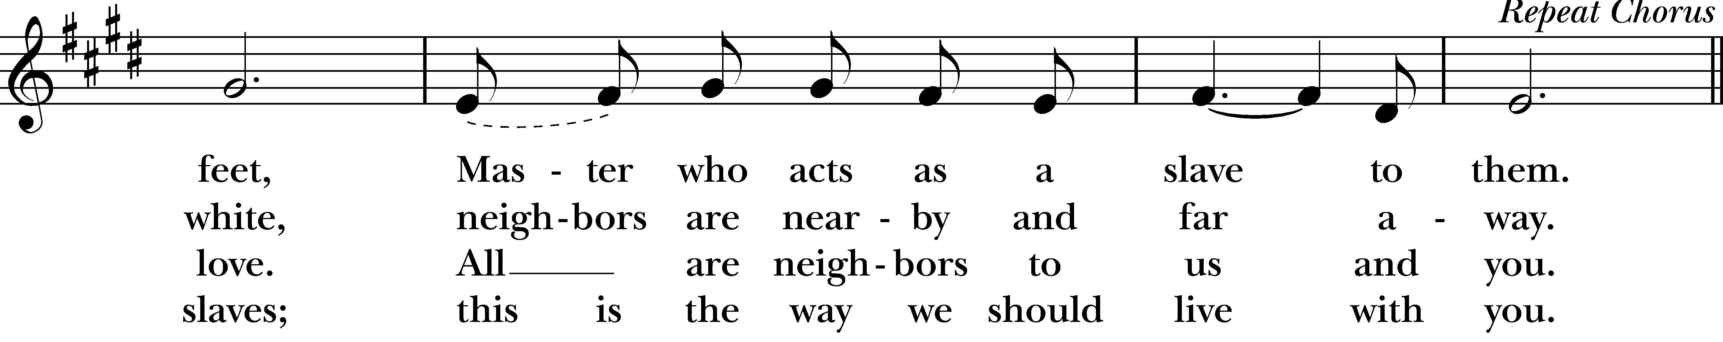
Reprinted/streamed with permission via One License and RiteSong. All rights reserved.
Celebrant: Turning now to page 365 in the Book of Common Prayer, let us pray:

Prayer After Communion BCP p. 365

Eternal God, heavenly Father, you have graciously accepted us as living members of your Son our Savior Jesus Christ, and you have fed us with spiritual food in the Sacrament of his Body and Blood. Send us now into the world in peace, and grant us strength and courage to love and serve you with gladness and singleness of heart; through Christ our Lord. Amen.
Blessing Rev. Katy

Announcements Vicki MarkAnthony

Subdeacon: Please stand as you are able and sing together our Recessional Hymn, “How lovely is thy dwelling place,” hymn #517.

Recessional Hymn “How lovely is thy dwelling place” Hymnal #517

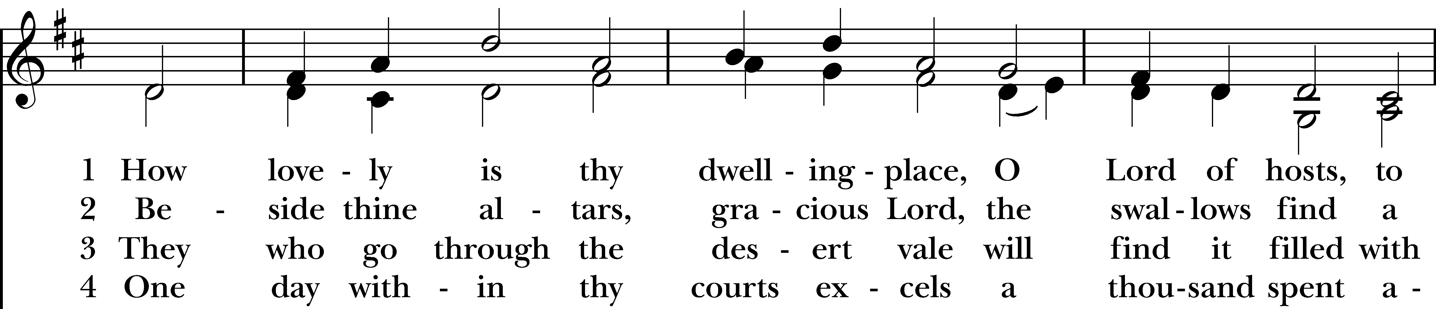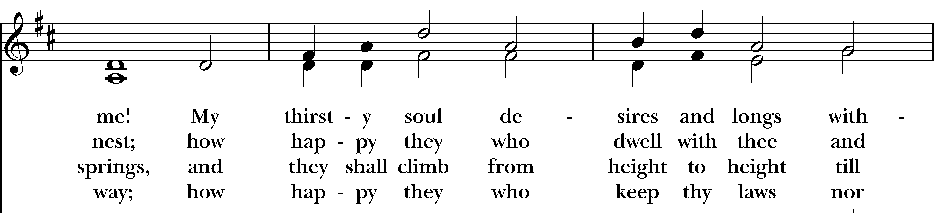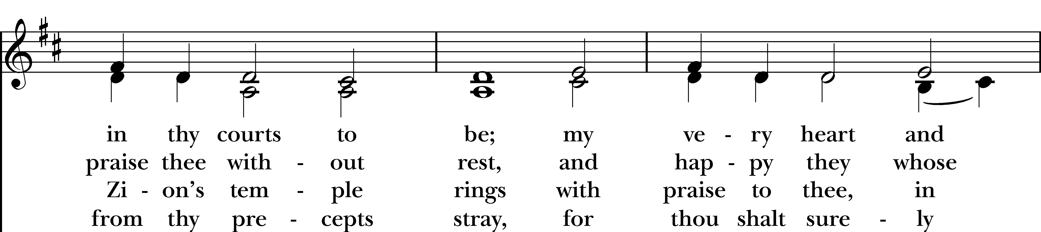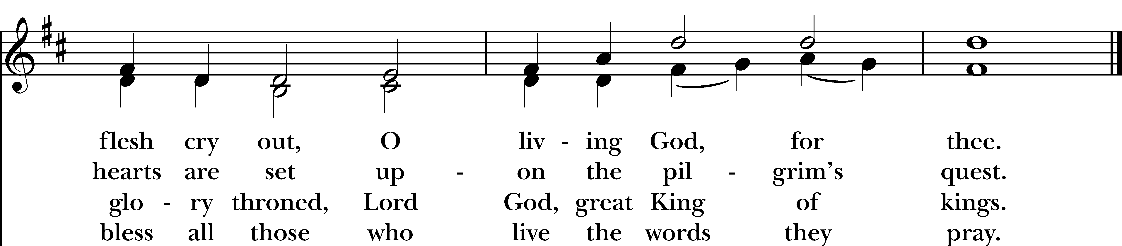
Reprinted/streamed with permission via One License and RiteSong. All rights reserved.

Dismissal

Subdeacon: Our worship is ended. Our Service begins. Let us go in peace to love & serve the Lord. Alleluia, alleluia!
People: Thanks be to God. Alleluia, alleluia!
Announcements for October 25th, 2026

COFFEE HOUR: Sign-up to host an upcoming coffee hour! Sign-up sheet is in the narthex.

FAMILY SUNDAY: The next Family Sunday will be November 22nd. Please let Tracy or Vicki know if your child would like to participate by doing a reading, bringing up the gifts, etc. An introductory Confirmation class with Rev. Katy will follow the service. Spread the word to any families with 7th and 8th graders!

SOCKTOBER: Next Sunday is the last day to bring in donations of new socks for Socktober.

ALL SAINTS DAY: Next Sunday is All Saints Day, and we will be worshipping here as a joint service with parishioners from Emmanuel.

SENIOR CENTER RAFFLE: Please see Vicki if you’d like to buy raffle tickets.

GIFT CARDS to gas stations & grocery stores are always needed. With the holidays approaching, gift cards to stores like Target are appreciated for parents to buy gifts. Thank you for your continued generosity.

Welcome to Christ Church Easton!
Whether you are a newcomer, visitor, or longtime member, we bid you a warm welcome!
Please join us for coffee hour following service. Sign up for our email list at www.christchurcheaston.com.
Music Minister: Tracy Carlucci

Choir Members: Amy Strachan, Andy Verrocchi, Bob Ellwanger, David McCann, Diane McCann, Marina Philips, Katie Tressler, Vicki MarkAnthony

Christ Church Nursery School: Maggie Supple, Director, www.ccnseaston.com
Vestry: Jim Swann, Jr. Warden; Bob Ellwanger, Treasurer; Amy Bailas, Clerk

Vestry Members: Russ Bailas, Marina Philips, Claire Wilkes, Peg Ellwanger

Diocesan Delegates: Diane McCann, Bob Ellwanger; Alternate: Deborah Swann
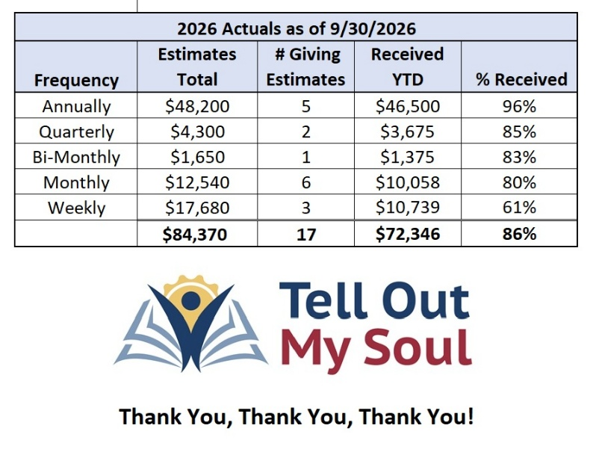
Christ Church – Parish Office Hours:

Mondays & Wednesdays: 9:30-1:30

59 Church Rd, Easton, CT
(203) 268-3569

christchurcheaston@gmail.com
www.christchurcheaston.com

Priest-in-Charge: Katy Piazza

Senior Warden: Vicki MarkAnthony

Parish Administrator: Tracy Carlucci
UPCOMING WORSHIP SCHEDULE

Sundays at 9:30 am:

November 1st: All Saints Day Eucharist – Rev. Katy Piazza

November 8th: Morning Prayer – Deborah Swann

November 15th: Eucharist – Rev. Sandy Belcher

November 22nd: – Eucharist & Family Sunday – Rev. Katy Piazza

