Sunday, February 22nd, 2026: The First Sunday in Lent
264th Annual Meeting of Christ Church Easton
Rev. Katy Piazza, Priest-in-Charge

Celebrant: As we gather to worship, let us recognize that we gather on the ancestral lands and traditional territory of the (Aspetuck River Valley dwelling) Paugussett people.

Celebrant: The 264th Annual Meeting of Christ Church is now open.

Celebrant: Please stand as you are able and sing together our Processional Hymn, “The glory of these forty days,” #143 in the hymnal.

Processional Hymn “The glory of these forty days” Hymnal #143

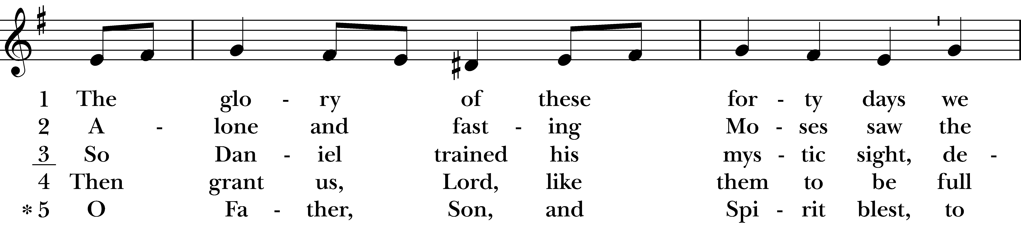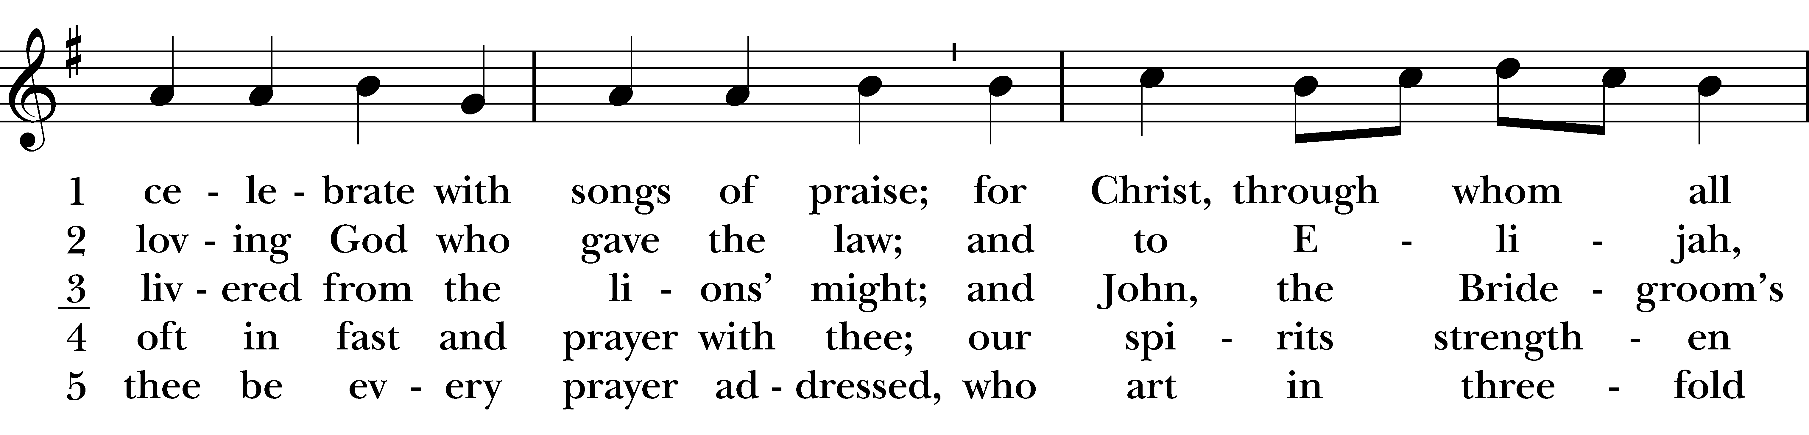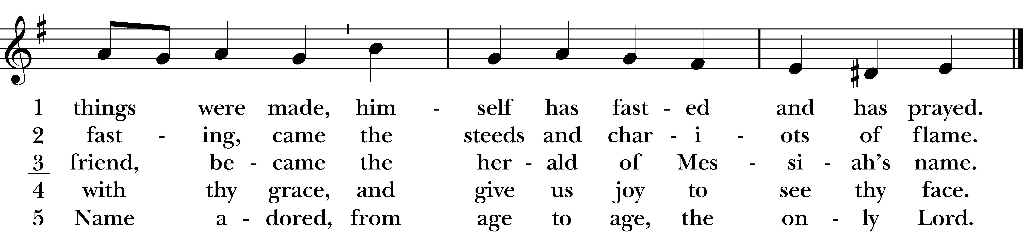
Reprinted/streamed with permission via One License and RiteSong. All rights reserved.
The Word of God

Celebrant: Bless the Lord who forgives all our sins;
People: His mercy endures for ever.

The Collect for Purity
Almighty God, to you all hearts are open, all desires known, and from you no secrets are hid: Cleanse the thoughts of our hearts by the inspiration of your Holy Spirit, that we may perfectly love you, and worthily magnify your holy Name; through Christ our Lord. Amen.

Collect of the Day

Celebrant: The Lord be with you.
People: And also with you.

Let us pray. Almighty God, whose blessed Son was led by the Spirit to be tempted by Satan; Come quickly to help us who are assaulted by many temptations; and, as you know the weaknesses of each of us, let each one find you mighty to save; through Jesus Christ your Son our Lord, who lives and reigns with you and the Holy Spirit, one God, now and for ever. Amen.

The Psalm Psalm 32

Happy are they whose transgressions are forgiven, *
and whose sin is put away!
Happy are they to whom the LORD imputes no guilt, *
and in whose spirit there is no guile!
While I held my tongue, my bones withered away, *
because of my groaning all day long.
For your hand was heavy upon me day and night; *
my moisture was dried up as in the heat of summer.
Then I acknowledged my sin to you, *
and did not conceal my guilt.
I said, “I will confess my transgressions to the LORD.” *
Then you forgave me the guilt of my sin.
Therefore all the faithful will make their prayers to you in time of trouble; *
when the great waters overflow, they shall not reach them.
You are my hiding-place; you preserve me from trouble; *
you surround me with shouts of deliverance.
“I will instruct you and teach you in the way that you should go; *
I will guide you with my eye.
Do not be like horse or mule, which have no understanding; *
who must be fitted with bit and bridle, or else they will not stay near you.”
Great are the tribulations of the wicked; *
but mercy embraces those who trust in the LORD.
Be glad, you righteous, and rejoice in the LORD; *
shout for joy, all who are true of heart.

Celebrant: Please stand as you are able and sing together hymn #440 “Blessed Jesus, at thy word.” We will sing verses 1 and 2 before the Gospel and verse 3 after.

Gospel Hymn “Blessed Jesus, at thy word” Hymnal #440
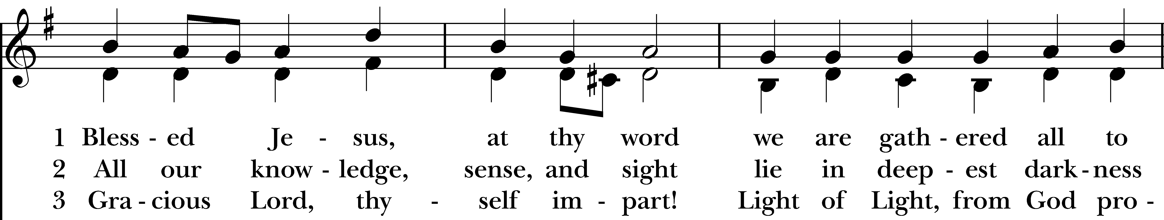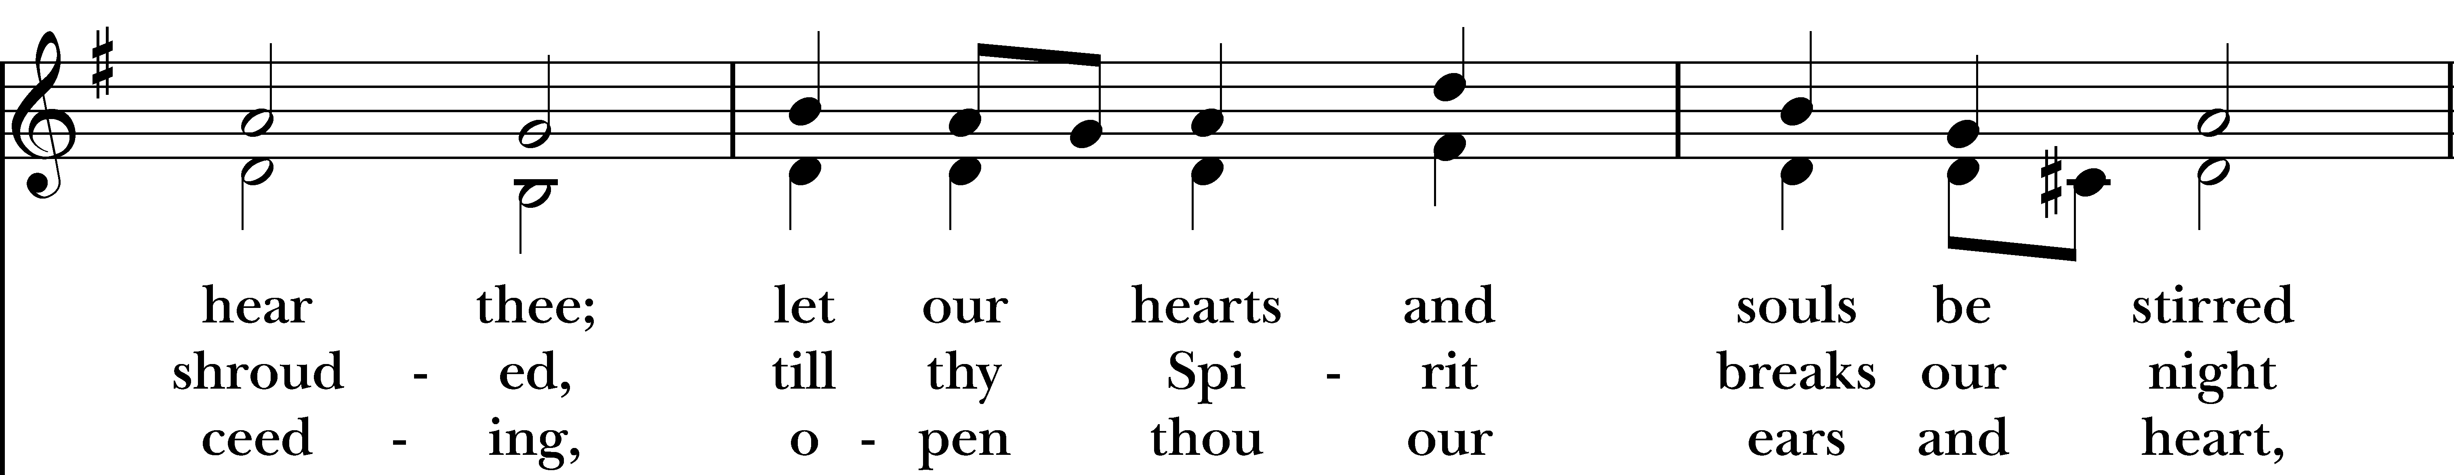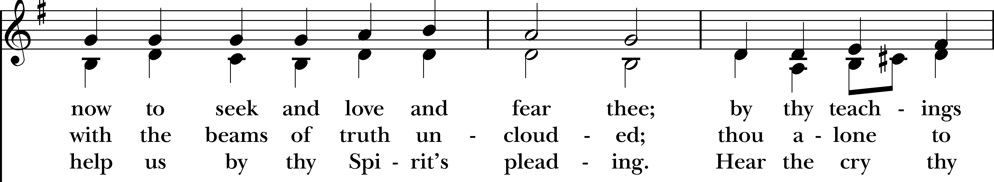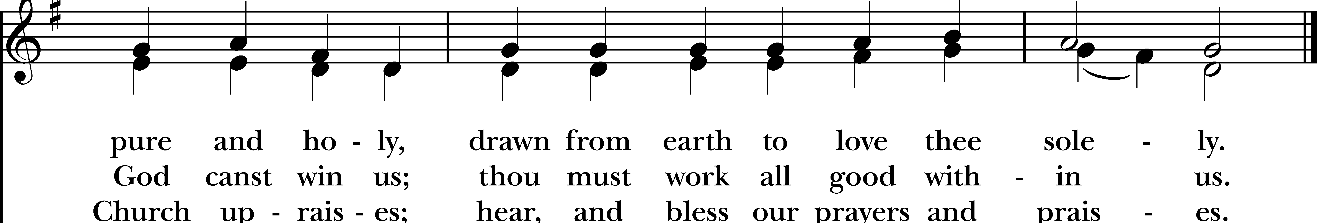
Reprinted/streamed with permission via One License and/or RiteSong. All rights reserved.
The Gospel Matthew 4:1-11

The Holy Gospel of our Lord Jesus Christ, according to Matthew.
Glory to you, Lord Christ.

Then Jesus was led up by the Spirit into the wilderness to be tempted by the devil. He fasted forty days and forty nights, and afterwards he was famished. The tempter came and said to him, “If you are the Son of God, command these stones to become loaves of bread.” But he answered, “It is written, ‘One does not live by bread alone, but by every word that comes from the mouth of God.’” Then the devil took him to the holy city and placed him on the pinnacle of the temple, saying to him, “If you are the Son of God, throw yourself down; for it is written, ‘He will command his angels concerning you,’ and ‘On their hands they will bear you up, so that you will not dash your foot against a stone.’” Jesus said to him, “Again it is written, ‘Do not put the Lord your God to the test.’” Again, the devil took him to a very high mountain and showed him all the kingdoms of the world and their splendor; and he said to him, “All these I will give you, if you will fall down and worship me.” Jesus said to him, “Away with you, Satan! for it is written, ‘Worship the Lord your God, and serve only him.’” Then the devil left him, and suddenly angels came and waited on him.

The Gospel of the Lord.
Praise to you, Lord Christ.

Sermon Rev. Katy

Prayers of the People: Form III BCP p. 387
Subdeacon: The Prayers of the People are Form III, found on page 387 in the Book of Common Prayer.

Father, we pray for your holy Catholic Church;
That we all may be one.

Grant that every member of the Church may truly and humbly serve you;
That your Name may be glorified by all people.

We pray for all bishops, priests, and deacons;
That they may be faithful ministers of your Word and Sacraments.
We pray for all who govern and hold authority in the nations of the world;
That there may be justice and peace on the earth.

Give us grace to do your will in all that we undertake;
That our works may find favor in your sight.

Have compassion on those who suffer from any grief or trouble;
That they may be delivered from their distress.

Give to the departed eternal rest.
Let light perpetual shine upon them.

We praise you for your saints who have entered into joy;
May we also come to share in your heavenly kingdom.

Let us pray for our own needs and those of others. We pray especially for those on our parish prayer list…

Celebrant: O Lord our God, accept the fervent prayers of your people; in the multitude of your mercies, look with compassion upon us and all who turn to you for help; for you are gracious, O lover of souls, and to you we give glory, Father, Son, and Holy Spirit, now and for ever. Amen.

The Peace
Celebrant: Please stand for The Peace.
Celebrant: The peace of the Lord be always with you.
People: And also with you.

Announcements

The Holy Communion

Walk in love, as Christ loved us and gave himself for us, an offering and sacrifice to God. Ephesians 5:2

Offertory Instrumental

Eucharistic Prayer B BCP p. 367
Celebrant: Please stand as you are able and turn to page 367 in the Book of Common Prayer.

Celebrant: The Lord be with you.
People: And also with you.
Celebrant: Lift up your hearts.
People: We lift them to the Lord.
Celebrant: Let us give thanks to the Lord our God.
People: It is right to give him thanks and praise.

It is right, and a good and joyful thing, always and everywhere to give thanks to you, Father Almighty, Creator of heaven and earth.

You bid your faithful people cleanse their hearts, and prepare with joy for the Paschal feast; that, fervent in prayer and in works of mercy, and renewed by your Word and Sacraments, they may come to the fullness of grace which you have prepared for those who love you.

Therefore we praise you, joining our voices with Angels and Archangels and with all the company of heaven, who for ever say this hymn to proclaim the glory of your Name:

Holy, holy, holy, Lord, God of power and might, heaven and earth are full of your glory.
Hosanna in the highest. Blessed is he who comes in the name of the Lord. Hosanna in the highest.

We give thanks to you, O God, for the goodness and love which you have made known to us in creation; in the calling of Israel to be your people; in your Word spoken through the prophets; and above all in the Word made flesh, Jesus, your Son. For in these last days you sent him to be incarnate from the Virgin Mary, to be the Savior and Redeemer of the world. In him, you have delivered us from evil, and made us worthy to stand before you. In him, you have brought us out of error into truth, out of sin into righteousness, out of death into life.

On the night before he died for us, our Lord Jesus Christ took bread; and when he had given thanks to you, he broke it, and gave it to his disciples, and said, “Take, eat: This is my Body, which is given for you. Do this for the remembrance of me.”

After supper he took the cup of wine; and when he had given thanks, he gave it to them, and said, “Drink this, all of you: This is my Blood of the new Covenant, which is shed for you and for many for the forgiveness of sins. Whenever you drink it, do this for the remembrance of me.”

And now, as our Savior Christ has taught us, we are bold to say,

Our Father who art in heaven, hallowed be thy Name, thy kingdom come, thy will be done, on earth as it is in in heaven. Give us this day our daily bread. And forgive us our trespasses as we forgive those who trespass against us. And lead us not into temptation but deliver us from evil. For thine is the kingdom, the power, and the glory, for ever and ever. Amen.

The Breaking of the Bread

Celebrant: Christ our Passover is sacrificed for us.
People: Therefore let us keep the feast.
Celebrant: The Gifts of God for the People of God.

Communion Hymn On Eagle’s Wings WLP 810

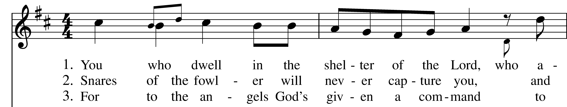
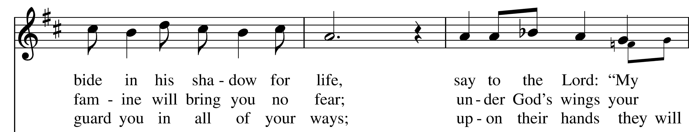
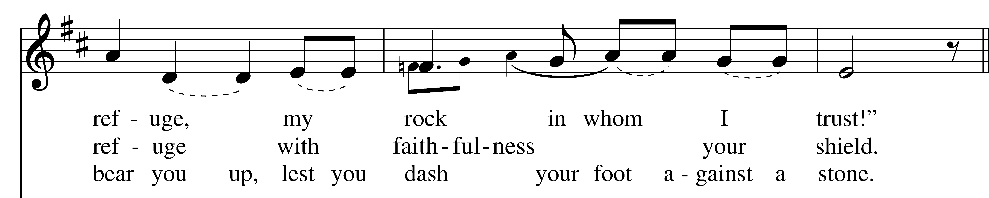
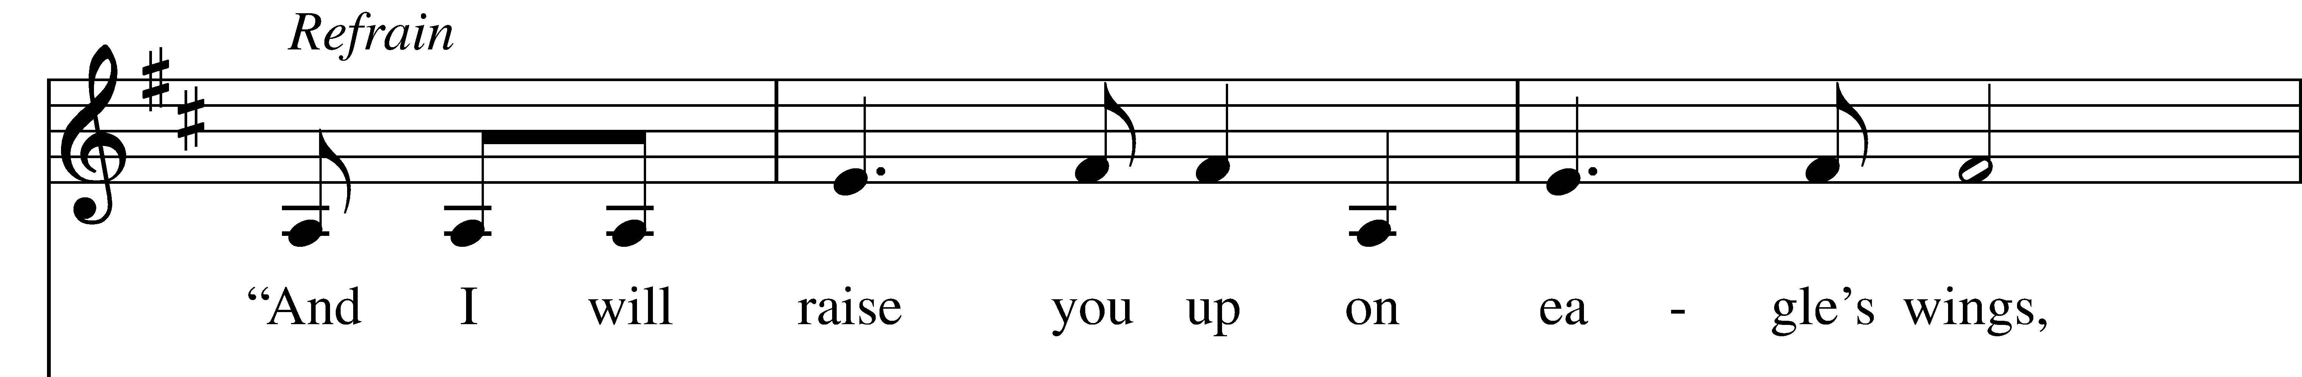
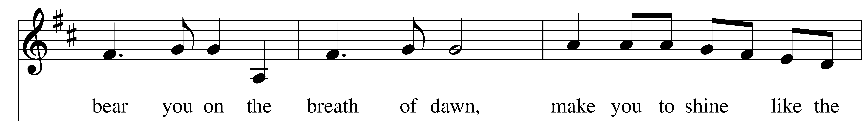
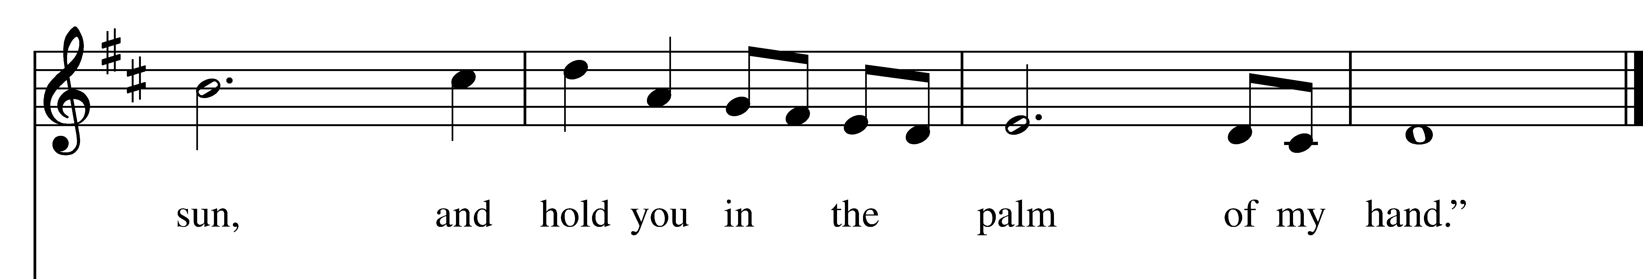
Reprinted/streamed with permission via RiteSong. All rights reserved.
Prayer After Communion BCP p. 365
Celebrant: Turning now to page 365 in the Book of Common Prayer, let us pray:

Eternal God, heavenly Father, you have graciously accepted us as living members of your Son our Savior Jesus Christ, and you have fed us with spiritual food in the Sacrament of his Body and Blood.
Send us now into the world in peace, and grant us strength and courage to love and serve you with gladness and singleness of heart; through Christ our Lord. Amen.
Meeting Reports
Hymn after Senior Warden’s Report:

Chorus – 4x’s: You gotta put one foot in front of the other, And lead with love
Put one foot in front of the other, And lead with love

Verses (call and response):
Don’t give up hope, You’re not alone, Don’t you give up, Keep movin’ on
Blessing Rev. Katy

Celebrant: Please stand as you are able for our Recessional Hymn, “A mighty fortress is our God,” #688.

Recessional Hymn “A mighty fortress is our God” Hymnal #688

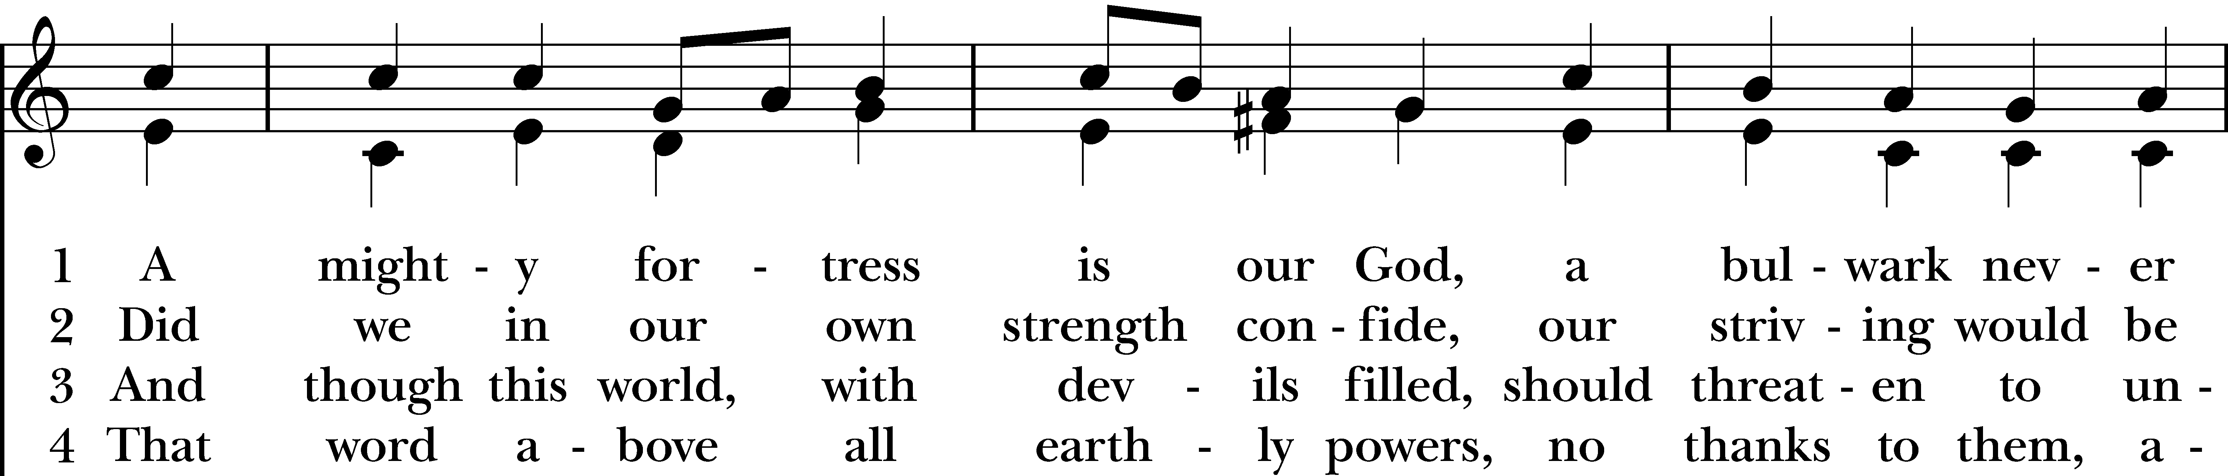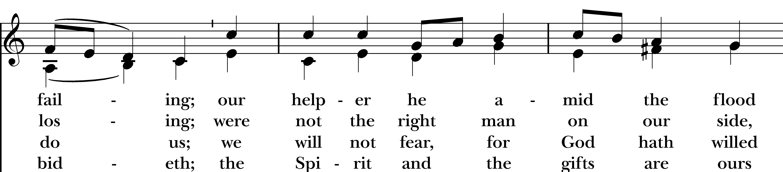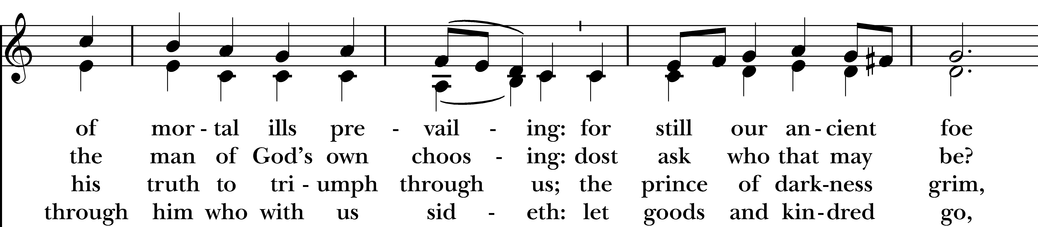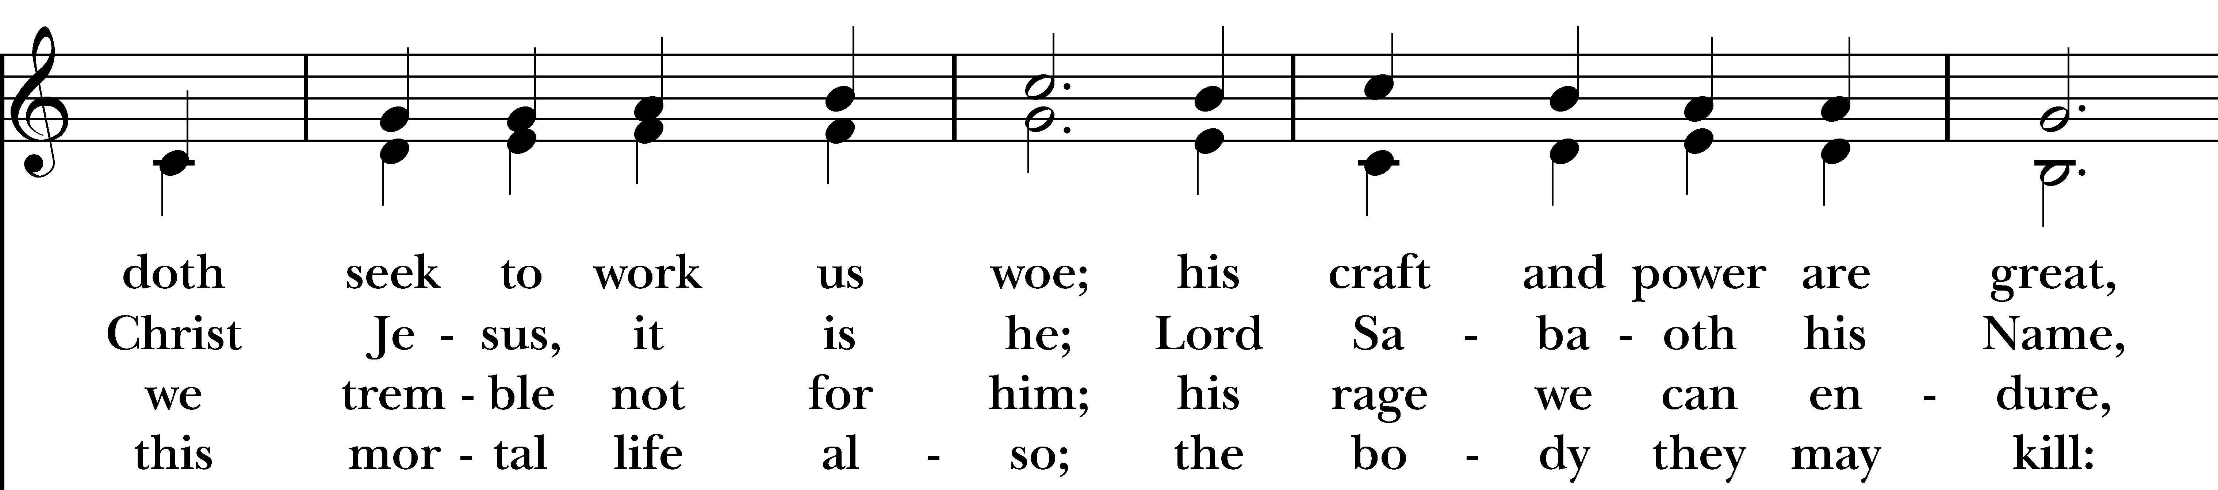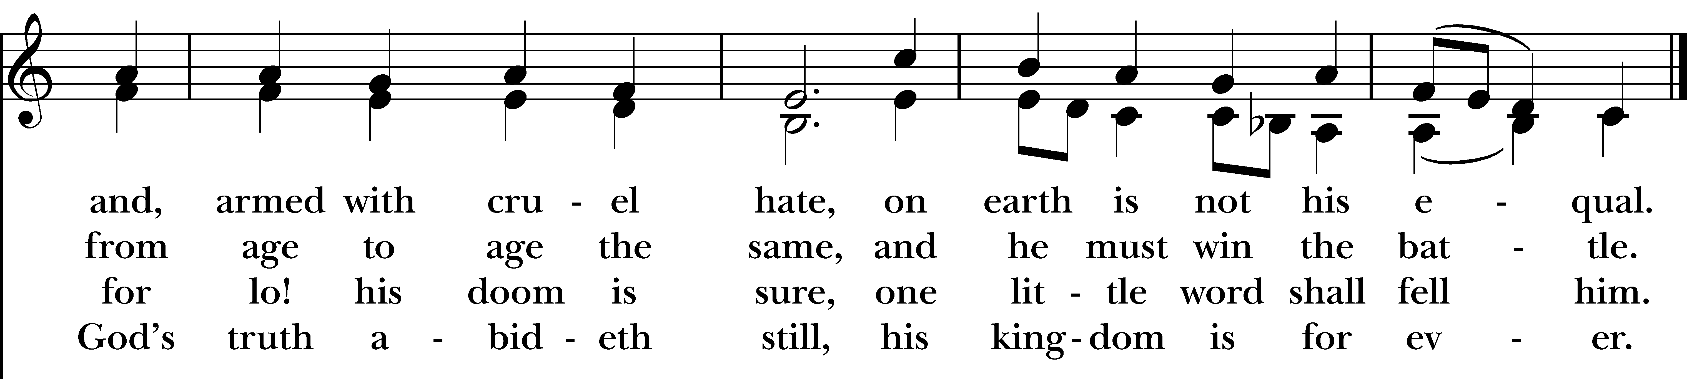
Reprinted/streamed with permission via RiteSong. All rights reserved.

Dismissal

Celebrant: The 264th Annual Meeting of Christ Church is adjourned.
Our worship is ended. Our Service begins. Go in peace to love & serve the Lord.
People: Thanks be to God.
Announcements for February 22nd, 2026

NAME TAGS: A reminder to please wear your name tag each week, found in the back of the church.

COFFEE HOUR: Please consider signing up to provide refreshments for an upcoming Sunday.

VESTRY MEETING: Our next vestry meeting is Tuesday, 2/24 at 7pm. All are welcome. Email Vicki for the Zoom link.

LUMOS CONCERT: Friday, March 27th – Lumos concert here at Christ Church, presenting a “Beatles Candlelight Experience.” Tickets available on their website: lumos-experiences.com.

GIFT CARDS to gas stations & grocery stores are always needed. Thank you for your continued generosity.

UPCOMING WORSHIP DATES – Sunday Services @ 9:30 am

Sunday, 3/1: Morning Prayer – Andy Hathaway

Sunday, 3/8: Eucharist & Family Sunday – Rev. Katy Piazza

Sunday, 3/15: Morning Prayer – Deborah Swann

Sunday, 3/22: Morning Prayer – Molly Adams
Vestry: Jim Swann, Jr. Warden; Bob Ellwanger, Treasurer; Peg Ellwanger, Clerk

Vestry Members: Russ Bailas, Amy Bailas, Marina Philips, Claire Wilkes

Diocesan Delegates: Diane McCann, Bob Ellwanger; Alternate: Deborah Swann

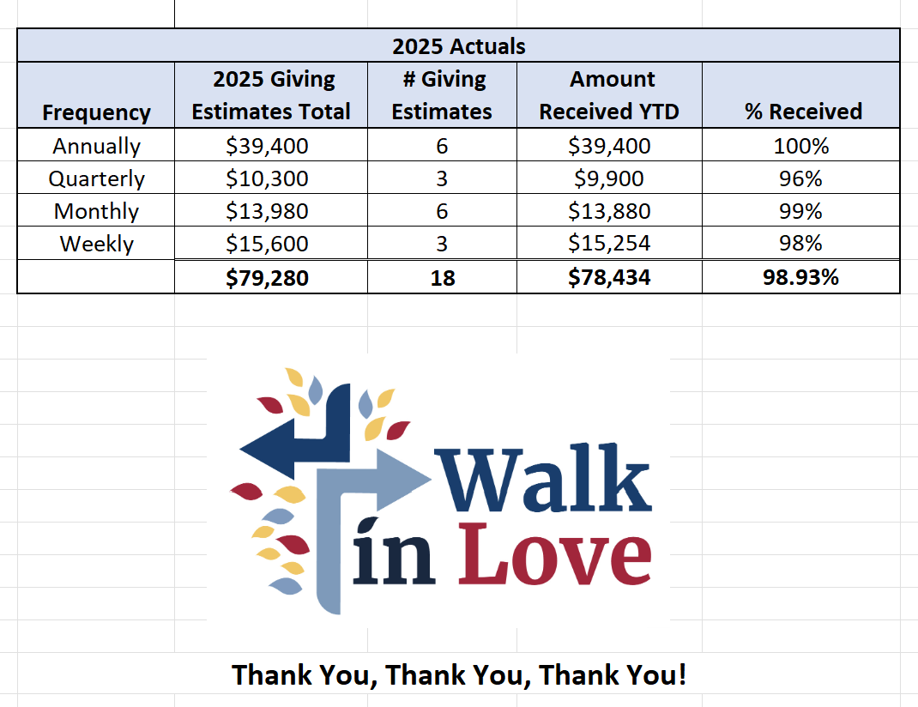
Christ Church – Parish Office Hours:
Mondays & Wednesdays: 9:30-1:30

59 Church Rd, Easton, CT
(203) 268-3569

christchurcheaston@gmail.com
www.christchurcheaston.com

Priest-in-Charge: Katy Piazza

Senior Warden: Vicki MarkAnthony

Parish Administrator: Tracy Carlucci
Music Minister: Tracy Carlucci

Choir Members: Amy Strachan, Andy Verrocchi, Bob Ellwanger, David McCann, Diane McCann, Marina Philips, Katie Tressler, Vicki MarkAnthony

Christ Church Nursery School: Maggie Supple, Director www.ccnseaston.com

