Holy Eucharist
December 25th, 2025
Christmas Day

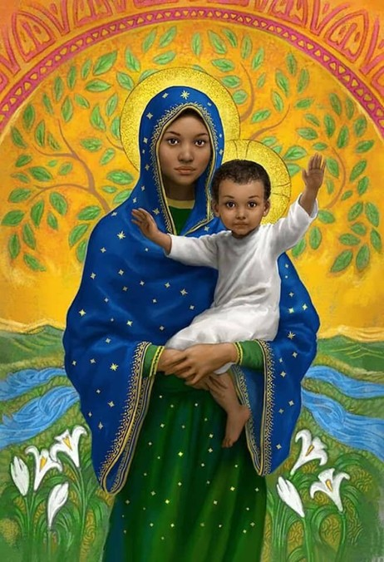
Anthony VanArsdale, Madonna and Child

Christ Church Easton
Rev. Katy Piazza, Priest-in-Charge

Christmas Flowers 2025

Marilyn Caruso In loving memory of Carol & Edward Knauff, and Eleanor & Palmerino Caruso

Vicki MarkAnthony In loving memory of Joe, Sally, and Mike MarkAnthony, Christina & Joseph MarkAnthony, Dorothy & Colin Simpson, Bruce & Colin Simpson, Stella & Leo Gavril

Karen Emanuelson Ginger & Cliff Emanuelson

Sandy Breyan In loving memory of Nick Breyan

Russ & Amy Bailas In loving memory of Tod & Dot Bailas and Helen & Robert Baumbach
In thanksgiving for Morgan & Sandra Bailas and the Baumbach Family

Molly Adams In loving memory of Katie Mullowney and Tony Adams

Katie Tressler In loving memory of Will Tressler, Ella & Donald Tressler, Eleanor Brown, Donald & Amelia McCann, Helen, Tom, Gloria Hennigan, Mary McCann and Gary Bradicich, Don, Mike, Michael McCann, Martha McCann, Peggie Plosa, Agnes & Frances Donovan, Aracy Beth Belcher, Cindy Rohr-Blyth; for ALL deceased members who had worshiped here since the inception of Christ’s Church – those who donated the land, those who were involved in the planning & building here, those known and unknown who had shared their Time, Talent, and Treasure, faithfully serving Christ’s Church.

In thanksgiving for my family and my grandchildren: Colman, Tiernan, Clara, & Tristan & Baby Faye on the way; for Rev. Katy Piazza; for our Supply Priests, the Senior and Junior Wardens; Vestry Members, our Organist/Parish Secretary, Choir, teachers, parents and students of CCNS, Committee Members, our Church Members and their Precious Children.

James & Deborah Swann In thanksgiving for the Swann and Mrotek family

Margaret Silvestri In thanksgiving for my grandchildren: Maggie, Joseph, Will and Julia Maselli; Adriana, Cordelia and Kyla Silvestri

Peg & Bob Ellwanger In thanksgiving for our grandchildren: Ella & Danny Carlucci and Kevin McCahey

Diane McCann In thanksgiving for Emerson Mae Zukauskas and Matthew John Zukauskas

Cathy Cody In loving memory of Marge & Nick Kowtko, Catherine Nevilles, Mary Renehan, Catherine Shannon

John & Mary Gennarini For family, living and deceased

Dennis & Holly Pryor For the Pryor and Turner families

Claire Wilkes In loving memory of Milton Coward, Rosalyn Wood, and Raymond Wilkes

Marina Philips In thanksgiving for our two granddaughters, Talia and Nora

Celebrant: As we gather to worship, let us recognize that we gather on the ancestral lands and traditional territory of the (Aspetuck River Valley dwelling) Paugussett people.

Please stand as you are able and sing together our Processional Hymn, #83 “O come, all ye faithful,” found in your hymnal. We will sing verses 1, 3 and 6.

Processional Hymn “O come, all ye faithful” Hymnal #83
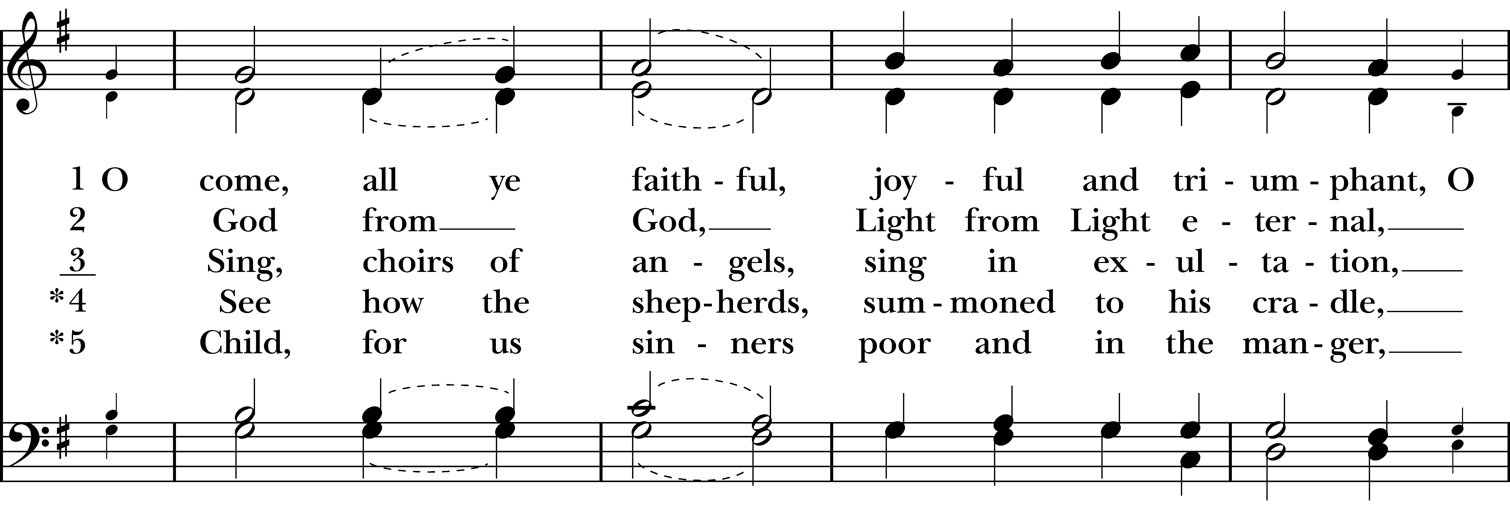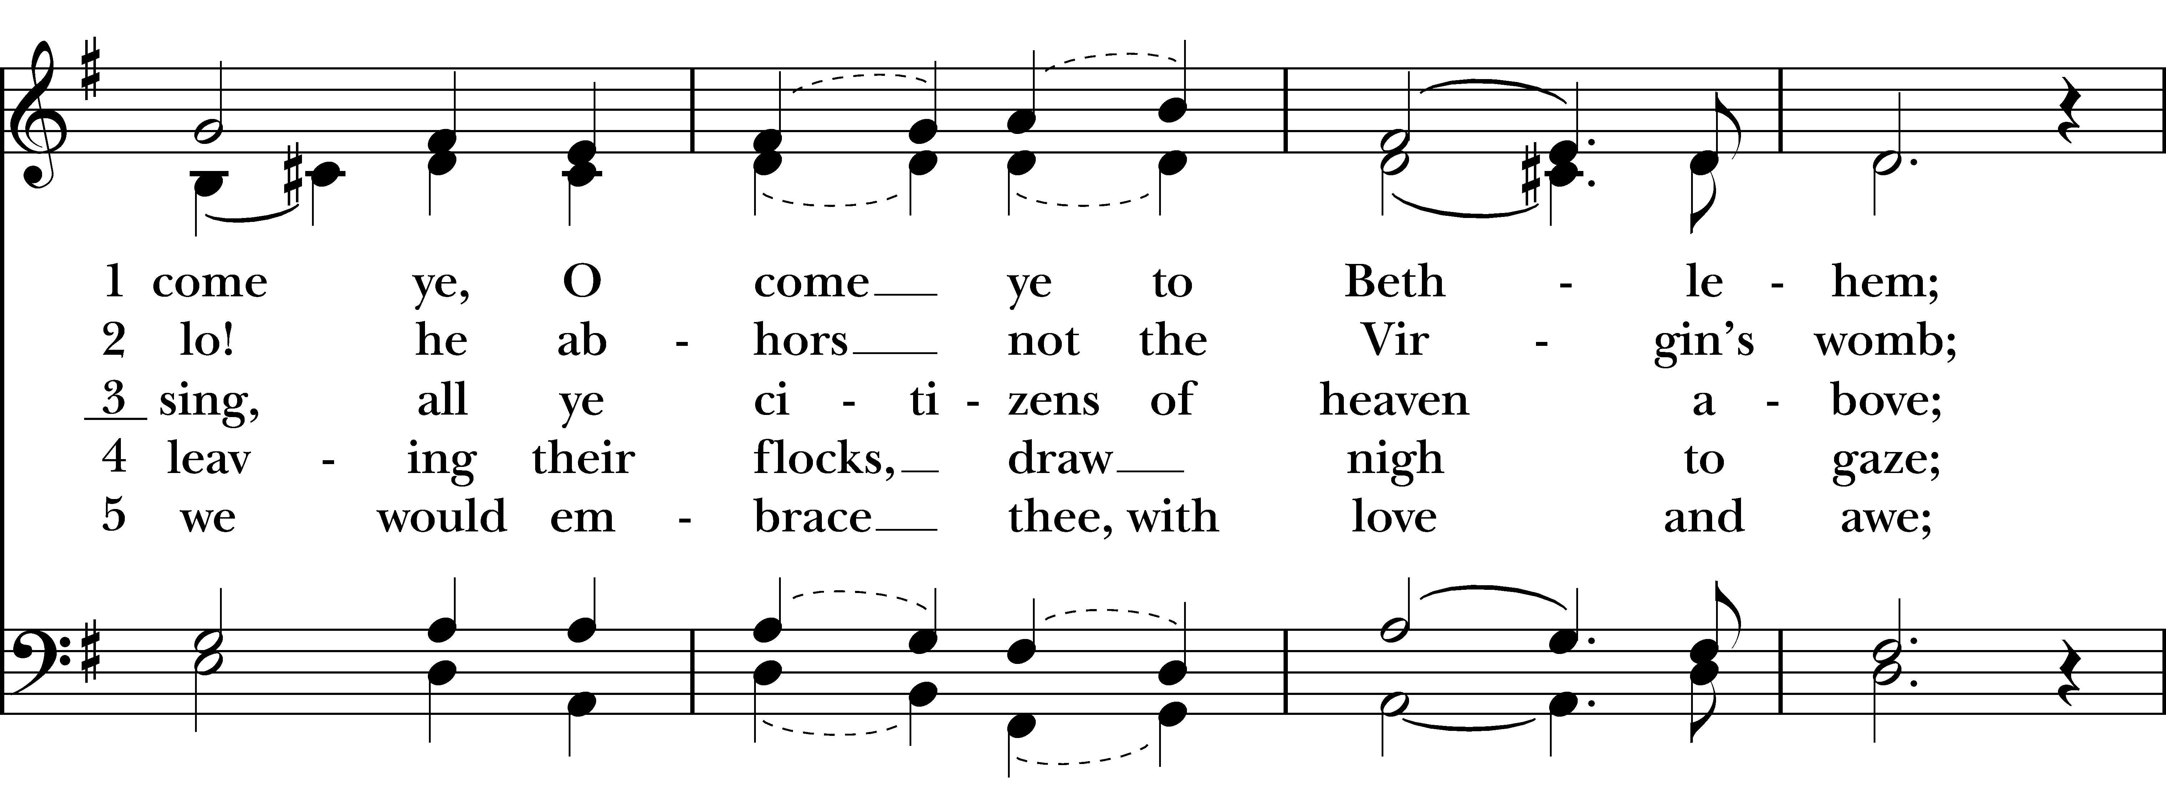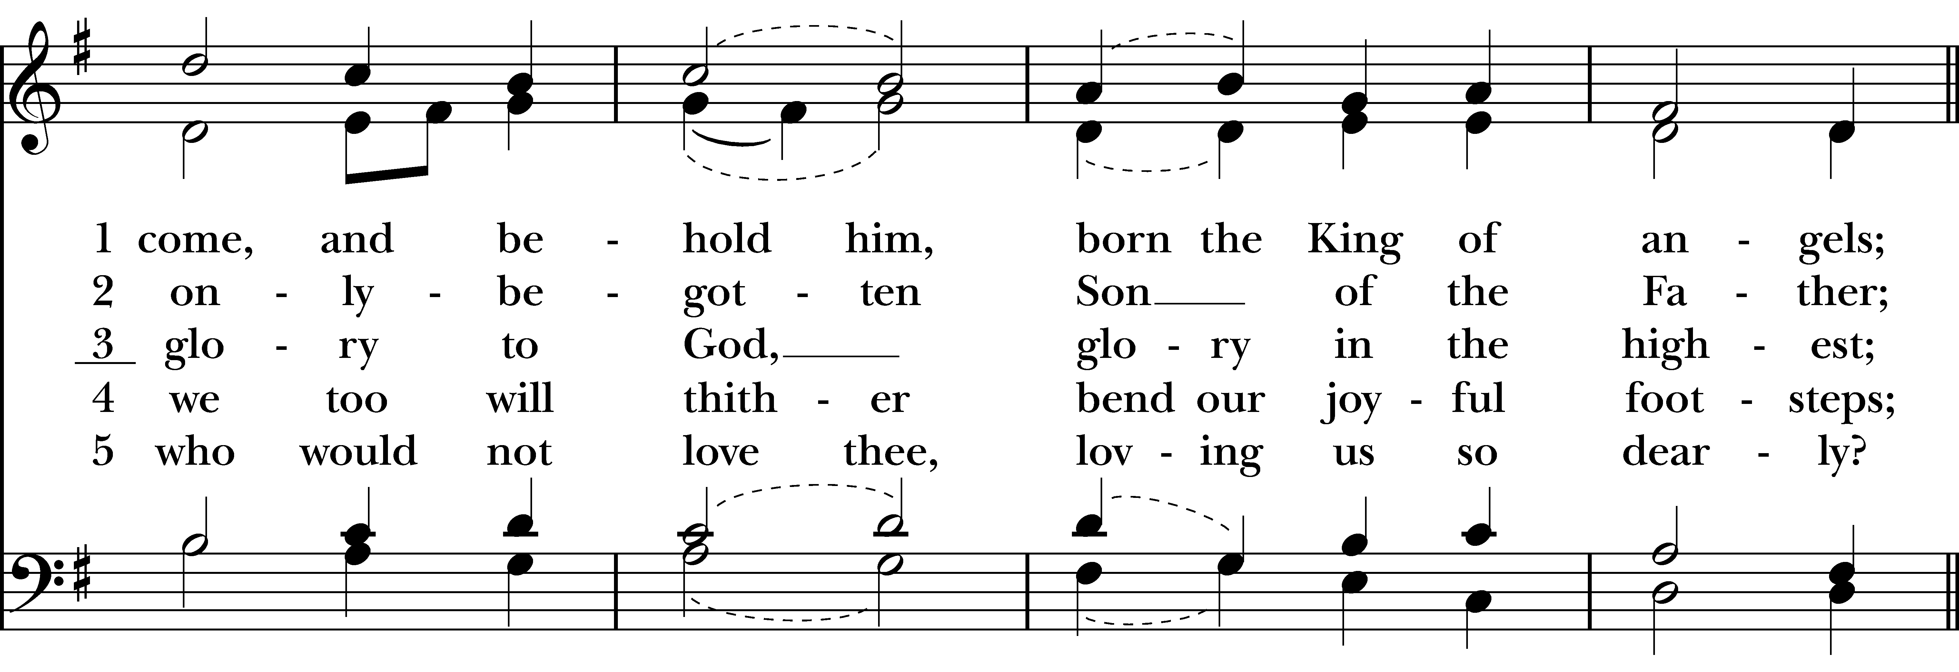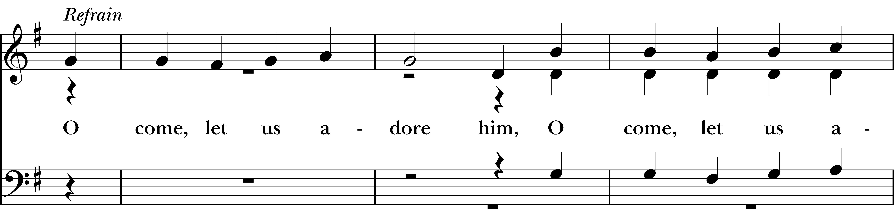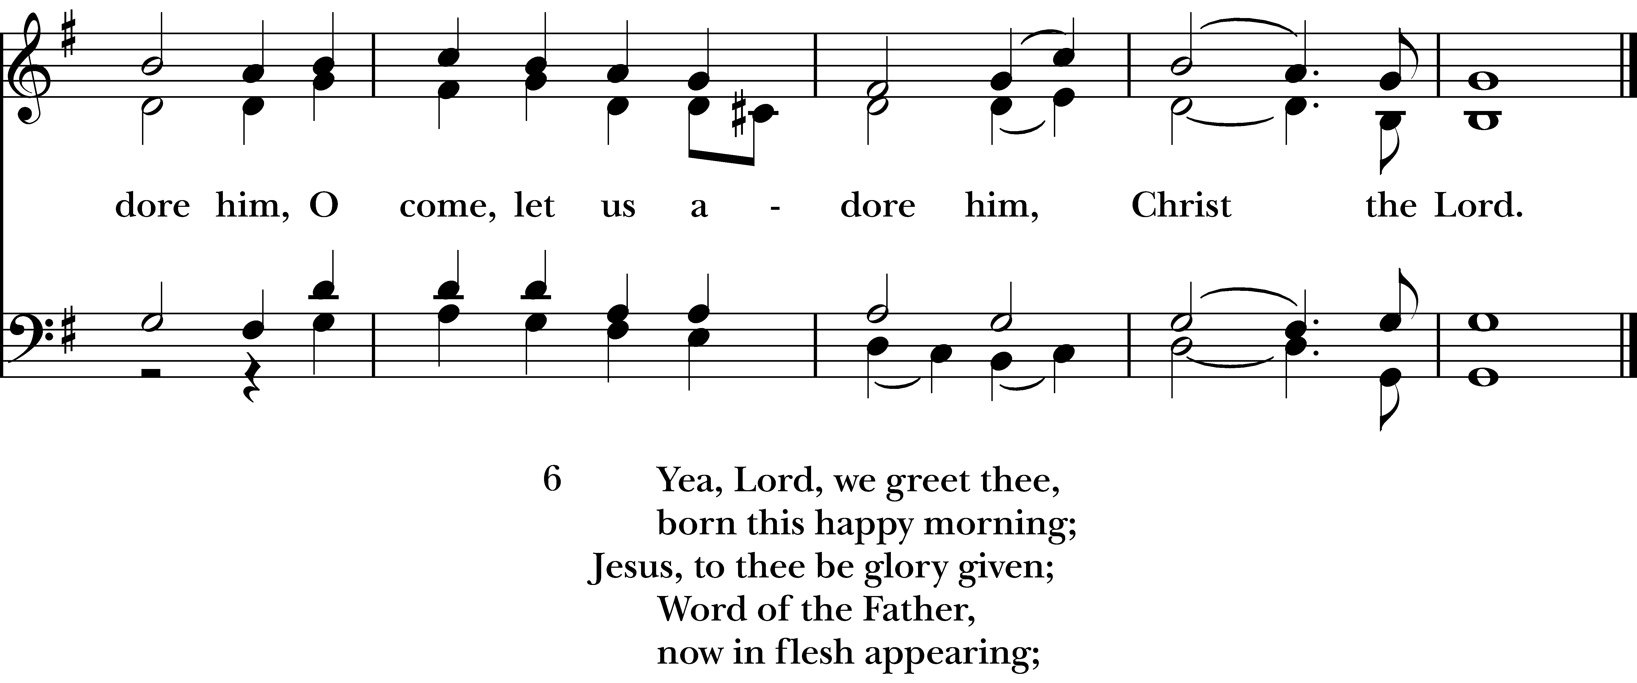
Reprinted/streamed with permission via One License and RiteSong. All rights reserved.
The Word of God BCP p. 355

Celebrant: Blessed be God: Father, Son, and Holy Spirit.
People: And blessed be his kingdom, now and for ever. Amen.

The Collect for Purity
Almighty God, to you all hearts are open, all desires known, and from you no secrets are hid: Cleanse the thoughts of our hearts by the inspiration of your Holy Spirit, that we may perfectly love you, and worthily magnify your holy Name; through Christ our Lord. Amen.

Gloria in Excelsis BCP p. 356

Glory to God in the highest, and peace to his people on earth.
Lord God, heavenly King, almighty God and Father,
we worship you, we give you thanks, we praise you for your glory.
Lord Jesus Christ, only Son of the Father,
Lord God, Lamb of God, you take away the sin of the world: have mercy on us;
you are seated at the right hand of the Father: receive our prayer.
For you alone are the Holy One, you alone are the Lord, you alone are the Most High,
Jesus Christ, with the Holy Spirit, in the glory of God the Father. Amen.

The Collect of the Day

Celebrant: The Lord be with you.
People: And also with you.
Let us pray. O God, you make us glad by the yearly festival of the birth of your only Son Jesus Christ: Grant that we, who joyfully receive him as our Redeemer, may with sure confidence behold him when he comes to be our Judge; who lives and reigns with you and the Holy Spirit, one God, now and for ever. Amen.

The First Reading Isaiah 9:2-7
A Reading from the Book of the Prophet Isaiah.

The people who walked in darkness have seen a great light; those who lived in a land of deep darkness— on them light has shined. You have multiplied the nation, you have increased its joy; they rejoice before you as with joy at the harvest, as people exult when dividing plunder. For the yoke of their burden, and the bar across their shoulders, the rod of their oppressor, you have broken as on the day of Midian. For all the boots of the tramping warriors and all the garments rolled in blood shall be burned as fuel for the fire. For a child has been born for us, a son given to us; authority rests upon his shoulders; and he is named Wonderful Counselor, Mighty God, Everlasting Father, Prince of Peace. His authority shall grow continually, and there shall be endless peace for the throne of David and his kingdom. He will establish and uphold it with justice and with righteousness from this time onward and forevermore. The zeal of the LORD of hosts will do this.

The Word of the Lord.
Thanks be to God.

The Psalm Psalm 96
Sing to the LORD a new song; *
sing to the LORD, all the whole earth.
Sing to the LORD and bless his Name; *
proclaim the good news of his salvation from day to day.
Declare his glory among the nations *
and his wonders among all peoples.
For great is the LORD and greatly to be praised; *
he is more to be feared than all gods.
As for all the gods of the nations, they are but idols; *
but it is the LORD who made the heavens.
Oh, the majesty and magnificence of his presence! *
Oh, the power and the splendor of his sanctuary!
Ascribe to the LORD, you families of the peoples; *
ascribe to the LORD honor and power.
Ascribe to the LORD the honor due his Name; *
bring offerings and come into his courts.
Worship the LORD in the beauty of holiness; *
let the whole earth tremble before him.
Tell it out among the nations: “The LORD is King! *
he has made the world so firm that it cannot be moved; he will judge the peoples with equity.”
Let the heavens rejoice, and let the earth be glad; let the sea thunder and all that is in it; *
let the field be joyful and all that is therein.
Then shall all the trees of the wood shout for joy before the LORD when he comes, *
when he comes to judge the earth.
He will judge the world with righteousness *
and the peoples with his truth.

The Second Reading Titus 2:11-14

A Reading from the Letter to Titus.

For the grace of God has appeared, bringing salvation to all, training us to renounce impiety and worldly passions, and in the present age to live lives that are self-controlled, upright, and godly, while we wait for the blessed hope and the manifestation of the glory of our great God and Savior, Jesus Christ. He it is who gave himself for us that he might redeem us from all iniquity and purify for himself a people of his own who are zealous for good deeds.

The Word of the Lord
Thanks be to God.

The Gospel Luke 2:1-14,(15-20)
The Holy Gospel of our Lord Jesus Christ, according to Luke.
Glory to you, Lord Christ.

In those days a decree went out from Emperor Augustus that all the world should be registered. This was the first registration and was taken while Quirinius was governor of Syria. All went to their own towns to be registered. Joseph also went from the town of Nazareth in Galilee to Judea, to the city of David called Bethlehem, because he was descended from the house and family of David. He went to be registered with Mary, to whom he was engaged and who was expecting a child. While they were there, the time came for her to deliver her child. And she gave birth to her firstborn son and wrapped him in bands of cloth, and laid him in a manger, because there was no place for them in the inn.

In that region there were shepherds living in the fields, keeping watch over their flock by night. Then an angel of the Lord stood before them, and the glory of the Lord shone around them, and they were terrified. But the angel said to them, “Do not be afraid; for see—I am bringing you good news of great joy for all the people: to you is born this day in the city of David a Savior, who is the Messiah, the Lord. This will be a sign for you: you will find a child wrapped in bands of cloth and lying in a manger.” And suddenly there was with the angel a multitude of the heavenly host, praising God and saying, “Glory to God in the highest heaven, and on earth peace among those whom he favors!” [When the angels had left them and gone into heaven, the shepherds said to one another, “Let us go now to Bethlehem and see this thing that has taken place, which the Lord has made known to us.” So they went with haste and found Mary and Joseph, and the child lying in the manger. When they saw this, they made known what had been told them about this child; and all who heard it were amazed at what the shepherds told them. But Mary treasured all these words and pondered them in her heart. The shepherds returned, glorifying and praising God for all they had heard and seen, as it had been told them.]

The Gospel of the Lord.
Praise to you, Lord Christ.

Sermon Rev. Katy

Celebrant: Please stand as you are able for The Nicene Creed.

The Nicene Creed BCP p. 358

We believe in one God, the Father, the Almighty, maker of heaven and earth, of all that is, seen and unseen. We believe in one Lord, Jesus Christ, the only Son of God, eternally begotten of the Father, God from God, Light from Light, true God from true God, begotten, not made, of one Being with the Father. Through him all things were made.

For us and for our salvation, he came down from heaven: by the power of the Holy Spirit he became incarnate from the Virgin Mary, and was made man. For our sake he was crucified under Pontius Pilate; he suffered death and was buried. On the third day he rose again in accordance with the Scriptures; he ascended into heaven and is seated at the right hand of the Father. He will come again in glory to judge the living and the dead, and his kingdom will have no end.

We believe in the Holy Spirit, the Lord, the giver of life, who proceeds from the Father and the Son. With the Father and the Son he is worshiped and glorified. He has spoken through the Prophets. We believe in one holy catholic and apostolic Church. We acknowledge one baptism for the forgiveness of sins. We look for the resurrection of the dead, and the life of the world to come. Amen.

Prayers of the People for Christmas

Celebrant: As we celebrate the birth of the Christ child, let us come before him with our petitions:

Lector: Christ, for whom there was no room in the inn, give courage to all who are homeless; we pray for generous hearts that we may answer their need in your mercy, hear our prayer.

Christ, who fled into Egypt, give comfort to all refugees. We pray for travelers, for the sick and the suffering, the oppressed, the lonely and the abused; we pray especially for those on our parish prayer list… In your mercy, hear our prayer.

Christ, who fasted in the desert, give relief to all who are starving; we pray for all those who work in food pantries and soup kitchens; in your mercy, hear our prayer.

Christ, who hung in agony on the cross, give strength to all who suffer; we pray for those who are close to death, for those afflicted with the diseases throughout the world and those in the health care industry that they should not falter; in your mercy, hear our prayer.

Christ, who died to save us, open wide your arms that all who have died may rest in your loving embrace, especially those whom we hold in our hearts. [Silence]. In your mercy, hear our prayer.

Christ of the perfect priesthood, we pray for all clergy and ministers of your holy church that they may lead with courage and abiding faith; in your mercy, hear our prayer.

Christ, the King of Kings who governs with justice and mercy, give guidance and inspiration to leaders of the world and all in authority; we pray for Joseph our president, and the leaders of war-torn nations; in your mercy, hear our prayer.

Celebrant: Loving God and Father of all, you have made us your children in Christ. Make us one in heart and mind to serve you with joy forever, and keep us true to you until we see you face to face. We ask this through Christ our Lord. Amen.

The Confession of Sin BCP p. 360

Celebrant: Turning now to page 360 in the Book of Common Prayer, let us confess our sins to God.

Most merciful God, we confess that we have sinned against you in thought, word, and deed,
by what we have done, and by what we have left undone. We have not loved you with our whole heart; we have not loved our neighbors as ourselves. We are truly sorry and we humbly repent. For the sake of our Savior Jesus Christ, have mercy on us and forgive us; that we may delight in your will, and walk in your ways, to the glory of your Name. Amen.

Almighty God have mercy on you, forgive you all your sins through our Lord Jesus Christ, strengthen you in all goodness, and by the power of the Holy Spirit keep you in eternal life. Amen.

The Peace
Celebrant: The peace of the Lord be always with you.
People: And also with you.

Announcements
The Holy Communion

Walk in love, as Christ loved us and gave himself for us, an offering and sacrifice to God. Ephesians 5:2

Offertory Hymn “Away, in a Manger” Hymnal #101

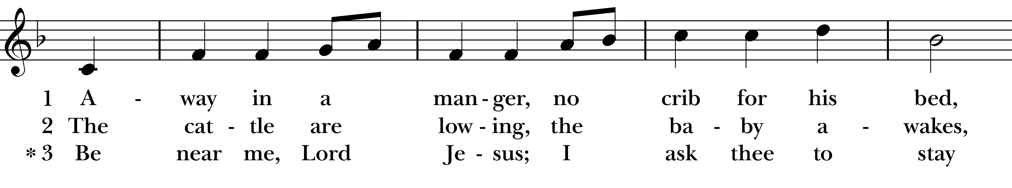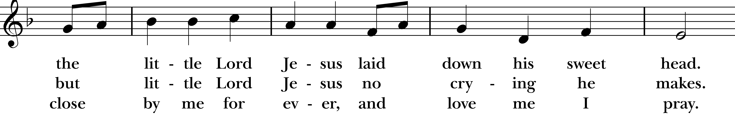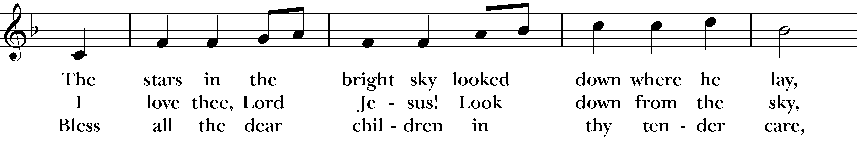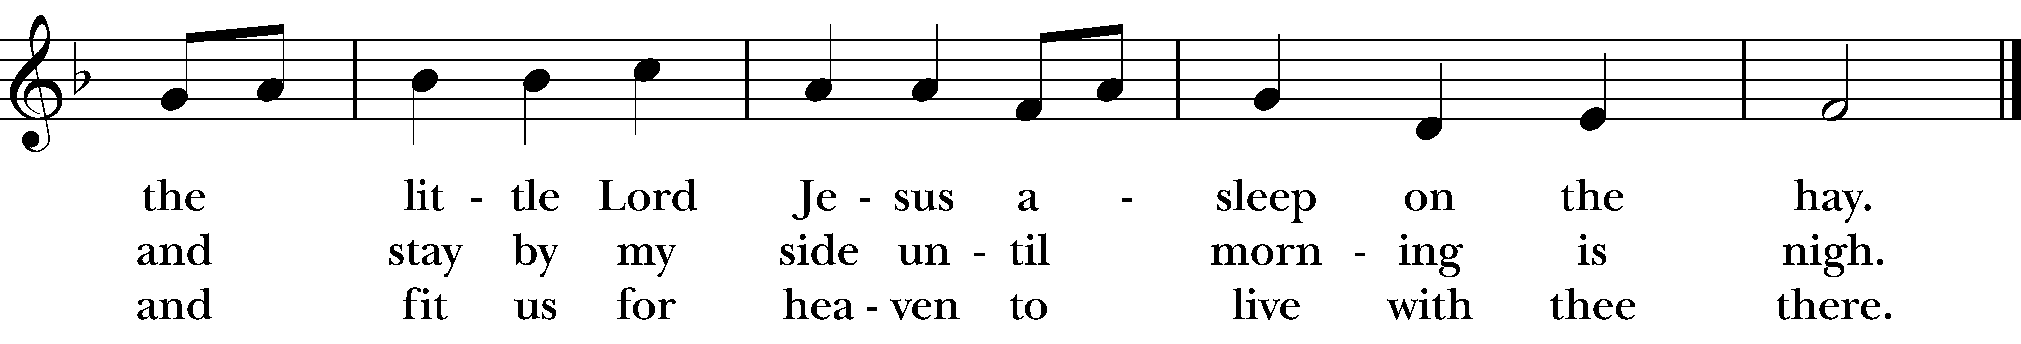
Reprinted/streamed with permission via One License and RiteSong. All rights reserved.
Eucharistic Prayer B BCP p. 367

Celebrant: The Lord be with you.
People: And also with you.
Celebrant: Lift up your hearts.
People: We lift them to the Lord.
Celebrant: Let us give thanks to the Lord our God.
People: It is right to give him thanks and praise.

It is right, and a good and joyful thing, always and everywhere to give thanks to you, Father Almighty, Creator of heaven and earth.
Because you sent your beloved Son to redeem us from sin and death, and to make us heirs in him of everlasting life; that when he shall come again in power and great triumph to judge the world, we may without shame or fear rejoice to behold his appearing.
Therefore we praise you, joining our voices with Angels and Archangels and with all the company of heaven, who for ever say this hymn to proclaim the glory of your Name:
Holy, Holy, Holy Lord, God of power and might, heaven and earth are full of your glory. Hosanna in the highest. Blessed is he who comes in the name of the Lord. Hosanna in the highest.

We give thanks to you, O God, for the goodness and love which you have made known to us in creation; in the calling of Israel to be your people; in your Word spoken through the prophets; and above all in the Word made flesh, Jesus, your Son. For in these last days you sent him to be incarnate from the Virgin Mary, to be the Savior and Redeemer of the world. In him, you have delivered us from evil, and made us worthy to stand before you. In him, you have brought us out of error into truth, out of sin into righteousness, out of death into life.

On the night before he died for us, our Lord Jesus Christ took bread; and when he had given thanks to you, he broke it, and gave it to his disciples, and said, “Take, eat: This is my Body, which is given for you. Do this for the remembrance of me.”
After supper he took the cup of wine; and when he had given thanks, he gave it to them, and said, “Drink this, all of you: This is my Blood of the new Covenant, which is shed for you and for many for the forgiveness of sins. Whenever you drink it, do this for the remembrance of me.”
And now, as our Savior Christ has taught us, we are bold to say,

Our Father who art in heaven, hallowed be thy Name, thy kingdom come, thy will be done, on earth as it is in in heaven. Give us this day our daily bread. And forgive us our trespasses as we forgive those who trespass against us. And lead us not into temptation but deliver us from evil. For thine is the kingdom, the power, and the glory, for ever and ever. Amen.

The Breaking of the Bread

Celebrant: Christ our Passover is sacrificed for us.
People: Therefore let us keep the feast.
Celebrant: The Gifts of God for the People of God.

A Prayer for Spiritual Communion:

Let us pray. We believe that you are truly present in the Holy Sacrament, and we pray you to come into our hearts, praying especially with those at home who cannot at this time receive communion. I unite myself with you and embrace you with all my heart, my soul, and my mind. Let nothing separate me from you; let me serve you in this life until, by your grace, I come to your glorious kingdom and unending peace. Amen.

Communion Instrumental

Prayer After Communion BCP 365

Eternal God, heavenly Father, you have graciously accepted us as living members of your Son our Savior Jesus Christ, and you have fed us with spiritual food in the Sacrament of his Body and Blood.
Send us now into the world in peace, and grant us strength and courage to love and serve you with gladness and singleness of heart; through Christ our Lord. Amen.
Blessing Rev. Katy

Celebrant: Please stand as you are able and sing together “Hark, the herald angels sing.”

Recessional Hymn “Hark, the herald angels sing” Hymnal #87
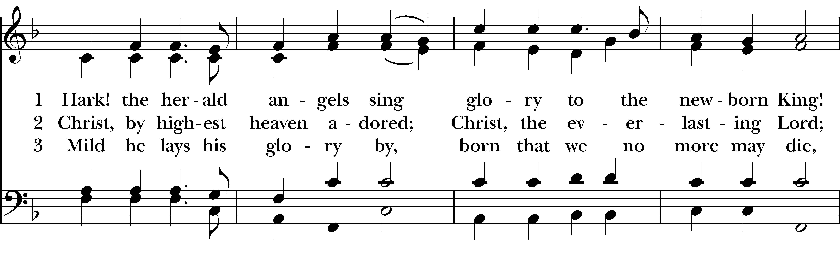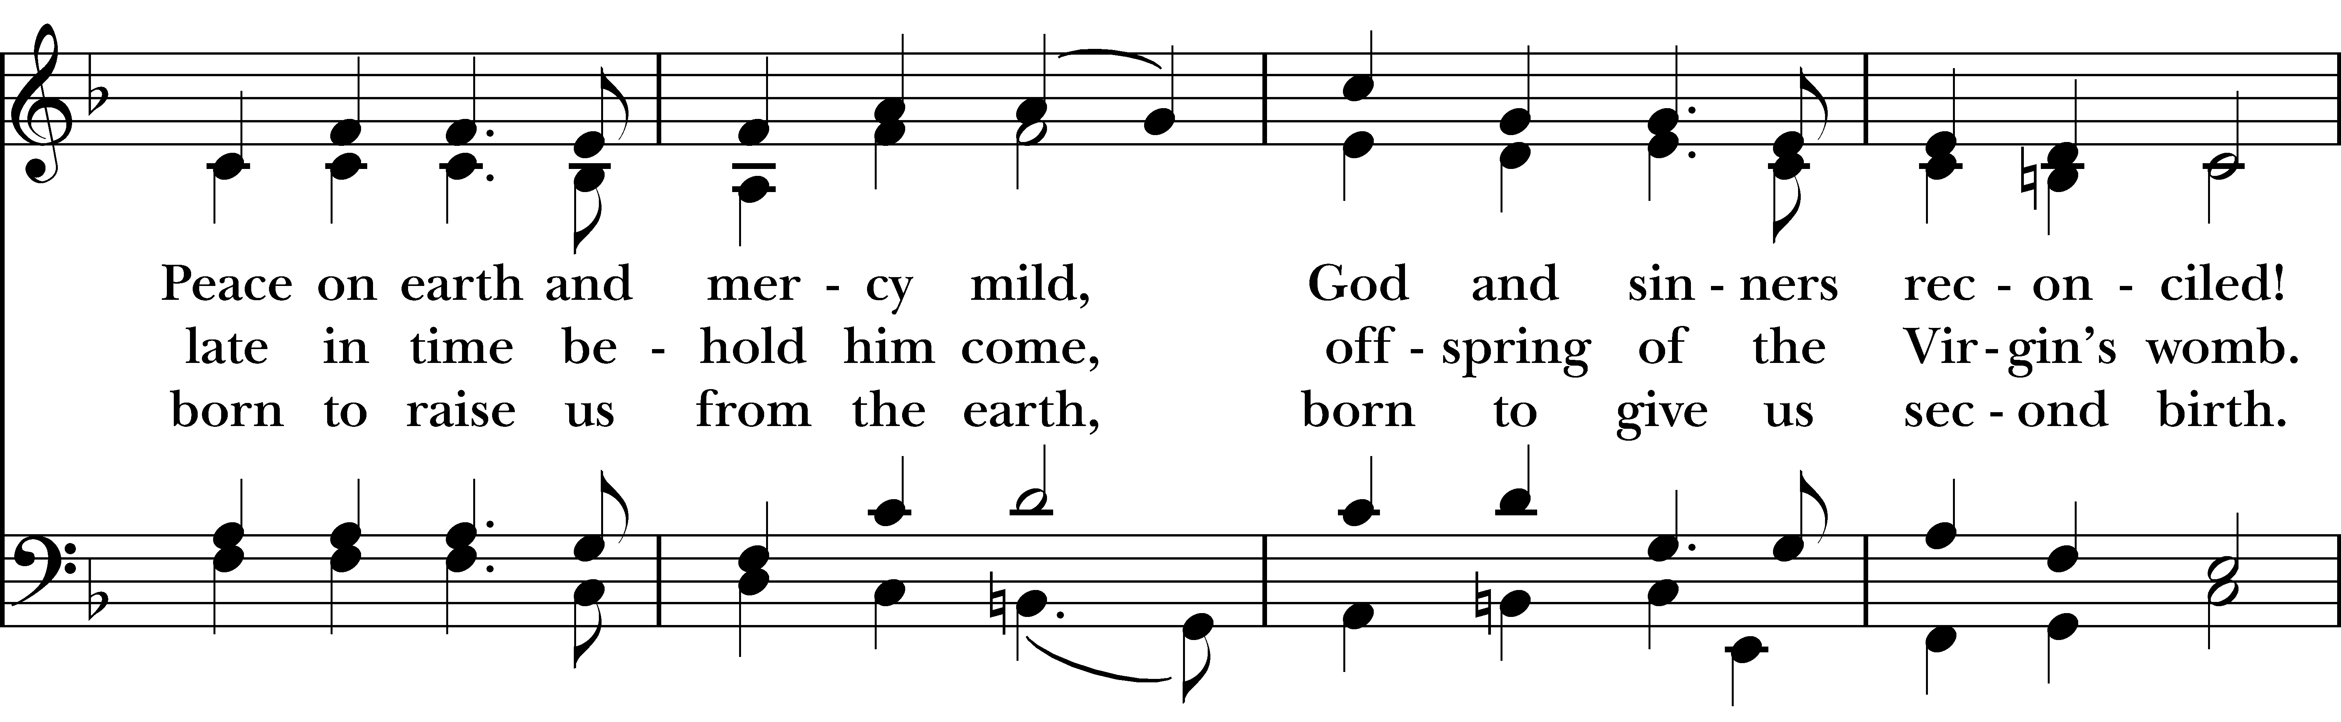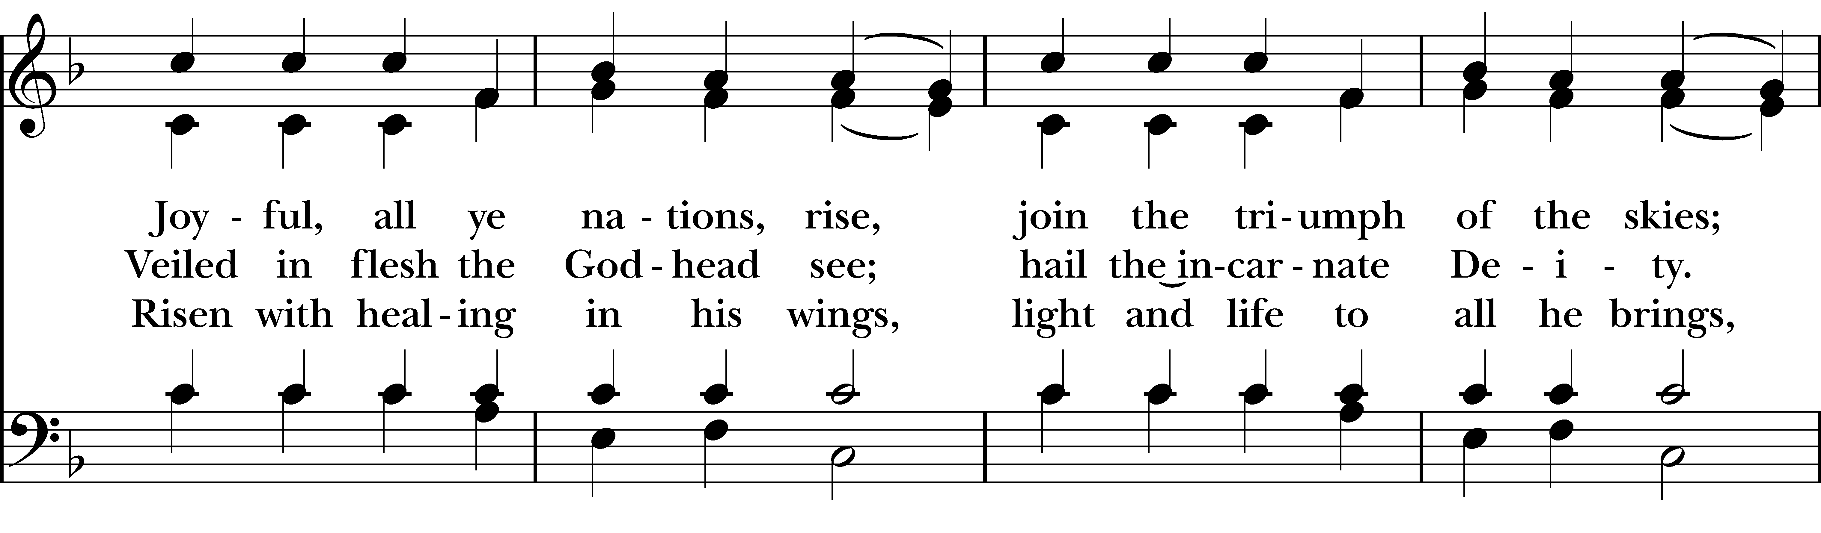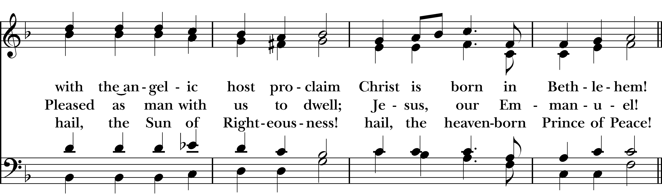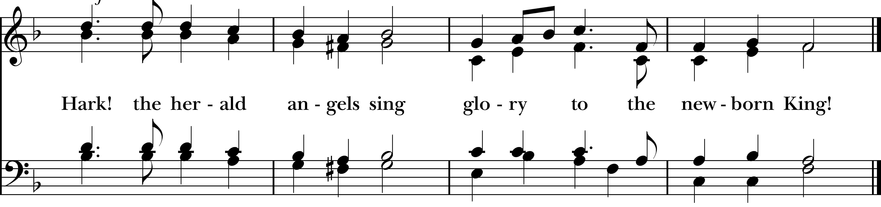
Dismissal

Celebrant: Our worship is ended. Our Service begins. Go in peace to love & serve the Lord.
People: Thanks be to God.

Welcome to Christ Church Easton!

Whether you are a newcomer, visitor, or longtime member, we bid you a warm welcome!
Please join us for coffee hour following service.
Sign up for our email list at www.christchurcheaston.com

Announcements for December 25th, 2025

CHRISTMAS FLOWERS: Thank you to everyone who contributed to our Christmas Flowers fund.

DIAPER DRIVE: Donations of diapers and wipes can be left in the back pews or in the bin outside the double doors throughout the month of December for our annual “Baby Shower for Jesus.” Thank you!

SPECIAL HOLIDAY MEDITATION: In-person here on Sunday, December 28th from 3:00-4:00pm, led by Deborah Swann. All are welcome.

GIFT CARDS to gas stations & grocery stores are always needed. Thank you for your continued generosity.

UPCOMING WORSHIP DATES – Sunday Services @ 9:30 am

Sunday, 12/28: Morning Prayer – Molly Adams

Sunday, 1/4: Eucharist – Rev. Katy Piazza

Sunday, 1/11: Morning Prayer – Andy Hathaway

Sunday, 1/18: Eucharist – Rev. Katy Piazza

Christ Church – Parish Office Hours:
Mondays & Wednesdays: 9:30-1:30

59 Church Rd, Easton, CT
(203) 268-3569

christchurcheaston@gmail.com
www.christchurcheaston.com

Priest-in-Charge: Katy Piazza

Senior Warden: Vicki MarkAnthony

Parish Administrator: Tracy Carlucci
Vestry: Jim Swann, Jr. Warden; Bob Ellwanger, Treasurer; Peg Ellwanger, Clerk

Vestry Members: Russ Bailas, Amy Bailas, Marina Philips, Claire Wilkes

Diocesan Delegates: Diane McCann, Bob Ellwanger; Alternate: Deborah Swann
Music Minister: Tracy Carlucci

Choir Members: Amy Strachan, Andy Verrocchi, Bob Ellwanger, David McCann, Diane McCann, Marina Philips, Katie Tressler, Vicki MarkAnthony

Christ Church Nursery School: Maggie Supple, Director www.ccnseaston.com

